Keone Hiraide
November 19, 2013
Computer Vision

Homework 4 Report

For both the synthetic image datasets and the real image datasets, my approach was the same. I first read in all four images, and created four vectors holding the intensities of these images. Their values were normalized to be in the range of 0-1.

I then created matrix 'S' by using the source vectors that were given in this assignment, assuming the camera parameter k is 1.

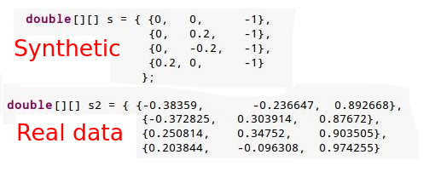
I then proceeded by using the following equation in order to form my "I' matrix.

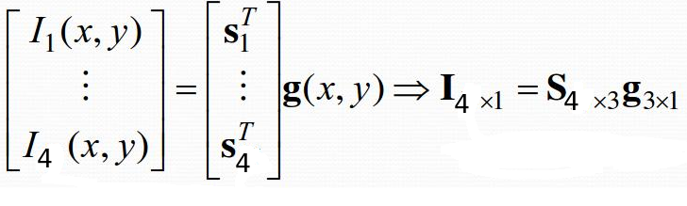
Once I had my "I" and my "S", I then solved for the surface description 'g' , using the trick for dealing with shadows by doing the following:

I = Sg
(I * I) = (I * S) g
S^T (I * I) = S^T (I * S) g
[S^T (I * S)]^-1 [S^T (I * I)] = g

This then produced a single column matrix 'g' with 3 rows and 1 column. I then solved for the albedo by taking the magnitude of 'g' where:
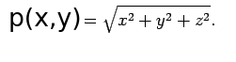
I then retrieved the x, y, and z components for the surface normal by using the following equation:

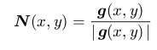
Once I had the surface normal and the albedo, I then retrieved the depth map by using the following equation.
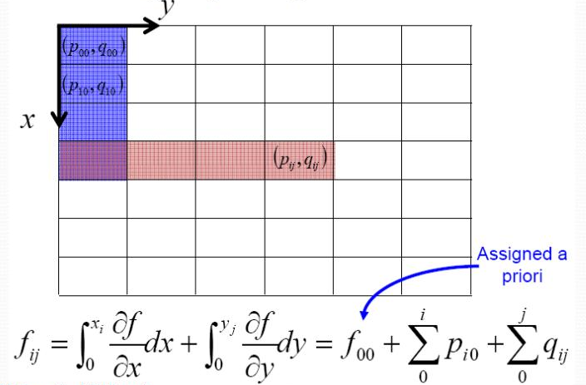
I outputted my images, with their values normalized in the range of 0-255, in various files:

imAlbedo.png - The albedo map for the synthetic image dataset
imX.png - The surface normal for the x component of the synthetic image dataset.
imY.png - The surface normal for the y component of the synthetic image dataset
imZ.png - The surface normal for the z component of the synthetic image dataset.
imD.png - The depth map of the synthetic image dataset.

realAlbedo.png - The albedo map for the real image dataset.
realX.png - The surface normal for the x component of the real image dataset.
realY.png - The surface normal for the y component of the real image dataset.
realZ.png - The surface normal for the z component of the real image dataset.
realD.png - The depth map of the real image dataset.

Lastly, when you run my program, a two 3D surface should show on the screen representing the synthetic image and the real image.

