CONVENTION FOR THE SAFEGUARDING OF
INTANGIBLE CULTURAL HERITAGE
CAPACITY-BUILDING for PERIODIC REPORTing
UNDER THE 2003 CONVENTION – REGIONAL WORKSHOP FOR AFRICA
9 to 11 November 2026
Algiers
Agenda and schedule

Before the workshop, participants must have completed the following steps:
- Online modules available on the Learning Platform of UNESCO dedicated to the safeguarding of intangible cultural heritage. Two learning pathways are offered: one for new focal points, the other for focal points who have already taken part in a cycle of reports’ preparation.
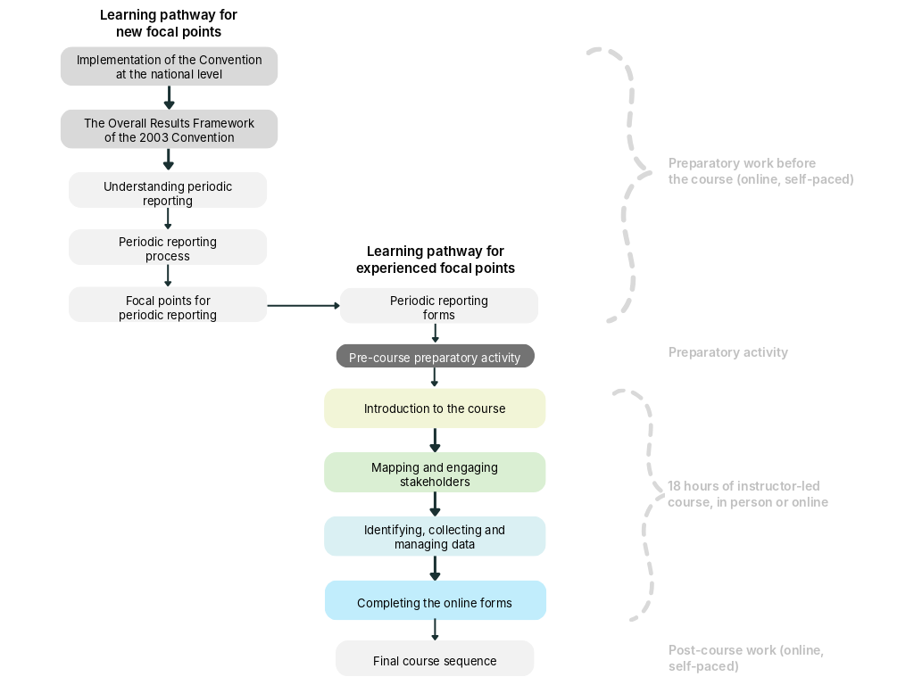

- Document 1 – Training preparation activity: The document must be completed online and sent to the organiser one week before the start of the in-person workshop.

Agenda and schedule of the in-person training
Day 1: Monday 9 November 2026
Time | Session | Resources | Duration
09:00-10:00 | Official opening ceremony | Speeches and talks | 1 hour
10:00-12:00  12:00-13:00 | Introduction to the training  - Welcome  - Training objective, learning outcomes and schedule  - Training materials, tools and resources  - Fostering peer learning, including through the feedback model or approach proposed for the training  - Participant introductions  - Recap of the micro-module content  - Planning the periodic reporting exercise (preparation and consultation)  - Human, financial, institutional and technical resources | Document 2 – National roadmap template  Practical manual for periodic reporting | 2 hours
10:00-12:00  12:00-13:00 | Mapping and engaging stakeholders  - Why engage stakeholders?  - Identifying key stakeholders  - Ensuring inclusivity  - Examples of stakeholders  - Building support for the reporting process  - Prioritising stakeholders  - Considering what might motivate stakeholders to participate | Document 2 – National roadmap template  Practical manual for periodic reporting | 1 hour
13:00-14:30 | Lunch |  | 1 h 30 min
14:30-18:00 (with a 30-minute break) | Mapping and engaging stakeholders (continued)  - Different ways of approaching participation  - Ways of engaging stakeholders  - Ethical principles  - Deciding when and how to engage stakeholders  - Challenges in engaging stakeholders and ways to address them  - Taking stakeholders’ needs into account  Note: Participants must read documents 2, 3 and 4 to prepare for the module Completing the online forms. At the end of the day, participants will also be able to continue working on their national roadmap. | Document 2 – National roadmap template  Practical manual for periodic reporting | 3 hours

Day 2: Tuesday 10 November 2026
Time | Session | Resources | Duration
08:00-08:30  08:30-12:30 (with a 30-minute break) | Mapping and engaging stakeholders (continued)  - Remaining topics to be covered in the module | Document 2 – National roadmap template | 30 min
08:00-08:30  08:30-12:30 (with a 30-minute break) | Identifying, collecting and managing data  - Questions to consider when planning  - Identifying data sources  - Primary data (original data collected for the purposes of periodic reporting)  - Secondary data (existing data)  - Examples of data sources for reporting on elements inscribed on the Representative List and on the List of Intangible Cultural Heritage in Need of Urgent Safeguarding  - Data collection methods  - Determining the type of data needed  - Taking into account the cost and difficulty of collection  - Ethics of data collection  - Good practices  - Data collection tools  - Data management | Document 2 – National roadmap template  Practical manual for periodic reporting | 3 h 30 min
12:30-14:00 | Lunch |  | 1 h 30 min
14:00-16:00 | Completing the online forms  - Moving from raw data to information ready for inclusion in the report  - Tips for selecting baselines and targets  - Specific guidance on reporting on elements inscribed on the List of Intangible Cultural Heritage in Need of Urgent Safeguarding (ICH-11)  - Organising the drafting and validation process  - Common challenges and ways to address them  Note: At the end of the day, participants will be able to continue working on their national roadmap. | Document 2 – National roadmap template  Documents 3, 4 and 5 – Fictitious data  Form ICH-10  Form ICH-11  Practical manual for periodic reporting | 2 hours

Day 3: Wednesday 11 November 2026
Time | Session | Resources | Duration
08:30-12:00 (with a 30-minute break) | Completing the online forms (continued)  - Continuation of the topics covered the previous day  - Characteristics of a clear and compelling response  - Good drafting practices  - Tips for improving reporting | Document 2 – National roadmap template  Documents 3, 4 and 5 – Fictitious data  Form ICH-10  Form ICH-11  Practical manual for periodic reporting | 3 hours
12:00-13:30 | Lunch |  | 1 h 30 min
13:30-17:00 (with a 30-minute break) | Completing the online forms (continued)  - Tips for updating your work plan and timeline  - Reviewing and finalising the national roadmaps developed by participants throughout the training  - Training evaluation  - Instructions for post-training work | Document 2 – National roadmap template  Documents 3, 4 and 5 – Fictitious data  Form ICH-10  Form ICH-11  Practical manual for periodic reporting | 3 hours

