KDSPOZ
Retail Billing & Inventory
User Guide
Version 1.0 · 3 November 2026
How to use billing, purchase, stock, products and barcode labels

1. Introduction
KDSPOZ is a retail point-of-sale and inventory system for shops. This guide explains the main day-to-day features with screenshots.
You can use KDSPOZ on:
• Desktop app (recommended for billing printers and label printers)
• Android / tablet for counter billing and stock
Main modules covered in this guide:
• Login
• Billing (sales)
• Purchase Entry
• Add Stock
• Products & variants
• Barcode label printing
• Printer setup

2. Login
Open the KDSPOZ app and sign in with your shop user account.
• Enter your phone / username and password
• Tap Login
• After login you land on the dashboard / menu
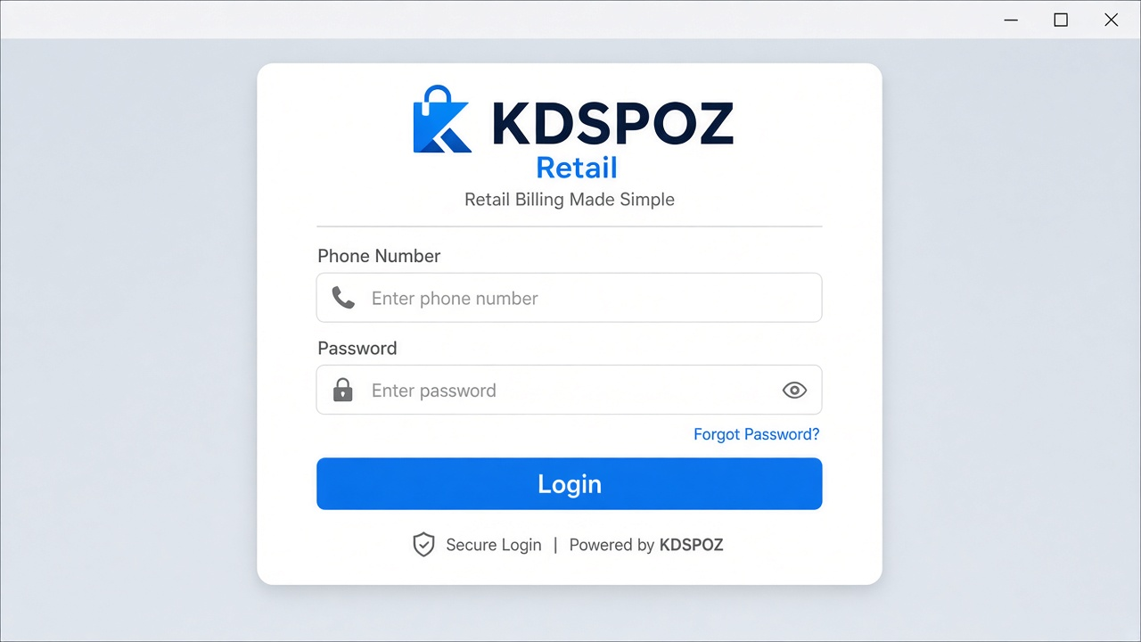
Figure 1 — Login screen
Tip: If login fails, check internet / server connection and ask the admin to reset your password.

3. Billing (Sales)

3.1 Open Billing
From the menu open Billing. On a wide desktop screen you see products on the left and the bill panel on the right.
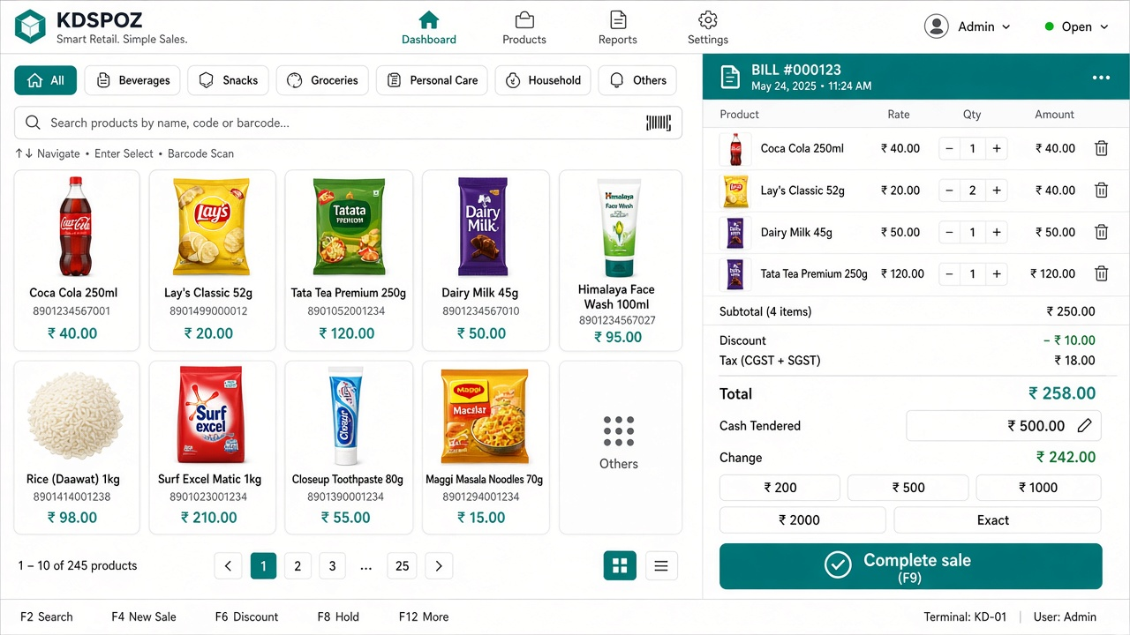
Figure 2 — Billing screen with product grid and bill panel

3.2 Add products to the bill
• Search by name, SKU or scan a barcode
• Tap a product tile to add it
• For weight / decimal items, enter the quantity when asked
• Items appear in the bill table: Product | Rate | Qty | Amount

3.3 Edit quantity inline
You do not need a popup to change qty. In the Qty column:
• Tap − or + to step the quantity
• Or type the quantity directly in the box and press Enter / leave the field
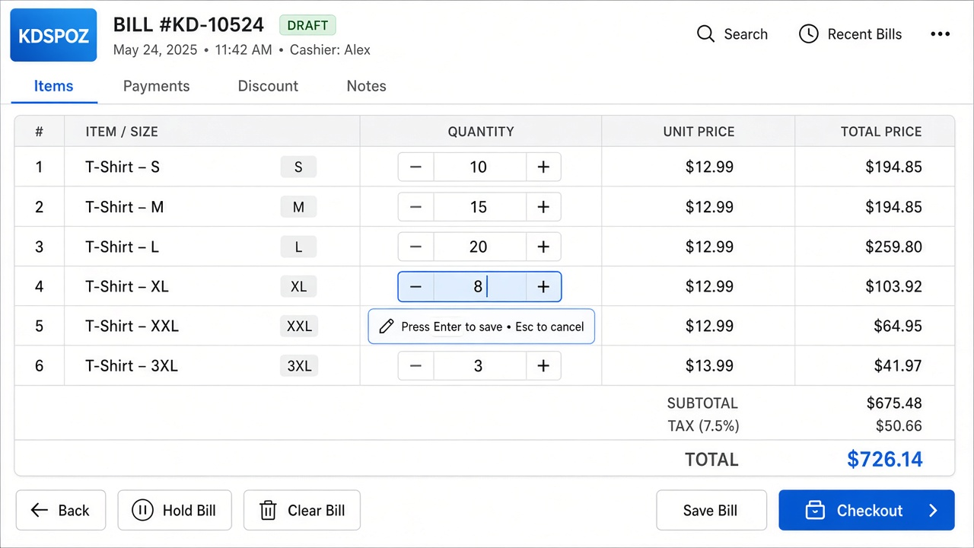
Figure 3 — Inline quantity editing on the bill table
Tip: Quantity is saved when you finish typing (blur). This keeps payment split / round-off stable while you type.

3.4 Take payment
• Choose payment mode: Cash, UPI, Card, Credit, etc.
• Optional: bill discount, round off, or split payment
• Tap Print for a receipt (if a billing printer is set)
• Tap Complete to save the sale and clear the cart

4. Purchase Entry
Use Purchase Entry when you buy stock from a supplier. Stock increases for each purchased size/variant.
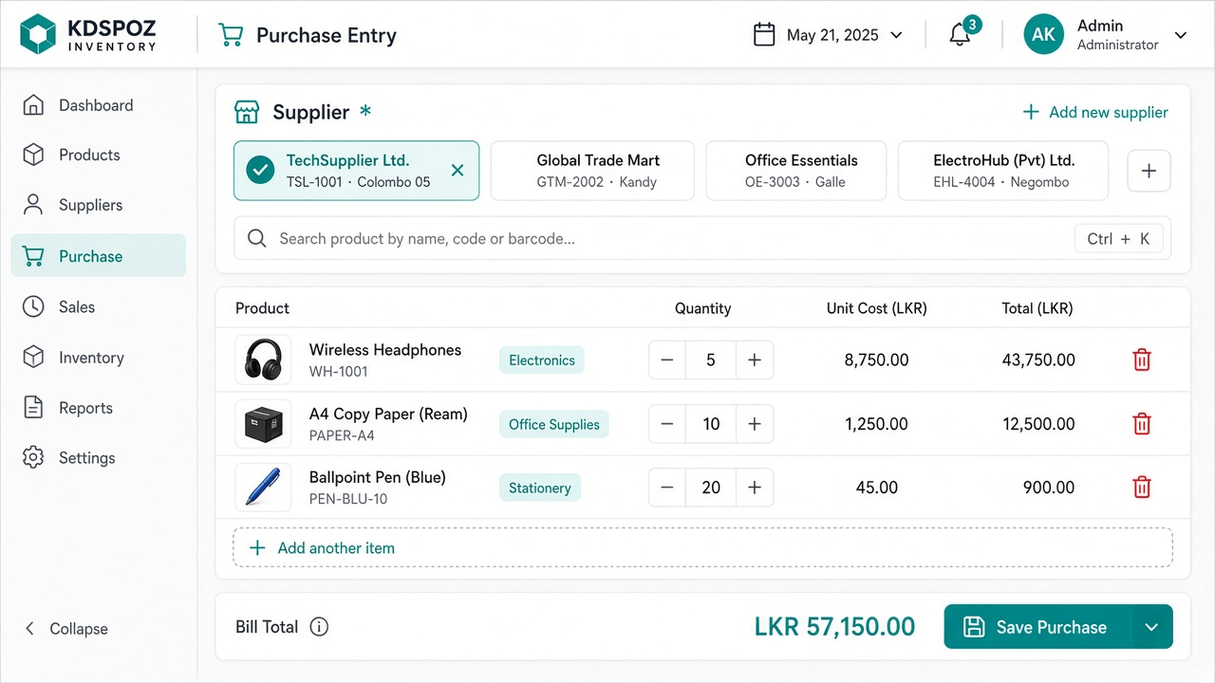
Figure 4 — Purchase Entry overview

4.1 Select supplier
• Choose an existing supplier chip, or tap Add to create one

4.2 Add products (with variants)
• Search the product by name / SKU / barcode
• If the product has sizes, all active variants open inline (no popup)
• Enter Qty and Purchase ₹ for each size you are buying (leave 0 to skip)
• Tap Add to purchase
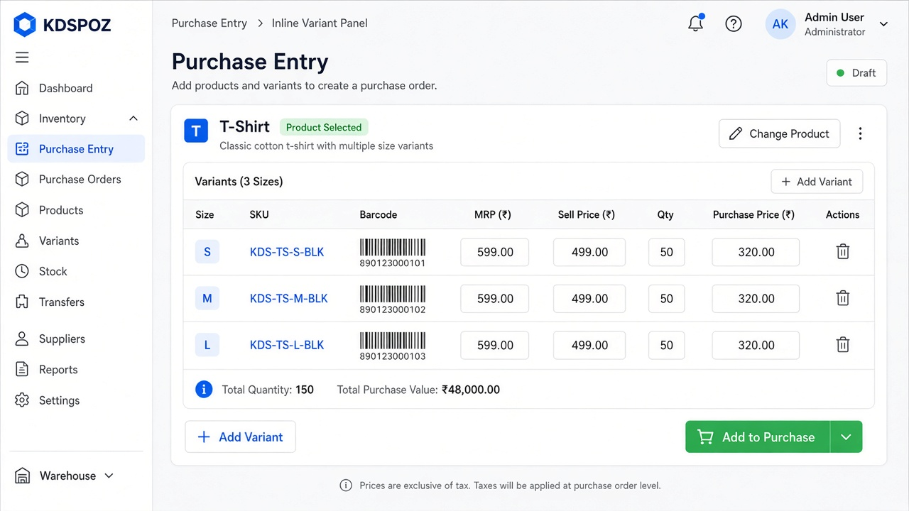
Figure 5 — Inline variant qty & purchase price

4.3 Add a new size while purchasing
• On the inline variant panel tap Add variant
• Enter Size (required), optional Colour, Selling price, Qty and Purchase ₹
• Add to purchase — the new size is marked New
• When you Save purchase, KDSPOZ creates that size on the product, then posts stock
Tip: Existing stock of other sizes is not split or changed when you add a new size from purchase.

4.4 Save purchase
• Review purchase items and totals
• Tap Save purchase & stock in
• Stock movements (PURCHASE_IN) are created per variant

5. Add Stock
Use Add Stock for manual stock-in without a purchase bill (opening, damage, adjust, remove).
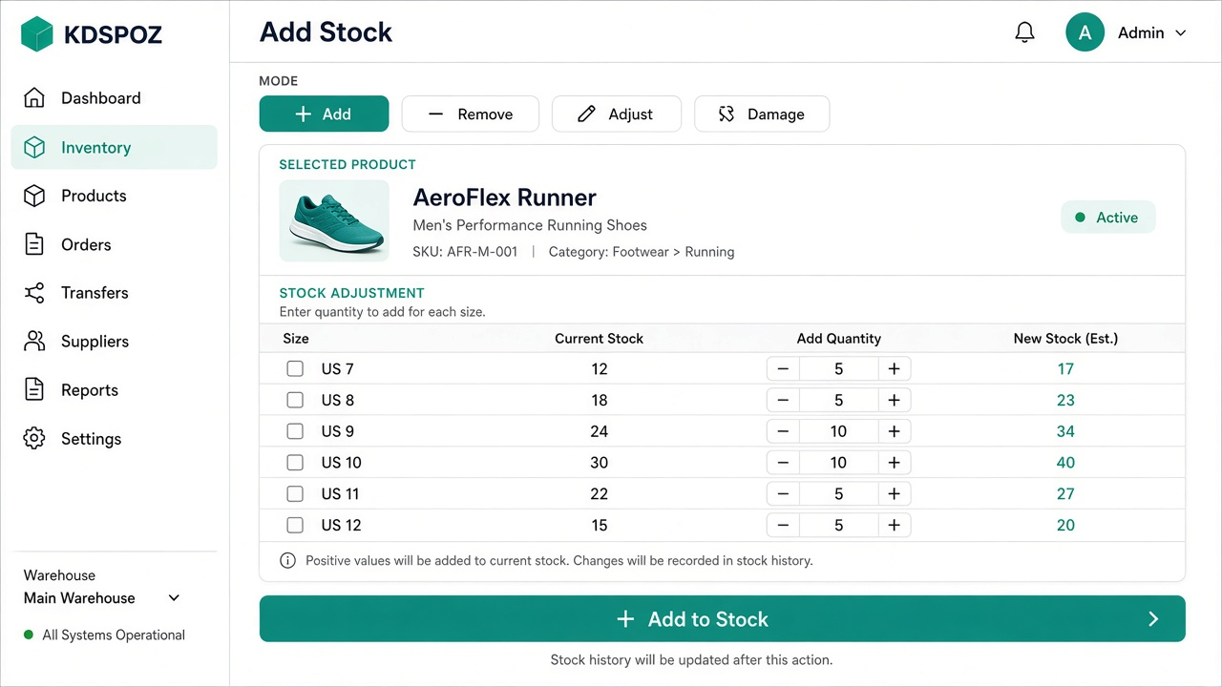
Figure 6 — Add Stock with per-size quantities
• Choose mode: Add / Remove / Adjust / Damage (or Opening)
• Search and select a product
• If it has variants, all active sizes appear with qty fields
• Enter qty only for sizes you want to change, then save
Tip: Printing labels never changes stock. Only stock / purchase / sale screens do.

6. Products & variants
Create or edit products from the Products menu.
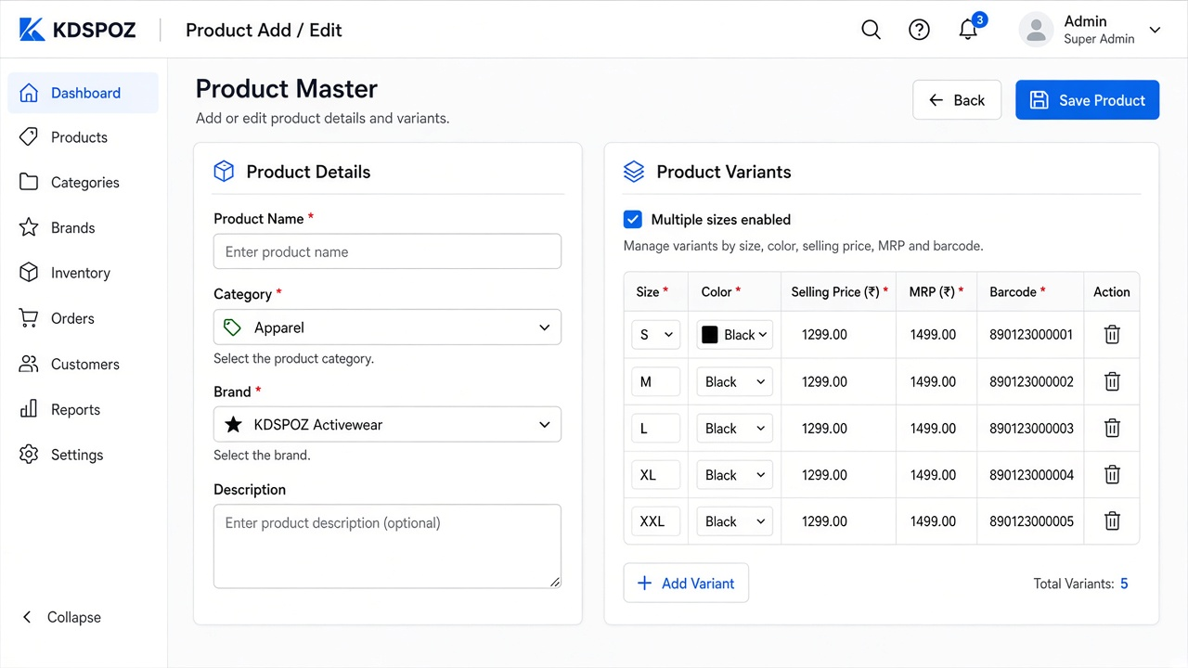
Figure 7 — Product form with multiple sizes
• Enter product name, category, brand, unit
• Enable multiple sizes / variants when needed
• For each size enter selling price, optional MRP, cost and barcode
• When multiple sizes exist, pricing and stock are kept per size — not on the parent product
Tip: Every sellable size should have its own barcode for billing and labels.

7. Barcode label printing
Open Barcode Labels to print 50 × 25 mm sticker labels.
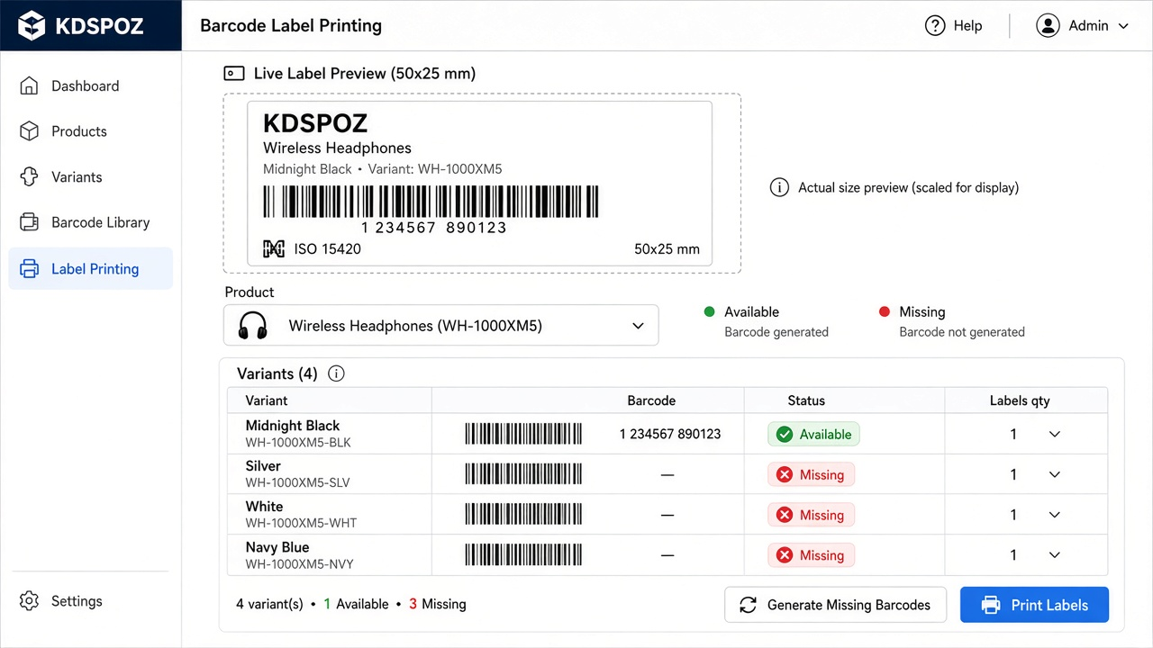
Figure 8 — Label screen with variant barcode status

7.1 Select product & variants
• Search and select a product
• All active variants are listed with barcode status: Available / Missing / Duplicate
• Select the sizes to print (Select all / Select none)
• Set Labels quantity per size
• Preview updates live — barcodes are never auto-created during preview

7.2 Generate missing barcodes
• If some sizes show Missing, tap Generate Missing Barcodes
• KDSPOZ creates unique internal Code 128 barcodes (KDSPOZ…) only for missing sizes
• Existing manufacturer barcodes are never overwritten

7.3 Print
• Connect / select the Label printer (separate from the billing printer)
• Tap Print — one label is printed per selected size using that size’s barcode
• Use Reprint last labels if you need the same job again
Tip: Label printing does not change inventory or prices.

8. Printers
KDSPOZ keeps billing and label printers separate so receipt and sticker jobs do not mix.
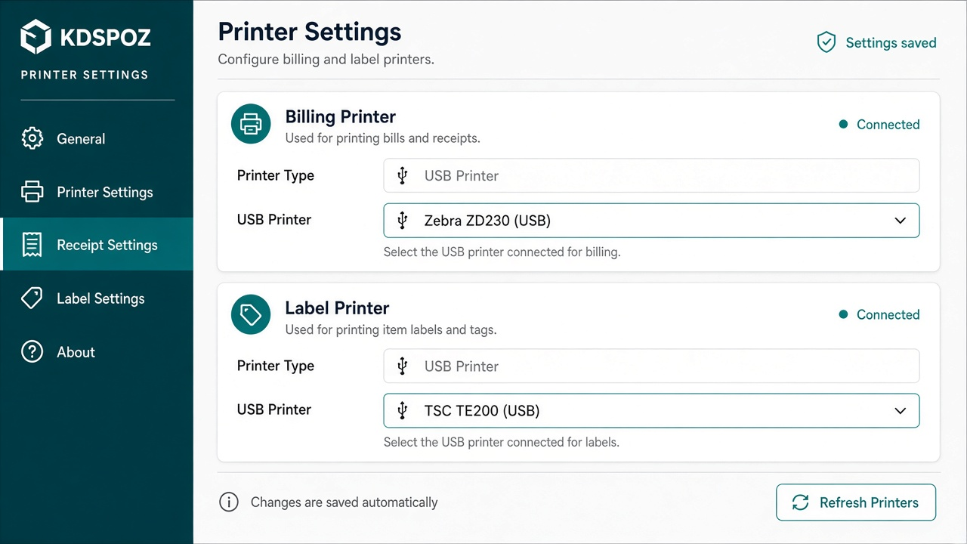
Figure 9 — Billing printer vs Label printer
• Billing printer — receipts from the Billing screen
• Label printer — 50×25 mm stickers from Barcode Labels
• On desktop, choose the USB / system printer for each role
• On Android, pair the Bluetooth label printer for labels

9. Quick checklist
Task | Where
Sell items & edit qty | Billing
Buy stock from supplier | Purchase Entry
Add a new size while buying | Purchase → Add variant → Save
Manual stock adjust | Add Stock
Create product with sizes | Products
Print price / barcode stickers | Barcode Labels
Set receipt vs sticker printer | Printer settings / Label screen

10. Support notes
• Always finish an open variant panel on Purchase before saving the bill
• Inactive sizes do not appear in normal label / purchase selection
• If a barcode shows Duplicate, fix the product barcode before printing that size
• For training, practice on a test product before using live stock

