First 6 pictures using open CV built in SIFT

Original:

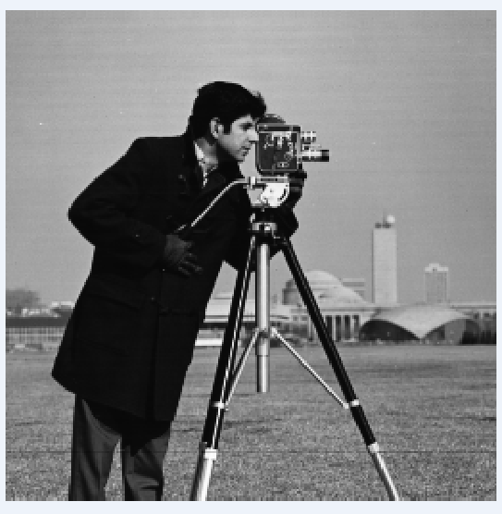

All Key Points:

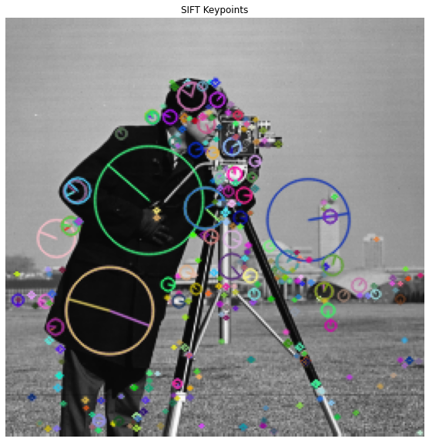

10 Strongest Points:

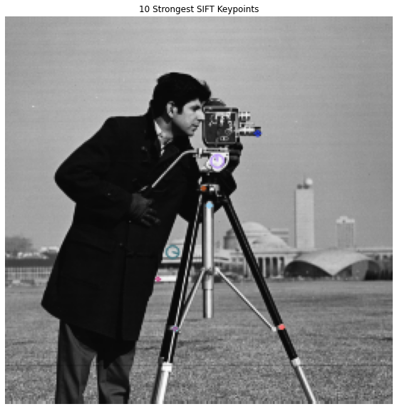

Point 1: (182.26068115234375, 204.73240661621094)

Point 2: (182.26068115234375, 204.73240661621094)

Point 3: (111.76130676269531, 205.8682403564453)

Point 4: (111.76130676269531, 205.8682403564453)

Point 5: (139.72889709472656, 95.17049407958984)

Point 6: (134.54725646972656, 124.41365051269531)

Point 7: (100.54109191894531, 173.00363159179688)

Point 8: (110.19285583496094, 155.21484375)

Point 9: (166.33738708496094, 76.77320098876953)

Point 10: (130.62796020507812, 113.03823852539062)

5 weakest points:

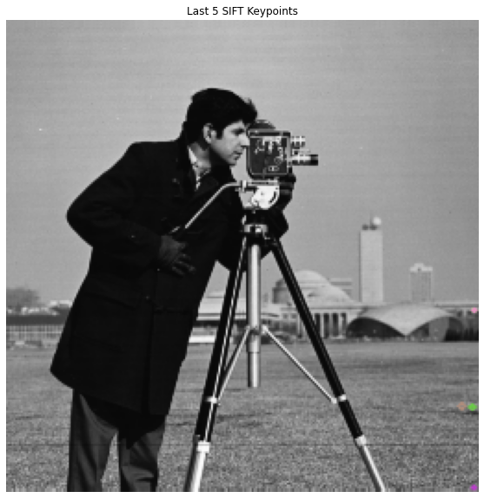

Harris Corners:

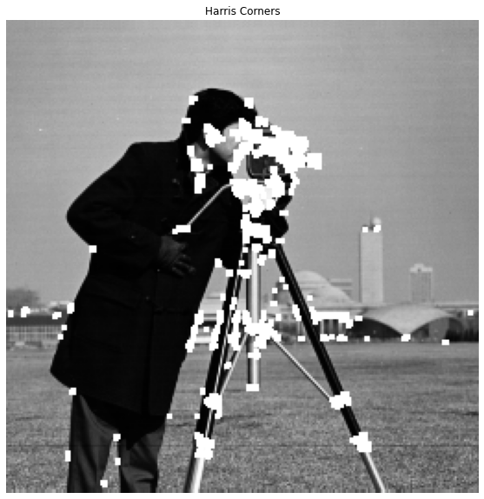

Extracted Corner Features:

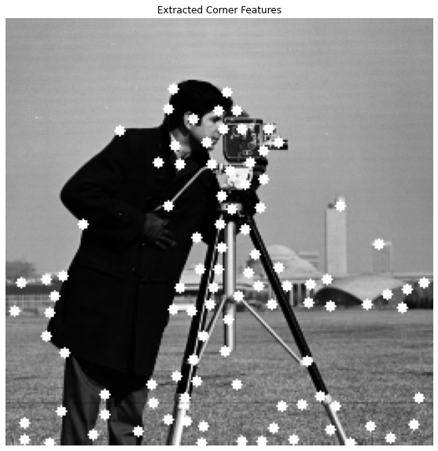

Detected ALL Keypoints by implementing SIFT manually, not built in SIFT (Second code)

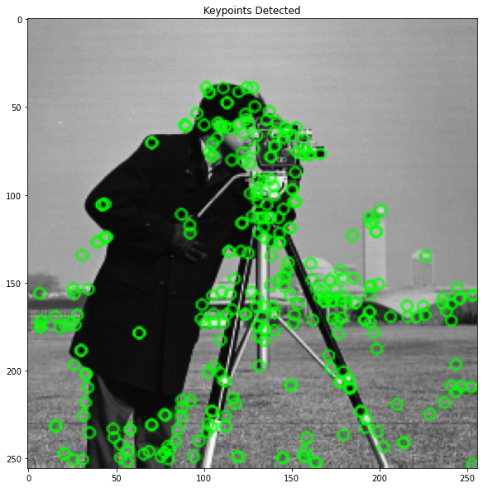

**Code using built in SIFT**

import cv2

import matplotlib.pyplot as plt

import numpy as np

# Load the image

image = cv2.imread("C:\\Users\\zezva\\Desktop\\Lab#7\\cameraman.tif", cv2.IMREAD_GRAYSCALE)

# Create SIFT detector object

sift = cv2.SIFT_create()

# Detect SIFT features

keypoints, descriptors = sift.detectAndCompute(image, None)

# Draw the keypoints on the image

image_with_keypoints = cv2.drawKeypoints(image, keypoints, None, flags=cv2.DRAW_MATCHES_FLAGS_DRAW_RICH_KEYPOINTS)

# Display the image with keypoints

plt.figure(figsize=(10, 10))

plt.imshow(image_with_keypoints, cmap='gray')

plt.title('SIFT Keypoints')

plt.axis('off')

plt.show()

#############################  Display the 10 strongest points

# Sort keypoints based on their response (strength)

keypoints = sorted(keypoints, key=lambda x: -x.response)

# Display the 10 strongest points

strongest_keypoints = keypoints[:10]

image_with_strongest_keypoints = cv2.drawKeypoints(image, strongest_keypoints, None, flags=cv2.DRAW_MATCHES_FLAGS_DRAW_RICH_KEYPOINTS)

# Print the coordinates of the strongest keypoints

print("Coordinates of the 10 strongest keypoints:")

for i, kp in enumerate(strongest_keypoints):

    print(f"Point {i+1}: ({kp.pt[0]}, {kp.pt[1]})")

# Display the image with the 10 strongest keypoints

plt.figure(figsize=(10, 10))

plt.imshow(image_with_strongest_keypoints, cmap='gray')

plt.title('10 Strongest SIFT Keypoints')

plt.axis('off')

plt.show()

########################### Detect and display the last 5 SIFT features

# Display the last 5 detected points

last_keypoints = keypoints[-5:]

image_with_last_keypoints = cv2.drawKeypoints(image, last_keypoints, None, flags=cv2.DRAW_MATCHES_FLAGS_DRAW_RICH_KEYPOINTS)

# Display the image with the last 5 keypoints

plt.figure(figsize=(10, 10))

plt.imshow(image_with_last_keypoints, cmap='gray')

plt.title('Last 5 SIFT Keypoints')

plt.axis('off')

plt.show()

###########################   Detect Harris corner features and extract them

# Detect Harris corners

harris_corners = cv2.cornerHarris(image, blockSize=2, ksize=3, k=0.04)

# Dilate corner image to enhance corner points

harris_corners = cv2.dilate(harris_corners, None)

# Threshold for an optimal value, it may vary depending on the image

threshold = 0.01 * harris_corners.max()

image_with_harris = image.copy()

image_with_harris[harris_corners > threshold] = 255

# Display the Harris corners

plt.figure(figsize=(10, 10))

plt.imshow(image_with_harris, cmap='gray')

plt.title('Harris Corners')

plt.axis('off')

plt.show()

#########################   Extract Harris features:

# Find and extract corner features from the image

corners = cv2.goodFeaturesToTrack(image, maxCorners=100, qualityLevel=0.01, minDistance=10)

corners = np.int0(corners)

# Draw corners on the image

image_with_corners = image.copy()

for corner in corners:

    x, y = corner.ravel()

    cv2.circle(image_with_corners, (x, y), 3, 255, -1)

# Display the corners

plt.figure(figsize=(10, 10))

plt.imshow(image_with_corners, cmap='gray')

plt.title('Extracted Corner Features')

plt.axis('off')

plt.show()

**Code implementing “building” SIFT**

import cv2

import numpy as np

import logging

from functools import cmp_to_key

# Initialize logging

logger = logging.getLogger(__name__)

# Global variables

float_tolerance = 1e-7

def computeKeypointsAndDescriptors(image, sigma=1.6, num_intervals=3, assumed_blur=0.5, image_border_width=5):

    """Compute SIFT keypoints and descriptors for an input image

    """

    image = image.astype('float32')

    base_image = generateBaseImage(image, sigma, assumed_blur)

    num_octaves = computeNumberOfOctaves(base_image.shape)

    gaussian_kernels = generateGaussianKernels(sigma, num_intervals)

    gaussian_images = generateGaussianImages(base_image, num_octaves, gaussian_kernels)

    dog_images = generateDoGImages(gaussian_images)

    keypoints = findScaleSpaceExtrema(gaussian_images, dog_images, num_intervals, sigma, image_border_width)

    keypoints = removeDuplicateKeypoints(keypoints)

    keypoints = convertKeypointsToInputImageSize(keypoints)

    descriptors = generateDescriptors(keypoints, gaussian_images)

    return keypoints, descriptors

def generateBaseImage(image, sigma, assumed_blur):

    """Generate base image from input image by upsampling by 2 in both directions and blurring

    """

    logger.debug('Generating base image...')

    image = cv2.resize(image, (0, 0), fx=2, fy=2, interpolation=cv2.INTER_LINEAR)

    sigma_diff = np.sqrt(max((sigma ** 2) - ((2 * assumed_blur) ** 2), 0.01))

    return cv2.GaussianBlur(image, (0, 0), sigmaX=sigma_diff, sigmaY=sigma_diff)

def computeNumberOfOctaves(image_shape):

    """Compute number of octaves in image pyramid as function of base image shape (OpenCV default)

    """

    return int(round(np.log(min(image_shape)) / np.log(2) - 1))

def generateGaussianKernels(sigma, num_intervals):

    """Generate list of gaussian kernels at which to blur the input image. Default values of sigma, intervals, and octaves follow section 3 of Lowe's paper.

    """

    logger.debug('Generating scales...')

    num_images_per_octave = num_intervals + 3

    k = 2 ** (1. / num_intervals)

    gaussian_kernels = np.zeros(num_images_per_octave)

    gaussian_kernels[0] = sigma

    for image_index in range(1, num_images_per_octave):

        sigma_previous = (k ** (image_index - 1)) * sigma

        sigma_total = k * sigma_previous

        gaussian_kernels[image_index] = np.sqrt(sigma_total ** 2 - sigma_previous ** 2)

    return gaussian_kernels

def generateGaussianImages(image, num_octaves, gaussian_kernels):

    """Generate scale-space pyramid of Gaussian images

    """

    logger.debug('Generating Gaussian images...')

    gaussian_images = []

    for octave_index in range(num_octaves):

        gaussian_images_in_octave = []

        gaussian_images_in_octave.append(image)

        for gaussian_kernel in gaussian_kernels[1:]:

            image = cv2.GaussianBlur(image, (0, 0), sigmaX=gaussian_kernel, sigmaY=gaussian_kernel)

            gaussian_images_in_octave.append(image)

        gaussian_images.append(gaussian_images_in_octave)

        octave_base = gaussian_images_in_octave[-3]

        image = cv2.resize(octave_base, (int(octave_base.shape[1] / 2), int(octave_base.shape[0] / 2)), interpolation=cv2.INTER_NEAREST)

    return np.array(gaussian_images, dtype=object)

def generateDoGImages(gaussian_images):

    """Generate Difference-of-Gaussians image pyramid

    """

    logger.debug('Generating Difference-of-Gaussian images...')

    dog_images = []

    for gaussian_images_in_octave in gaussian_images:

        dog_images_in_octave = []

        for first_image, second_image in zip(gaussian_images_in_octave, gaussian_images_in_octave[1:]):

            dog_images_in_octave.append(cv2.subtract(second_image, first_image))

        dog_images.append(dog_images_in_octave)

    return np.array(dog_images, dtype=object)

def findScaleSpaceExtrema(gaussian_images, dog_images, num_intervals, sigma, image_border_width, contrast_threshold=0.04):

    """Find pixel positions of all scale-space extrema in the image pyramid

    """

    logger.debug('Finding scale-space extrema...')

    threshold = np.floor(0.5 * contrast_threshold / num_intervals * 255)

    keypoints = []

    for octave_index, dog_images_in_octave in enumerate(dog_images):

        for image_index, (first_image, second_image, third_image) in enumerate(zip(dog_images_in_octave, dog_images_in_octave[1:], dog_images_in_octave[2:])):

            for i in range(image_border_width, first_image.shape[0] - image_border_width):

                for j in range(image_border_width, first_image.shape[1] - image_border_width):

                    if isPixelAnExtremum(first_image[i-1:i+2, j-1:j+2], second_image[i-1:i+2, j-1:j+2], third_image[i-1:i+2, j-1:j+2], threshold):

                        localization_result = localizeExtremumViaQuadraticFit(i, j, image_index + 1, octave_index, num_intervals, dog_images_in_octave, sigma, contrast_threshold, image_border_width)

                        if localization_result is not None:

                            keypoint, localized_image_index = localization_result

                            keypoints_with_orientations = computeKeypointsWithOrientations(keypoint, octave_index, gaussian_images[octave_index][localized_image_index])

                            for keypoint_with_orientation in keypoints_with_orientations:

                                keypoints.append(keypoint_with_orientation)

    return keypoints

def isPixelAnExtremum(first_subimage, second_subimage, third_subimage, threshold):

    """Return True if the center element of the 3x3x3 input array is strictly greater than or less than all its neighbors, False otherwise

    """

    center_pixel_value = second_subimage[1, 1]

    if abs(center_pixel_value) > threshold:

        if center_pixel_value > 0:

            return np.all(center_pixel_value >= first_subimage) and \

                   np.all(center_pixel_value >= third_subimage) and \

                   np.all(center_pixel_value >= second_subimage[0, :]) and \

                   np.all(center_pixel_value >= second_subimage[2, :]) and \

                   center_pixel_value >= second_subimage[1, 0] and \

                   center_pixel_value >= second_subimage[1, 2]

        elif center_pixel_value < 0:

            return np.all(center_pixel_value <= first_subimage) and \

                   np.all(center_pixel_value <= third_subimage) and \

                   np.all(center_pixel_value <= second_subimage[0, :]) and \

                   np.all(center_pixel_value <= second_subimage[2, :]) and \

                   center_pixel_value <= second_subimage[1, 0] and \

                   center_pixel_value <= second_subimage[1, 2]

    return False

def localizeExtremumViaQuadraticFit(i, j, image_index, octave_index, num_intervals, dog_images_in_octave, sigma, contrast_threshold, image_border_width, eigenvalue_ratio=10, num_attempts_until_convergence=5):

    """Iteratively refine pixel positions of scale-space extrema via quadratic fit around each extremum's neighbors

    """

    logger.debug('Localizing scale-space extrema...')

    extremum_is_outside_image = False

    image_shape = dog_images_in_octave[0].shape

    for attempt_index in range(num_attempts_until_convergence):

        first_image, second_image, third_image = dog_images_in_octave[image_index-1:image_index+2]

        pixel_cube = np.stack([first_image[i-1:i+2, j-1:j+2],

                               second_image[i-1:i+2, j-1:j+2],

                               third_image[i-1:i+2, j-1:j+2]]).astype('float32') / 255.

        gradient = computeGradientAtCenterPixel(pixel_cube)

        hessian = computeHessianAtCenterPixel(pixel_cube)

        extremum_update = -np.linalg.lstsq(hessian, gradient, rcond=None)[0]

        if abs(extremum_update[0]) < 0.5 and abs(extremum_update[1]) < 0.5 and abs(extremum_update[2]) < 0.5:

            break

        j += int(round(extremum_update[0]))

        i += int(round(extremum_update[1]))

        image_index += int(round(extremum_update[2]))

        if i < image_border_width or i >= image_shape[0] - image_border_width or j < image_border_width or j >= image_shape[1] - image_border_width or image_index < 1 or image_index > num_intervals:

            extremum_is_outside_image = True

            break

    if extremum_is_outside_image:

        logger.debug('Updated extremum moved outside of image before reaching convergence. Skipping...')

        return None

    if attempt_index >= num_attempts_until_convergence - 1:

        logger.debug('Exceeded maximum number of attempts without reaching convergence for this extremum. Skipping...')

        return None

    functionValueAtUpdatedExtremum = pixel_cube[1, 1, 1] + 0.5 * np.dot(gradient, extremum_update)

    if abs(functionValueAtUpdatedExtremum) * num_intervals >= contrast_threshold:

        xy_hessian = hessian[:2, :2]

        xy_hessian_trace = np.trace(xy_hessian)

        xy_hessian_det = np.linalg.det(xy_hessian)

        if xy_hessian_det > 0 and eigenvalue_ratio * (xy_hessian_trace ** 2) < ((eigenvalue_ratio + 1) ** 2) * xy_hessian_det:

            keypoint = cv2.KeyPoint()

            keypoint.pt = ((j + extremum_update[0]) * (2 ** octave_index), (i + extremum_update[1]) * (2 ** octave_index))

            keypoint.octave = octave_index + image_index * (2 ** 8) + int(round((extremum_update[2] + 0.5) * 255)) * (2 ** 16)

            keypoint.size = sigma * (2 ** ((image_index + extremum_update[2]) / np.float32(num_intervals))) * (2 ** (octave_index + 1))

            keypoint.response = abs(functionValueAtUpdatedExtremum)

            return keypoint, image_index

    return None

def computeGradientAtCenterPixel(pixel_array):

    """Approximate gradient at center pixel [1, 1, 1] of 3x3x3 array using central difference formula of order O(h^2), where h is the step size

    """

    dx = 0.5 * (pixel_array[1, 1, 2] - pixel_array[1, 1, 0])

    dy = 0.5 * (pixel_array[1, 2, 1] - pixel_array[1, 0, 1])

    ds = 0.5 * (pixel_array[2, 1, 1] - pixel_array[0, 1, 1])

    return np.array([dx, dy, ds])

def computeHessianAtCenterPixel(pixel_array):

    """Approximate Hessian at center pixel [1, 1, 1] of 3x3x3 array using central difference formula of order O(h^2), where h is the step size

    """

    center_pixel_value = pixel_array[1, 1, 1]

    dxx = pixel_array[1, 1, 2] - 2 * center_pixel_value + pixel_array[1, 1, 0]

    dyy = pixel_array[1, 2, 1] - 2 * center_pixel_value + pixel_array[1, 0, 1]

    dss = pixel_array[2, 1, 1] - 2 * center_pixel_value + pixel_array[0, 1, 1]

    dxy = 0.25 * (pixel_array[1, 2, 2] - pixel_array[1, 2, 0] - pixel_array[1, 0, 2] + pixel_array[1, 0, 0])

    dxs = 0.25 * (pixel_array[2, 1, 2] - pixel_array[2, 1, 0] - pixel_array[0, 1, 2] + pixel_array[0, 1, 0])

    dys = 0.25 * (pixel_array[2, 2, 1] - pixel_array[2, 0, 1] - pixel_array[0, 2, 1] + pixel_array[0, 0, 1])

    return np.array([[dxx, dxy, dxs],

                     [dxy, dyy, dys],

                     [dxs, dys, dss]])

def computeKeypointsWithOrientations(keypoint, octave_index, gaussian_image, radius_factor=3, num_bins=36, peak_ratio=0.8, scale_factor=1.5):

    """Compute orientations for each keypoint

    """

    logger.debug('Computing keypoint orientations...')

    keypoints_with_orientations = []

    image_shape = gaussian_image.shape

    scale = scale_factor * keypoint.size / np.float32(2 ** (octave_index + 1))

    radius = int(round(radius_factor * scale))

    weight_factor = -0.5 / (scale ** 2)

    raw_histogram = np.zeros(num_bins)

    smooth_histogram = np.zeros(num_bins)

    for i in range(-radius, radius + 1):

        region_y = int(round(keypoint.pt[1] / np.float32(2 ** octave_index))) + i

        if region_y > 0 and region_y < image_shape[0] - 1:

            for j in range(-radius, radius + 1):

                region_x = int(round(keypoint.pt[0] / np.float32(2 ** octave_index))) + j

                if region_x > 0 and region_x < image_shape[1] - 1:

                    dx = gaussian_image[region_y, region_x + 1] - gaussian_image[region_y, region_x - 1]

                    dy = gaussian_image[region_y - 1, region_x] - gaussian_image[region_y + 1, region_x]

                    gradient_magnitude = np.sqrt(dx * dx + dy * dy)

                    gradient_orientation = np.rad2deg(np.arctan2(dy, dx))

                    weight = np.exp(weight_factor * (i ** 2 + j ** 2))

                    histogram_index = int(round(gradient_orientation * num_bins / 360.))

                    raw_histogram[histogram_index % num_bins] += weight * gradient_magnitude

    for n in range(num_bins):

        smooth_histogram[n] = (6 * raw_histogram[n] + 4 * (raw_histogram[n - 1] + raw_histogram[(n + 1) % num_bins]) + raw_histogram[n - 2] + raw_histogram[(n + 2) % num_bins]) / 16.

    orientation_max = max(smooth_histogram)

    orientation_peaks = np.where(np.logical_and(smooth_histogram > np.roll(smooth_histogram, 1), smooth_histogram > np.roll(smooth_histogram, -1)))[0]

    for peak_index in orientation_peaks:

        peak_value = smooth_histogram[peak_index]

        if peak_value >= peak_ratio * orientation_max:

            left_value = smooth_histogram[(peak_index - 1) % num_bins]

            right_value = smooth_histogram[(peak_index + 1) % num_bins]

            interpolated_peak_index = (peak_index + 0.5 * (left_value - right_value) / (left_value - 2 * peak_value + right_value)) % num_bins

            orientation = 360. - interpolated_peak_index * 360. / num_bins

            if abs(orientation - 360.) < float_tolerance:

                orientation = 0

            new_keypoint = cv2.KeyPoint(*keypoint.pt, keypoint.size, orientation, keypoint.response, keypoint.octave)

            keypoints_with_orientations.append(new_keypoint)

    return keypoints_with_orientations

def compareKeypoints(keypoint1, keypoint2):

    """Return True if keypoint1 is less than keypoint2

    """

    if keypoint1.pt[0] != keypoint2.pt[0]:

        return keypoint1.pt[0] - keypoint2.pt[0]

    if keypoint1.pt[1] != keypoint2.pt[1]:

        return keypoint1.pt[1] - keypoint2.pt[1]

    if keypoint1.size != keypoint2.size:

        return keypoint2.size - keypoint1.size

    if keypoint1.angle != keypoint2.angle:

        return keypoint1.angle - keypoint2.angle

    if keypoint1.response != keypoint2.response:

        return keypoint2.response - keypoint1.response

    if keypoint1.octave != keypoint2.octave:

        return keypoint2.octave - keypoint1.octave

    return keypoint2.class_id - keypoint1.class_id

def removeDuplicateKeypoints(keypoints):

    """Sort keypoints and remove duplicate keypoints

    """

    if len(keypoints) < 2:

        return keypoints

    keypoints.sort(key=cmp_to_key(compareKeypoints))

    unique_keypoints = [keypoints[0]]

    for next_keypoint in keypoints[1:]:

        last_unique_keypoint = unique_keypoints[-1]

        if last_unique_keypoint.pt[0] != next_keypoint.pt[0] or \

           last_unique_keypoint.pt[1] != next_keypoint.pt[1] or \

           last_unique_keypoint.size != next_keypoint.size or \

           last_unique_keypoint.angle != next_keypoint.angle:

            unique_keypoints.append(next_keypoint)

    return unique_keypoints

def convertKeypointsToInputImageSize(keypoints):

    """Convert keypoint point, size, and octave to input image size

    """

    converted_keypoints = []

    for keypoint in keypoints:

        keypoint.pt = tuple(0.5 * np.array(keypoint.pt))

        keypoint.size *= 0.5

        keypoint.octave = (keypoint.octave & ~255) | ((keypoint.octave - 1) & 255)

        converted_keypoints.append(keypoint)

    return converted_keypoints

def unpackOctave(keypoint):

    """Compute octave, layer, and scale from a keypoint

    """

    octave = keypoint.octave & 255

    layer = (keypoint.octave >> 8) & 255

    if octave >= 128:

        octave = octave | -128

    scale = 1 / np.float32(1 << octave) if octave >= 0 else np.float32(1 << -octave)

    return octave, layer, scale

def generateDescriptors(keypoints, gaussian_images, window_width=4, num_bins=8, scale_multiplier=3, descriptor_max_value=0.2):

    """Generate descriptors for each keypoint

    """

    logger.debug('Generating descriptors...')

    descriptors = []

    for keypoint in keypoints:

        octave, layer, scale = unpackOctave(keypoint)

        gaussian_image = gaussian_images[octave + 1, layer]

        num_rows, num_cols = gaussian_image.shape

        point = np.round(scale * np.array(keypoint.pt)).astype('int')

        bins_per_degree = num_bins / 360.

        angle = 360. - keypoint.angle

        cos_angle = np.cos(np.deg2rad(angle))

        sin_angle = np.sin(np.deg2rad(angle))

        weight_multiplier = -0.5 / ((0.5 * window_width) ** 2)

        row_bin_list = []

        col_bin_list = []

        magnitude_list = []

        orientation_bin_list = []

        histogram_tensor = np.zeros((window_width + 2, window_width + 2, num_bins))

        hist_width = scale_multiplier * 0.5 * scale * keypoint.size

        half_width = int(round(hist_width * np.sqrt(2) * (window_width + 1) * 0.5))

        half_width = int(min(half_width, np.sqrt(num_rows ** 2 + num_cols ** 2)))

        for row in range(-half_width, half_width + 1):

            for col in range(-half_width, half_width + 1):

                row_rot = col * sin_angle + row * cos_angle

                col_rot = col * cos_angle - row * sin_angle

                row_bin = (row_rot / hist_width) + 0.5 * window_width - 0.5

                col_bin = (col_rot / hist_width) + 0.5 * window_width - 0.5

                if row_bin > -1 and row_bin < window_width and col_bin > -1 and col_bin < window_width:

                    window_row = int(round(point[1] + row))

                    window_col = int(round(point[0] + col))

                    if window_row > 0 and window_row < num_rows - 1 and window_col > 0 and window_col < num_cols - 1:

                        dx = gaussian_image[window_row, window_col + 1] - gaussian_image[window_row, window_col - 1]

                        dy = gaussian_image[window_row - 1, window_col] - gaussian_image[window_row + 1, window_col]

                        gradient_magnitude = np.sqrt(dx * dx + dy * dy)

                        gradient_orientation = np.rad2deg(np.arctan2(dy, dx)) % 360

                        weight = np.exp(weight_multiplier * ((row_rot / hist_width) ** 2 + (col_rot / hist_width) ** 2))

                        row_bin_list.append(row_bin)

                        col_bin_list.append(col_bin)

                        magnitude_list.append(weight * gradient_magnitude)

                        orientation_bin_list.append((gradient_orientation - angle) * bins_per_degree)

        for row_bin, col_bin, magnitude, orientation_bin in zip(row_bin_list, col_bin_list, magnitude_list, orientation_bin_list):

            row_bin_floor, col_bin_floor, orientation_bin_floor = np.floor([row_bin, col_bin, orientation_bin]).astype(int)

            row_fraction, col_fraction, orientation_fraction = row_bin - row_bin_floor, col_bin - col_bin_floor, orientation_bin - orientation_bin_floor

            if orientation_bin_floor < 0:

                orientation_bin_floor += num_bins

            if orientation_bin_floor >= num_bins:

                orientation_bin_floor -= num_bins

            c1 = magnitude * row_fraction

            c0 = magnitude * (1 - row_fraction)

            c11 = c1 * col_fraction

            c10 = c1 * (1 - col_fraction)

            c01 = c0 * col_fraction

            c00 = c0 * (1 - col_fraction)

            c111 = c11 * orientation_fraction

            c110 = c11 * (1 - orientation_fraction)

            c101 = c10 * orientation_fraction

            c100 = c10 * (1 - orientation_fraction)

            c011 = c01 * orientation_fraction

            c010 = c01 * (1 - orientation_fraction)

            c001 = c00 * orientation_fraction

            c000 = c00 * (1 - orientation_fraction)

            histogram_tensor[row_bin_floor + 1, col_bin_floor + 1, orientation_bin_floor] += c000

            histogram_tensor[row_bin_floor + 1, col_bin_floor + 1, (orientation_bin_floor + 1) % num_bins] += c001

            histogram_tensor[row_bin_floor + 1, col_bin_floor + 2, orientation_bin_floor] += c010

            histogram_tensor[row_bin_floor + 1, col_bin_floor + 2, (orientation_bin_floor + 1) % num_bins] += c011

            histogram_tensor[row_bin_floor + 2, col_bin_floor + 1, orientation_bin_floor] += c100

            histogram_tensor[row_bin_floor + 2, col_bin_floor + 1, (orientation_bin_floor + 1) % num_bins] += c101

            histogram_tensor[row_bin_floor + 2, col_bin_floor + 2, orientation_bin_floor] += c110

            histogram_tensor[row_bin_floor + 2, col_bin_floor + 2, (orientation_bin_floor + 1) % num_bins] += c111

        descriptor_vector = histogram_tensor[1:-1, 1:-1, :].flatten()

        threshold = np.linalg.norm(descriptor_vector) * descriptor_max_value

        descriptor_vector[descriptor_vector > threshold] = threshold

        descriptor_vector /= max(np.linalg.norm(descriptor_vector), float_tolerance)

        descriptor_vector = np.round(512 * descriptor_vector)

        descriptor_vector[descriptor_vector < 0] = 0

        descriptor_vector[descriptor_vector > 255] = 255

        descriptors.append(descriptor_vector)

    return np.array(descriptors, dtype='float32')

# Example usage:

image = cv2.imread("C:\\Users\\zezva\\Desktop\\Lab#7\\cameraman.tif", 0)

keypoints, descriptors = computeKeypointsAndDescriptors(image)

import matplotlib.pyplot as plt

# Draw keypoints on the image

image_with_keypoints = cv2.drawKeypoints(image, keypoints, None, color=(0, 255, 0))

# Display the image with keypoints

plt.figure(figsize=(10, 10))

plt.imshow(image_with_keypoints, cmap='gray')

plt.title('Keypoints Detected')

plt.show()