N1

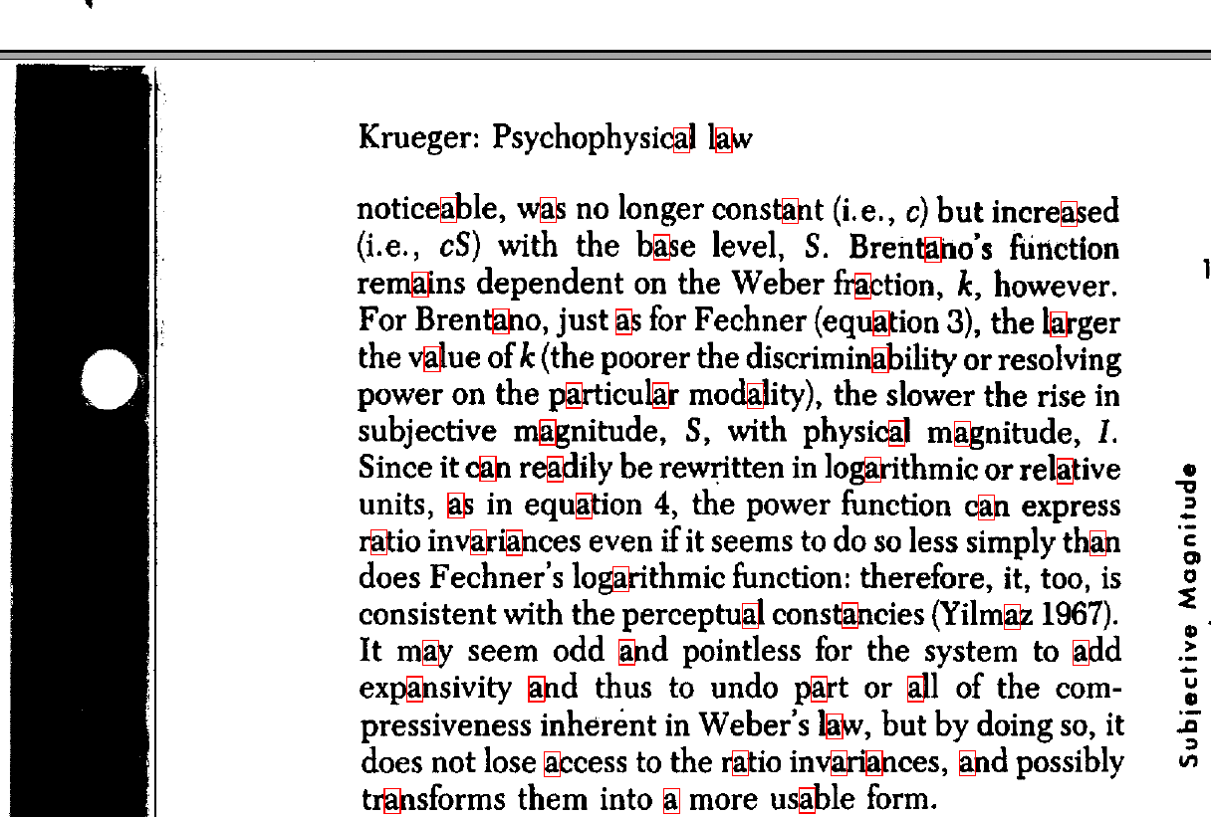

Number of detected "a"s: **53**

Code:

# -*- coding: utf-8 -*-

"""

Created on Mon Jul 22 15:24:06 2024

@author: Zakaria

"""

import cv2

import numpy as np

import matplotlib.pyplot as plt

# Load the image

image_path = "C:\\Users\\Zakaria\\Desktop\\CSCI-507HW#5\\textsample.tif"

image = cv2.imread(image_path, cv2.IMREAD_GRAYSCALE)

# Extract the template subimage of 'a' (manually selected region)

x, y, w, h = 442, 198, 16, 25  # Example coordinates for the letter 'a'

template = image[y:y+h, x:x+w]

# Show the template image

plt.imshow(template, cmap='gray')

plt.title('Template Image')

plt.axis('off')

plt.show()

# Match the template

result = cv2.matchTemplate(image, template, cv2.TM_CCOEFF_NORMED)

# Threshold peaks

threshold = 0.8  # Adjust this threshold as necessary

loc = np.where(result >= threshold)

# Create a binary image of the peaks

binary_peaks = np.zeros_like(result)

binary_peaks[loc] = 1

# Use connectedComponentsWithStats to extract the centroids of the peaks

num_labels, labels, stats, centroids = cv2.connectedComponentsWithStats(binary_peaks.astype(np.uint8), connectivity=8)

# Draw rectangles on the original image at the detected locations

output_image = cv2.cvtColor(image, cv2.COLOR_GRAY2BGR)

count_a = num_labels - 1  # Subtract 1 because background is also labeled

for pt in zip(*loc[::-1]):

    top_left = (pt[0], pt[1])

    bottom_right = (pt[0] + w, pt[1] + h)

    cv2.rectangle(output_image, top_left, bottom_right, (0, 0, 255), 1)

# Show the template image, the scores image, and the result

plt.figure(figsize=(15, 5))

plt.subplot(1, 3, 1)

plt.title('Template Image')

plt.imshow(template, cmap='gray')

plt.axis('off')

plt.subplot(1, 3, 2)

plt.title('Scores Image')

plt.imshow(result, cmap='gray')

plt.colorbar()

plt.axis('off')

plt.subplot(1, 3, 3)

plt.title('Detected "a"s in Image')

plt.imshow(output_image)

plt.axis('off')

plt.show()

# Save the result image

output_image_path = "C:\\Users\\Zakaria\\Desktop\\CSCI-507HW#5\\output_image_with_a_markers.png"

cv2.imwrite(output_image_path, output_image)

# Save the scores image

scores_image_path = "C:\\Users\\Zakaria\\Desktop\\CSCI-507HW#5\\scores_image.png"

cv2.imwrite(scores_image_path, (result * 255).astype(np.uint8))

# Print the number of detected 'a's

print(f'Number of detected "a"s: {count_a}')

N2

