# Introduction

The OOD of the scanner class will be documented here. It scans the input lines of the keypad. Each scanner object will have its own array of capture lines.

## Design Methodology

The OO design methodology of writing use cases, using CRC to filter the actual objects and then draw the class diagram.

## Use cases

### Object Creation

A scanner object is created for each keypad. It contains the capture objects for the input lines. So scanner object is like a manager. Each Object has its some parameters like frequency which is common for all lines. Each capture line is bound to a GPIO specified. The total number of pulse widths and tolerance is also registered.

### Input pulse arrives

When an input pulse arrives the capture objects for each line check whether the pulse is greater than a min value. If not it is ignored.

If the pulse width is greater, then the service class handles it and checks whether the width is one of the registerd widths (within the tolerance range), if it is then the user of the class is informed about the event and the source of the event

### Parsing

Parsing is done here and also basic intuitive filtering is also done here to remove the clearly not useful nouns.

**Nouns (Potential Classes or Attributes, Consolidated):**

* **scanner** (class: Scanner) **✔ Potential Class**
* **object** (general term, part of class names) ❌
* **keypad** (class: Keypad or attribute) ❌ User of this class so not designed here
* **capture** (class: Capture or CaptureObject) **✔ Potential Class**
* **objects** (plural, instances of Capture) ❌
* **input** (attribute or event: inputPulse) ❌
* **lines** (attribute or class: Line) ❌
* **manager** (role of Scanner) ❌
* **parameters** (attribute of Scanner or Capture) ❌
* **frequency** (attribute of Scanner or Capture) **✔ Attribute**
* **line** (singular, instance of Line) **✔ Potential Class**
* **GPIO number** (attribute of Line or Capture) **✔ Attribute**
* **pulse** width(attribute or class: Pulse) **✔ Attribute**
* **tolerance range** (attribute: tolerance or toleranceRange) **✔ Attribute**
* **width min** value(attribute: minValue) **✔ Attribute**
* **event** (class: Event or attribute) **✔ Attribute**

**Verbs (Potential Methods, Consolidated):**

* **created** (method: createScanner or constructor for Scanner) **✔**
* **contains** (method: containsCaptureObjects in Scanner)
* **has** (method: getParameters in Scanner or Capture)
* **bound** (method: bindToGPIO in Capture or Line) **✔**
* **specified** (method: specifyGPIO in Capture)
* **registered** (method: registerPulseWidthsAndTolerance in Scanner or Service) **✔**
* **arrives** (method: onPulseArrive in Capture or Service) **✔**
* **check** (method: checkPulse in Capture) **✔**
* **ignored** (method: ignorePulse in Capture) **✔**
* **handles** (method: handlePulse in Service) **✔**
* **checks** (method: checkWidth in Service) **✔**
* **informed** (method: informUser in Service) **✔**

### CRC Diagram

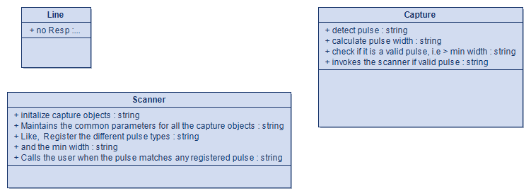

Class Diagram