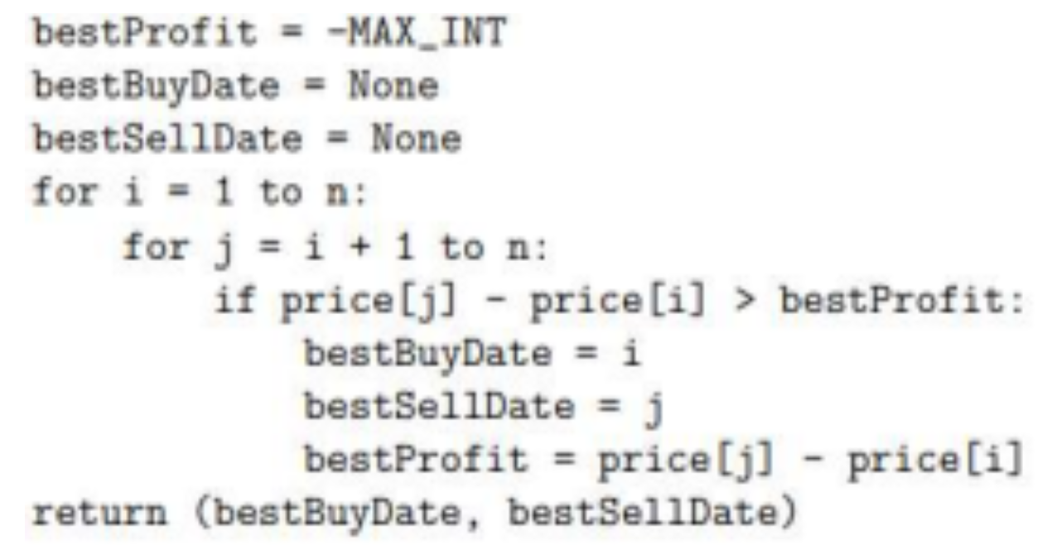

To calculate the time complexity of this algorithm:

i j j-runtime

1 2 to n n-1 times

2 3 to n n-2 times

3 4 to n n-3 times

n-2 n-1 to n 1 time

n-1 n 0 time

$$T= \left(n-1\right)+\left(n-2\right)+\left(n-3\right)+…1+0 \\ = Sum of first n-1 natural numbers \\ = \frac{n\left(n-1\right)}{2} \\ =\frac{n^{2}-n}{2}$$

Taking only the highest-powered polynomial:

$Time Complexity=O(n^{2})$

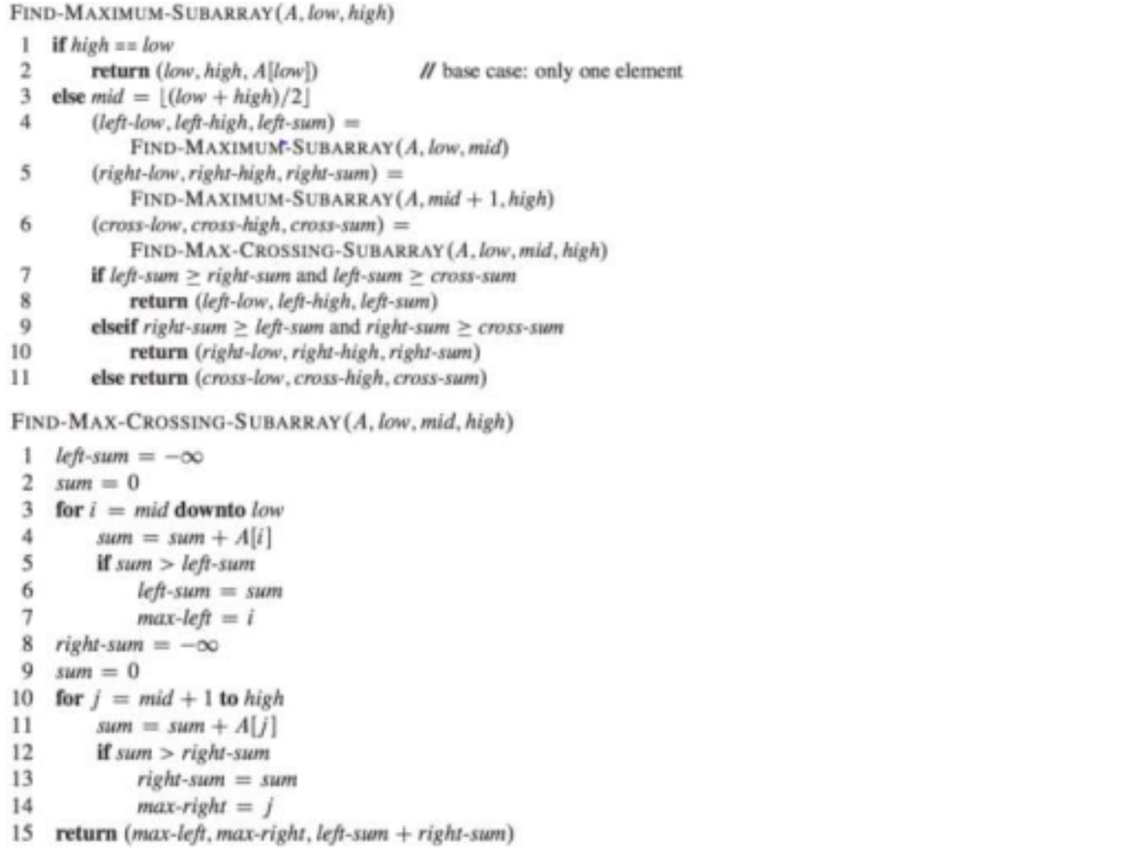

To calculate the time complexity of this algorithm (FIND-MAXIMUM-SUBARRAY, call it ‘T’):

Base Case:

When n = 1, then just one statement will run. Hence, time complexity is O(1)

When n > 1:

T(n) runs three functions: T(n/2) twice, and FIND-MAX-CROSSING-SUBARRAY(n) once, call it ‘P’.

Since the algorithm P(n) takes an array and runs two loops starting from the middle, one backwards and the other forwards – it *de facto* spans the whole array of size ‘n’ once, hence its time complexity is O(n).

Thus, we can write:

$T\left(n\right)=\left\{\begin{aligned}1 n=1 \\ 2T\left(\frac{n}{2}\right)+n &n>1\end{aligned}\right.$

Using the substitution method:

$$T\left(n\right)=2T\left(\frac{n}{2}\right)+n \left(1.1\right)$$

If the input to eq 1.1 is half, then:

$$T\left(\frac{n}{2}\right)=2T\left(\frac{n}{4}\right)+\frac{n}{2} \left(1.2\right) \\ Substituting eq 1.2 in eq 1.1 \\ T\left(n\right)=2\left\{2T\left(\frac{n}{4}\right)+\frac{n}{2}\right\}+n \\ = 4T\left(\frac{n}{4}\right)+2n (1.3)$$