 **FACULTY OF COMPUTER SCIENCE AND ENGINEERING**

**Time: 1.5 hr CS221 Lab Marks: 10**

**Lab No: 01 Dated: 10/12/2021**

**Lab Activity 1:**

Learning objective: How to access and operate arrays through pointers

In C/C++ language, arrays work on memory addresses so as pointers and hence they are strongly related. Design a C program which take an array of 6 elements from the user and do the following:

1. Declare the pointer and refernce it with the array address
2. Display every element of an array by using the pointer
3. Find the maximum value in array using pointer

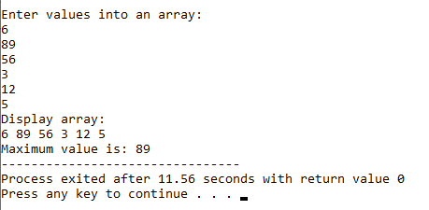

**Lab Activity 2:**

Learning Objective: Pointers in function call

In this activity you will have to use pointers to perform the following tasks on dynamically allocated array of type **int having size 5**.

1. Write a function **int smallest = smallest_value(int *temp, int size)**, which receives an array as pointer and find out smallest value using pointer to array.
2. Write a function **void traversal_back(int *temp, int sizeofarry)**, which receives an array as pointer and traverse array from last index to first index and print its value with its address as well.

