

CENTRAL MESS MANAGEMENT SYSTEM

CE323 Project Report

Khezar Hayat (2016194)

Muhammad Shahab (2016353)

Niaz Ahmed (2016387)

Abstract:

*This report presents information about the mess management system. The main purpose of the mess is to provide quality food to the students on time. The central mess in GIKI do all calculations manually which consumes so much time and sometimes lead to calculation mistakes. Thus, there arises a need to develop a software that will make the central mess of GIKI an automated system. This software will be able to help students to interact with central mess from anywhere by using their phone or laptop. This will also help central mess management to do everything automatically.*

Introduction:

GIKI has a central mess that is responsible for time delivery of food to the students. Above 80% of the students in GIKI are served by the central mess. Students face many problems regarding the central mess. Some of the problems are check in/out problem, payment of bill, voting for new menu and many more. The main aim behind this project is to provide easy and automated software for the students to do all these mess related work from their phone, tablet or laptop.

In this software, we are maintaining the data of all the students that are having their lunch/dinner at regular basis. We are also showing the updated menu to the students. Students can easily see the updated mess menu. Students are also able to check in/out their mess from anywhere by using their phone or laptop. This make the job easier for the students because they can’t access the mess all the time. The software can be used to pay the mess bill online by using credit/debit card anytime and anywhere. This help students because they are mostly busy at day time and unable to pay the bill on time.

The software is providing the method through which students can vote for the selection of best menu. Students can also request special food in the case of sickness. Similarly, this software can be used for complaints and suggestion regarding the central mess. The students can easily complain about anything to the central mess management.

Proposed Work:

Our software will work as follows.

Step 1: The student will first login to the software by entering the username and password. After writing correct username and password, student will be able to login to the system. This software also provide the facility to change password.

Step 2: After successful login to the software, the option page will be displayed which has the following options: Mess In/Out, Display menu, Pay Bills, Request special Food, complaints/suggestions.

Step 3: In the Mess in/out option, student will enter his/her name, registration number, room number and hostel number. Then they will select either in or out. A confirmation message will be displayed on successful check in/out.

Step 4: In Display menu option, the latest menu will be displayed to the student. The students will pay their bill online using their debit/credit card by clicking the Pay Bills option. They will enter their credit card details and their bill will be automatically paid by the software. The money will be transferred to the central mess bank account.

Step 5: In Request special food option, student can request special food in case of illness. They can tell their desired food to the central mess. Similarly, they can complaint about anything or suggest anything to the central mess.

Step 6: When there is time to change the mess menu, the Vote for menu option will be displayed on the option page as well as a notification will appear on the main page to inform the student about the voting for the new menu. Multiple options will be provided and they can enter their desired choices. Similarly, if there is any new notification from the central mess then that will be posted in the home page.

Use Case Diagram:

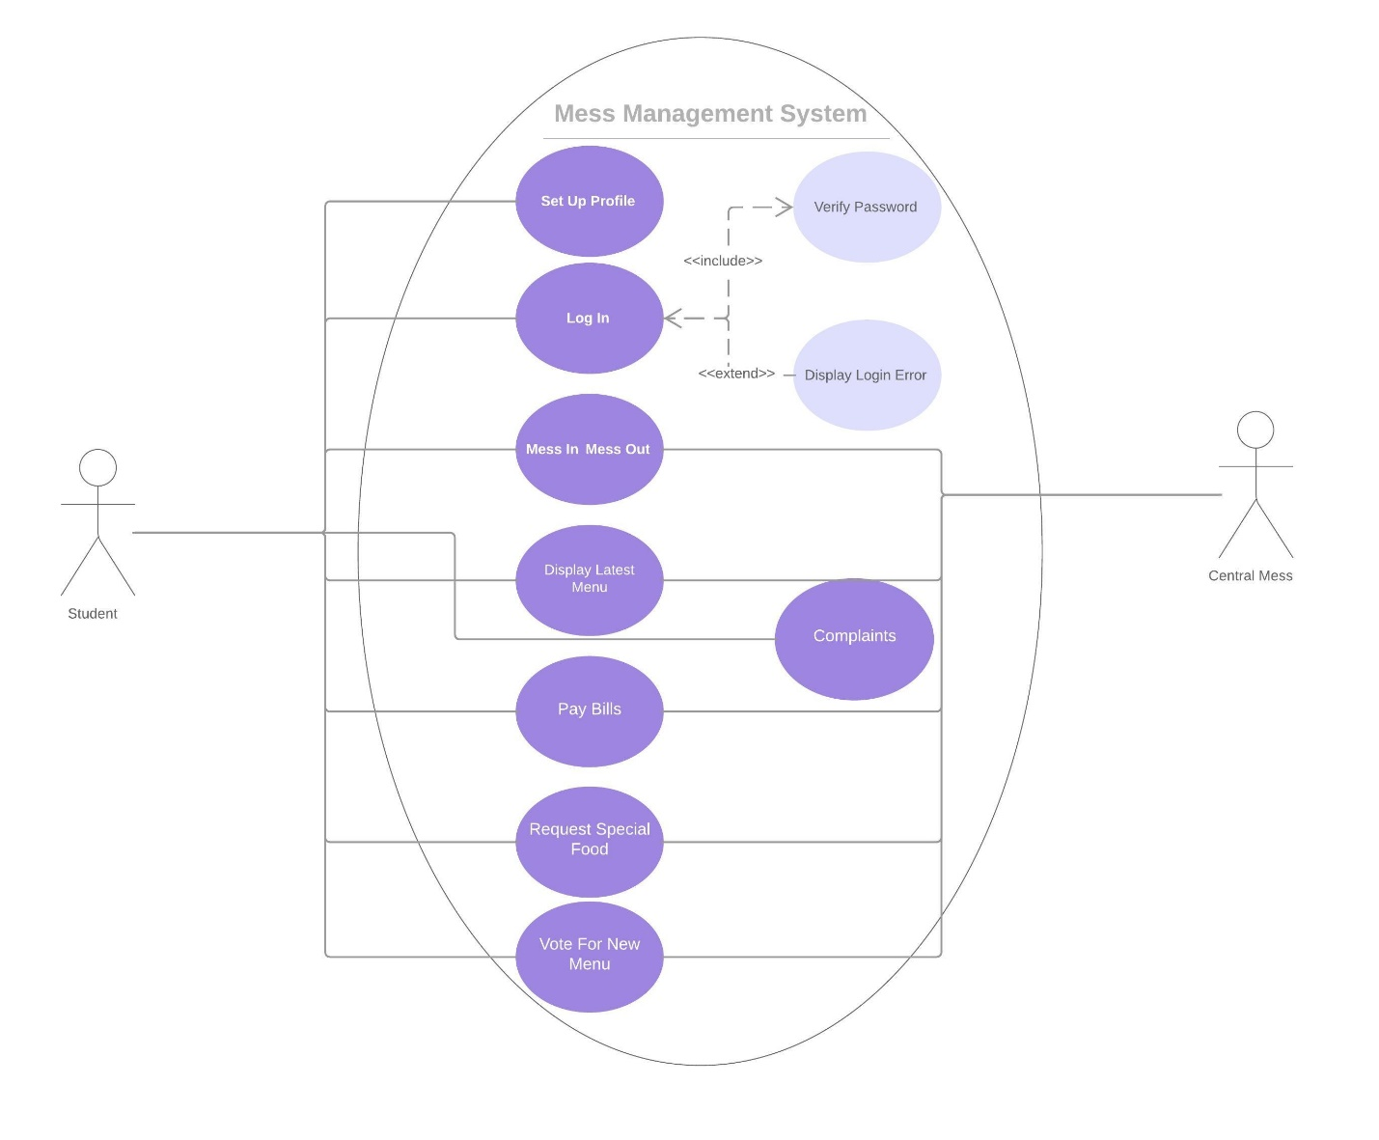

As per above diagram, the student can set up his/her profile if he/she is new to the system. All the students will be saved in the database. Similarly, he/she can log in to the system by using his username and password. The student log in details are also saved in the database. In case a password is changed by the student then the old password will be replaced by the updated password in the database.

Class Diagram:

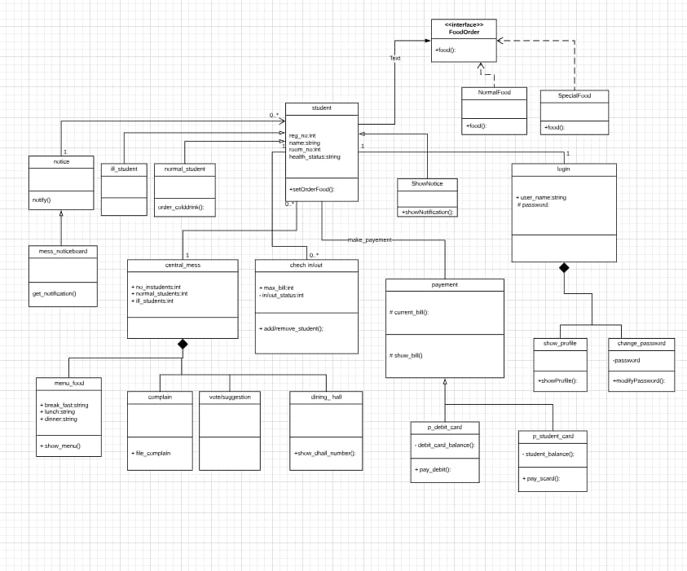

Sequence Diagram:

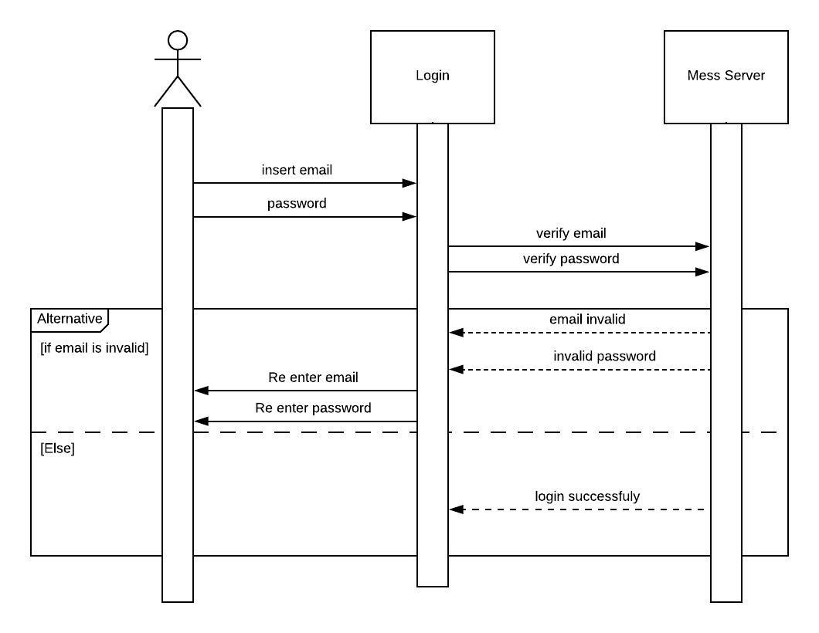

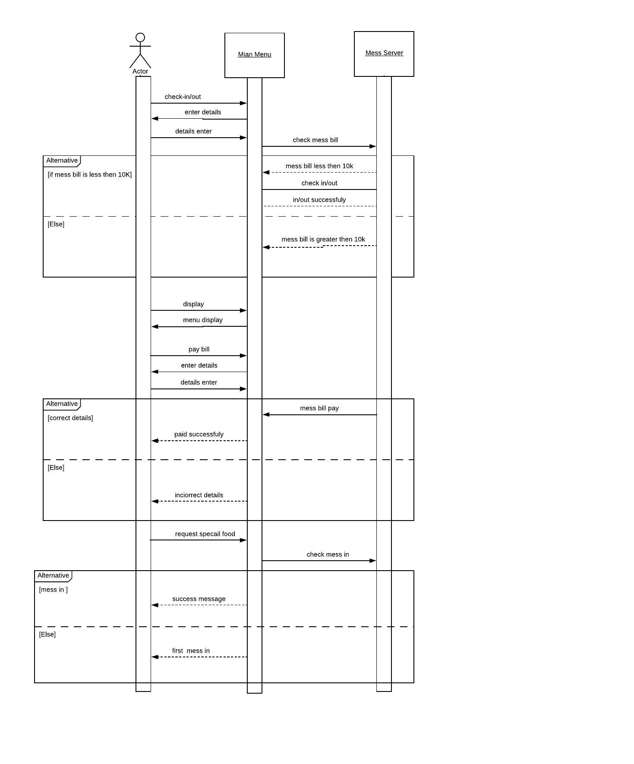

Observable Pattern:

This pattern states that the observer will not observe the observable repeatedly. When there happen a change in the observable, it will notify the observer automatically and there is no need to check it again and again. In our project, we have used this pattern as such that when there is any notification from central mess it will be automatically displayed on the main page and there is no need for the student to check it again and again.

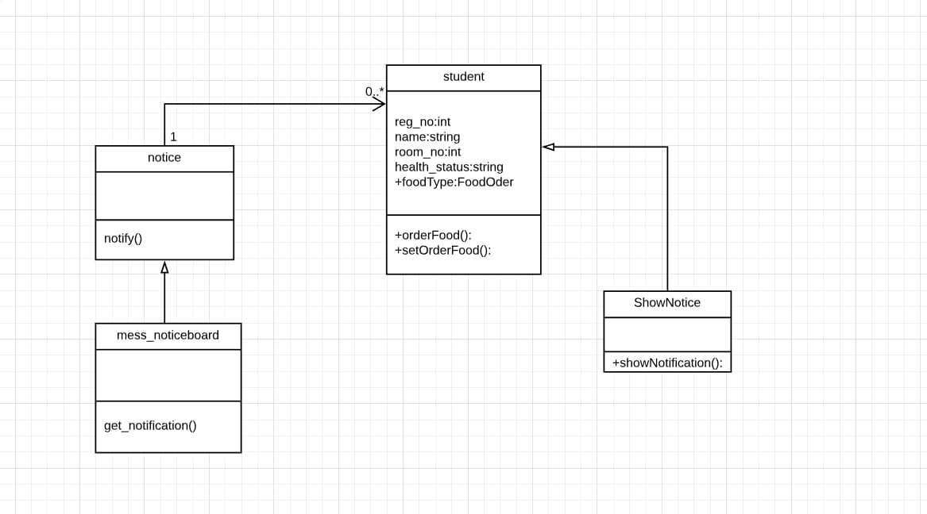

Strategy Pattern:

In this pattern, a class behavior or algorithm its algorithm can be changed at runtime. There is separate food for the ill student and normal student. If they order the same food repeatedly then it is not feasible. Instead of this, we will define an interface which will have two classes: normal food and special food. If the student is in normal conditions then the student class will call the normal food class and if he/she is ill then the student class will call the special food class dynamically at runtime.

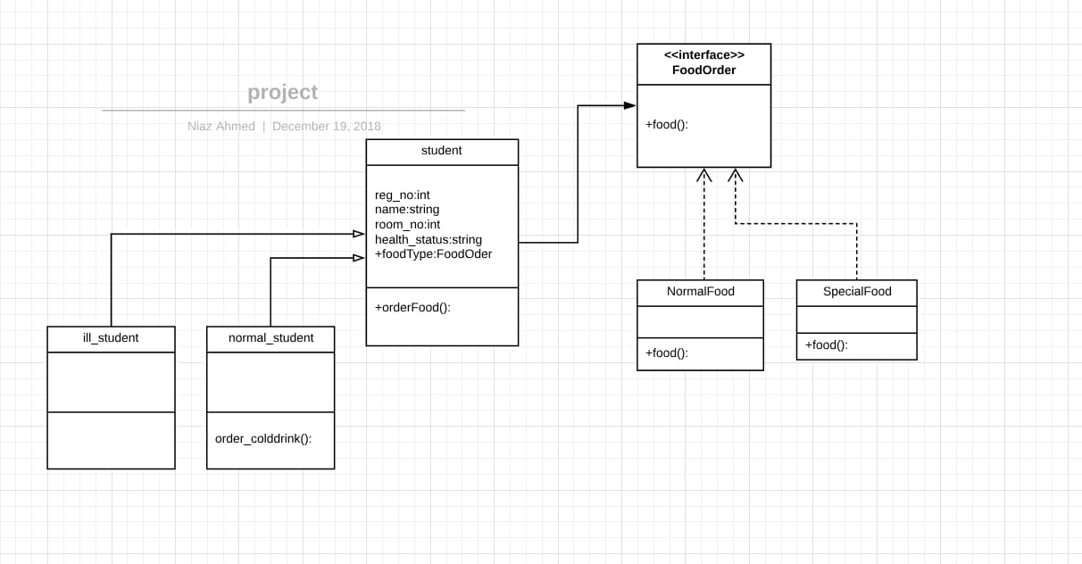

Single Responsibility Principle (only one reason to change):   
We have used single responsibility principle in our project. This principle states that there should be one responsibility of each class.  
A class should have one only function. Robert C. Martin a renowned software engineer, he define this principle as that there should be one and only one reason to change the class.  
For example in our project show_menu is a class. If any change occur in mess menu so then only this class will be changed. A class will not change due to two or more changes. In our whole design we applied this principle and there is only responsibility associated with each class.

Advantages:   
Let’s assume that we have a class that has two responsibilities then if there is any change in the method of that class we will change the whole class which is too hard to do. So instead of this we will define two separate class for each function and whenever a change will occur in the respective class then we will change easily and other class will not be affected.

Violation:   
 This principle will be violated if there is more than one responsibility assign to the class.  
There should be no “AND” while explaining responsibility of class.  If we say that this class will do this “AND” this then single responsibility principle will be violated.

Conclusion:

This software will be useful for students in interacting with the mess online from anywhere and at any time. Using this software all the check in/out will be done automatically and there will be no manual work. Also, mess bill can be paid easily and there will be no need to wait in line in bank in order to pay the mess bill. Thus, this software is very beneficial for the students.