What is API testing?

API is an acronym for Application Programming Interface.
In software application (app) development, API is the middle layer between the presentation (UI) and the database layer. APIs enable communication and data exchange from one software system to another.
API testing is a software testing practice that tests the APIs directly — from their functionality, reliability, performance, to security. Part of integration testing, API testing effectively validates the logic of the build architecture within a short amount of time

Where is API testing performed?
There are three separate layers in a typical app: the presentation (or user interface) layer, the business layer, and the database layer for modeling and manipulating data.
API testing is performed at the most critical layer: business, in which business logic processing is carried out and all transactions between the user interface and database layers happen.

Benefits of API testing

Language-independent
Data is exchanged via XML and JSON formats, so any language can be used for test automation. XML and JSON are typically structured data, making the verification fast and stable. There are also built-in libraries to support comparing data using these data formats.

GUI-independent
API testing can be performed in the app prior to GUI testing. Early testing means early feedback and better team productivity. The app's core functionalities can be tested to expose small errors and to evaluate the build's strengths.

Improved test coverage
Most API/web services have specifications, allowing you to create automated tests with high coverage — including functional testing and non-functional testing.

Faster releases
It is common that executing API testing saves up to eight hours compared to UI testing, allowing software development teams to release products faster.

API Testing Types

Validation Testing
Validation testing occurs among the final steps and plays an essential role in the development process. It verifies the aspects of product, behavior, and efficiency. In other words, validation testing can be seen as an assurance of the correct development.

Functional testing
Includes testing particular functions in the codebase. These features are the representation of specific scenarios to make sure the API functions are handled well within the planned parameters.

UI testing
UI testing is defined as a test of the user interface for the API and other integral parts. UI testing focuses more on the interface which ties into the API rather than the API testing itself. Although UI testing is not a specific test of API in terms of codebase, this technique still provides an overview of the health, usability, and efficiency of the app’s front and back ends.

Security testing
This practice ensures the API implementation is secure from external threats. Security testing also includes additional steps such as validation of encryption methodologies, and of the design of the API access control. It also includes user rights management and authorization validation.

Load testing
Load testing generally occurs after a specific unit or the whole codebase has been completed. This technique checks if the theoretical solutions work as planned. Load testing monitors the app's performance at both normal and peak conditions.

Runtime and error detection
This testing type is related to the actual running of the API — particularly with the universal results of utilizing the API codebase. This technique focuses on one of the below aspects: monitoring, execution errors, resource leaks, or error detection.

Penetration testing
Penetration testing is considered the second test in the auditing process. In this type, users with limited API knowledge will try to assess the threat vector from an outside perspective, which is about functions, resources, processes, or aim to the entire API and its components.

Fuzz testing
Fuzz testing is another step in the security audit process. In fuzz testing, a vast amount of random data (referred to as "noise" or "fuzz") will be input into the system to detect any forced crashes or negative behaviors. This technique tests the API’s limits to prepare for the "worst-case scenarios."

10 API Testing Tips for Beginners (SOAP & REST)
An API is essentially the “middle man” of the layers and systems within an application or software.
API (application programming interface) testing is performed at the message layer without GUI. It is a part of integration testing that determines whether the APIs meet the testers’ expectations of functionality, reliability, performance, and security.

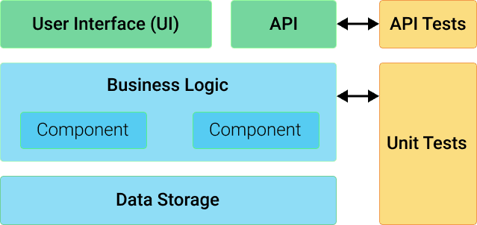
There are two broad classes of web service for Web API: SOAP and REST.
SOAP (Simple Object Access Protocol) is a standard protocol defined by the W3C standards for sending and receiving web service requests and responses.
REST (Representational State Transfer) is the web standards-based architecture that uses HTTP. Unlike SOAP-based Web services, there is no official standard for RESTful Web APIs.
Here are 10 basic tips that you need to know for API testing:

1. Understand API requirements
Before testing your APIs, you need to answer these questions to thoroughly understand the API’s requirements:
- What is the API’s purpose?
Knowing the purpose of the API will set a firm foundation for you to well prepare your test data for input and output. This step also helps you define the verification approach. For example, for some APIs, you will verify the responses against the database; and for some others, it is better to verify the responses against other APIs.
- What is the workflow of the application; and where is the API in that flow?
Generally, APIs of an application are used to manipulate its resources in reading (GET), creating (POST), updating (PUT) and deleting (DELETE). Knowing the purpose of the API will set a firm foundation for you to well prepare your API testing data for input and output.
In addition, this step also helps you define the verification approach. For example, for some APIs, you will verify the responses against the database; and for some others, it is better to verify the responses against other APIs.
For example, the output of the “Create user” API will be the input of the “Get user” API for verification. The output of the “Get user” API can be used as the input of the “Update user” API, and so on.

2. Specify the API output status
The most common API output you need to verify in API testing is the response status code.
Verifying if the response code equals to 200 or not to decide whether an API testing is passed or failed is familiar to new API testers. This is not a wrong verification. However, it does not reflect all test scenarios of the API.
All API response status codes are separated into five classes (or categories) in a global standard. The first digit of the status code defines the class of response. The last two digits do not have any class or categorization role.
There are five values for the first digit:
- 1xx (Informational): The request is received and continues to be processed
- 2xx (Successful): The request is successfully received, understood, and accepted
- 3xx (Redirection): Further action needs to be taken to complete the request
- 4xx (Client Error): The request contains the wrong syntax or cannot be fulfilled
- 5xx (Server Error): The server fails to fulfill an apparently valid request
However, the actual response status code of an API is specified by the development team that built the API. So as a tester, you need to verify whether:
- The code follows global standard classes
- The code is specified in the requirement.

3. Focus on small functional APIs
In a testing project, there are always some APIs that are simple with only one or two inputs such as login API, get token API, health check API, etc. However, these APIs are necessary and are considered as the “gate” to enter further APIs. Focusing on these APIs before the others will ensure that the API servers, environment, and authentication work properly.
You should also avoid testing more than one API in a test case. It is painful if errors occur because you will have to debug the data flow generated by API in a sequence. Keep your testing as simple as possible. There are some cases in which you need to call a series of API to achieve an end-to-end testing flow. However, these tasks should come after all APIs have been individually tested.

4. Organize API endpoints
A testing project may have a few or even hundreds of APIs for testing. We highly suggest that you organize them into categories for better test management. It takes one extra step but will significantly help you create test scenarios with high coverage and integration. Take JIRA’s API, for example:
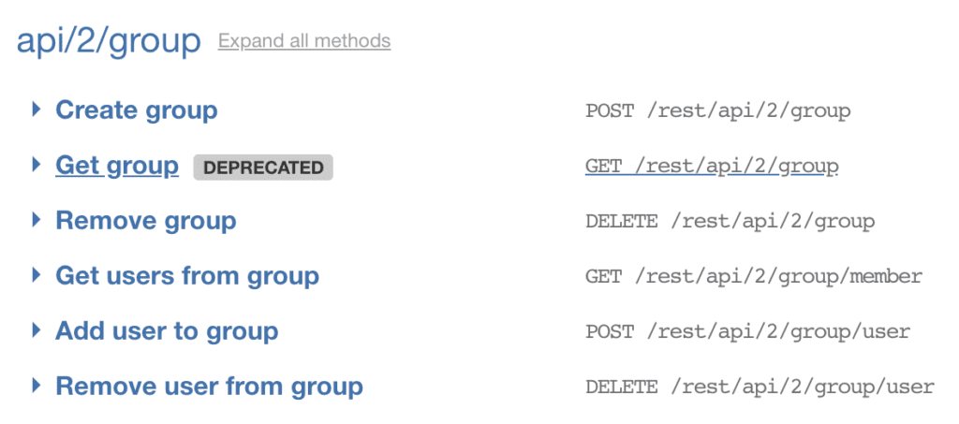
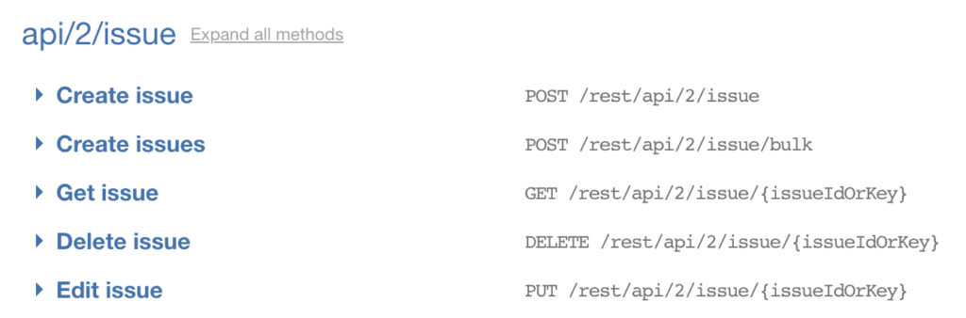
APIs in the same category share some common information such as resource type, path, etc. Organizing your tests with the same structures will make your test reusable and extendable with integration flow.

5. Leverage automation capability for API testing
Leverage automation capability for your API testing process as much and as early as possible. Here are some significant benefits of automating API tests:
- Test data and execution history can be saved along with API endpoints. This makes it easier to rerun tests later.
- API tests are stable and changed with care. An API reflects a business rule of the system. Any change in the API needs an explicit requirement; so testers can always stay alert of any changes and adjust them on time.
- Test execution is much faster compared to Web UI test
- API testing is considered black-box testing in which the users send input and get output for verification. Automation with a data-driven approach — i.e. applying different datasets in the same test scenario — can help increase API test coverage
- Data input and output follow some specific templates or models so that you can create test scripts only once. These test scripts can also be reused throughout the entire testing project.
- API tests can be performed at the early stage of the software development lifecycle. An automation approach with mocking techniques can help verify API and its integration before the actual API is developed. Hence, the level of dependency within the team is reduced.

6. Choose a suitable automation tool
A further step to leverage the automation capability of API testing is choosing the most or a set of suitable tools from hundreds of options in the market. Here are some criteria that you should consider when choosing an API testing automated testing tool:
- Does the tool support test the API/Web service types that your AUT (Application Under Test) is using? It will not make sense if the selected tool supports testing RESTful services while your AUT is using SOAP services.
- Does the tool support the authorization methods that your AUT services require? Here are some authorization methods that your API can use:
- No Auth  - Bearer Token  - Basic auth  - Digest Auth  - NTLM Authentication | - OAuth 1.0  - OAuth 2.0  - Hawk Authentication  - AWS Signature
This is an essential task since you cannot start testing an API without authorization.
- Does the tool support import API/Web service endpoints from WSDL, Swagger, WADL, and other service specifications? This is an optional feature. However, it will be time-consuming if you have hundreds of APIs to test.
- Does the tool support data-driven methods? This is also an optional feature. However, your test coverage will increase dramatically if the tool has this function.
- Last but not least, besides API testing, do you need to perform other types of testing, such as WebUI or data source? API testing is performed at the business layer between data sources and UI. It is normal that all these layers have to be tested. A tool that supports all testing types would be an ideal choice so that your test objects and test scripts can be shared across all layers.

7. Choose suitable verification methods
While the response status code tells the status of the request, the response body content is what an API returns with the given input.
An API response content varies from data types to sizes. The responses can be in plain text, a JSON data structure, an XML document, and more. They can be a simple few-word string (even empty), or a hundred-page JSON/XML file. Hence, it is essential to choose a suitable verification method for a given API.
Katalon Studio has provided rich libraries to verify different data types using matching, regular expression, JsonPath, and XmlPath.
Generally, there are some basic methods to verify an API response body content:
- Compare the whole response body content with the expected information
This method is suitable for a simple response with static contents. Dynamic information such as date time, increasing ID, etc. will cause trouble in the assertion.
- Compare each attribute value of the response
For those responses in JSON or XML format, it is easy to get the value of a given key or attribute. Hence, this method is helpful when verifying dynamic content, or individual value rather than the whole content.
- Compare matching with regular expression
Together with verifying individual attribute values, this method is used to verify data responses with a specific pattern to handle complex dynamic data.
Each verification method has pros and cons, and there is no one-size-fits-all option. You need to choose the solution that best fits your testing project.


8. Create positive and negative tests
API testing requires both positive and negative tests to ensure that the API is working correctly. Since API testing is considered a type of black-box testing, both types of testings are driven by input and output data. There are a few suggestions for test scenario generation:
- Positive test
  - Verify that the API receives input and returns the expected output as specified in the requirement.
  - Verify that the response status code is returned as specified in the requirement, whether it returns a 2xx or error code.
  - Specify input with minimum required fields and with maximum fields.
- Negative test
  - Verify that the API returns an appropriate response when the expected output does not exist.
  - Perform input validation test.
  - Verify the API’s behaviors with different levels of authorization.

9. Live testing process
Scheduling API test execution every day while the testing process is live is highly recommended. Since API test execution is fast, stable, and small enough, it is easy to add more tests into the current testing process with minimum risks. This is only possible with automated API testing tools that come with features like:
- Test scheduling with built-in test commands
- Integration with test management tools and defect tracking tools
- Continuous Integration with various leading CI tools
- Visual log reports generation
Once the testing process is completed, you can get the result of those tests every day. If failed tests occur, you can check the outputs and validate issues to have proper solutions.

10. Do not underestimate API automation testing
API testing flow is quite simple with three main steps:
- Send the request with necessary input data
- Get the response having output data
- Verify that the response returned as expected in the requirement
The most touch parts of API testing are not either sending requests or receiving the response. They are test data management and verification. It is common that testing a few first APIs such as login, query some resources, etc. is quite simple.
The testing task becomes more and more difficult to further APIs. Therefore, the API testing task is easy to be underestimated.
At some point in time, you would find yourself in the middle of choosing a good approach for test data and verification methods. It is because the returned data have similar structures, but not the same in a testing project.
Furthermore, deciding the right one would be difficult if you should verify the JSON/XML data key by key, or use object mapping to leverage the power of programming language.
Considering API automation testing a real development project is highly suggested. It should be structured to be extendable, reusable, and maintainable.

Start out your API Testing journey with ease – Katalon Studio
There you have it: 10 API Testing Tips for you to set foot in the wonders of API Testing, no sweat.
Whether experienced or just starting out with API Testing, Katalon Studio is an optimal solution regardless of the level of expertise. Equipped with minimum maintenance requirements, integrations with CI/CD and DevOps practices and so much more.
It is the hidden gem for your API Testing journey.

API Testing Tutorial: A Complete Guide For Beginners
Last Updated:May 4, 2022
This In-Depth API Testing Tutorial Explains All About API Testing, Web Services and How To Introduce API Testing In Your Organization:
Gain a deep insight into API Testing along with the concept of shift-left testing and web services from this introductory tutorial.
Concepts like Web API, how API works (with real-world example) and how is it different from Web Services are well explained with examples in this tutorial.
=> SCROLL DOWN to see the entire list of 5 In-Depth API Testing Tutorials for Beginners
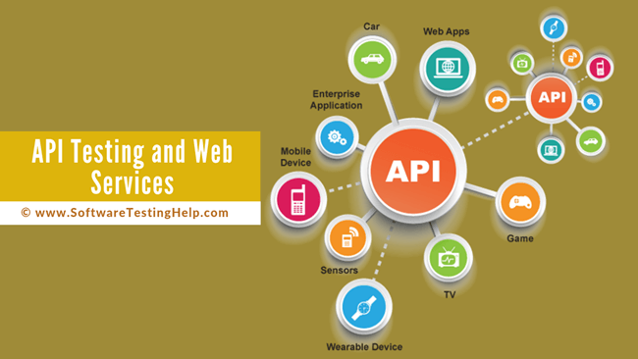
What You Will Learn: [hide]
- List Of API Testing Tutorials
- Overview Of Tutorials In This API Testing Series
- API Testing Tutorial
  - Shift Left Testing
  - Software Development Life Cycle (SDLC) Before Shift Left Testing
  - Phases Of Left Shift Testing
  - Web API
  - How Does an API Work?
  - Web Services
  - Web Services vs Web API
- Introducing API Testing In Your Organization
  - Focus Shift to API Testing
  - Full Spectrum of API Testing
    - (i) Functional Testing
    - (ii) Load and Performance Testing
    - (iii) Security Testing
  - How to Introduce API Testing in Your Organization
  - Common Challenges And Ways to Mitigate Them
    - #1) Choosing the Right Tool
    - #2) Missing Test Specifications
    - #3) Learning Curve
    - #4) Existing Skill Set
  - Case Study
- Conclusion
  - Recommended Reading

List Of API Testing Tutorials
Tutorial #1: API Testing Tutorial: A Complete Guide For Beginners
Tutorial #2: Web Services Tutorial: Components, Architecture, Types & Examples
Tutorial #3: Top 35 ASP.Net And Web API Interview Questions With Answers
Tutorial #4: POSTMAN Tutorial: API Testing Using POSTMAN
Tutorial #5: Web Services Testing Using Apache HTTP Client

Overview Of Tutorials In This API Testing Series
Tutorial # | What You Will Learn
Tutorial_#1: | API Testing Tutorial: A Complete Guide For Beginners  This In-Depth API Testing tutorial will explain all about API Testing, and Web Services in detail and also educate you on how to Introduce API Testing in your organization.
Tutorial_#2: | Web Services Tutorial: Components, Architecture, Types & Examples  This Web Services tutorial explains the Architecture, Types & Components of Web Services along with Important Terminologies and the Differences between SOAP vs REST.
Tutorial_#3: | Top 35 ASP.Net And Web API Interview Questions With Answers  You can explore the list of the most popular frequently asked ASP.Net and Web API Interview Questions with answers & examples for beginners and experienced professionals in this tutorial.
Tutorial_#4: | POSTMAN Tutorial: API Testing Using POSTMAN  This step by step tutorial will explain API Testing Using POSTMAN along with the Basics of POSTMAN, its Components and Sample Request & Response in simple terms for your easy understanding.
Tutorial_#5: | Web Services Testing Using Apache HTTP Client  This API Tutorial is about performing various CRUD Operations on Web Services and Testing Web Services using Apache HTTP Client

API Testing Tutorial
This section will help you get a basic understanding of Web Services and Web API, which, in turn, will be helpful in understanding the major concepts in the upcoming tutorials in this API Testing series.
API (Application Programming Interface) is a set of all procedures and functions that allow us to create an application by accessing the data or features of the operating system or platforms. Testing of such procedures is known as API Testing.

Shift Left Testing
One of the important types of testing that is being asked nowadays in API Testing Interviews is Shift Left Testing. This type of testing is practiced in almost all projects that follow an Agile Methodology.
Before Shift Left Testing was introduced, software testing came into picture only after the coding was complete and code was delivered to the testers. This practice led to the last minute hustle to meet the deadline and it also hampered the product quality to a great extent.
Apart from that, the efforts made (when defects were reported at the last phase before production) were huge as developers had to go through both the design and coding phase all over again.

Software Development Life Cycle (SDLC) Before Shift Left Testing
Tradional SDLC flow was: Requirement –> Design –> Coding –> Testing.
Disadvantages of Traditional Testing
- Testing is at extreme right. A lot of costs are incurred when a bug is identified at the last minute.
- Time consumed in resolving the bug and retesting it before promoting it to production is huge.
Hence, a new idea popped up to shift the testing phase to the left which thereby led to Shift Left Testing.
Suggested Read => Shift Left Testing: A Secret Mantra For Software Success

Phases Of Left Shift Testing
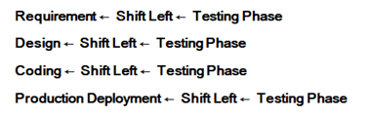
Left Shift Testing led to a successful migration from Defect Detection to Defect Prevention. It also helped the software to fail fast and fix all the failures at the earliest.
Also Read =>> What Are Vulkan Runtime Libraries

Web API
In general terms, a Web API can be defined as something that takes the request from a client system to a web server and sends back the response from a web server to a client machine.

How Does an API Work?
Let’s take a very common scenario of booking a flight on www.makemytrip.com, which is an online travel service that aggregates information from multiple airlines. When you go for a flight booking, you enter information like journey date/return date, class, etc. and click on search.
This will show you the price of multiple airlines and their availability. In this case, the application interacts with APIs of multiple airlines and thereby gives access to the airline’s data.
Another example is www.trivago.com which compares and lists down the price, availability, etc. of different hotels from a particular city. This website communicates with APIs of multiple hotels to access the database and lists down the prices and availability from their website.
Thus, a Web API can be defined as “an interface which facilitates the communication between a client machine and the webserver”.

Web Services
Web Services are (like Web API) the services that serve from one machine to another. But the major difference that arises between API and Web Services is that the Web Services uses a network.
It is safe to say that all Web Services are Web APIs but all Web APIs are not Web Services (explained in the latter part of the article). Thus, Web Services are a subset of Web API. Refer to the below diagram to know more about Web API and Web Services.
Web API vs Web Services
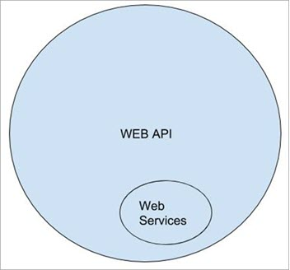

Web Services vs Web API
Both Web API and Web Services are used to facilitate the communication between the client and the server. The major difference comes only in the way they communicate.
Each of them requires a request body that is acceptable in a specific language, their differences in providing a secure connection, their speed of communicating to the server and responding back to the client, etc.
Differences Between Web Services and Web API is listed below for your reference.
Web Service
- Web Services generally use XML (Extensible Markup Language), which means they are more secure.
- Web Services is more secure as both Web Services and APIs provide SSL (Secure Socket Layer) during data transmission, but it also provides WSS (Web Services Security).
- Web Service is a subset of Web API. For Example, Web Services are based only on three styles of use i.e. SOAP, REST and XML-RPC.
- Web Services always need a network to operate.
- Web Services support “One Code different applications”. This means a more generic code is written across different applications.
Web API
- A Web API generally uses JSON (JavaScript Object Notation), which means Web API is faster.
- Web API is faster as JSON is light-weighted, unlike XML.
- Web APIs are the superset of Web Services. For Example, All three styles of Web Services are present in the Web API as well, but apart from that, it uses other styles like JSON – RPC.
- Web API does not necessarily require a network to operate.
- Web API may or may not support interoperability depending upon the nature of the system or application.

Introducing API Testing In Your Organization
In our day to day life, all of us are so used to interacting with the Apps with APIs and yet we do not even think about the back-end processes that drive the underlying functionality.
For Example, Let us consider that you are browsing through the products on Amazon.com and you see a product/deal that you really like and you wish to share it with your Facebook network.
The moment you click on the Facebook icon on the share section of the page and enter your Facebook account credentials to share, you are interacting with an API that is seamlessly connecting the Amazon website to Facebook.

Focus Shift to API Testing
Before discussing more on API testing, let’s discuss the reasons for which the API based applications have gained popularity in recent times.
There are several reasons for which organizations are transitioning to API based products and applications. And few of them are enlisted below for your reference.
#1) API based applications are more scalable when compared to traditional applications/software. The rate of code development is faster and the same API can service more requests without any major code or infrastructural changes.
#2) Development teams don’t need to start coding from scratch every time they start working on developing a feature or application. APIs most often reuse existing, repeatable functions, libraries, stored procedures, etc. and hence this process can make them more productive overall.
For Example, If you are a developer working on an e-commerce website and you want to add Amazon as a payment processor – then you do not have to write the code from scratch.
All you need to do is to set up integration between your website and Amazon API using Integration keys and call Amazon API for processing payments during checkout.
#3) APIs allow easy integration with the other systems both for supported standalone applications as well as with API based software products.
For Example, Let us consider that you want to send a shipment from Toronto to New York. You go online, navigate to a well know Freight or Logistics website and enter the required information.
After providing the mandatory information, when you click on Get Rates button – in the back end, this logistics website may be connecting with several carrier and service provider APIs and applications to get the dynamic rates for the origin to destination combination of locations.

Full Spectrum of API Testing
Testing of APIs is not restricted to sending a request to API and analyzing the response for correctness alone. The APIs need to be tested for their performance under different loads for vulnerabilities.
Let’s discuss this in detail.

(i) Functional Testing
Functional testing can be a challenging task due to the lack of a GUI interface.
Let’s see how the functional testing approach for APIs is different from GUI based application and we will also discuss some examples around it.
a) The most obvious difference is that there is no GUI to interact with. Testers who usually do GUI based functional testing find it a little harder to transition into non-GUI application testing when compared to someone who is already familiar with it.
Initially, even before you start testing the API, you will need to test and verify the Authentication process itself. The authentication method will vary from one API to another API and would involve some sort of key or token for authentication.
If you are unable to connect to the API successfully, then further testing cannot proceed. This process can be considered comparable to user authentication in the standard applications where you need valid credentials to log in and use the application.
b) Testing field validations or input data validation is very important during testing APIs. If an actual form-based (GUI) interface was available, then field validations could be implemented in the front end or back end, thereby ensuring that a user is not allowed to enter invalid field values.
For Example, If an application needs the date format to be DD/MM/YYYY, then we can apply this validation on the form collecting information to ensure that the application is receiving and processing a valid date.
This, however, is not the same for API applications. We need to ensure that the API is well written and is able to enforce all these validations, distinguish between valid and invalid data and return the status code and validation error message to the end-user through a response.
c) Testing the correctness of the responses from API for valid and invalid response is crucial indeed. If a status code of 200 (meaning all Okay) is received as a response from test API, but if the response text says an error has been encountered, then this is a defect.
Additionally, if the error message itself is incorrect, then that can be very misleading to the end customer who is trying to integrate with this API.
In the screenshot below, the user has entered invalid weight, which is more than the acceptable 2267 Kgs. The API responds with the error status code and error message. However, the error message incorrectly mentions the weight units as lbs instead of KG. This is a defect that can confuse the end customer.
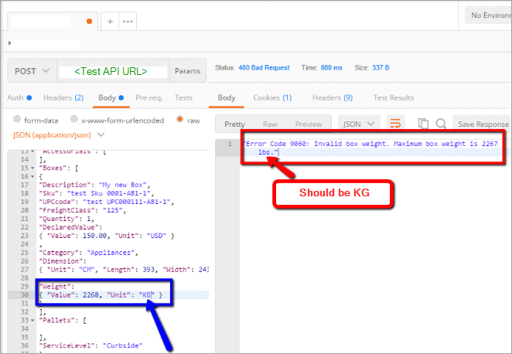

(ii) Load and Performance Testing
APIs are meant to be scalable by design.
This, in turn, makes Load and Performance Testing essential, especially if the system being designed is expected to be servicing thousands of requests per minute or hour, depending on the requirement. Routinely performing Load and Performance Tests on the API can help benchmark the performance, peak loads and breaking point.
This data is useful while planning to scale up an application. Having this information available will help to support decisions and planning especially if the organization is planning to add more customers, which would mean more incoming requests.
For Example, let’s say that based on the requirements provided, we know that the API that is designed needs to service at least 500 requests per hour and maintain the average response time of less than .01 seconds.
Based on our load and performance tests we found out that as long as API receives less than 500 requests per hour, it is able to maintain SLA for average response time. However, if it receives another 200 requests, then the average response time increases and the breaking point is reached when the incoming request exceeds 1200 per hour.
Usually, it is seen that during the initial design phases, the emphasis is often on the functional aspects of the API. As time goes by, a product starts supporting multiple live clients, that is when the testing for API performance and Load testing comes into the picture in a more routine manner.

(iii) Security Testing
Application Programming Interfaces or APIs are vulnerable and are the easiest access point for malicious hackers who want access to data or gain control of an application.
This can lead any company into legal trouble, where due to a security breach unintended people and/or organizations are able to access client’s data through a venerable API.
Security testing is a specialized branch of testing and should be handled by specialists. The security testing resources can be from within the organization or independent consultants.
Also read =>> What is Pact Contract Testing

How to Introduce API Testing in Your Organization
The process for introducing API testing in any organization is similar to the process used for implementing or rolling out any other testing tool and framework.
Phase | Step | Expected Outcome
Tool Selection | Gather requirements and identify constraints | Understand the requirements for researching market for appropriate API test tool.  E.g.  What kind of API is being tested - SOAP or REST?  Do we need to hire tester for this role or train existing tester?  What kind of tests will be performed - functional, performance tests etc.  What is the budget for implementation?
 | Evaluate available tools | Compare available tools and shortlist 1 or 2 tools that best meet the requirements.
 | Proof of Concept | Implement a subset of tests with the shortlisted tool.  Present findings to stakeholders.  Finalize the tool to be implemented.
Implementation | Getting started | Depending on your choice of tool, you would wither need to install the required tool on a PC, Virtual machine or server.  If tool of choice is subscription based, create required team accounts.  Train the team if required.
 | Get going | Create tests  Execute tests  Report defects
The table below summarizes the main steps along with the expected outcome of each step.

Common Challenges And Ways to Mitigate Them
Let us discuss some of the common challenges that QA teams face while trying to implement an API testing framework in an organization.

#1) Choosing the Right Tool
Selecting the correct tool for the job is the most common challenge. There are several API test tools that are available in the market.
It may seem very appealing to implement the latest, most expensive tool available in the market- but if it does not bring the desired results, then that tool is of no use.
Hence, always choose the tool that addresses the ‘must-have’ requirements based on your organizational needs.
Here is a sample tool evaluation matrix for the available API Tools
Tool | Pricing | Notes
Soap UI | Free Version available for SoapUI Open Source (Functional testing) | * REST, SOAP and other popular API and IoT protocols.  * Included in Free version  SOAP and REST ad-hoc testing  Message Assertion  Drag & Drop Test Creation  Test Logs  Test Configuration  Test from Recordings  Unit Reporting.  * Complete list of features can be found in their website.
Postman | Free Postman App available | * Most-used for REST.  * Features can be found in their website.
Parasoft | It’s a paid tool, requires purchasing a license and then requires installation before the tool can be used. | * Comprehensive API testing: functional, load, security testing, test data management
vREST | Based on Number of users | * Automated REST API Testing.  * Record and replay.  * Removes dependency from frontend and backend using mock APIs.  * Powerful Response Validation.  * Works for test applications deployed on localhost/intranet/internet.  * JIRA Integration, Jenkins Integration Imports from Swagger, Postman.
HttpMaster | Express Edition: Free to download  Professional version: Based on Number of users | * Helps in Website testing as well as API testing.  * Other features include an ability to define global parameters, provides the user with an ability to create checks for data response validation by using the large set of validation types that it supports.
Runscope | Based on the number of users and plan types | * For monitoring and testing API’s.  * Can be used for data validation to ensure correct data are returned.  * Contains feature of tracking and notifying in the case of any API transaction failure ( if your application requires payment validation, then this tool can prove to be a good choice ).
LoadFocus | Based on the number of users and the plan types | * Can be used for API load testing - allows running few tests to find out the number of users an API can support.  * Simple to use - allows running tests within the browser.
PingAPI | Free for 1 project (1,000 request) | * Beneficial for Automated API Testing and Monitoring.

#2) Missing Test Specifications
As testers, we need to know the expected results to effectively test an application. This is often a challenge, as in order to know the expected results, we need to have clear precise requirements – which is not the case.
For Example, consider the requirements provided below:
“The application should only accept a valid shipping date and all invalid requirements should be rejected”
These requirements are missing key details and are very ambiguous – how are we defining a valid date? What about the format? Are we returning any rejection message to the end-user, etc.?
Example of Clear Requirements:
1) The application should only accept a valid shipping date.
The shipping date is considered valid if it is
- Not in the past
- Greater or equal to today’s date
- Is in acceptable format: DD/MM/YYYY
2) <For all valid shipping dates >
Response Status code = 200
Message: OK
3) The shipping date that does not meet the above criteria should be considered invalid. If a customer sends an invalid shipping date, then it must respond with the following error message(s):
3.1 <If date format is incorrect>
Response Status code NOT 200
Error: The shipping date provided is invalid; please ensure that the date is in DD/MM/YYYY format
3.2 <if date is in past>
Response Status code NOT 200
Error: Provided shipping date is in the past

#3) Learning Curve
As mentioned previously, the approach for API testing is different when compared to the approach followed while testing GUI based applications.
If you are hiring specialists either in-house or consultants for API testing, then the learning curve of the API test approach or the API test tool may be minimal. Any learning curve, in this case, would be associated with acquiring the product or application knowledge.
If an existing team member is assigned to learn API testing, then depending on the tool of choice, the learning curve may be medium to high, along with changing the test approach. The learning curve for the product or application itself may be low-medium depending on whether this tester has tested that application before or not.

#4) Existing Skill Set
This ties in directly with the previous point about the learning curve.
If a tester was transitioning over from GUI based testing, then the tester would need to change the testing approach and learn the new tool or framework as required. E.g. If the API accepts the requests in JSON format, then the tester would need to learn what JSON is, in order to start creating the tests.

Case Study
Task
In order to scale up an existing application, a company wanted to offer a product in API as well as a standard GUI application. QA Team was asked to provide a Test Coverage Plan to ensure that they are ready to accommodate API testing beyond the regular GUI based tests.
Challenges
- None of the other software products had API based architecture, hence to accommodate testing around this task, the team needs to establish the API test process from scratch. This means that the tools were to be evaluated, shortlisted, finalized and the team had to be trained for the tests.
- There was no additional budget allocated for acquiring and implementing the tool. This means that the team had to choose a free or open-source API testing tool and someone from the existing team had to be trained to take this task.
- There were no requirements for API fields and data validation. Requirements were “should work the same as the corresponding GUI application”.
The approach followed by the team to mitigate risks and work around the challenges
- QA team worked with the project team to identify the following requirements:
  - API type (REST/SOAP ): REST
  - Tests required (Functional, Load, Security): Functional testing only
  - Automated Tests required (Yes/No): Optional for now
  - Test reports (Yes/No): Required
- QA team did tool evaluation on the available API testing tools based on the must-have requirements. Postman API Tool was finalized as a tool of their choice as it was free, and easy to use as well, thus minimizing the learning curve, and had the potential to automate tests, and came with good inbuilt reports.
- The same tester who tested the application was trained for using Postman to create initial tests thereby eliminating any product knowledge gaps.
- To deal with the missing requirements, the project team built the high-level field-level documentation using Swagger. This however left some gaps in terms of acceptable data formats and this was taken up with the project team and the expected formats were agreed on and documented.

Conclusion
API based applications have gained popularity in recent times. These applications are more scalable compared to the traditional applications/software and allow easier integration with the other APIs or applications.
This API Testing tutorial explained all about API Testing, Shift Left Testing, Web Services, and Web API in detail. We also explored the differences between Web Services vs Web API with examples.
In the second part of the tutorial, we discussed the full spectrum of API Testing, how to introduce API Testing in your organization and some common challenges in this process along with solutions for them.

