**Deployment and Component diagram:**

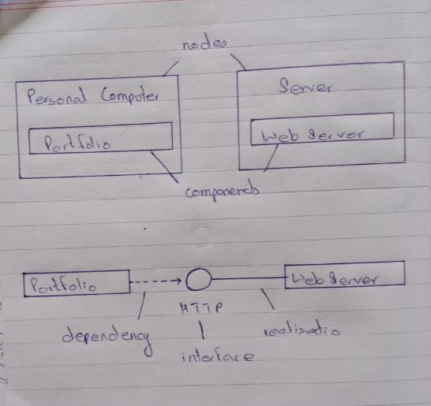

**Architecture:**

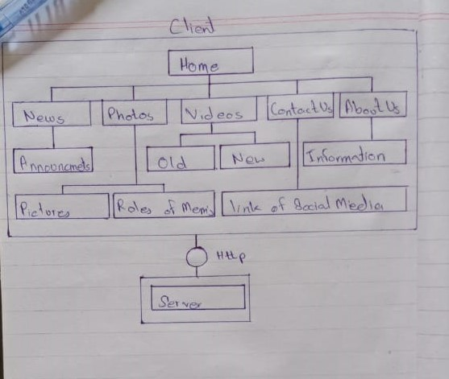

**Q:** **What architectural style would you use for the customer database?**

**Answer:** Client Server

**Q** **Why would you choose this style?**

**Answer:** Because our website does not have any database in it