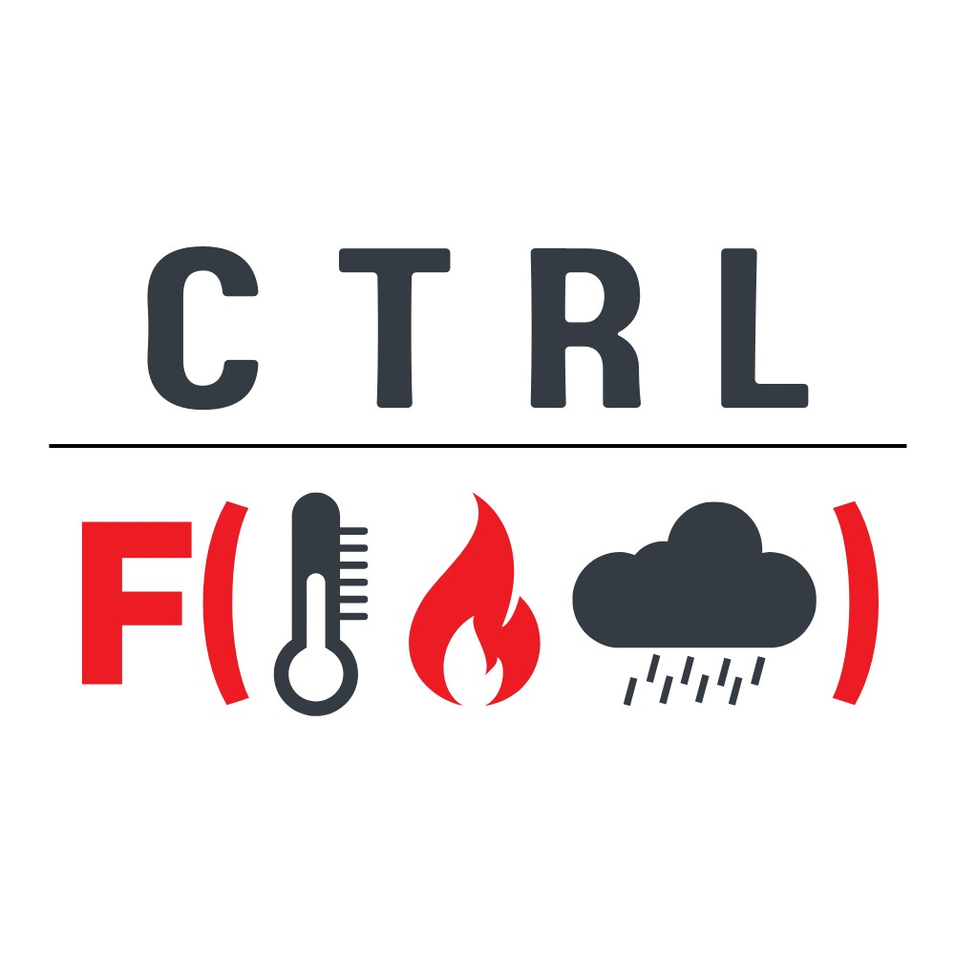

**Software Development**

Project Proposal

June 9, 2023

**Project Team:**

Elena Nafieva

Jevaughn Henry

Khizer Zakir

Rama Kamala Rajeswari Parasa

1. **Overview**

Climate change is the defining challenge of our time. Its impacts know no borders and all members of society are being affected. To tackle this challenge, there is a constant need for the development of sustainable solutions. One impact of rising temperatures and changing precipitation patterns is the occurrence of more large-scale wildfires. These wildfires damage/destroy ecosystems and pose significant health risks to human beings. The risk of fire is increased by warm and dry weather. This calls for continuous monitoring and dissemination of atmospheric and weather indicators that can help track and study wildfire conditions over different regions.

We propose the development of a climate-related application; ‘Ctrl+F (Fire)’ that allows users to locate and visualise wildfires. Additionally, the users can use the application to check atmospheric metrics such as temperature and precipitation, as they are pertinent to forecasting wildfires.

1. **Scope and Objectives**

The main objective of the application will be to provide the user with a platform to retrieve spatiotemporal information about wildfires and weather conditions in an area of interest. After assessing the complexity of the data, the development process, and the time available, we will decide on whether to scale down the project to cover only one country or a specific region (e.g., Iberian Peninsula or Amazon Rainforest) would be more effective for the demonstration of the objectives.

1. **Methodology**

We will explore datasets and API endpoints from the [Copernicus Climate Change Service (C3S)](https://climate.copernicus.eu/) and the Copernicus Atmosphere Monitoring Service to pull data on wildfires and weather conditions. We will look at the [Climate Data Store](https://cds.climate.copernicus.eu/#!/home) and the [Global Fire Assimilation System (GFAS)](https://ads.atmosphere.copernicus.eu/cdsapp#!/dataset/cams-global-fire-emissions-gfas?tab=overview) as potential data sources. For building the application, we will assess the suitability of the native Toolbox Editor of the C3S. Other tools that will be utilised include Python and Jupyter Notebooks. Python packages that will be utilised include Pandas, GeoPandas, Matplotlib and Folium.

1. **Collaboration Tools**

We will use GitHub and Microsoft 365 to collaborate on code and documentation throughout the development process. Team communication will take place via WhatsApp and email.

1. **Project Team and Roles**

|  |  |  |
| --- | --- | --- |
|  | Team member | Task |
| 1. | Elena Nafieva | Exploring available datasets on CDS, API exploration, data wrangling, interface design, contributing to documentation, testing |
| 2. | Jevaughn Henry | Leading documentation, exploring available datasets on CDS, exploring the functionality of API endpoints and their linking to our tool, testing |
| 3. | Khizer Zakir | Data wrangling, data processing, tool building, contributing to documentation, testing |
| 4. | Rama Kamala Rajeswari Parasa | Data wrangling, data processing, tool building, contributing to documentation, testing |

1. **Project Timeline**

We plan to spend approximately 25 hours each on this project. We estimate the project to be completed by the end of July.

|  |  |  |
| --- | --- | --- |
|  | Task | To be done by |
| 1. | Project Initiation | 22nd May 2023 |
| 2. | Proposal | 9th June 2023 |
| 3. | Completion of needs assessment   1. Finishing identification of the right dataset 2. Finalising the type of development environment (E.g., CDS Toolbox, Python Dash/Flask or other) 3. Find sample applications that may be a useful guide 4. Initial data wrangling | 20th June 2023 |
| 4. | Early Prototype | 30th June 2023 |
| 5. | Completion of Development and Documentation | 15th July 2023 |
| 6. | Testing and final corrections | 20th July 2023 |
| 7. | Submission | 30th July 2023 |

1. **Terms of Use**

We plan for all outputs of this project to be available openly under a CC-BY license.