**Input & Output Screenshots**

* oc create -f node-red-deployment.yaml
* oc create -f nodered-pvc.yaml
* oc get all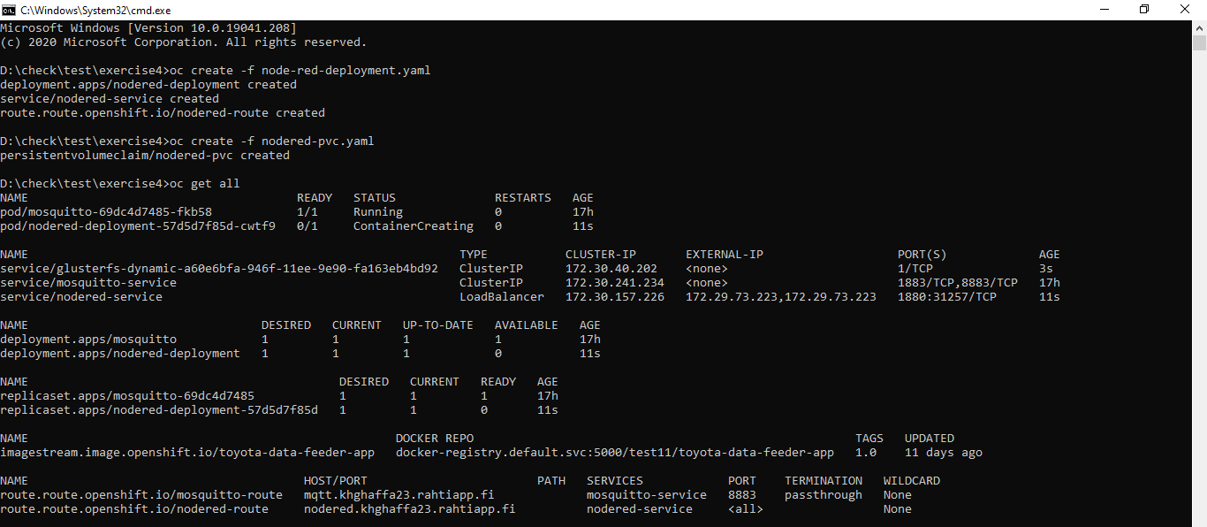
* oc status
* oc get pods

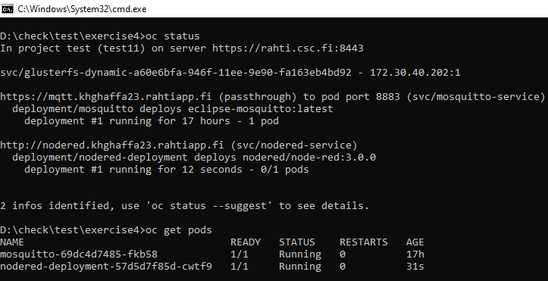

* oc exec nodered-deployment-57d5d7f85d-cwtf9 -i -t -- sh
* cd /data
* ls
* echo hello > hello.txt
* cat hello.txt
* exit
* oc delete pod nodered-deployment-57d5d7f85d-cwtf9
* oc replace --force -f node-red-deployment.yaml
* oc get pods
* oc exec nodered-deployment-57d5d7f85d-s9hh8 -i -t -- sh
* cd /data
* cat hello.txt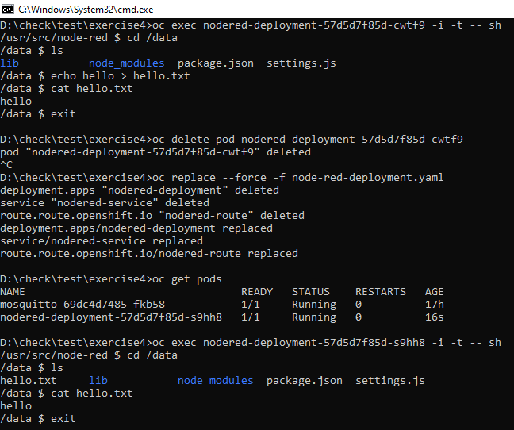
* docker run -e MQTT_URL=mqtt.khghaffa23.rahtiapp.fi -e MQTT_PORT=443 -e CLIENT_ID=khghaffa23 docker-registry.rahti.csc.fi/test11/toyota-data-feeder-app:1.0

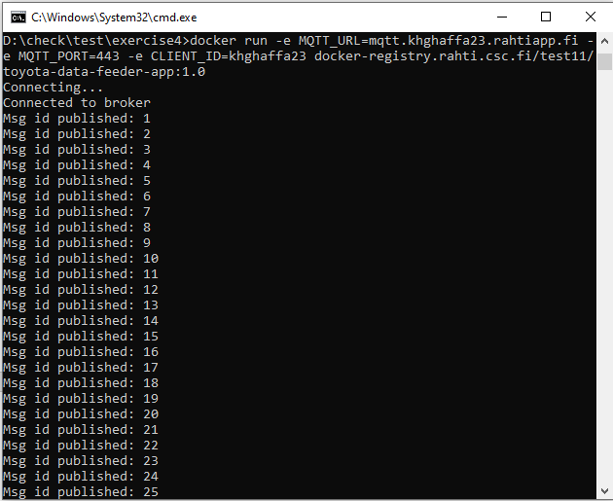

**Speedometer Output Screenshots**

These are the screenshots when I first time performed this task:

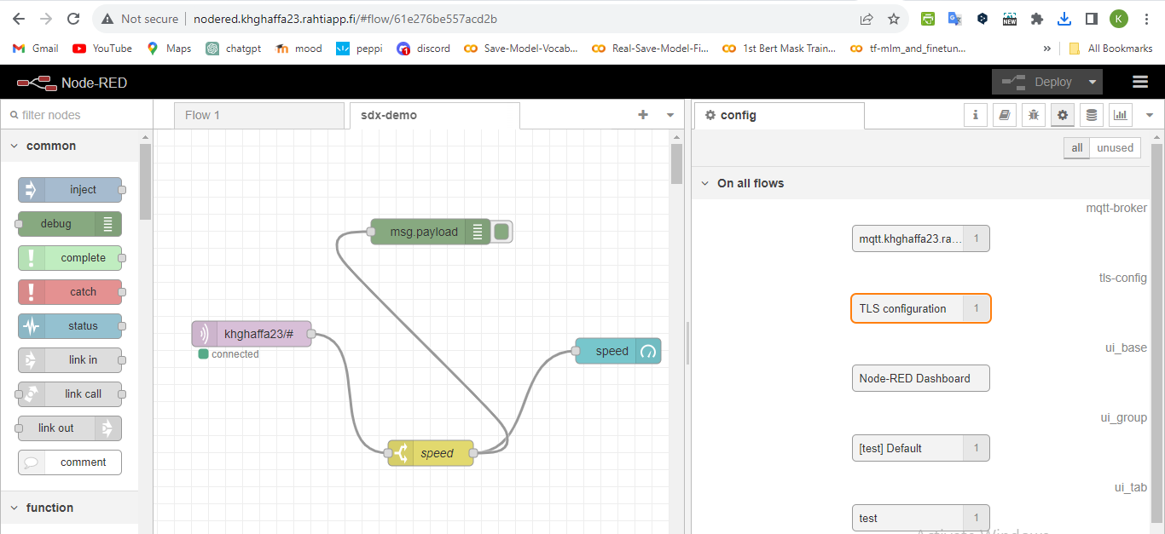

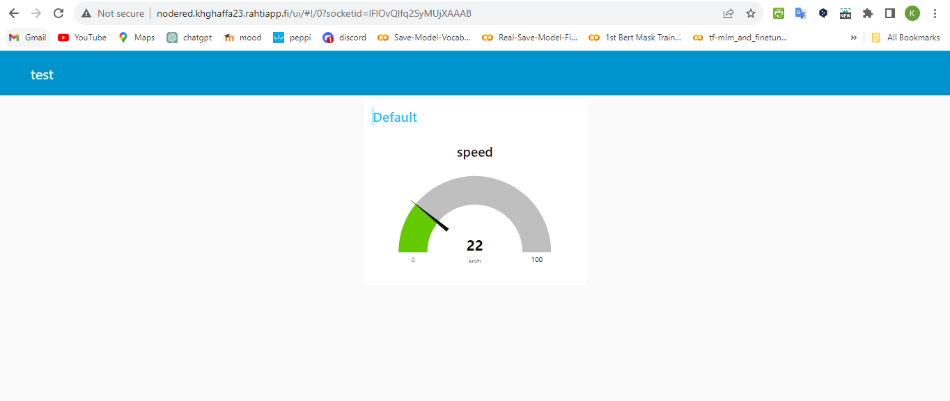

And this is when I second time performed this task:

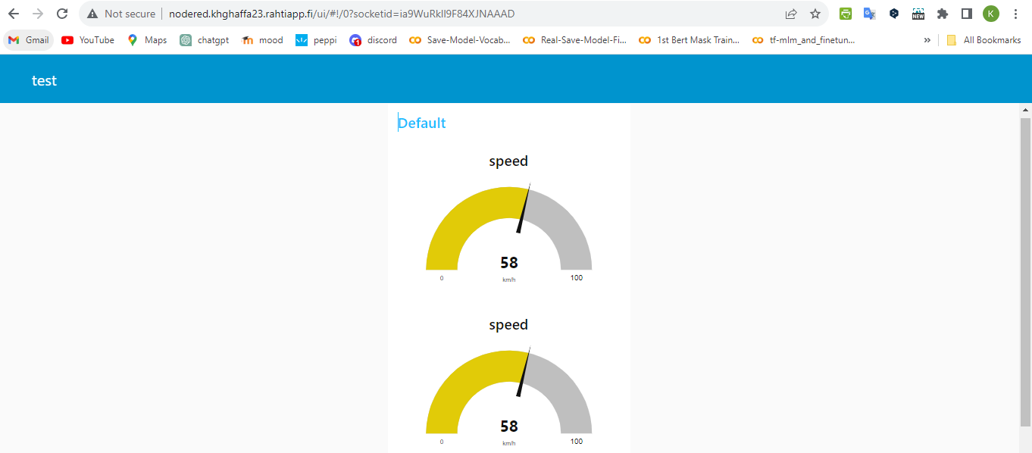

These are the screenshots when I was preparing the video for this assignment:

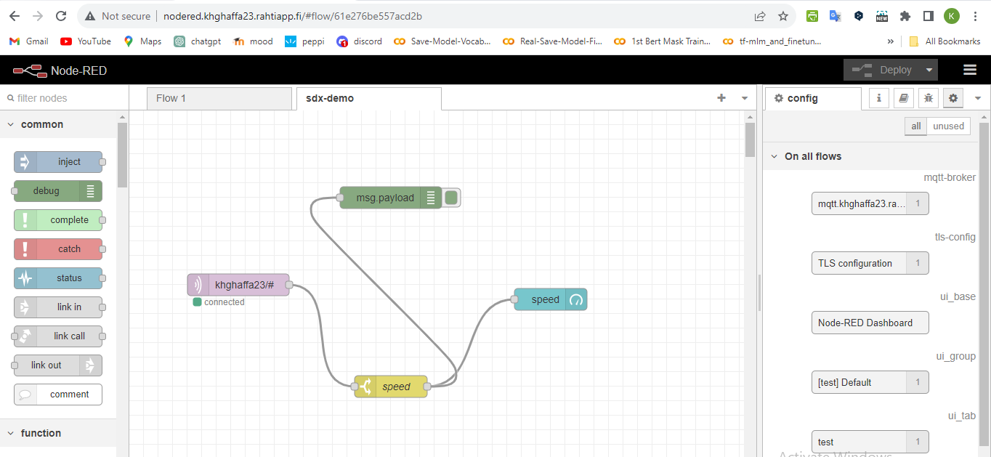

I have taken these screenshots after completing the vide as speedometer is taking time and I also discussed this with the teacher **Olli Timonen**, and he said it is fine to not show the movement in the video as you have the screenshot:

