**Input & Output Screenshots**

* oc create -f mosquitto.yaml
* oc create -f route.yaml

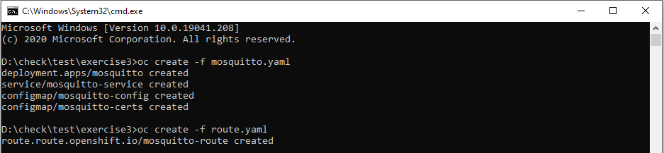

* oc get all
* oc get pod

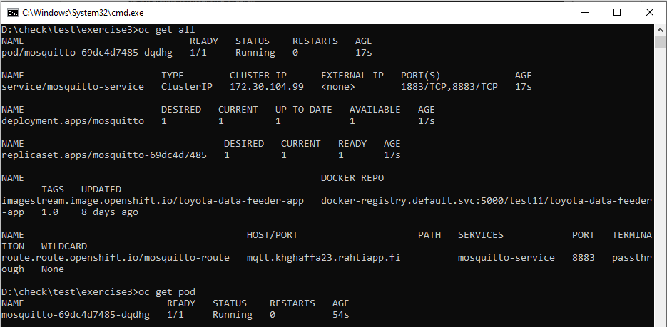

* oc exec mosquitto-69dc4d7485-jqt9n -i -t -- sh
* ls mosquitto/config/certs
* cat mosquitto/config/mosquitto.conf

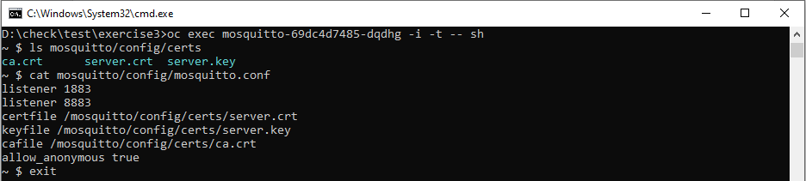

* docker run --rm -it --name toyota-data-feeder-app -e MQTT_URL=mqtt.khghaffa23.rahtiapp.fi -e MQTT_PORT=443 -e CLIENT_ID=khghaffa23 docker-registry.rahti.csc.fi/test11/toyota-data-feeder-app:1.0

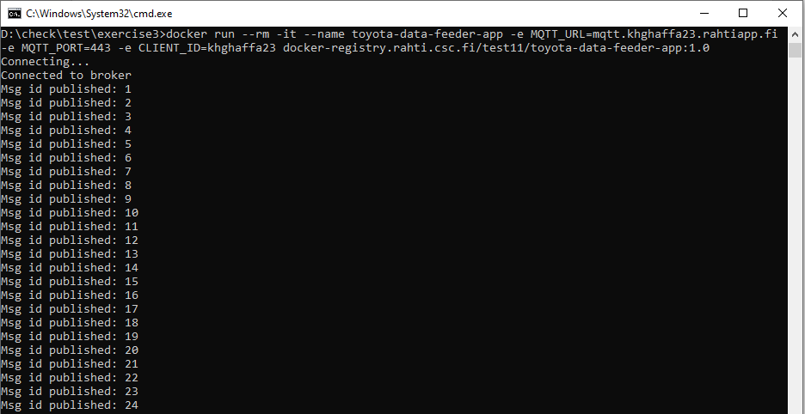

* mosquitto_sub -t "khghaffa23/#" --cafile ca.crt --insecure --host mqtt.khghaffa23.rahtiapp.fi --port 443 -v

