Information Security Final Exam Fall 2020, Class 1

Modify openssl such that the random numbers included in the ClientHello message are displayed during the client and server communication. **You have to explain in detail how you have solved this problem.**

client:

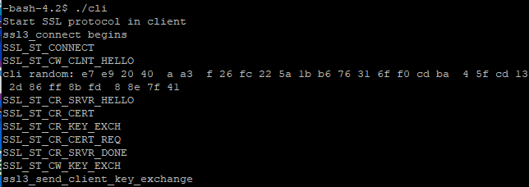

server:

...........................................