Data Logger

Features
-- Power
Long battery life
Build-in Solar panel and battery
Low power consumption(3.3V)
-- Data
Recording data into SD card
Build-in RTC chip
-- Compatible
Using Arduino based architecture
Switchable Sensor extend board
-- Other
Low cost
Wireless(Future)

Hardware architecture
Pressure sensor
Moisture sensor

Solar Panel
Battery
ADS1115 ADC
Regulator

Arduino Compatible extend board

Power management

RTC DS3231
SD reader

Seeeduino Stalker Board

1.1 Seeeduino Stalker Board
http://www.seeedstudio.com/depot/Seeeduino-Stalker-v2-p-727.html

This Arduino compatible board, specially designed for Data logger usage, is the best choice for our project because of following features:
- Powerful chip: Atmel 328P controller
- Low power consumption: Working on 3.3V voltage and few environment circuits. 1/5 typical power consumption comparing to original Arduino UNO.
- Build-in RTC: By using DS 3231, this controller has not only the real time ability, but can also use RTC chip to wake the controller up after put it into deep sleep mode to save a lot of power.
- Smart power management. This controller has build-in Solar panel and Li-poly battery manage ability.
- On-board SD card: By supporting high capacity TF(micro SD) card, this controller can store a lot of logging data.
- Outstanding compatibility: Compatible with pin setup of arduino, and can also mount on Bee board
.

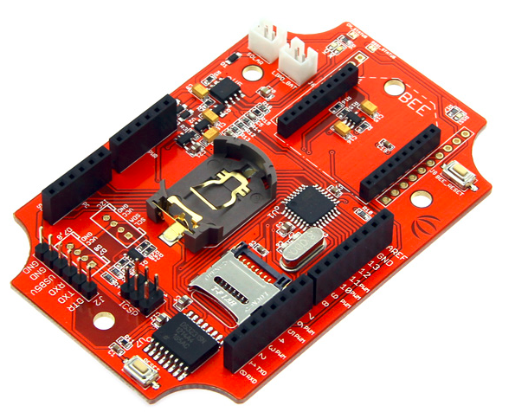
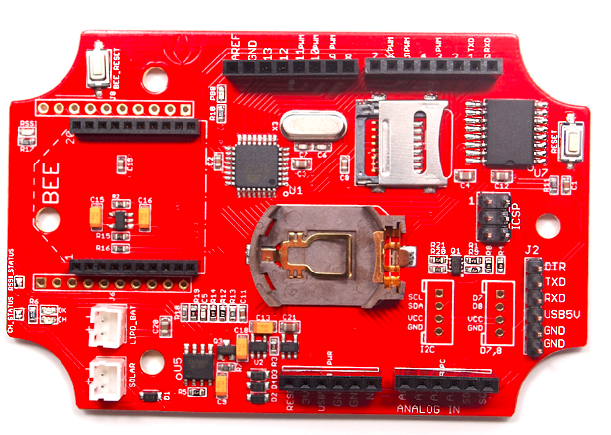

1.1.1 DS3231 RTC
There several modules of RTC chips in the market, DS3231 it a powerful module of them. Not only because it has precision clock feature, but mostly due to its programmable alarm feature, which can give out a trigger to wake up controller in any time that we want.

1.1.2 SD card reader
We have tried several modules of SD card reader, but we always have problems with it. Fortunately, this SD reader works perfect on Seeedunio. After test, this SD reader supports 4G TF card and FAT32 partition.

1.2 Extend board

In order to separate controller and I/O, I designed an extend board to mount on all the other circuit including connector on it. Thanks to such a board, we can upgrade and modify out design in quick and clear way.

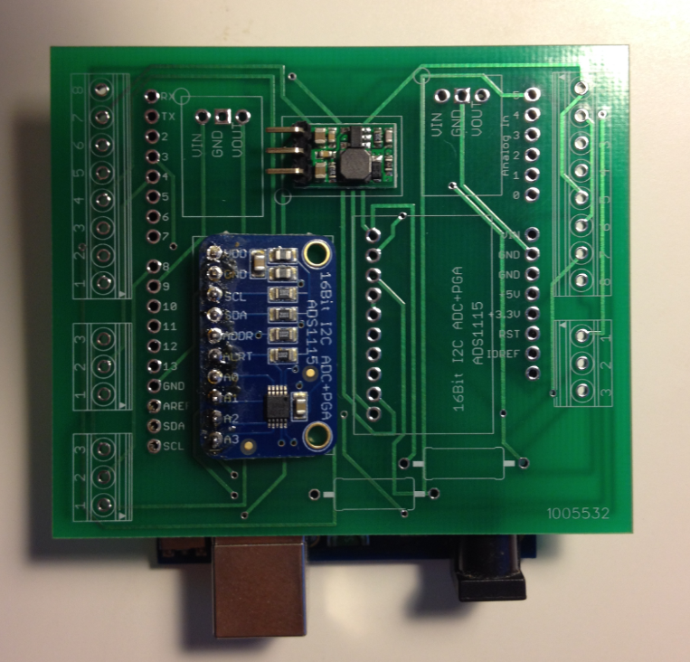

This board right now does not have any circuit, because the only thing this board does is connecting sensors with ADC and voltage regulators, to the controller.
This board was designed by Eagle. I used tried to use NI Multisim and NI Ultiboard to design, but their lacking of some footprints makes it very hard.

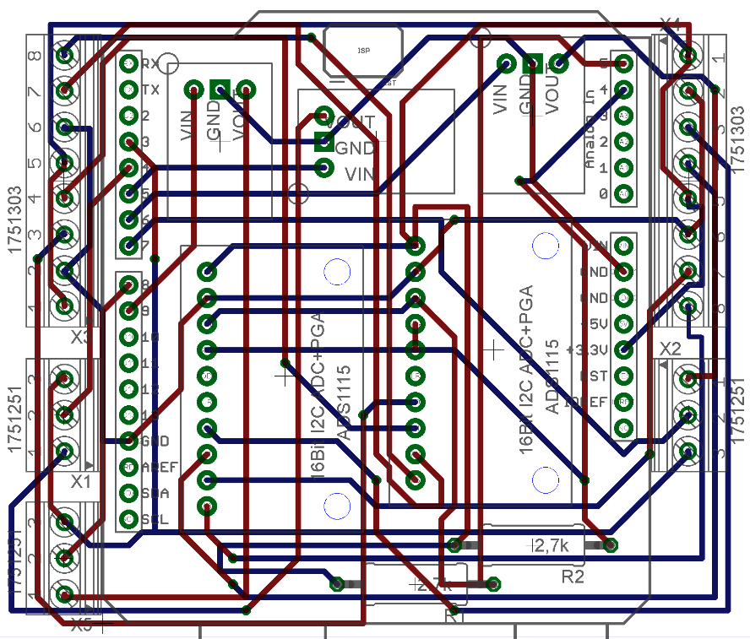

1.2.1 ADS1115
This is a 16-bit ADC (Analog to digital convert) board made by Adafruit. By using ads1115 chip, this circuit gives us outstanding precision and low power consumption. We can measure two differential analogy sensors on it and measure them at the same time.
This ADC circuit uses I2C communication protocol, so we can uses many this board on controller only depends on how many different addresses it have, which is 5, including default one.

1.2.2 Voltage regulator
This tricky sensor is moisture sensor named 5TE, made by Analog Device that, it needs minimum 3.6V working voltage and relative large working current (over 10mA). So we need a boost voltage regulator, which is POLOLU Step-UP NCP1402 regulator. This regulator receives 0.8V to 5V input voltage, and output 5V.
However, in practice situation, if we connect over one 5TE sensors, reading value will be inaccurate. So we still use one regulator power on one 5TE sensors.

Connectivity
There are several connections in this data logger.
2.1 Sensors
We used phoenix screw terminal to connect sensors and boards.
Sensors | Pressure sensor #1 | VCC | ADC #1 VCC
Sensors | Pressure sensor #1 | COM1 | ADC #1 A0
Sensors | Pressure sensor #1 | GND | ADC #1 GND
Sensors | Pressure sensor #1 | COM2 | ADC #1 A1
Sensors | Pressure sensor #2 | VCC | ADC #1 VCC
Sensors | Pressure sensor #2 | COM1 | ADC #1 A2
Sensors | Pressure sensor #2 | GND | ADC #1 GND
Sensors | Pressure sensor #2 | COM2 | ADC #1 A3
Sensors | Pressure sensor #3 | VCC | ADC #2 VCC
Sensors | Pressure sensor #3 | COM1 | ADC #2 A0
Sensors | Pressure sensor #3 | GND | ADC #2 GND
Sensors | Pressure sensor #3 | COM2 | ADC #2 A1
Sensors | Pressure sensor #4 | VCC | ADC #2 VCC
Sensors | Pressure sensor #4 | COM1 | ADC #2 A2
Sensors | Pressure sensor #4 | GND | ADC #2 GND
Sensors | Pressure sensor #4 | COM2 | ADC #2 A3
Sensors | 5TE #1 | VCC | REG #1 VOUT
Sensors | 5TE #1 | GND | REG #1 GND
Sensors | 5TE #1 | COM | D4
Sensors | 5TE #2 | VCC | REG #2 VOUT
Sensors | 5TE #2 | GND | REG #2 GND
Sensors | 5TE #2 | COM | D7
Sensors | 5TE #3 | VCC | REG #3 VOUT
Sensors | 5TE #3 | GND | REG #3 GND
Sensors | 5TE #3 | COM | D8
Board/  shield | ADC #1 | VCC | D3
Board/  shield | ADC #1 | GND | GND
Board/  shield | ADC #1 | SCL | A5
Board/  shield | ADC #1 | SDA | A4
Board/  shield | ADC #1 | ADDR | NC
Board/  shield | ADC #1 | ALRT | NC
 | ADC #1 | VCC | D3
 | ADC #1 | GND | GND
 | ADC #1 | SCL | A5
 | ADC #1 | SDA | A4
 | ADC #1 | ADDR | ADC #2 SDA
 | ADC #1 | ALRT | NC
 | REG #1 | VIN | D5
 | REG #1 | GND | GND
 | REG #1 | VOUT | Pressure sensor #1
 | REG #2 | VIN | D6
 | REG #2 | GND | GND
 | REG #2 | VOUT | Pressure sensor #1
 | REG #3 | VIN | D9
 | REG #3 | GND | GND
 | REG #3 | VOUT | Pressure sensor #1

Software
Control software was developed based on Arduino IDE. Until Aug.4 2014, we have two branches and 24 versions. Now the version code is Ver 2.001, which is fully support all 7 sensors(4 pressure sensors with 3 moisture sensors), recording data every hour and store then in SD card. However, this version of controller program does not have ability to communicate with computer or downloader via serial cable. The only way to download data is unplugging SD card. This version of program is stable version, that can normally record the data even in abruptly unplugging and re-plug in SD card and in unexpected losing power.
Also thanks to deep sleeping strategy, with a small 0.5W solar panel, out data logger can keep work unless the doomsday.

Future

We have several expect in future development.
Wireless ability.
In order to save time, we want to apply wireless ability that can directly upload data to internet, but shrink the physical size and low power consumption at the same time.

