XBEE report Dec 4
Hengjiu (Tony) Kang
Dec/4/2014

Summary
At this time, we have a simple 2.4G wireless network based on Xbee that has an contaminator and multiple clients. I have not test the connection range yet.

What we want & what we have
We want have a robust area network that send out data (maybe down-sampling data from busy On-Car can bus) from car to computer. This network should have features including high-speed, robust, long range.
For some reasons, I have several XBee S2B rf modules, which are working on 2.4GHz frequency, have on-board programmable chip (made by Freescale). This high-end class Xbee support API protocol, which is a communicating syntax looks like CAN, however for quick setup, I used transparent mode. Under this communication mode, Xbee just broadcast the message it received from UART pins to the air. Please notice that, this is communication mode, but not network mode, so at this time, Xbee can still support some key features including multi-point network rather than point-to-point.
Then, this is what we have right now.

coordinator
Client 2
Client 1

There is a coordinator Xbee, form and administrate a network with PAN Code 2001.
There are two routers/end-devices that sent data.
Coordinator will receive data and then show them on the laptop serial terminal.
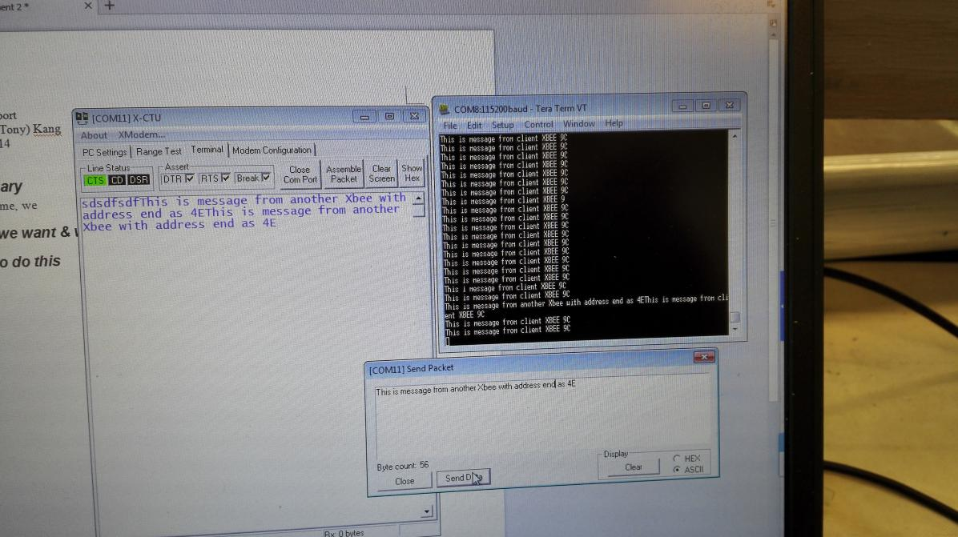

Coordinator in Serial Com8 print out all the messages it received from two Xbees.

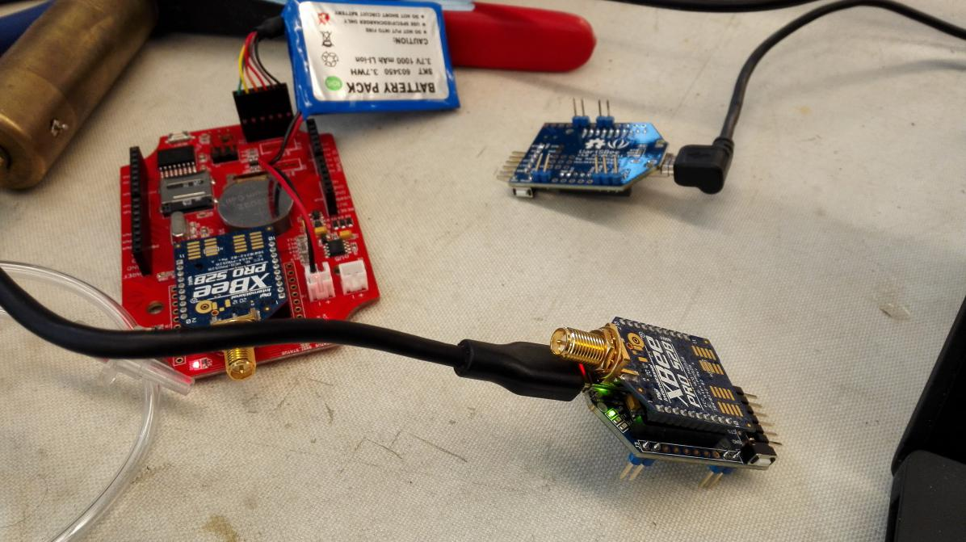Lower Xbee is setup as coordinator, left side is a router xbee, continuously sending out message. Upper adapter has another xbee on it. (I took the picture before I plugin in Xbee module)

How to do this
Preparation:
All of these Xbees are programmable, but in this application, we dont need that feature, so I first bootup them into bootloader, then I write in a shot program that just bypass the freescale chip, reveal the Xbee to outside.
Then I used X-CTU to write in new firmwares, change their roles into Coordinator, router, and also change their communication mode from API to AT.
(To be honest, few articles on the internet talk about these important steps, so it takes me long time to try out them)
Then I used an arduino with simple code:

void setup(){
Serial.begin(115200);
}

void loop(){
Serial.print("This is message from client XBEE 9C\r\n");
delay(1000);

}

To send message “this is message from client XBEE 9C” every second.(9C is last 2-digit address of that XBEE).

The last step is just power on all xbees, and open serial terminal, see what’s going on .u

