Supplementary material for the breast ultrasound segmentation study
Fixed-threshold transfer and equal-review ranking in breast ultrasound segmentation quality control
Haoze Lan; Ziyuan Zhu; v8 author-review revision, 6 November 2026
Table S1. Locked thresholds and scoring settings
Setting | Value
Development budget | 20 % target. Each method flagged 43/213 (20.19 %) in development.
Locked risk threshold A | 0.13705134391784668
Locked risk threshold B | 0.06972856653991777
Review trigger | Risk score ≥ the corresponding locked threshold.
Fixed threshold ties | Include every case at the cutoff. If two cutoffs are equally close to the target, select the one with fewer reviews.
SAM source commit | dca509fe793f601edb92606367a655c15ac00fdf
Checkpoint SHA-256 | ec2df62732614e57411cdcf32a23ffdf28910380d03139ee0f4fcbe91eb8c912
Formal scoring environment | Python 3.8.20, PyTorch 2.4.1+cu118, torchvision 0.19.1+cu118, Pillow 10.4.0, NumPy 1.24.4.
SAM, Segment Anything Model. Inference used the official sam_vit_b_01ec64.pth checkpoint with float32 weights on a GeForce RTX 3060 Laptop GPU. Statistical replay used Python 3.12.14.

Sensitivity to the low quality definition
Table S2. Test performance at alternative reference Dice cutoffs
Dice  cutoff | Test cohort | Method | Detection,  n/N (%) | Simulated review,  n/N (%) | Misses, n | Misses per  100 patients
< 0.50 | BUS-BRA internal | A | 52/53 (98.11 %) | 174/851 (20.45 %) | 1 | 0.12
< 0.50 | BUS-BRA internal | B | 43/53 (81.13 %) | 150/851 (17.63 %) | 10 | 1.18
< 0.50 | BrEaST external | A | 5/7 (71.43 %) | 35/252 (13.89 %) | 2 | 0.79
< 0.50 | BrEaST external | B | 5/7 (71.43 %) | 33/252 (13.10 %) | 2 | 0.79
< 0.80 | BUS-BRA internal | A | 109/183 (59.56 %) | 174/851 (20.45 %) | 74 | 8.70
< 0.80 | BUS-BRA internal | B | 95/183 (51.91 %) | 150/851 (17.63 %) | 88 | 10.34
< 0.80 | BrEaST external | A | 21/50 (42.00 %) | 35/252 (13.89 %) | 29 | 11.51
< 0.80 | BrEaST external | B | 21/50 (42.00 %) | 33/252 (13.10 %) | 29 | 11.51
Both risk thresholds remained fixed. Detection uses the low-quality masks under the stated cutoff as its denominator. Simulated review and misses per 100 use all scored patients.

Detection rate contrasts
Table S3. Detection rate contrasts at alternative reference Dice cutoffs
Dice cutoff | Contrast | Difference, pp | Nominal 95 % CI, pp
< 0.50 | Method A detection, external minus internal | −26.68 | [−62.25, −4.80]
< 0.50 | External detection, Method B minus Method A | 0.00 | [−27.14, +27.14]
< 0.80 | Method A detection, external minus internal | −17.56 | [−31.92, −2.01]
< 0.80 | External detection, Method B minus Method A | 0.00 | [−10.06, +10.06]
pp, percentage points. CI, confidence interval. Between-cohort contrasts use independent Newcombe intervals. Within-BrEaST contrasts use paired Newcombe intervals.
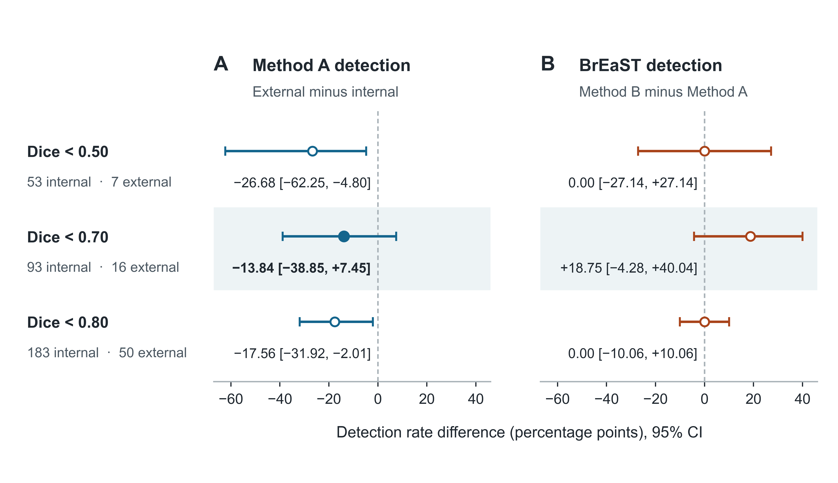
Figure S1. Sensitivity to the definition of low quality. Panel A shows the external-minus-internal detection difference for method A. Panel B shows the paired B-minus-A difference in BrEaST. Risk thresholds remain fixed while reference Dice cutoffs vary. The filled marker denotes H1 at Dice below 0.70. The remaining 95 % confidence intervals are nominal.

Equal review volume in BrEaST
Table S4. BrEaST performance at equal review volume
Method | Detection,  n/N (%) | Simulated review,  n/N (%) | Misses, n | Misses per  100 patients
A | 14/16 (87.50 %) | 50/252 (19.84 %) | 2 | 0.79
B | 13/16 (81.25 %) | 50/252 (19.84 %) | 3 | 1.19
Each method selected 50 of the 252 scored cases in descending risk order. Ties followed lexicographic case identifier order. Low quality used reference Dice below 0.70.
Among the 16 low-quality cases, both methods flagged 12, only A flagged 2, only B flagged 1, and neither flagged 1. The paired B-minus-A difference was −6.25 percentage points (nominal 95 % confidence interval [−31.61, +19.57]). This interval is conditional on the observed rankings.
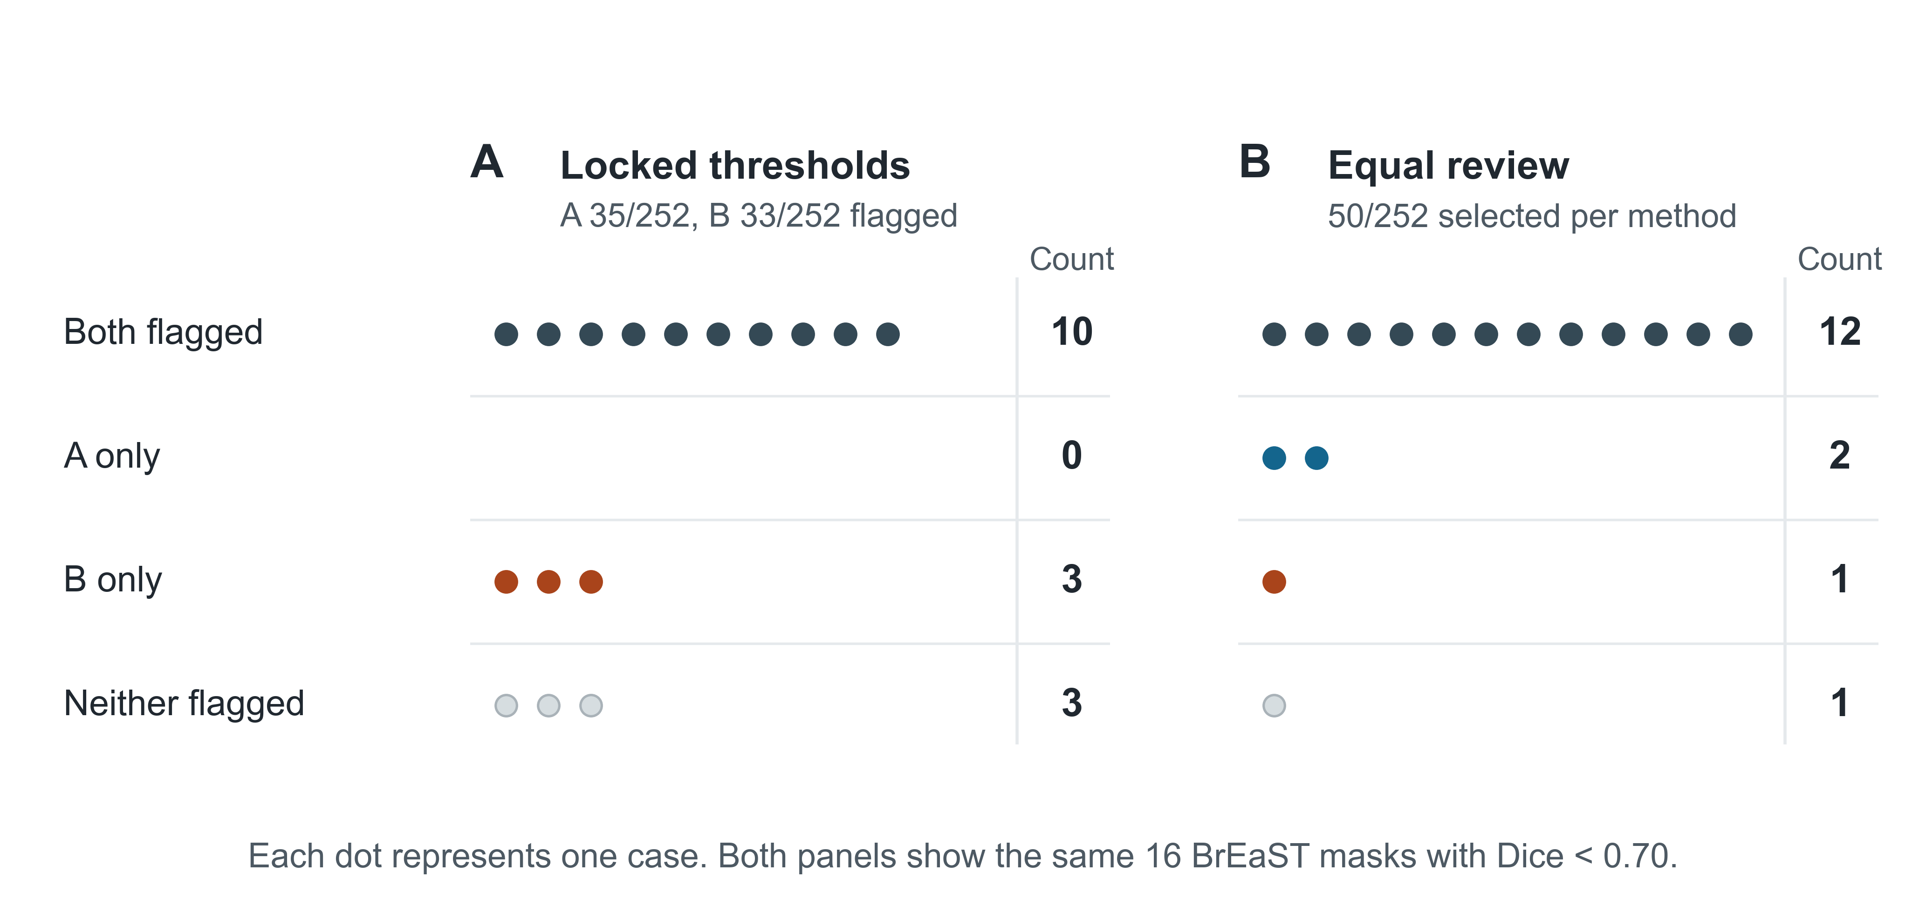
Figure S2. Paired outcomes among the 16 low-quality BrEaST masks. Each dot represents one low-quality case. Panel A uses the two locked thresholds. Panel B ranks each score separately and selects 50 of 252 patients per method. The right column in each panel reports the counts.

Computational reproducibility
Table S5. Agreement between the raw-image rerun and archived scores
Cohort | Compared /  expected | Maximum absolute  difference | Cases with  changed flags, n | Cases with  changed status, n
BUS-BRA development | 213/213 | 0 | 0 | 0
BUS-BRA internal | 851/851 | 0 | 0 | 0
BrEaST external | 252/252 | 0 | 0 | 0
The numerical comparison covered reference Dice, SAM predicted intersection over union, the two risk scores and the four shifted-mask Dice values. Flag and count comparisons included the quality label, both review flags, the empty-mask flag and the distinct-box count. Runtime was recorded separately.
Recomputing statistics from archived scores and rerunning inference from the original images both reproduced the locked thresholds, primary and supplementary results, and review-curve counts. The reproducibility package contains the case manifests, input hashes and per-cohort verification records.
Revision audit provenance. Archived-score replay and the original same-environment full-cohort image rerun remain distinct from the six-case CPU replay reported in Table S13. The latter was actually executed for this revision, saved new prediction arrays and retained the original scores for every cohort analysis. Computational reproducibility is distinct from independent validation.

Additional descriptive quality-control measures
These post hoc descriptive analyses use the unchanged locked risk thresholds and the primary reference Dice cutoff of 0.70. The positive condition is a low-quality segmentation; the positive test is a review flag. These are mask-quality screening measures, not breast-cancer diagnostic measures. Development results describe calibration data and are not independent test performance.
Table S6. Classification counts at the primary quality cutoff
Cohort | Score | TP, n | FP, n | TN, n | FN, n
BUS-BRA development | A | 19 | 24 | 165 | 5
BUS-BRA development | B | 17 | 26 | 163 | 7
BUS-BRA internal | A | 71 | 103 | 655 | 22
BUS-BRA internal | B | 68 | 82 | 676 | 25
BrEaST external | A | 10 | 25 | 211 | 6
BrEaST external | B | 13 | 20 | 216 | 3
TP, true positive (flagged low quality); FP, false positive (flagged quality-acceptable); TN, true negative (unflagged quality-acceptable); FN, false negative (unflagged low quality); n, number of patients. A, model-confidence risk; B, prompt-disagreement risk.
Table S7. Sensitivity, specificity and predictive values
Cohort | Score | Sensitivity | Specificity | PPV | NPV
BUS-BRA development | A | 19/24 (79.17 %)  [59.53, 90.76] | 165/189 (87.30 %)  [81.80, 91.32] | 19/43 (44.19 %)  [30.43, 58.89] | 165/170 (97.06 %)  [93.30, 98.74]
BUS-BRA development | B | 17/24 (70.83 %)  [50.83, 85.09] | 163/189 (86.24 %)  [80.61, 90.44] | 17/43 (39.53 %)  [26.37, 54.42] | 163/170 (95.88 %)  [91.75, 97.99]
BUS-BRA internal | A | 71/93 (76.34 %)  [66.77, 83.83] | 655/758 (86.41 %)  [83.79, 88.67] | 71/174 (40.80 %)  [33.78, 48.23] | 655/677 (96.75 %)  [95.13, 97.84]
BUS-BRA internal | B | 68/93 (73.12 %)  [63.32, 81.08] | 676/758 (89.18 %)  [86.77, 91.20] | 68/150 (45.33 %)  [37.58, 53.32] | 676/701 (96.43 %)  [94.79, 97.57]
BrEaST external | A | 10/16 (62.50 %)  [38.64, 81.52] | 211/236 (89.41 %)  [84.83, 92.72] | 10/35 (28.57 %)  [16.33, 45.05] | 211/217 (97.24 %)  [94.10, 98.73]
BrEaST external | B | 13/16 (81.25 %)  [56.99, 93.41] | 216/236 (91.53 %)  [87.27, 94.45] | 13/33 (39.39 %)  [24.68, 56.32] | 216/219 (98.63 %)  [96.05, 99.53]
Entries show n/N (%), followed by Wilson 95 % confidence intervals in percent. PPV, positive predictive value; NPV, negative predictive value. Sensitivity equals the low-quality detection measure used in the prespecified analysis. Predictive values depend on the frequency of low-quality segmentations. Machine-readable descriptive results for Dice cutoffs 0.50, 0.70 and 0.80 are supplied as Additional_quality_control_metrics.csv. Misses per 100 patients remain in the original main Table 2 and supplementary Tables S2 and S4.

Exploratory diagnostic stratification
Table S8. Quality-control detection and review by dataset-reported benign/malignant classification
Cohort | Diagnostic stratum | N / low quality | Score | Detection, n/F (%)  [95 % CI, %] | Review, n/N (%)  [95 % CI, %]
BUS-BRA internal | Benign | 577 / 53 | A | 51/53 (96.23 %)  [87.25, 98.96] | 102/577 (17.68 %)  [14.78, 21.00]
BUS-BRA internal | Benign | 577 / 53 | B | 41/53 (77.36 %)  [64.47, 86.55] | 80/577 (13.86 %)  [11.28, 16.92]
BUS-BRA internal | Malignant | 274 / 40 | A | 20/40 (50.00 %)  [35.20, 64.80] | 72/274 (26.28 %)  [21.42, 31.79]
BUS-BRA internal | Malignant | 274 / 40 | B | 27/40 (67.50 %)  [52.02, 79.92] | 70/274 (25.55 %)  [20.75, 31.02]
BrEaST external | Benign | 154 / 8 | A | 5/8 (62.50 %)  [30.57, 86.32] | 15/154 (9.74 %)  [5.99, 15.45]
BrEaST external | Benign | 154 / 8 | B | 7/8 (87.50 %)  [52.91, 97.76] | 13/154 (8.44 %)  [5.00, 13.91]
BrEaST external | Malignant | 98 / 8 | A | 5/8 (62.50 %)  [30.57, 86.32] | 20/98 (20.41 %)  [13.62, 29.43]
BrEaST external | Malignant | 98 / 8 | B | 6/8 (75.00 %)  [40.93, 92.85] | 20/98 (20.41 %)  [13.62, 29.43]
Post hoc exploratory analysis with unchanged locked thresholds and reference Dice < 0.70. N, all scored patients in the stratum; F, low-quality masks; n, detected or reviewed cases as indicated; CI, Wilson confidence interval; A, model-confidence score; B, prompt-disagreement score. Classification is dataset-reported and is not uniformly histopathologically confirmed in BrEaST. These are quality-screening measures, not diagnostic sensitivity for malignancy. No hypothesis or interaction tests were performed. Complete machine-readable results also include the development strata, confusion counts and misses per 100 patients.

Empty-mask audit
Across 213 development, 851 internal and 252 external images, the saved initial_mask_empty flag was zero for every initial prediction. Every one of the 5,264 initial-to-shifted Dice values was strictly positive, which also establishes that no shifted prediction was empty. Consequently the convention Dice(empty, empty)=1 affected zero recorded scores. A reference Dice of zero alone was not treated as evidence of an empty prediction. No affected-case sensitivity analysis was needed.

External missed-case records
Table S9. All six low-quality external cases missed by method A
Case / label | Detected by | Reference Dice | Risk A | A flag | Risk B | B flag | Mean consistency Dice
case089  malignant | Neither | 0.3191 | 0.104072 | 0 | 0.041041 | 0 | 0.9590
case175  benign | Neither | 0.0293 | 0.114944 | 0 | 0.020059 | 0 | 0.9799
case238  malignant | Neither | 0.6813 | 0.038909 | 0 | 0.005766 | 0 | 0.9942
case024  benign | B only | 0.6852 | 0.054510 | 0 | 0.109995 | 1 | 0.8900
case105  malignant | B only | 0.6546 | 0.102471 | 0 | 0.259671 | 1 | 0.7403
case222  benign | B only | 0.5784 | 0.126987 | 0 | 0.201743 | 1 | 0.7983
All external cases with reference Dice < 0.70 and A flag=0 are included, partitioned by the B flag. A flag and B flag equal 1 when risk is at least the respective full-precision locked cutoff: A=0.13705134391784668; B=0.06972856653991777. Displayed scores are rounded; decisions use the original precision. Mean consistency is one minus Risk B. Each initial prediction was nonempty, and every initial-to-shifted Dice was positive. This outcome-defined case set illustrates score behavior and is not used to estimate an additional performance advantage.
Actual predictions for these six cases have now been captured in a targeted CPU replay using the checksum-identical checkpoint and exact SAM source. Figure S6 shows the replayed contours and Table S13 compares the new values with the archived scores. The original six CUDA arrays were not retained; pixel identity across environments cannot be checked. Table S9 continues to report the original scores. The Figure 2 case001 illustration is not used as a substitute for a missed case.

Table S10. Complete post hoc review-budget scan. Panel A: development calibration.
Target budget (%) | A threshold | B threshold | Reviews R/N (%) | A detected TP/F (%) | B detected TP/F (%)
5 | 0.230097890 | 0.143395298 | 11/213 (5.16) | 6/24 (25.00) | 7/24 (29.17)
10 | 0.187371969 | 0.091432393 | 21/213 (9.86) | 11/24 (45.83) | 10/24 (41.67)
15 | 0.153415680 | 0.075878174 | 32/213 (15.02) | 17/24 (70.83) | 13/24 (54.17)
20 | 0.137051344 | 0.069728567 | 43/213 (20.19) | 19/24 (79.17) | 17/24 (70.83)
25 | 0.099984050 | 0.060165861 | 53/213 (24.88) | 21/24 (87.50) | 19/24 (79.17)
30 | 0.082495153 | 0.052356279 | 64/213 (30.05) | 21/24 (87.50) | 23/24 (95.83)
40 | 0.060212433 | 0.034317724 | 85/213 (39.91) | 21/24 (87.50) | 24/24 (100.00)
50 | 0.051672816 | 0.023950987 | 106/213 (49.77) | 23/24 (95.83) | 24/24 (100.00)
Post hoc exploratory analysis of the unchanged development cohort (N=213; low-quality cases F=24). A is confidence-based risk; B is prompt-instability risk. Low quality is reference Dice <0.70.
Each threshold minimizes the absolute difference from the target review fraction using development risks only. Risk ties are kept together; a zero-review candidate is included; equally close candidates select fewer reviews. All selected candidates here are nonzero. Displayed thresholds are rounded; analyses use full-precision stored thresholds.
R is the number selected for review; TP is the number of low-quality cases selected; F is the number of low-quality cases. Percentages in count cells use the displayed denominator. Settings were fixed before these new computations, not preregistered for the original study.

Table S10 (continued). Panel B: BUS-BRA internal holdout: development-calibrated thresholds.
Target (%) | A reviews R/N (%) | B reviews R/N (%) | A detected TP/F (%) | B detected TP/F (%) | B−A detection, pp [95 % CI] | B−A review, pp [95 % CI]
5 | 64/851 (7.52) | 60/851 (7.05) | 41/93 (44.09) | 39/93 (41.94) | -2.15 [-10.64, +6.41] | -0.47 [-1.97, +1.00]
10 | 106/851 (12.46) | 110/851 (12.93) | 56/93 (60.22) | 58/93 (62.37) | +2.15 [-6.43, +10.67] | +0.47 [-1.46, +2.41]
15 | 158/851 (18.57) | 135/851 (15.86) | 67/93 (72.04) | 65/93 (69.89) | -2.15 [-12.16, +7.91] | -2.70 [-4.95, -0.47]
20 | 174/851 (20.45) | 150/851 (17.63) | 71/93 (76.34) | 68/93 (73.12) | -3.23 [-13.48, +7.09] | -2.82 [-5.06, -0.60]
25 | 234/851 (27.50) | 180/851 (21.15) | 83/93 (89.25) | 73/93 (78.49) | -10.75 [-20.42, -1.21] | -6.35 [-8.64, -4.07]
30 | 282/851 (33.14) | 232/851 (27.26) | 87/93 (93.55) | 81/93 (87.10) | -6.45 [-15.45, +2.30] | -5.88 [-8.09, -3.67]
40 | 358/851 (42.07) | 349/851 (41.01) | 92/93 (98.92) | 89/93 (95.70) | -3.23 [-9.55, +2.26] | -1.06 [-3.59, +1.48]
50 | 423/851 (49.71) | 438/851 (51.47) | 92/93 (98.92) | 92/93 (98.92) | 0.00 [-4.86, +4.86] | +1.76 [-1.15, +4.66]
Post hoc exploratory analysis; N=851; F=93. Count-cell percentages use the displayed denominator. pp, percentage points.
The development thresholds in Panel A are transferred without test-cohort recalibration. Therefore actual review fractions may differ from the target and between A and B.
Detection and review contrasts are paired within patients. Nominal two-sided 95 % confidence intervals use the original paired Newcombe method 10 with its correction for positive association.
The presented confidence intervals are conditional on the observed calibration and selection, exclude calibration uncertainty and re-ranking bootstrap uncertainty, and have no multiplicity correction. They do not replace or modify the original H1–H3 analyses.

Table S10 (continued). Panel C: BUS-BRA internal holdout: test-cohort equal review.
Target (%) | A reviews R/N (%) | B reviews R/N (%) | A detected TP/F (%) | B detected TP/F (%) | B−A detection, pp [95 % CI] | B−A review, pp
5 | 43/851 (5.05) | 43/851 (5.05) | 34/93 (36.56) | 29/93 (31.18) | -5.38 [-14.57, +3.95] | 0 (by design)
10 | 85/851 (9.99) | 85/851 (9.99) | 49/93 (52.69) | 50/93 (53.76) | +1.08 [-7.20, +9.32] | 0 (by design)
15 | 128/851 (15.04) | 128/851 (15.04) | 63/93 (67.74) | 63/93 (67.74) | 0.00 [-10.00, +10.00] | 0 (by design)
20 | 170/851 (19.98) | 170/851 (19.98) | 71/93 (76.34) | 72/93 (77.42) | +1.08 [-9.27, +11.40] | 0 (by design)
25 | 213/851 (25.03) | 213/851 (25.03) | 81/93 (87.10) | 78/93 (83.87) | -3.23 [-12.88, +6.39] | 0 (by design)
30 | 255/851 (29.96) | 255/851 (29.96) | 84/93 (90.32) | 83/93 (89.25) | -1.08 [-9.94, +7.74] | 0 (by design)
40 | 340/851 (39.95) | 340/851 (39.95) | 92/93 (98.92) | 89/93 (95.70) | -3.23 [-9.55, +2.26] | 0 (by design)
50 | 425/851 (49.94) | 425/851 (49.94) | 92/93 (98.92) | 92/93 (98.92) | 0.00 [-4.86, +4.86] | 0 (by design)
Post hoc exploratory analysis; N=851; F=93. Count-cell percentages use the displayed denominator. pp, percentage points.
Each method selects the same K highest-risk cases within this test cohort. K is the nearest integer to target budget × N, with ties selecting fewer. Internal 50 % therefore uses K=425. Ranking is risk descending, followed by the exact archived patient-identifier string; no test labels are used to select K. This is a cohort-relative ranking policy, not a portable threshold.
Detection contrasts are paired within patients. Their nominal two-sided 95 % confidence intervals use the original paired Newcombe method 10 with its correction for positive association. Review volume is exactly K for both methods, so the policy-level B−A review-fraction difference is zero by design; no policy review-difference interval is presented. The archived conditional Newcombe calculations for individual paired review flags are retained in the unrounded source CSV, and are not interpreted as intervals for the equal-K policy review-volume difference.
The presented confidence intervals are conditional on the observed calibration and selection, exclude calibration uncertainty and re-ranking bootstrap uncertainty, and have no multiplicity correction. They do not replace or modify the original H1–H3 analyses.

Table S10 (continued). Panel D: BrEaST external test: development-calibrated thresholds.
Target (%) | A reviews R/N (%) | B reviews R/N (%) | A detected TP/F (%) | B detected TP/F (%) | B−A detection, pp [95 % CI] | B−A review, pp [95 % CI]
5 | 17/252 (6.75) | 13/252 (5.16) | 8/16 (50.00) | 10/16 (62.50) | +12.50 [-12.93, +35.34] | -1.59 [-4.77, +1.38]
10 | 24/252 (9.52) | 23/252 (9.13) | 9/16 (56.25) | 12/16 (75.00) | +18.75 [-9.64, +43.30] | -0.40 [-3.91, +3.08]
15 | 32/252 (12.70) | 29/252 (11.51) | 10/16 (62.50) | 12/16 (75.00) | +12.50 [-13.65, +36.54] | -1.19 [-4.69, +2.23]
20 | 35/252 (13.89) | 33/252 (13.10) | 10/16 (62.50) | 13/16 (81.25) | +18.75 [-4.28, +40.04] | -0.79 [-4.18, +2.55]
25 | 49/252 (19.44) | 39/252 (15.48) | 14/16 (87.50) | 13/16 (81.25) | -6.25 [-31.61, +19.57] | -3.97 [-7.68, -0.41]
30 | 64/252 (25.40) | 46/252 (18.25) | 14/16 (87.50) | 13/16 (81.25) | -6.25 [-31.61, +19.57] | -7.14 [-11.62, -2.76]
40 | 94/252 (37.30) | 71/252 (28.17) | 14/16 (87.50) | 14/16 (87.50) | 0.00 [-23.96, +23.96] | -9.13 [-14.35, -3.84]
50 | 129/252 (51.19) | 97/252 (38.49) | 15/16 (93.75) | 14/16 (87.50) | -6.25 [-28.81, +15.01] | -12.70 [-18.23, -6.99]
Post hoc exploratory analysis; N=252; F=16. Count-cell percentages use the displayed denominator. pp, percentage points.
The development thresholds in Panel A are transferred without test-cohort recalibration. Therefore actual review fractions may differ from the target and between A and B.
Detection and review contrasts are paired within patients. Nominal two-sided 95 % confidence intervals use the original paired Newcombe method 10 with its correction for positive association.
The presented confidence intervals are conditional on the observed calibration and selection, exclude calibration uncertainty and re-ranking bootstrap uncertainty, and have no multiplicity correction. They do not replace or modify the original H1–H3 analyses.

Table S10 (continued). Panel E: BrEaST external test: test-cohort equal review.
Target (%) | A reviews R/N (%) | B reviews R/N (%) | A detected TP/F (%) | B detected TP/F (%) | B−A detection, pp [95 % CI] | B−A review, pp
5 | 13/252 (5.16) | 13/252 (5.16) | 7/16 (43.75) | 10/16 (62.50) | +18.75 [-9.16, +42.38] | 0 (by design)
10 | 25/252 (9.92) | 25/252 (9.92) | 9/16 (56.25) | 12/16 (75.00) | +18.75 [-9.64, +43.30] | 0 (by design)
15 | 38/252 (15.08) | 38/252 (15.08) | 11/16 (68.75) | 13/16 (81.25) | +12.50 [-8.31, +33.02] | 0 (by design)
20 | 50/252 (19.84) | 50/252 (19.84) | 14/16 (87.50) | 13/16 (81.25) | -6.25 [-31.61, +19.57] | 0 (by design)
25 | 63/252 (25.00) | 63/252 (25.00) | 14/16 (87.50) | 14/16 (87.50) | 0.00 [-23.96, +23.96] | 0 (by design)
30 | 76/252 (30.16) | 76/252 (30.16) | 14/16 (87.50) | 14/16 (87.50) | 0.00 [-23.96, +23.96] | 0 (by design)
40 | 101/252 (40.08) | 101/252 (40.08) | 14/16 (87.50) | 14/16 (87.50) | 0.00 [-23.96, +23.96] | 0 (by design)
50 | 126/252 (50.00) | 126/252 (50.00) | 15/16 (93.75) | 15/16 (93.75) | 0.00 [-20.20, +20.20] | 0 (by design)
Post hoc exploratory analysis; N=252; F=16. Count-cell percentages use the displayed denominator. pp, percentage points.
Each method selects the same K highest-risk cases within this test cohort. K is the nearest integer to target budget × N, with ties selecting fewer. External 50 % therefore uses K=126. Ranking is risk descending, followed by the exact archived patient-identifier string; no test labels are used to select K. This is a cohort-relative ranking policy, not a portable threshold.
Detection contrasts are paired within patients. Their nominal two-sided 95 % confidence intervals use the original paired Newcombe method 10 with its correction for positive association. Review volume is exactly K for both methods, so the policy-level B−A review-fraction difference is zero by design; no policy review-difference interval is presented. The archived conditional Newcombe calculations for individual paired review flags are retained in the unrounded source CSV, and are not interpreted as intervals for the equal-K policy review-volume difference.
The presented confidence intervals are conditional on the observed calibration and selection, exclude calibration uncertainty and re-ranking bootstrap uncertainty, and have no multiplicity correction. They do not replace or modify the original H1–H3 analyses.

Table S11. Post hoc three-route bootstrap sensitivity. Panel A: endpoint intervals.
Route | Endpoint | Observed (pp) | Bootstrap median (pp) | Nominal percentile 95 % interval (pp) | Valid n
R1 | H1: A detection, external−internal | -13.84 | -13.74 | [-40.16, +11.82] | 10000
R1 | H2: A review, external−internal | -6.56 | -6.51 | [-11.54, -1.31] | 10000
R1 | External B−A detection, threshold | +18.75 | +18.18 | [0.00, +40.00] | 10000
R1 | External B−A detection, equal K=50 | -6.25 | 0.00 | [-25.00, +21.43] | 10000
R2 | H1: A detection, external−internal | -13.84 | -13.84 | [-15.99, -2.82] | 10000
R2 | H2: A review, external−internal | -6.56 | -6.56 | [-9.02, -5.82] | 10000
R2 | External B−A detection, threshold | +18.75 | +18.75 | [-6.25, +18.75] | 10000
R2 | External B−A detection, equal K=50 | -6.25 | -6.25 | [-6.25, -6.25] | 10000
R3 | H1: A detection, external−internal | -13.84 | -12.12 | [-39.03, +11.71] | 10000
R3 | H2: A review, external−internal | -6.56 | -7.04 | [-12.70, -1.55] | 10000
R3 | External B−A detection, threshold | +18.75 | +14.29 | [-13.33, +37.50] | 10000
R3 | External B−A detection, equal K=50 | -6.25 | 0.00 | [-25.00, +21.43] | 10000
Post hoc exploratory patient bootstrap: 10,000 replicates per route; seed 20261106; NumPy PCG64. Values are percentage points. Intervals are nominal, unadjusted 2.5th–97.5th percentile intervals over valid replicates, using linear quantiles. All 12 endpoints have 10,000 valid replicates and zero NA replicates.
R1: test-cohort patient sampling at the locked development cutoffs; conditional on the observed development calibration. R2: development-patient resampling with recalibration to approximately 20 % review, evaluated on the unchanged test cohorts; conditional on those observed test cohorts. R3: full development-plus-test patient resampling, combining calibration variability and test-sampling variability within the observed empirical cohorts. A/B risks and quality stay paired within each sampled patient.
In R2, the equal-K=50 endpoint is necessarily constant because the test cohort and its risk ranking remain fixed; its degenerate interval is not evidence of population certainty. R1 and R3 share test draws, while R2 and R3 share development draws.
Every sampled draw is retained, including repeat draws of the same patient; these repetitions are not independent new cases. Equal review selects exactly 50 draw records by descending risk, original identifier string, then replica index. Calibration keeps all risk ties together and chooses fewer reviews when equally close; zero-denominator detection is NA without imputation.
The observed external low-quality paired table has both=10, A-only=0, B-only=3, neither=3. R1 cannot generate an A-only detection from this empirical support, so its threshold B−A contrast is structurally nonnegative. Its [0.00, +40.00] pp percentile interval does not exclude a population advantage for A.
These descriptive percentile intervals supplement, and do not replace, the original paired Newcombe intervals. The original external threshold B−A interval remains [−4.28, +40.04] pp. Empirical sign and reversal fractions are neither p-values nor posterior probabilities, and do not establish superiority or equivalence.

Table S11 (continued). Panel B: joint direction matrix for the external B−A detection contrasts.
Route | Threshold B−A sign | Equal K=50 B−A <0, n (%) | Equal K=50 B−A =0, n (%) | Equal K=50 B−A >0, n (%)
R1 | <0 | 0 (0.00) | 0 (0.00) | 0 (0.00)
R1 | =0 | 343 (3.43) | 126 (1.26) | 0 (0.00)
R1 | >0 | 3961 (39.61) | 2050 (20.50) | 3520 (35.20)
R2 | <0 | 525 (5.25) | 0 (0.00) | 0 (0.00)
R2 | =0 | 435 (4.35) | 0 (0.00) | 0 (0.00)
R2 | >0 | 9040 (90.40) | 0 (0.00) | 0 (0.00)
R3 | <0 | 668 (6.68) | 102 (1.02) | 90 (0.90)
R3 | =0 | 542 (5.42) | 364 (3.64) | 90 (0.90)
R3 | >0 | 3094 (30.94) | 1710 (17.10) | 3340 (33.40)
Post hoc exploratory bootstrap. Rows show the sign of the threshold contrast; columns show the sign of the equal-review contrast. Each cell is a count and percentage of 10,000 jointly valid paired replicates. Route definitions and empirical-support caveats are given in Panel A. Strict reversal requires opposite nonzero signs; ties are reported separately.
R1: observed-direction reversal (+,−), 3961 (39.61 %); opposite reversal (−,+), 0 (0.00 %); any strict reversal, 3961 (39.61 %); either contrast tied, 2519 (25.19 %).
R2: observed-direction reversal (+,−), 9040 (90.40 %); opposite reversal (−,+), 0 (0.00 %); any strict reversal, 9040 (90.40 %); either contrast tied, 435 (4.35 %).
R3: observed-direction reversal (+,−), 3094 (30.94 %); opposite reversal (−,+), 90 (0.90 %); any strict reversal, 3184 (31.84 %); either contrast tied, 2808 (28.08 %).

Table S12. Post hoc diagnostic-stratum symmetric Kitagawa decomposition of external-minus-internal differences.
Method: outcome | Overall difference, pp [95 % interval] | Composition-associated term, pp [95 % interval] | Within-stratum term, pp [95 % interval] | Valid overall n | Valid component n
A: Detection | -13.84 [-40.85, +11.40] | -1.62 [-10.89, +5.73] | -12.23 [-39.94, +14.30] | 5000 | 4999
A: Review fraction | -6.56 [-11.54, -1.31] | +0.64 [-0.01, +1.54] | -7.20 [-12.15, -2.08] | 5000 | 5000
B: Detection | +8.13 [-15.09, +28.18] | -0.78 [-6.43, +3.62] | +8.91 [-14.32, +28.70] | 5000 | 4999
B: Review fraction | -4.53 [-9.31, +0.41] | +0.79 [-0.01, +1.80] | -5.32 [-10.03, -0.56] | 5000 | 5000
Post hoc descriptive accounting at the locked 20 %-development-budget thresholds (A=0.13705134391784668; B=0.06972856653991777), without recalibration. Direction is external minus internal. Strata are dataset-reported benign and malignant diagnoses; not every diagnosis was histopathologically confirmed.
Symmetric Kitagawa identity: overall difference = Σ[(wE−wI)(pE+pI)/2] + Σ[(pE−pI)(wE+wI)/2]. Detection weights are the diagnostic proportions among low-quality cases; review weights are the diagnostic proportions among all patients. The first sum is composition-associated and the second is the within-stratum term. Weights are recomputed in every draw.
Intervals are nominal, unadjusted descriptive percentile 95 % intervals from 5,000 independent within-cohort patient bootstrap replicates (seed 20261107; NumPy PCG64; linear finite-value quantiles); A/B, quality and diagnosis remain paired. Duplicate draws are repeated observations of existing patients, not new cases.
Overall detection differences have 5,000 valid replicates. One draw has no external benign low-quality case, making its detection stratum rate undefined; the NA propagates to both detection components, leaving 4,999 valid component replicates. Review-fraction components and overall differences have 5,000 valid replicates. Undefined rates are not imputed even when their stratum weight is zero.
Two diagnostic strata cannot remove device, acquisition, annotation or other confounding. This decomposition is not a causal attribution and no percent-explained claim is made. Percentile intervals supplement the original H1–H3 Newcombe intervals; crossing zero does not demonstrate equivalence.
For diagnostic stratum s, C = Σ(w_E,s−w_I,s)(p_E,s+p_I,s)/2 and W = Σ(p_E,s−p_I,s)(w_E,s+w_I,s)/2, so D=C+W. Common weights w*=(w_E+w_I)/2 give a standardized external-minus-internal difference equal to W. Components may not sum to the displayed total after rounding. Method: Kitagawa EM, J Am Stat Assoc 1955;50:1168–1194, doi:10.1080/01621459.1955.10501299.

Table S13. Post hoc six-case targeted CPU replay. Panel A: reference Dice and saved-mask checks.
Case | Archived Dice | CPU replay Dice | Replay−archive Dice | Low quality (archive→CPU) | Nonempty masks
case089 | 0.319057 | 0.319100 | +0.00004325 | 1→1 | 5/5
case175 | 0.029287 | 0.029287 | +0.00000000 | 1→1 | 5/5
case238 | 0.681270 | 0.681270 | +0.00000000 | 1→1 | 5/5
case024 | 0.685173 | 0.685139 | -0.00003433 | 1→1 | 5/5
case105 | 0.654572 | 0.654579 | +0.00000657 | 1→1 | 5/5
case222 | 0.578368 | 0.578465 | +0.00009611 | 1→1 | 5/5
Post hoc targeted CPU replay of the six archived external low-quality cases missed by A: case089, case175 and case238 were missed by both methods; case024, case105 and case222 were detected only by B. The same six patients are replayed; this is not an independent validation cohort or a full-cohort rerun.
Low quality is reference Dice <0.70. Five predicted masks were saved per case (initial, left, right, up, down); all 30/30 are nonempty. Mask nonemptiness does not establish segmentation adequacy.
Reference Dice and risks were independently recomputed directly from the saved NPZ arrays and agree exactly with the replay receipt. Displayed values are rounded; unrounded case data and all 48 numerical comparisons are supplied as CSV.
Replay used CPU inference with the archived model checkpoint and frozen prompt geometry. The result checks numerical and decision reproducibility for these selected cases only; it is not a clinical-validity assessment.
The CPU replay used Python 3.12.14, PyTorch 2.4.1+cpu, torchvision 0.19.1+cpu, NumPy 1.26.4 and Pillow 10.4.0, with two PyTorch threads and float32 weights. The original GPU environment is in Table S1. Total wall time, including loading and figure generation, was 59.419 seconds; peak process RSS was 3,220.4 MiB. All 48 full-precision comparisons are supplied as S13_all_48_comparisons_unrounded.csv, alongside the captured arrays in the fixed evidence repository.

Table S13 (continued). Panel B: archived and replayed risks and review decisions.
Case | A risk (archive→CPU) | B risk (archive→CPU) | A review (archive→CPU) | B review (archive→CPU) | Maximum |Δ| across 8 fields
case089 | 0.104072→0.104081 | 0.041041→0.041228 | 0→0 | 0→0 | 0.00038020
case175 | 0.114944→0.114942 | 0.020059→0.020035 | 0→0 | 0→0 | 0.00022896
case238 | 0.038909→0.038918 | 0.005766→0.005717 | 0→0 | 0→0 | 0.00009787
case024 | 0.054510→0.054525 | 0.109995→0.110088 | 0→0 | 1→1 | 0.00021737
case105 | 0.102471→0.102474 | 0.259671→0.260030 | 0→0 | 1→1 | 0.00143543
case222 | 0.126987→0.127033 | 0.201743→0.201734 | 0→0 | 1→1 | 0.00009611
Post hoc exploratory replay; A is 1 minus the initial SAM predicted IoU, and B is 1 minus mean Dice consistency between the initial mask and four shifted-prompt masks. Review=1 when risk is greater than or equal to the locked threshold: A=0.13705134391784668 and B=0.06972856653991777. The archived and replayed A/B review decisions agree in 12/12 comparisons; all six low-quality labels agree.
Eight numerical fields per case are reference Dice, initial predicted IoU, risk A, risk B and the four prompt-shift Dice values. Of 48 comparisons, 6 are exactly equal and 42 differ numerically. Maximum |Δ| across all fields is 0.0014354348103014225 (case105, left-shift Dice). Maximum |Δ| in reference Dice is 0.00009610643066648716 (case222); risk A, 0.00004601478576660156 (case222); risk B, 0.0003589758947518673 (case105). Numerical replay is therefore not bitwise identical.
These selected cases provide a reproducibility check for the saved predictions and fixed decisions, not additional patients or evidence of a performance improvement.

Post hoc budget dependence
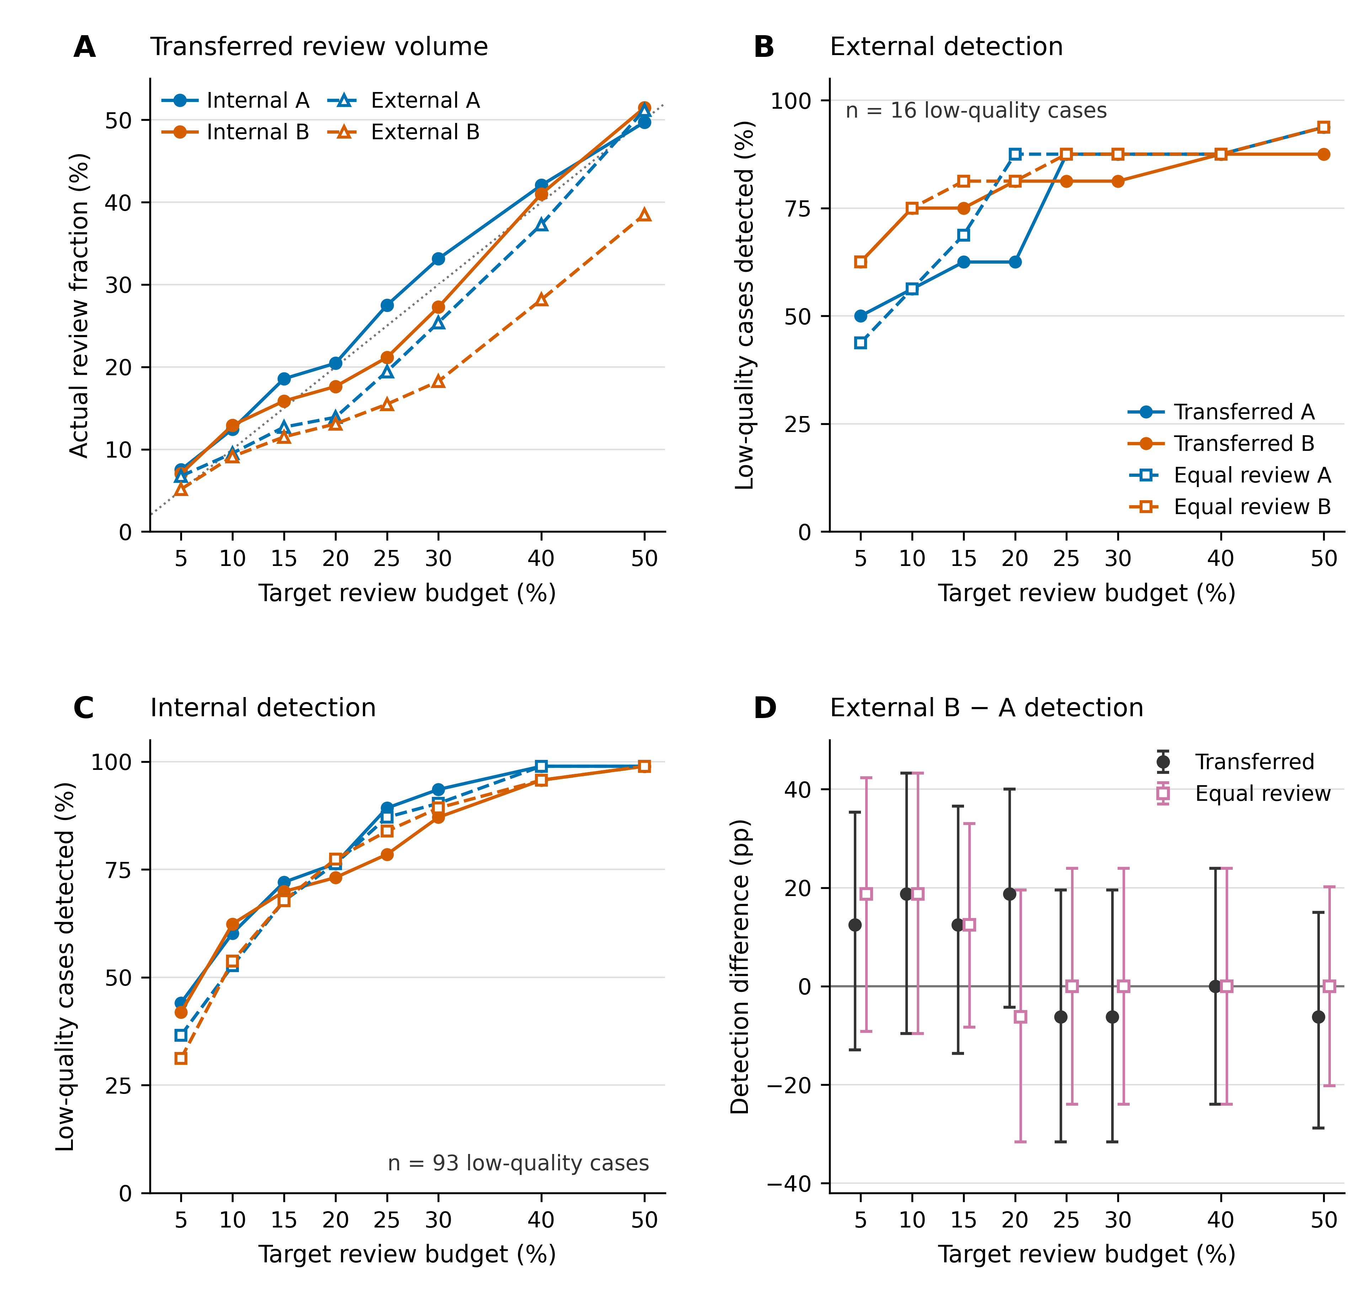
Figure S3. Complete review-budget scan. A shows actual review fractions after development-threshold transfer; B and C show external and internal low-quality detection under transferred cutoffs and equal-review ranking; D shows paired external B-minus-A detection differences. Each target was evaluated using both rules, with no selection of a favorable budget. External and internal low-quality denominators are 16 and 93. Error bars in D are nominal paired Newcombe 95 % intervals conditional on observed calibration and rankings; they do not incorporate recalibration or reranking uncertainty. Numerical values are in Table S10.

Post hoc calibration and sampling sensitivity
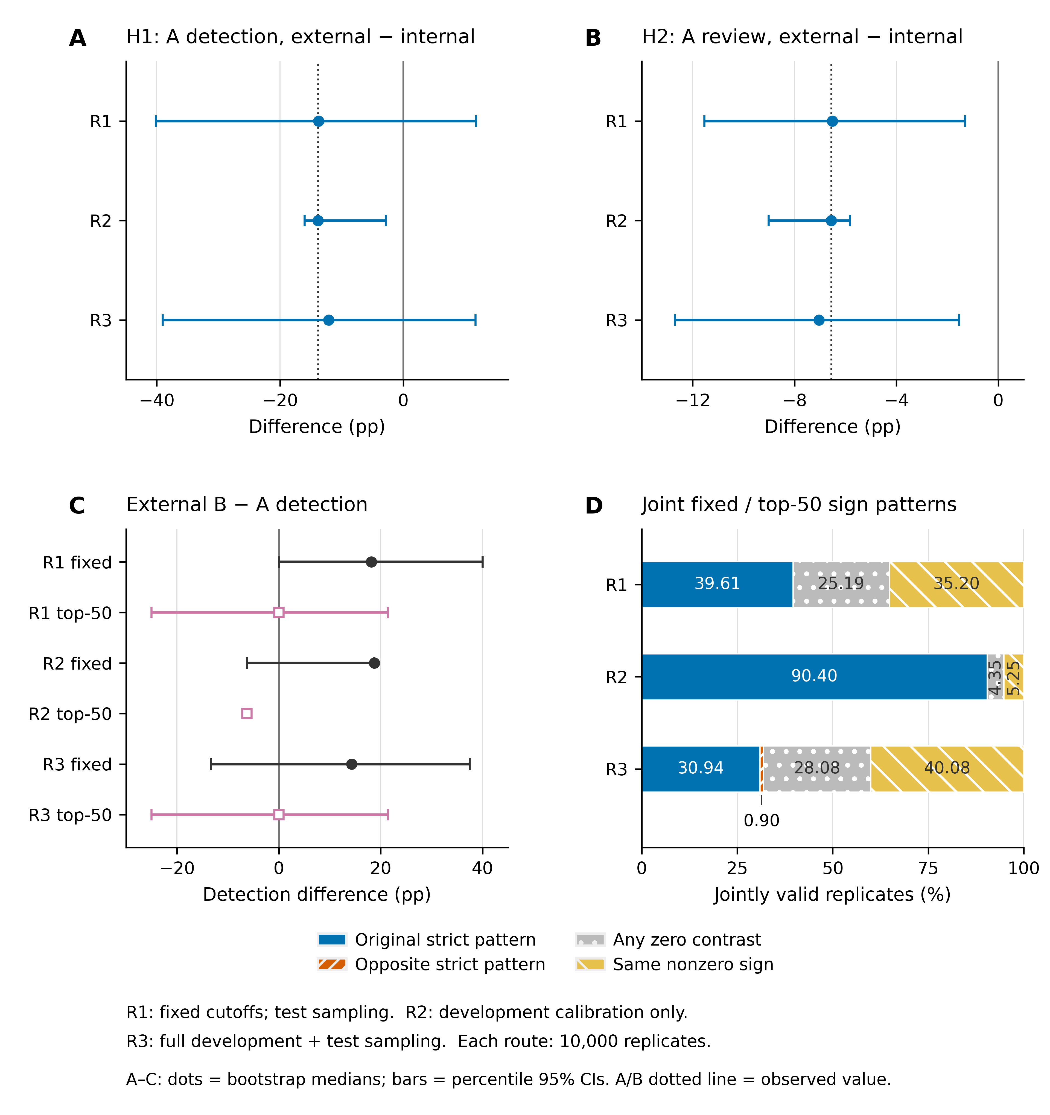
Figure S4. Patient-bootstrap sensitivity, 10,000 replicates per route. A and B show A external-minus-internal detection and review contrasts; C shows external B-minus-A detection under transferred cutoffs and equal-top50 ranking. Points and bars denote medians and descriptive percentile 95 % intervals, with original estimates identified separately. D shows the joint sign-pattern frequencies: original strict pattern (fixed>0/equal<0), opposite pattern, at least one zero contrast, or matching nonzero signs. Frequencies are empirical resampling summaries, not p-values or population probabilities. Test-only resampling cannot generate an unobserved A-only low-quality detection at the fixed cutoffs; its nonnegative support must not be used to exclude a population A advantage. The original H3 Newcombe interval is retained. Complete routes, denominators and the sign matrix are in Table S11.

Diagnostic composition accounting
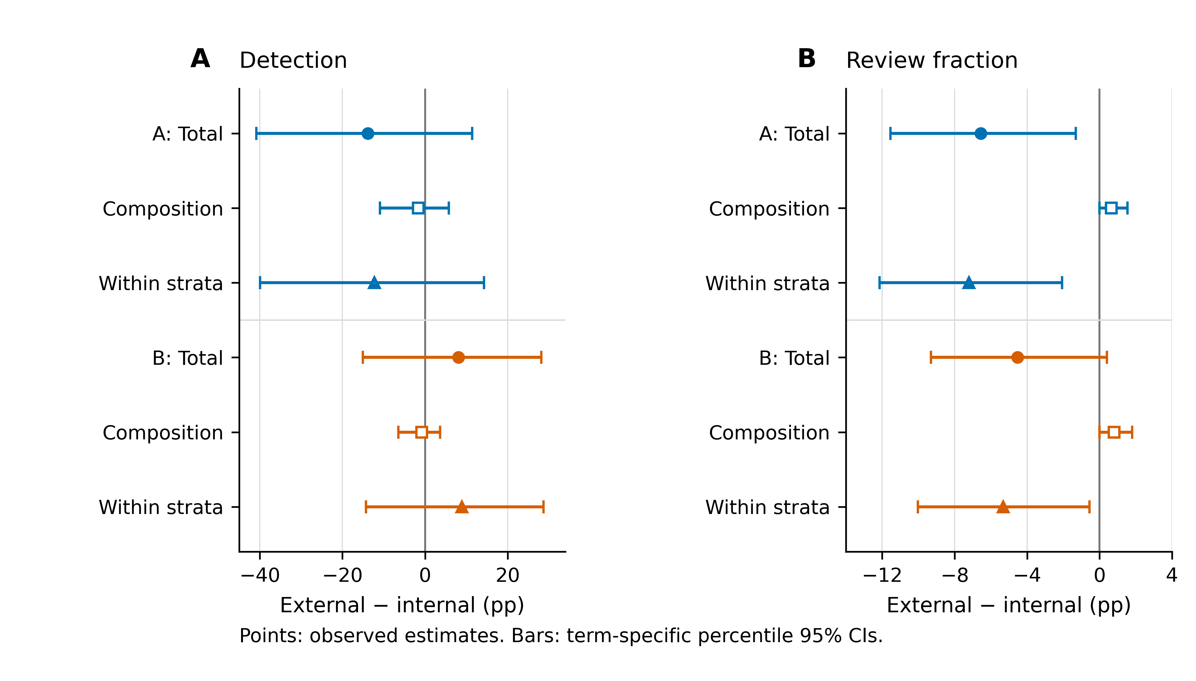
Figure S5. Symmetric Kitagawa accounting at the original locked cutoffs. A shows low-quality detection and B simulated review. Rows give the overall external-minus-internal difference and its composition-associated and within-stratum-rate terms for each score. Points show original estimates; bars show nominal percentile 95 % intervals from 5,000 patient-bootstrap draws. Detection components have 4,999 valid draws; overall differences and review components have 5,000. Detection weights describe diagnostic shares among low-quality cases; review weights describe shares among all patients. The within-stratum term equals the common-weight standardized difference. These are descriptive accounting terms, not causal effects. Values and rounding details are in Table S12.

Targeted CPU replay: shared misses
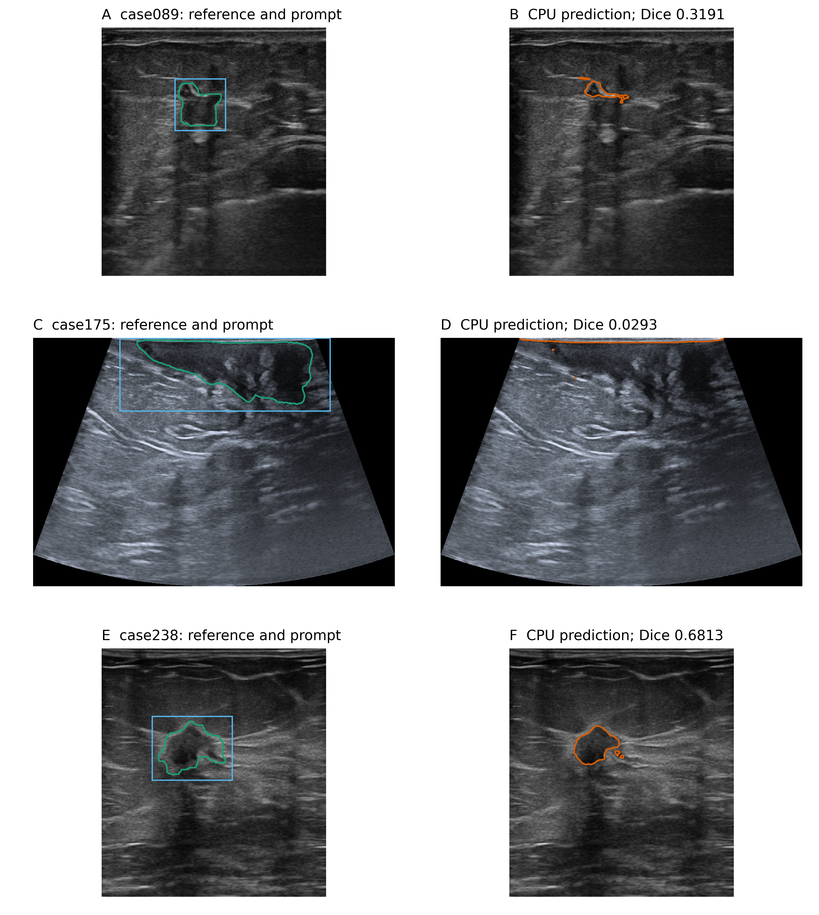
Figure S6 (A). Targeted CPU predictions for the three shared screening misses, case089, case175 and case238. Left panels show the original image with released reference (green) and initial reference-derived prompt (blue); right panels show the actual replay prediction (orange). Both A and B remain below their review cutoffs. The model checkpoint, source, float32 precision and prompt geometry match the frozen protocol. Dice labels are from the CPU replay. Table S13 reports environment details and summarizes the comparisons; all 48 full-precision values are supplied in S13_all_48_comparisons_unrounded.csv. Original scores are retained in Table S9.

Targeted CPU replay: B-only detections
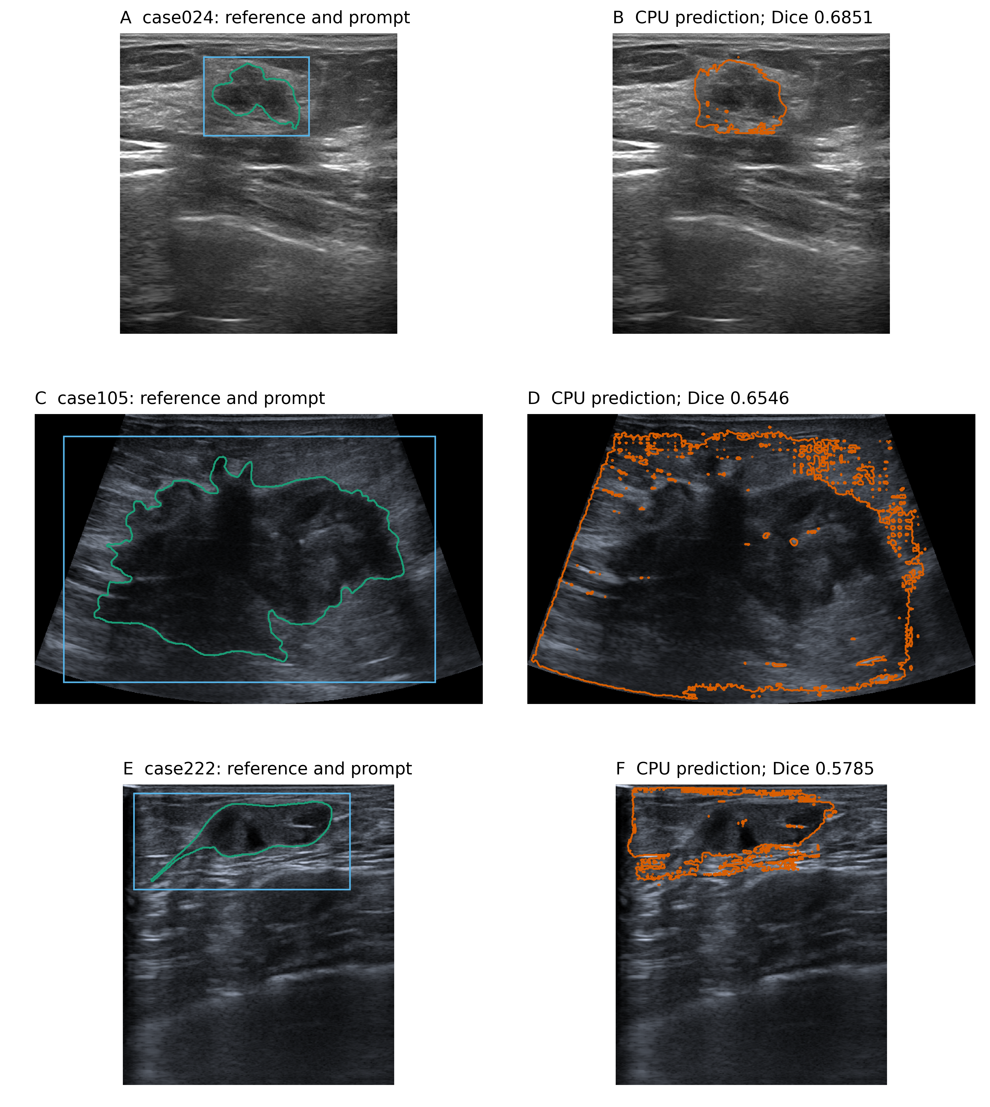
Figure S6 (B). Remaining A-missed low-quality cases, case024, case105 and case222, detected by B. Colors and panel layout follow part A. All 30 captured masks across the six patients are nonempty, and all quality labels and A/B review flags match the archive. The maximum initial-reference-Dice difference is 9.61 × 10−5; the maximum over all 48 fields is 0.00143543 (case105 left-shift consistency). These are new CPU arrays; original CUDA arrays were not saved, so cross-environment pixel identity cannot be verified. No new independent patients were introduced.

