Supplementary material for the breast ultrasound segmentation study
Transfer of fixed review thresholds for breast ultrasound segmentation quality control
Table S1. Locked thresholds and scoring settings
Setting | Value
Development budget | 20% target. Each method flagged 43/213 (20.19%) in development.
Locked risk threshold A | 0.13705134391784668
Locked risk threshold B | 0.06972856653991777
Review trigger | Risk score ≥ the corresponding locked threshold.
Fixed threshold ties | Include every case at the cutoff. If two cutoffs are equally close to the target, select the one with fewer reviews.
SAM source commit | dca509fe793f601edb92606367a655c15ac00fdf
Checkpoint SHA-256 | ec2df62732614e57411cdcf32a23ffdf28910380d03139ee0f4fcbe91eb8c912
Formal scoring environment | Python 3.8.20, PyTorch 2.4.1+cu118, torchvision 0.19.1+cu118, Pillow 10.4.0, NumPy 1.24.4.
SAM, Segment Anything Model. Inference used the official sam_vit_b_01ec64.pth checkpoint with float32 weights on a GeForce RTX 3060 Laptop GPU. Statistical replay used Python 3.12.14.

Sensitivity to the low quality definition
Table S2. Test performance at alternative reference Dice cutoffs
Dice  cutoff | Test cohort | Method | Detection,  n/N (%) | Simulated review,  n/N (%) | Misses, n | Misses per  100 patients
< 0.50 | BUS-BRA internal | A | 52/53 (98.11%) | 174/851 (20.45%) | 1 | 0.12
< 0.50 | BUS-BRA internal | B | 43/53 (81.13%) | 150/851 (17.63%) | 10 | 1.18
< 0.50 | BrEaST external | A | 5/7 (71.43%) | 35/252 (13.89%) | 2 | 0.79
< 0.50 | BrEaST external | B | 5/7 (71.43%) | 33/252 (13.10%) | 2 | 0.79
< 0.80 | BUS-BRA internal | A | 109/183 (59.56%) | 174/851 (20.45%) | 74 | 8.70
< 0.80 | BUS-BRA internal | B | 95/183 (51.91%) | 150/851 (17.63%) | 88 | 10.34
< 0.80 | BrEaST external | A | 21/50 (42.00%) | 35/252 (13.89%) | 29 | 11.51
< 0.80 | BrEaST external | B | 21/50 (42.00%) | 33/252 (13.10%) | 29 | 11.51
Both risk thresholds remained fixed. Detection uses the low-quality masks under the stated cutoff as its denominator. Simulated review and misses per 100 use all scored patients.

Detection rate contrasts
Table S3. Detection rate contrasts at alternative reference Dice cutoffs
Dice cutoff | Contrast | Difference, pp | Nominal 95% CI, pp
< 0.50 | Method A detection, external minus internal | −26.68 | [−62.25, −4.80]
< 0.50 | External detection, Method B minus Method A | 0.00 | [−27.14, +27.14]
< 0.80 | Method A detection, external minus internal | −17.56 | [−31.92, −2.01]
< 0.80 | External detection, Method B minus Method A | 0.00 | [−10.06, +10.06]
pp, percentage points. CI, confidence interval. Between-cohort contrasts use independent Newcombe intervals. Within-BrEaST contrasts use paired Newcombe intervals.
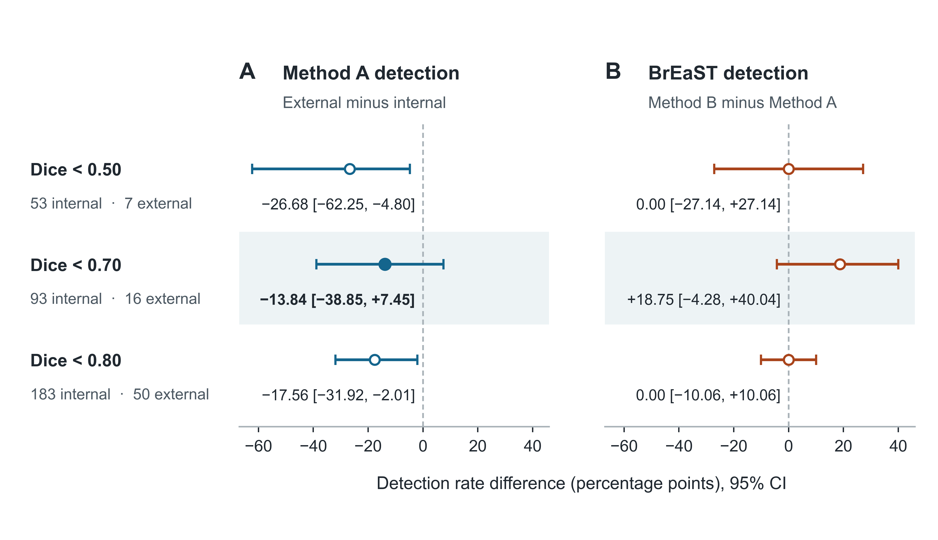
Figure S1. Sensitivity to the definition of low quality. Panel A shows the external-minus-internal detection difference for method A. Panel B shows the paired B-minus-A difference in BrEaST. Risk thresholds remain fixed while reference Dice cutoffs vary. The filled marker denotes H1 at Dice below 0.70. The remaining 95% confidence intervals are nominal.

Equal review volume in BrEaST
Table S4. BrEaST performance at equal review volume
Method | Detection,  n/N (%) | Simulated review,  n/N (%) | Misses, n | Misses per  100 patients
A | 14/16 (87.50%) | 50/252 (19.84%) | 2 | 0.79
B | 13/16 (81.25%) | 50/252 (19.84%) | 3 | 1.19
Each method selected 50 of the 252 scored cases in descending risk order. Ties followed lexicographic case identifier order. Low quality used reference Dice below 0.70.
Among the 16 low-quality cases, both methods flagged 12, only A flagged 2, only B flagged 1, and neither flagged 1. The paired B-minus-A difference was −6.25 percentage points (nominal 95% confidence interval [−31.61, +19.57]). This interval is conditional on the observed rankings.
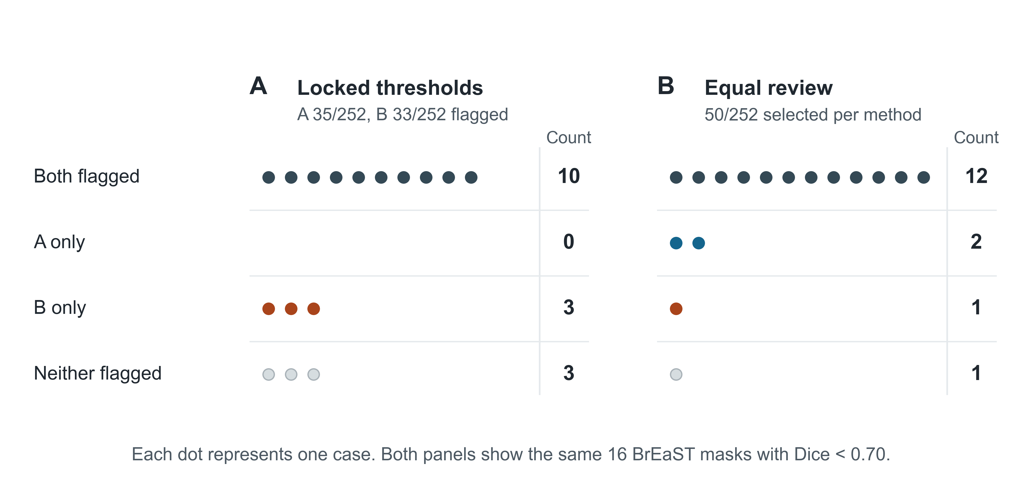
Figure S2. Paired outcomes among the 16 low-quality BrEaST masks. Each dot represents one low-quality case. Panel A uses the two locked thresholds. Panel B ranks each score separately and selects 50 of 252 patients per method. The right column in each panel reports the counts.

Computational reproducibility
Table S5. Agreement between the raw-image rerun and archived scores
Cohort | Compared /  expected | Maximum absolute  difference | Cases with  changed flags, n | Cases with  changed status, n
BUS-BRA development | 213/213 | 0 | 0 | 0
BUS-BRA internal | 851/851 | 0 | 0 | 0
BrEaST external | 252/252 | 0 | 0 | 0
The numerical comparison covered reference Dice, SAM predicted intersection over union, the two risk scores and the four shifted-mask Dice values. Flag and count comparisons included the quality label, both review flags, the empty-mask flag and the distinct-box count. Runtime was recorded separately.
Recomputing statistics from archived scores and rerunning inference from the original images both reproduced the locked thresholds, primary and supplementary results, and review-curve counts. The reproducibility package contains the case manifests, input hashes and per-cohort verification records.

