Transfer of fixed review thresholds for breast ultrasound segmentation quality control
Running title Fixed review thresholds in breast ultrasound
Authors and affiliations Haoze Lan [Confirm institutional affiliations and any additional authors]
Corresponding author [Confirm name, department, institution, postal address and email]

Abstract
Objectives To quantify how a fixed threshold for reviewing low-quality breast ultrasound segmentations performs on a second dataset and to compare two risk scores.
Methods We applied a frozen Segment Anything Model with box prompts derived from manual masks. Method A used predicted intersection over union and method B used mask disagreement after four box shifts. Each threshold targeted 20% simulated review in 213 BUS-BRA development cases and was applied unchanged to 851 BUS-BRA internal and 252 BrEaST external cases. Low quality was defined as a Dice coefficient below 0.70.
Results Method A flagged 71/93 (76.34%) low-quality masks internally and 10/16 (62.50%) externally, a difference of −13.84 percentage points (95% confidence interval −38.85 to 7.45). Its review fraction fell from 174/851 (20.45%) to 35/252 (13.89%). Externally, method B flagged 13/16 low-quality masks. At 50 reviews per method, A and B flagged 14 and 13, respectively.
Conclusions The fixed threshold for method A flagged a smaller fraction for review on the second dataset. The detection difference was imprecise, and the ordering of the two scores by detection depended on the review rule.
Keywords domain shift; external testing; prompt perturbation; selective prediction; vision foundation models

Introduction
The Segment Anything Model (SAM) can delineate an object from a spatial prompt, such as a box around a lesion [1]. Medical adaptations of SAM have evaluated box-prompted segmentation across several modalities, including breast ultrasound [2]. When a segmentation is used to support a measurement or other downstream analysis, a separate question is which outputs should be sent for review. A high overall Dice coefficient can coexist with a subset of masks that have poor agreement with a reference contour.
Case-level quality estimation without a new manual mask has been studied with reverse classification accuracy [3]. For promptable models, Kinalioglu used changes in mask structure under small prompt perturbations and combined them with model confidence for failure screening [4]. We examine a related operating question in breast ultrasound. If a service selects a risk-score threshold to review about one fifth of its development cases, the same numerical threshold may flag a different fraction and detect a different fraction of low-quality masks when applied to a second dataset.
We evaluated two scores for the same initial masks from a frozen SAM model. One score used the model's own estimate of mask overlap and the other used disagreement across four shifted box prompts. We selected a threshold for each score at a common development review target and assessed their transfer from BUS-BRA to BrEaST. The primary comparison was the change in low-quality mask detection with the model confidence score. Secondary analyses examined review workload and the paired comparison of the two scores on the external cases.

Materials and methods

Study design and datasets
This retrospective evaluation used anonymized images and manual lesion contours from two public breast ultrasound datasets. Reporting was informed by the Checklist for Artificial Intelligence in Medical Imaging (CLAIM) 2024 update [5]. The patient was the analysis unit, with one image and one primary reference mask per patient. Figure 1 shows the development, internal test and external test cohorts. Table 1 describes their composition.
BUS-BRA version 1.0 contains 1,875 images from 1,064 patients [6, 7]. We used a patient-level split stratified by benign or malignant lesion status to obtain 213 development and 851 internal test patients (seed 20261105). We selected one eligible image per patient using seed 20261106. The two cohorts had disjoint patient identifiers. We verified image and mask pairs and used the actual pixel dimensions when these differed from metadata. An initial 40-case feasibility run used a subset of development patients. The full development set supplied the formal thresholds.
The BrEaST version 1 archive includes 256 scans, each from a different patient [8, 9]. We matched the official image and main tumor mask by case identifier. Four normal cases lacked a primary lesion mask, leaving 252 external test patients. The primary reference was the provided main tumor contour. Fourteen additional masks were outside that reference definition. The audit found zero exact image matches between the datasets.
[Place Table 1 near here]

Prompted segmentation and risk scores
We used the official SAM ViT-B checkpoint (sam_vit_b_01ec64.pth) with frozen float32 weights and single-mask output [1]. The original source commit, checkpoint hash and software versions are recorded in Table S1. We decoded images to red, green and blue (RGB) channels. BrEaST images were alpha-composited over black before conversion to RGB. This changed the RGB pixel values of eight images relative to discarding the alpha channel. Reference masks were read as binary arrays.
We obtained the initial prompt box from the tight bounding box of the nonempty reference mask, expanded each horizontal side by 10% of the width and each vertical side by 10% of the height, and clipped the result to the image. This simulates a setting in which the lesion location is already supplied. We encoded the image once and used the resulting embedding for the initial prediction and four additional predictions (Figure 2).
Method A calculated risk as one minus the raw predicted intersection over union (IoU) returned for the initial mask. For method B, we shifted the initial clipped box left and right by 5% of its width and up and down by 5% of its height, clipping each shifted box to the image. We calculated the Dice coefficient between the initial predicted mask and each of the four shifted-prompt masks. Risk B was one minus the mean of these four Dice coefficients. We retained all four directions when clipping produced coincident boxes. Two empty predicted masks had a consistency Dice coefficient of 1.
For binary masks, the Dice coefficient is twice the number of shared foreground pixels divided by the sum of foreground pixels in the two masks. The quality reference for both methods was Dice between the initial prediction and the manual mask. An initial empty prediction against a nonempty reference contributed a Dice coefficient of 0. We defined low quality as reference Dice below 0.70, an operational cutoff for this evaluation.

Development threshold selection
For each method, we searched the distinct development risk scores and the option to flag zero cases. A case was flagged if its score met or exceeded the candidate threshold. The selected threshold gave the review fraction closest to 20%. Cases tied at the cutoff were flagged together. When two choices were equally close to the target, we selected the one with fewer flagged cases. The exact thresholds were locked before test scoring and applied to both test cohorts.

Outcomes and statistical analysis
The analysis included cases with a valid reference Dice and both finite risk scores. The procedure allowed one retry with the same configuration after a technical failure and recorded persistent failures separately. We report low-quality detection as the number of flagged low-quality masks divided by the number of low-quality masks. Simulated review is the number of flagged cases divided by all scored cases. Misses per 100 patients is 100 times the number of unflagged low-quality masks divided by all scored cases.
The dated analysis plan specified three contrasts. H1, the primary contrast, compared method A low-quality detection in BrEaST minus BUS-BRA internal testing. H2 used the same cohort order for method A simulated review. H3 assessed whether method B detected a larger fraction of the same low-quality BrEaST cases when the two cutoffs gave equal review counts in development. The paired contrast was B minus A. Differences are expressed in percentage points. We calculated two-sided 95% confidence intervals (CIs) using Newcombe score method 10 for independent proportions in H1 and H2 [10] and its paired counterpart in H3 [11]. H2, H3 and supplementary intervals are nominal, with no multiplicity adjustment.
We repeated the detection analysis with reference Dice cutoffs of 0.50 and 0.80 while retaining both locked risk thresholds. We also ranked the external cases by each risk score and selected the top 50 per method, the count closest to a 20% review fraction among 252 cases. We broke risk ties by lexicographic ordering of the official case identifiers. This equal-review comparison used a common number of reviews in the observed external cohort. Its paired interval is conditional on the observed rankings.

Computational reproducibility
We assessed computational reproducibility through two routes. We recomputed the statistical analyses directly from the archived case scores and reran the locked pipeline on all 1,316 study images in the same computing environment. We compared the new per-case Dice coefficients, predicted IoU, both risk scores, quality labels and review decisions with the original records. We also compared the recalculated calibration, statistical results and review-curve coordinates. Runtime was recorded separately.

Results

Cohort yield and development calibration
All 213 development, 851 internal test and 252 external test cases were scored. Low-quality masks occurred in 24/213 (11.27%) development cases, 93/851 (10.93%) internal cases and 16/252 (6.35%) external cases. Each method flagged 43/213 (20.19%) development cases. The locked thresholds were 0.13705134391784668 for A and 0.06972856653991777 for B.

Performance at the locked thresholds
For H1, method A flagged 71 of 93 low-quality masks in BUS-BRA internal testing (76.34%) and 10 of 16 in BrEaST (62.50%). The external-minus-internal difference was −13.84 percentage points (95% CI −38.85 to 7.45). The interval includes zero and is compatible with both a substantial decrease and a smaller increase in detection (Tables 2 and 3 and Figure 3).
[Place Tables 2 and 3 near here]
For H2, the method A simulated review fraction was 174/851 (20.45%) internally and 35/252 (13.89%) externally, a difference of −6.56 percentage points (nominal 95% CI −11.25 to −1.10). Among masks with reference Dice of at least 0.70, A flagged 103/758 (13.59%) internally and 25/236 (10.59%) externally. The overall rates of missed low-quality masks with A were 2.59 per 100 internal patients and 2.38 per 100 external patients.
For H3, method B flagged 13/16 (81.25%) low-quality BrEaST masks compared with 10/16 (62.50%) for A. Ten were flagged by both scores, three by B alone and three by neither. The paired difference was 18.75 percentage points (nominal 95% CI −4.28 to 40.04). B flagged 33/252 (13.10%) external cases and missed three low-quality masks. In the internal cohort, B flagged 150/851 (17.63%) cases, detected 68/93 (73.12%) low-quality masks and missed 25 (Table 2).

Sensitivity and equal-review comparisons
At reference Dice below 0.50, A detected 52/53 internal and 5/7 external low-quality masks, and B detected 43/53 and 5/7, respectively. At Dice below 0.80, the corresponding counts were 109/183 and 21/50 for A and 95/183 and 21/50 for B. With each alternative definition, A's external detection point estimate was lower than its internal estimate, and both methods had the same external detection count (Tables S2 and S3 and Figure S1).
At 50/252 reviews (19.84%) per method in BrEaST, A detected 14/16 (87.50%) and B detected 13/16 (81.25%) low-quality masks. The paired B-minus-A difference was −6.25 percentage points (nominal 95% CI −31.61 to 19.57). The order of the two detection point estimates differed between the locked-threshold and equal-review settings (Figure 4 and Table S4). Figure S2 shows the paired detections and misses in both settings.

Reproducibility checks
The raw-image rerun scored all 1,316 cases. Across the three cohorts, the maximum absolute difference was zero for each of the eight numerical fields compared. The quality and review decisions matched for every case (Table S5). Both routes reproduced the development thresholds, primary and supplementary statistics, and the count-level coordinates of the review curves.

Discussion

Transfer of the review threshold
The method A threshold selected near the 20% development review target flagged approximately one fifth of the internal cohort and approximately one seventh of BrEaST. The primary estimate for external detection was lower, but the confidence interval was wide with only 16 low-quality external masks. These results give different levels of precision for the two operational questions. The simulated review fraction was estimated from all 252 external patients, while detection was estimated from the 16 whose masks fell below the quality cutoff.
The review fraction depends on the mix of low-quality and acceptable masks and on how often each group is flagged. BrEaST had both a smaller low-quality fraction and a smaller flagged fraction among acceptable masks for A. Misses per 100 patients similarly depend on the frequency of low-quality masks. This explains how the external point estimate for A detection could decrease while the number of misses per 100 patients remained close to the internal estimate. The dataset comparison combines differences in case mix, image acquisition and reference annotations, and cannot identify their separate effects.

What prompt disagreement adds
In the locked external evaluation, the disagreement score flagged three low-quality masks missed by the confidence score. The paired interval leaves the size and direction of the underlying difference uncertain. At the same external review volume, the point estimate favored A, and the two alternative quality cutoffs yielded equal external detection counts. The observed advantage of B at its locked threshold therefore depends on the evaluation rule and review volume.
The two scores capture different properties of the same mask. A uses the quality estimate returned with the initial prediction, while B measures stability to a specific set of box translations. A mask can be stable under those translations and still differ from the manual contour. Prior prompt-response work combined structural changes with confidence and reported ranking-based screening [4]. Here, keeping the two scores separate and freezing the development cutoffs allows detection, review volume and misses to be inspected together on the second dataset.

Limitations and implications
The reference contour supplied the localization box and the target for quality assessment. The findings apply to this known-location setup and may differ for reader-drawn or automatically generated boxes. Only one SAM checkpoint, one image per patient and one external dataset were evaluated. Image-level overlap between the evaluation archives and the model's SA-1B pretraining corpus could not be determined from public records [1]. The small number of external low-quality masks limits precision, particularly for the paired comparison.
The Dice cutoff defines agreement with the released contours. A clinical standard for acceptable boundary error would require separate justification. Simulated review is a count of flags. Reader time, the success of mask correction and effects on downstream measurement would require evaluation with readers. Future testing should estimate workload and low-quality detection jointly under independently supplied prompts and across additional datasets.
For these two cohorts, a threshold selected near the target review volume in development transferred to a different review fraction on BrEaST. The external detection difference remained uncertain. Reporting fixed operating points alongside equal-review comparisons clarifies what a transferred threshold and a case ranking each contribute to quality control.

Declarations
Research ethics and informed consent. [Confirm the institutional determination for this retrospective secondary analysis and insert the applicable ethics and consent statements.]
Author contributions, funding and conflicts of interest. [Complete the separate BMT declaration form with confirmed author contributions, funding, conflicts and any acknowledgments.]
Data and code availability. BUS-BRA version 1.0 and BrEaST version 1 are publicly available from their original repositories [7, 9]. A reproducibility package contains the locked case manifests, derived scores, scoring and analysis scripts, and verification report. [Confirm the access route and any conditions for the study-derived materials and code.]
Use of AI tools. OpenAI Codex assisted with research code, figure preparation and drafting. Editorial drafting followed the Scientific Writing workflow in the Scientific Agent Skills library [12]. [Confirm author review and approval of the disclosure.]

References
1. Kirillov A, Mintun E, Ravi N, Mao H, Rolland C, Gustafson L, et al. Segment anything. In Proceedings of the IEEE/CVF International Conference on Computer Vision, Paris, France. IEEE, 2023. pp. 3992–4003. https://doi.org/10.1109/ICCV51070.2023.00371
2. Ma J, He Y, Li F, Han L, You C, Wang B. Segment anything in medical images. Nat Commun 2024;15:654. https://doi.org/10.1038/s41467-024-44824-z
3. Valindria VV, Lavdas I, Bai W, Kamnitsas K, Aboagye EO, Rockall AG, et al. Reverse classification accuracy: predicting segmentation performance in the absence of ground truth. IEEE Trans Med Imaging 2017;36:1597–1606. https://doi.org/10.1109/TMI.2017.2665165
4. Kinalioglu IH. Structural prompt-response consistency for label-free failure screening in promptable medical segmentation. Pattern Recognit Lett 2026;209:60–64. https://doi.org/10.1016/j.patrec.2026.08.026
5. Tejani AS, Klontzas ME, Gatti AA, Mongan JT, Moy L, Park SH, et al. Checklist for artificial intelligence in medical imaging (CLAIM): 2024 update. Radiol Artif Intell 2024;6:e240300. https://doi.org/10.1148/ryai.240300
6. Gómez-Flores W, Gregorio-Calas MJ, Pereira WCA. BUS-BRA: A breast ultrasound dataset for assessing computer-aided diagnosis systems. Med Phys 2024;51:3110–3123. https://doi.org/10.1002/mp.16812
7. Gómez-Flores W, Gregorio-Calas MJ, Pereira WCA. BUS-BRA: A breast ultrasound dataset for assessing computer-aided diagnosis systems. Version 1.0 [dataset]. Zenodo, 2023. https://doi.org/10.5281/zenodo.8231412
8. Pawłowska A, Ćwierz-Pieńkowska A, Domalik A, Jaguś D, Kasprzak P, Matkowski R, et al. Curated benchmark dataset for ultrasound based breast lesion analysis. Sci Data 2024;11:148. https://doi.org/10.1038/s41597-024-02984-z
9. Pawłowska A, Ćwierz-Pieńkowska A, Domalik A, Jaguś D, Kasprzak P, Matkowski R, et al. A curated benchmark dataset for ultrasound based breast lesion analysis (Breast-Lesions-USG). Version 1 [dataset]. The Cancer Imaging Archive, 2024. https://doi.org/10.7937/9WKK-Q141
10. Newcombe RG. Interval estimation for the difference between independent proportions: comparison of eleven methods. Stat Med 1998;17:873–890.
11. Newcombe RG. Improved confidence intervals for the difference between binomial proportions based on paired data. Stat Med 1998;17:2635–2650.
12. Kassis T, Agarwal V, He Y, Patel D, Brueckner AM. Scientific agent skills: a library of procedural knowledge for research agents. arXiv 2026. https://doi.org/10.48550/arXiv.2609.00065

Tables
Table 1. Study cohorts
Cohort | Patients, n | Benign, n | Malignant, n | Low-quality masks, n/N (%)
BUS-BRA development | 213 | 145 | 68 | 24/213 (11.27%)
BUS-BRA internal | 851 | 577 | 274 | 93/851 (10.93%)
BrEaST external | 252 | 154 | 98 | 16/252 (6.35%)
One image was selected per patient. Low-quality masks had a reference Dice coefficient below 0.70.
Table 2. Test performance at the locked review thresholds
Test cohort | Method | Detection,  n/N (%) | Simulated review,  n/N (%) | Misses, n | Misses per  100 patients
BUS-BRA internal | A | 71/93 (76.34%) | 174/851 (20.45%) | 22 | 2.59
BUS-BRA internal | B | 68/93 (73.12%) | 150/851 (17.63%) | 25 | 2.94
BrEaST external | A | 10/16 (62.50%) | 35/252 (13.89%) | 6 | 2.38
BrEaST external | B | 13/16 (81.25%) | 33/252 (13.10%) | 3 | 1.19
Detection uses low-quality masks as its denominator. Simulated review and misses per 100 use all scored patients in each cohort.
Table 3. Planned contrasts at the locked review thresholds
Analysis | Contrast | Difference, pp | 95% CI, pp
H1 (primary) | Method A detection, external minus internal | −13.84 | [−38.85, +7.45]
H2 (secondary) | Method A simulated review, external minus internal | −6.56 | [−11.25, −1.10]
H3 (secondary) | External detection, Method B minus Method A | +18.75 | [−4.28, +40.04]
pp, percentage points. CI, confidence interval. H1 and H2 use independent Newcombe intervals. H3 uses a paired interval in the 16 low-quality BrEaST cases. H2 and H3 intervals are nominal.

Figures and legends
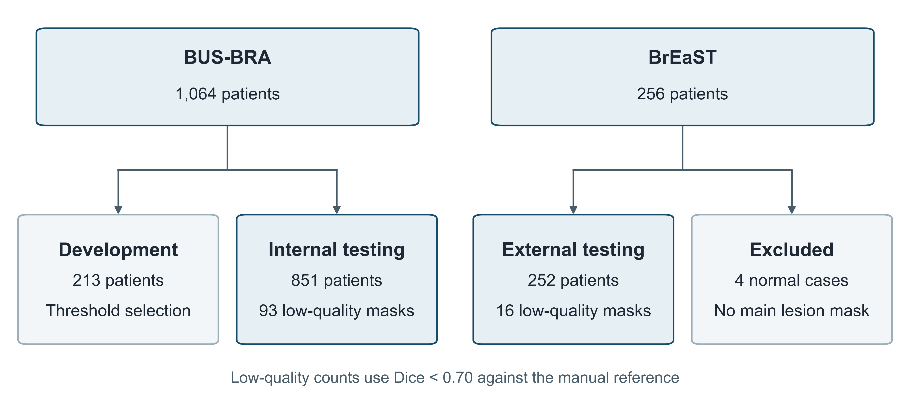
Figure 1. Study cohorts and analysis flow. BUS-BRA patients were assigned to development or internal testing. BrEaST contributed external test patients with a primary lesion mask. Each patient contributed one image. Low-quality masks had a reference Dice coefficient below 0.70.
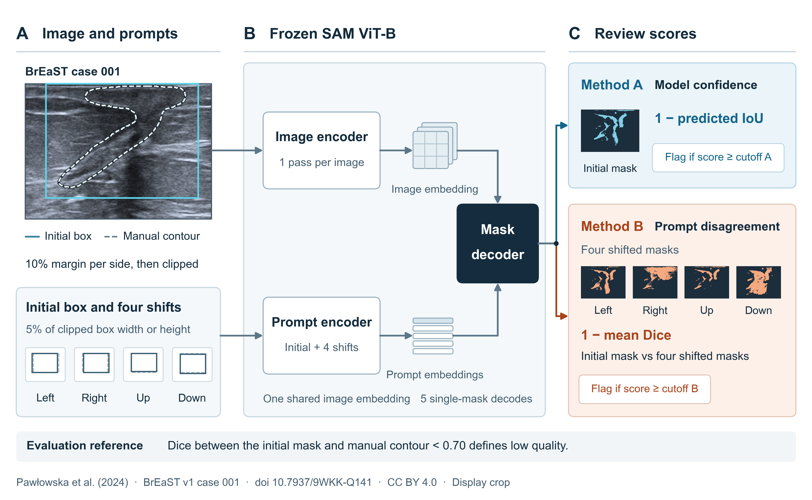
Figure 2. Review scores for prompted breast ultrasound segmentation. (A) The initial box is derived from the manual contour with a 10% margin per side and clipped to the image. Four further prompts shift the clipped box by 5% of its width or height. (B) Frozen Segment Anything Model (SAM) ViT-B reuses one image embedding to generate one mask per prompt. (C) Method A uses one minus predicted intersection over union for the initial mask. Method B uses one minus the mean Dice between the initial and four shifted masks. Each score triggers simulated review at or above its locked cutoff. The image and masks share a display crop from BrEaST case 001 [9].

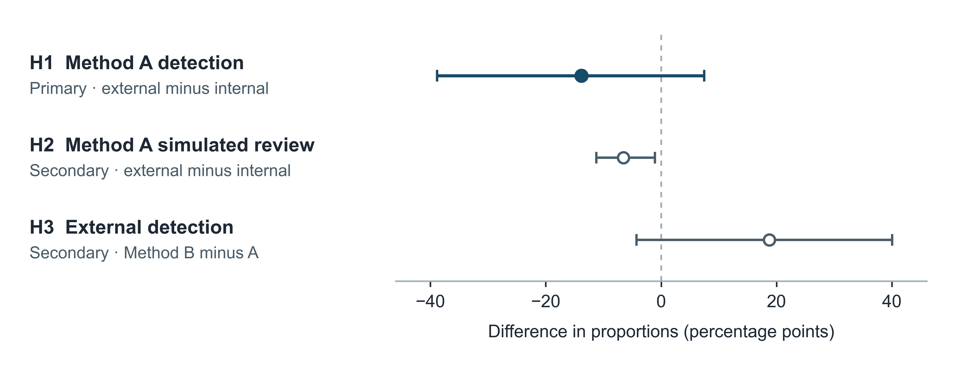
Figure 3. Planned differences at the locked thresholds. Points show differences in proportions and horizontal bars show two-sided 95% Newcombe confidence intervals. H1 and H2 compare BrEaST minus BUS-BRA internal testing. H3 compares B minus A in the same 16 low-quality BrEaST cases. H2 and H3 intervals are nominal. The dashed line marks zero difference.
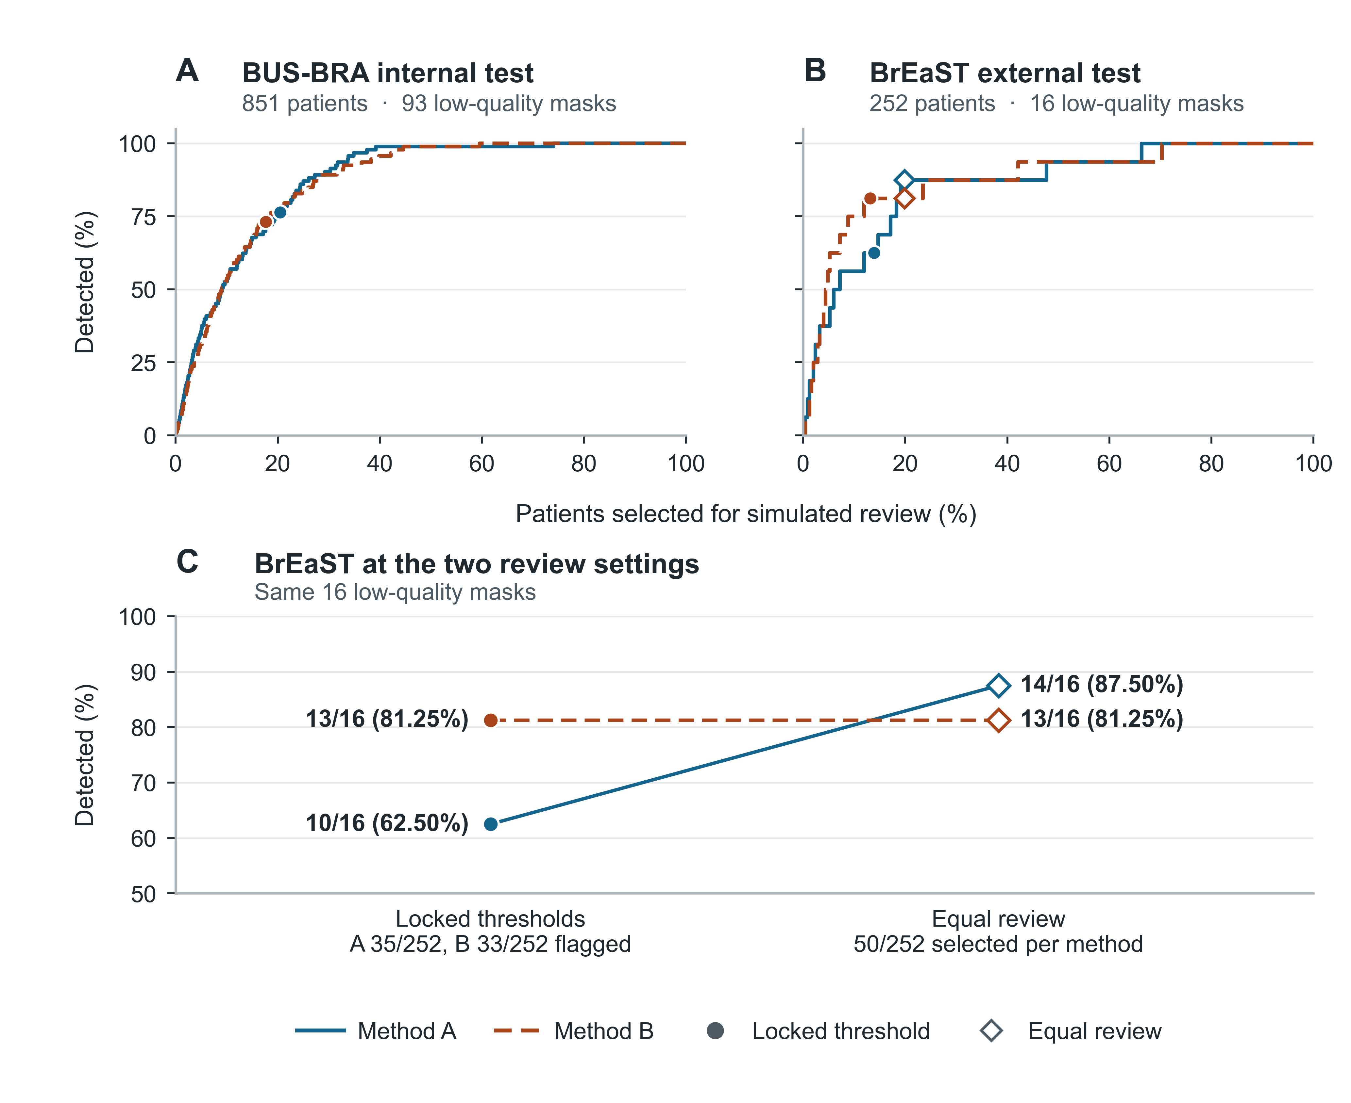
Figure 4. Low-quality mask detection by simulated review volume. Panels A and B show the percentage of low-quality masks detected as progressively more patients are selected in descending risk order in each test cohort. Markers identify the locked thresholds and the equal-review setting. Panel C compares detection in the same 16 low-quality external cases at the locked thresholds and at 50 reviews per method.

