Supplementary material for the breast ultrasound segmentation study
Fixed-threshold transfer and equal-review ranking in breast ultrasound segmentation quality control
Haoze Lan; Ziyuan Zhu
Table S1. Locked thresholds and scoring settings
Setting | Value
Development budget | 20 % target. Each method flagged 43/213 (20.19 %) in development.
Locked risk threshold A | 0.13705134391784668
Locked risk threshold B | 0.06972856653991777
Review trigger | Risk score ≥ the corresponding locked threshold.
Fixed threshold ties | Include every case at the cutoff. If two cutoffs are equally close to the target, select the one with fewer reviews.
SAM source commit | dca509fe793f601edb92606367a655c15ac00fdf
Checkpoint SHA-256 | ec2df62732614e57411cdcf32a23ffdf28910380d03139ee0f4fcbe91eb8c912
Formal scoring environment | Python 3.8.20, PyTorch 2.4.1+cu118, torchvision 0.19.1+cu118, Pillow 10.4.0, NumPy 1.24.4.
SAM, Segment Anything Model. Inference used the official sam_vit_b_01ec64.pth checkpoint with float32 weights on a GeForce RTX 3060 Laptop GPU. Statistical replay used Python 3.12.14.
Sensitivity to the low quality definition
Table S2. Test performance at alternative reference Dice cutoffs
Dice  cutoff | Test cohort | Method | Detection,  n/N (%) | Simulated review,  n/N (%) | Misses, n | Misses per  100 patients
< 0.50 | BUS-BRA internal | A | 52/53 (98.11 %) | 174/851 (20.45 %) | 1 | 0.12
< 0.50 | BUS-BRA internal | B | 43/53 (81.13 %) | 150/851 (17.63 %) | 10 | 1.18
< 0.50 | BrEaST external | A | 5/7 (71.43 %) | 35/252 (13.89 %) | 2 | 0.79
< 0.50 | BrEaST external | B | 5/7 (71.43 %) | 33/252 (13.10 %) | 2 | 0.79
< 0.80 | BUS-BRA internal | A | 109/183 (59.56 %) | 174/851 (20.45 %) | 74 | 8.70
< 0.80 | BUS-BRA internal | B | 95/183 (51.91 %) | 150/851 (17.63 %) | 88 | 10.34
< 0.80 | BrEaST external | A | 21/50 (42.00 %) | 35/252 (13.89 %) | 29 | 11.51
< 0.80 | BrEaST external | B | 21/50 (42.00 %) | 33/252 (13.10 %) | 29 | 11.51
Both risk thresholds remained fixed. Detection uses the low-quality masks under the stated cutoff as its denominator. Simulated review and misses per 100 use all scored patients.
Detection rate contrasts
Table S3. Detection rate contrasts at alternative reference Dice cutoffs
Dice cutoff | Contrast | Difference, pp | Nominal 95 % CI, pp
< 0.50 | Method A detection, external minus internal | −26.68 | [−62.25, −4.80]
< 0.50 | External detection, Method B minus Method A | 0.00 | [−27.14, +27.14]
< 0.80 | Method A detection, external minus internal | −17.56 | [−31.92, −2.01]
< 0.80 | External detection, Method B minus Method A | 0.00 | [−10.06, +10.06]
pp, percentage points. CI, confidence interval. Between-cohort contrasts use independent Newcombe intervals. Within-BrEaST contrasts use paired Newcombe intervals.
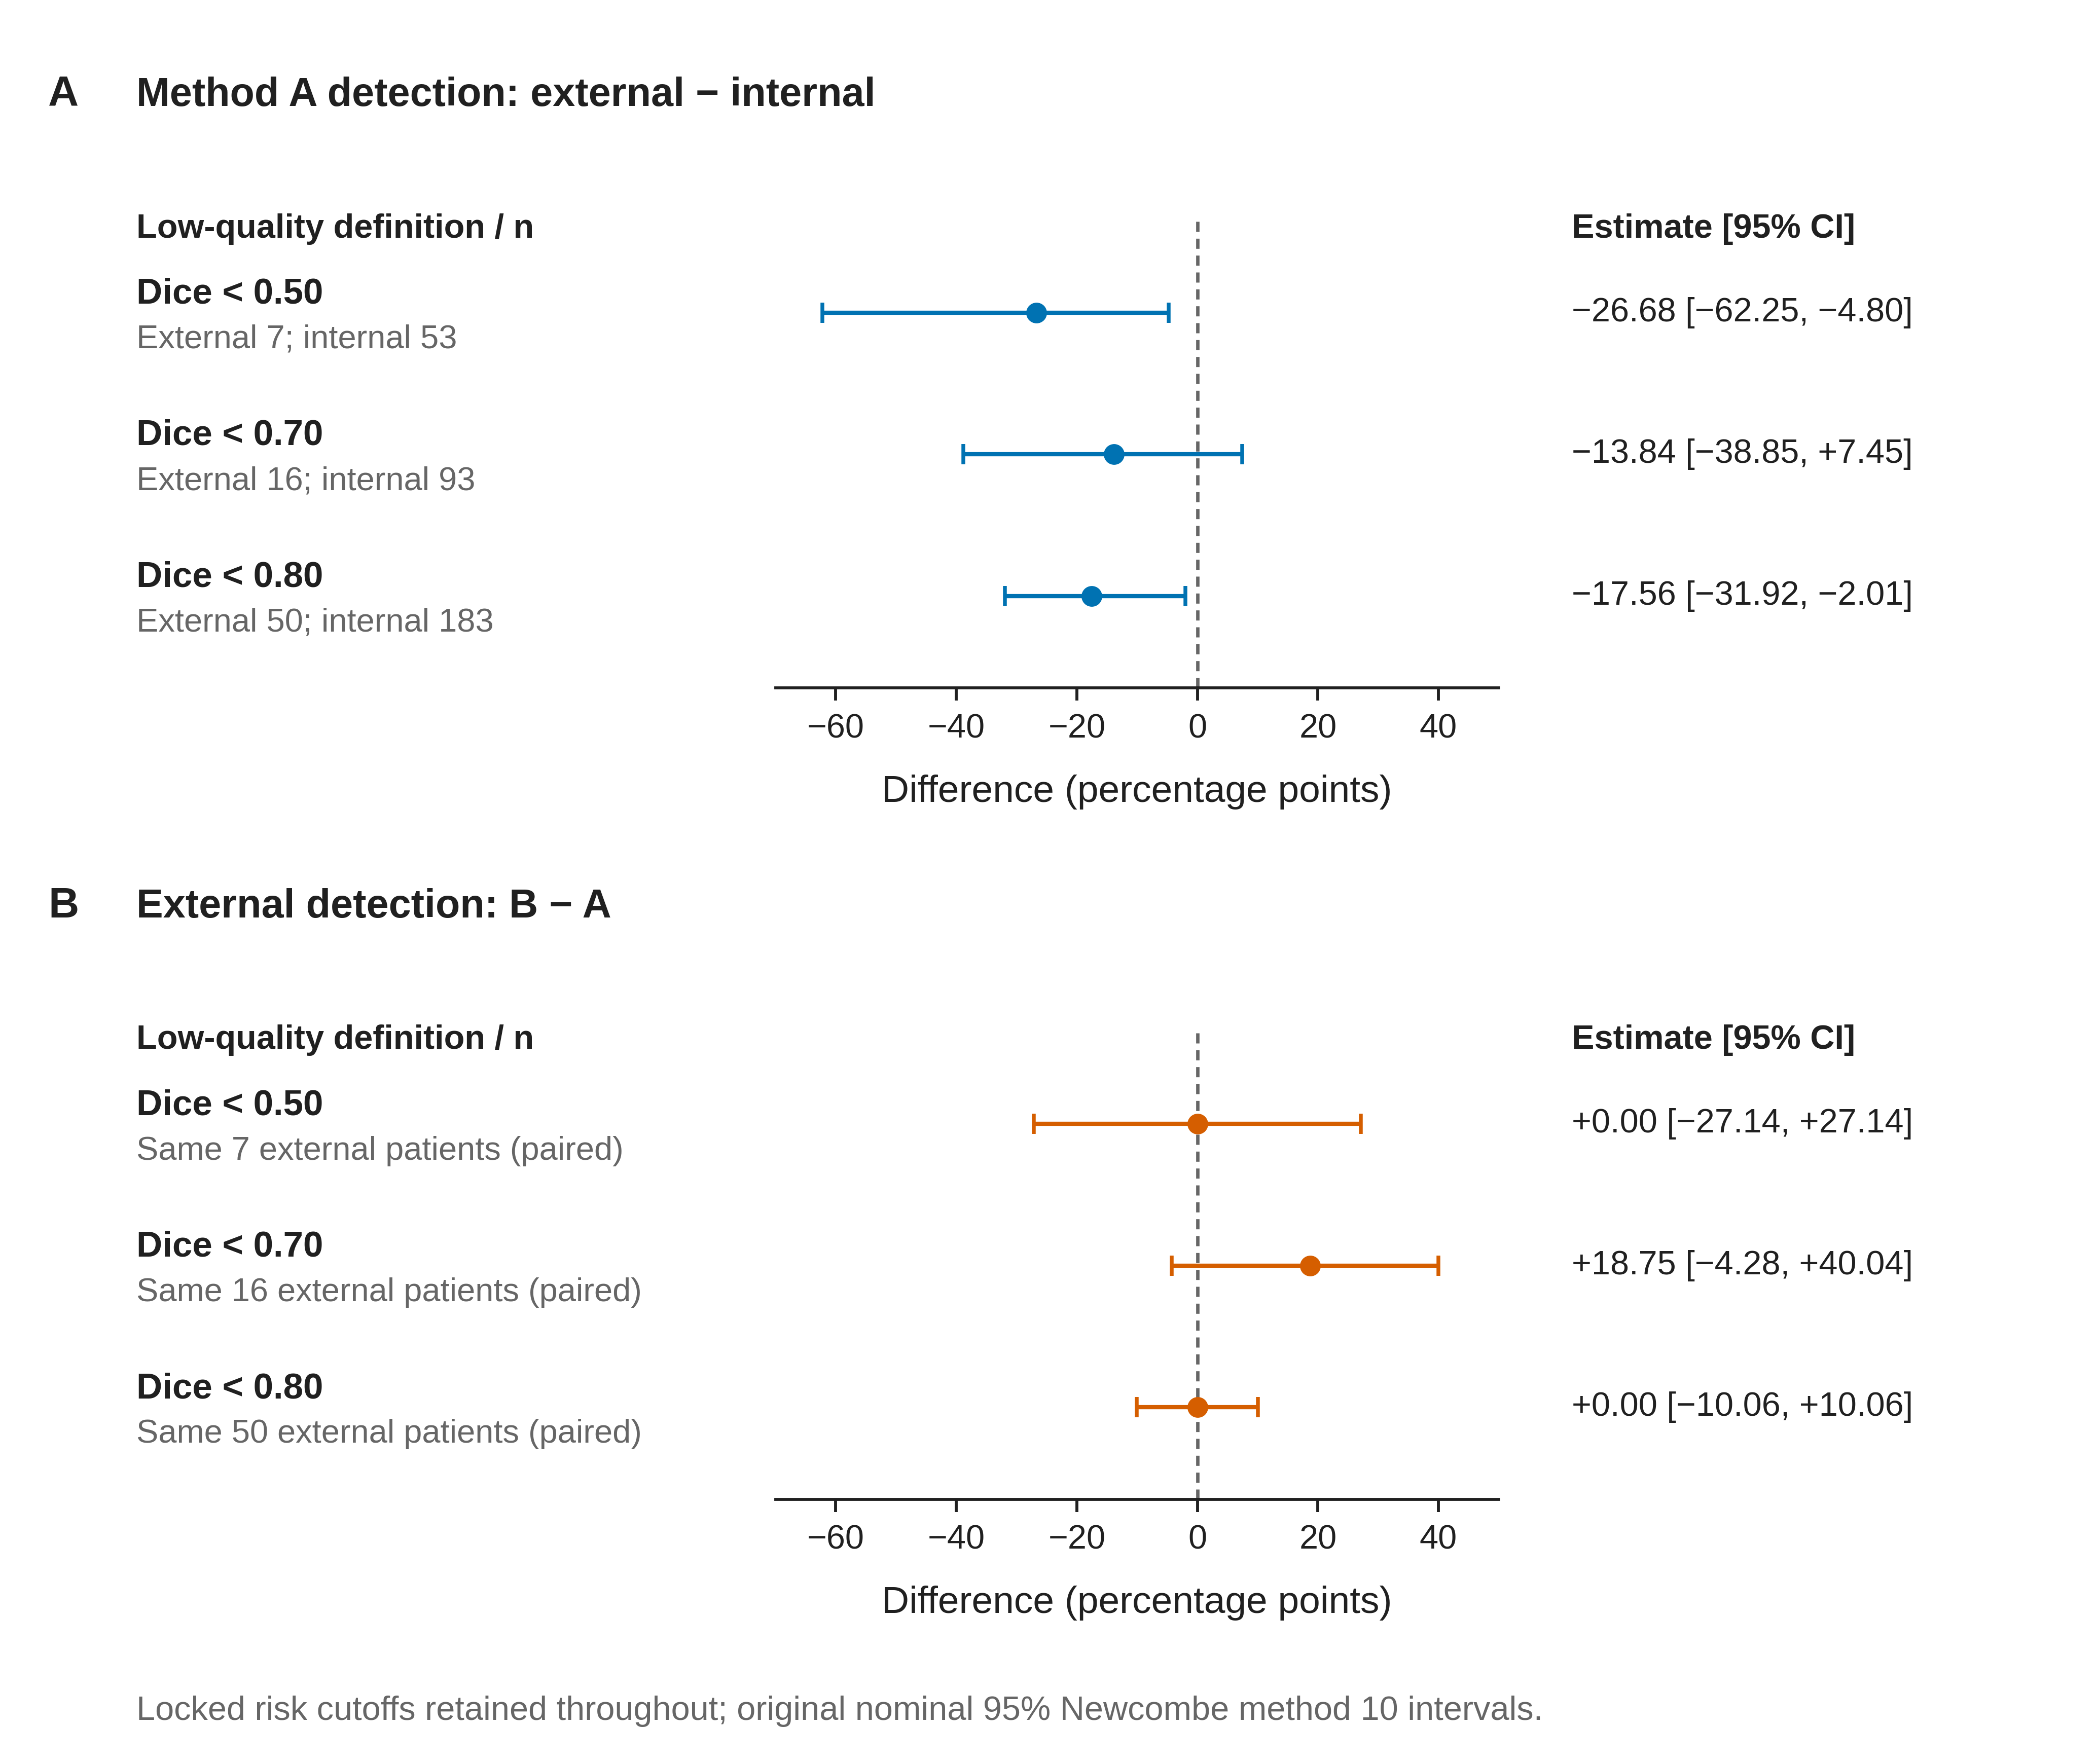
Figure S1. Sensitivity to the Dice definition of low quality with development-locked risk cutoffs unchanged. Panel A shows Method A detection in the BrEaST external test minus BUS-BRA internal holdout. Panel B shows paired Method B minus Method A detection in BrEaST. Low-quality denominators for Dice <0.50, <0.70, and <0.80 are 53, 93, and 183 internally and 7, 16, and 50 externally. Points show the original differences in percentage points and bars the original nominal two-sided 95 % Newcombe method 10 confidence intervals. No interval was replaced by a bootstrap interval.
Equal review volume in BrEaST
Table S4. BrEaST performance at equal review volume
Method | Detection,  n/N (%) | Simulated review,  n/N (%) | Misses, n | Misses per  100 patients
A | 14/16 (87.50 %) | 50/252 (19.84 %) | 2 | 0.79
B | 13/16 (81.25 %) | 50/252 (19.84 %) | 3 | 1.19
Each method selected 50 of the 252 scored cases in descending risk order. Ties followed lexicographic case identifier order. Low quality used reference Dice below 0.70.
Among the 16 low-quality cases, both methods flagged 12, only A flagged 2, only B flagged 1, and neither flagged 1. The paired B-minus-A difference was −6.25 percentage points (nominal 95 % confidence interval [−31.61, +19.57]). This interval is conditional on the observed rankings.
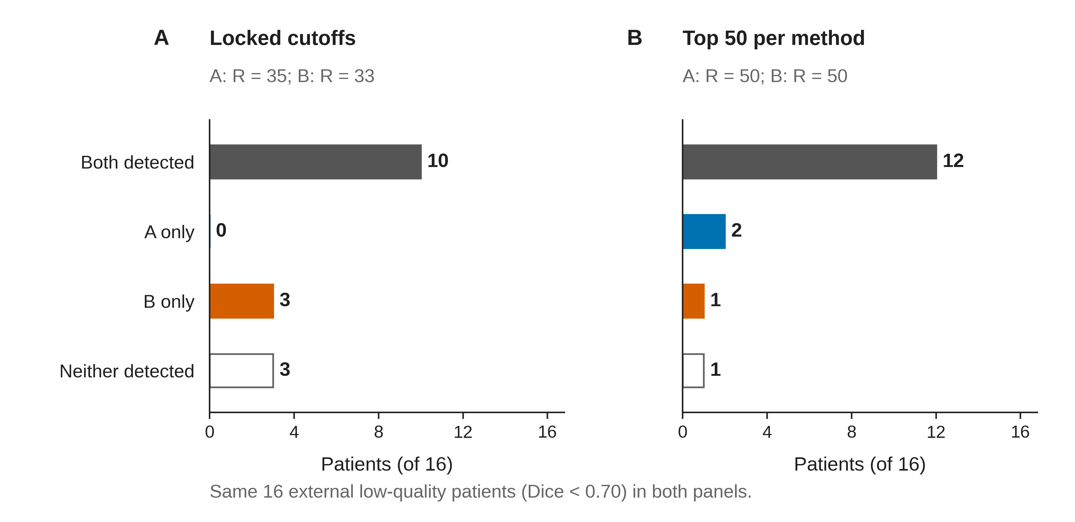
Figure S2. Paired detection outcomes for the same 16 BrEaST external low-quality patients (Dice <0.70), under two review policies. Panel A uses development-locked cutoffs: both methods detect 10 patients, Method A only 0, Method B only 3, and neither 3; the corresponding review counts are 35/252 for A and 33/252 for B. Panel B uses the top 50 ranked patients per method: both detect 12, A only 2, B only 1, and neither 1. The four mutually exclusive outcome categories sum to 16 under each policy. The locked-cutoff A-only cell has zero observed support.
Computational reproducibility
Table S5. Agreement between the raw-image rerun and archived scores
Cohort | Compared /  expected | Maximum absolute  difference | Cases with  changed flags, n | Cases with  changed status, n
BUS-BRA development | 213/213 | 0 | 0 | 0
BUS-BRA internal | 851/851 | 0 | 0 | 0
BrEaST external | 252/252 | 0 | 0 | 0
The numerical comparison covered reference Dice, SAM predicted intersection over union, the two risk scores and the four shifted-mask Dice values. Flag and count comparisons included the quality label, both review flags, the empty-mask flag and the distinct-box count. Runtime was recorded separately.
Recomputing statistics from archived scores and rerunning inference from the original images both reproduced the locked thresholds, primary and supplementary results, and review-curve counts. The reproducibility package contains the case manifests, input hashes and per-cohort verification records.
Revision audit provenance. Archived-score replay and the original same-environment full-cohort image rerun remain distinct from the six-case CPU replay reported in Table S13. The latter was actually executed for this revision, saved new prediction arrays and retained the original scores for every cohort analysis. Computational reproducibility is distinct from independent validation.
Additional descriptive quality-control measures
These post hoc descriptive analyses use the unchanged locked risk thresholds and the primary reference Dice cutoff of 0.70. The positive condition is a low-quality segmentation; the positive test is a review flag. These are mask-quality screening measures, not breast-cancer diagnostic measures. Development results describe calibration data and are not independent test performance.
Table S6. Classification counts at the primary quality cutoff
Cohort | Score | TP, n | FP, n | TN, n | FN, n
BUS-BRA development | A | 19 | 24 | 165 | 5
BUS-BRA development | B | 17 | 26 | 163 | 7
BUS-BRA internal | A | 71 | 103 | 655 | 22
BUS-BRA internal | B | 68 | 82 | 676 | 25
BrEaST external | A | 10 | 25 | 211 | 6
BrEaST external | B | 13 | 20 | 216 | 3
TP, true positive (flagged low quality); FP, false positive (flagged quality-acceptable); TN, true negative (unflagged quality-acceptable); FN, false negative (unflagged low quality); n, number of patients. A, model-confidence risk; B, prompt-disagreement risk.
Table S7. Sensitivity, specificity and predictive values
Cohort | Score | Sensitivity | Specificity | PPV | NPV
BUS-BRA development | A | 19/24 (79.17 %)  [59.53, 90.76] | 165/189 (87.30 %)  [81.80, 91.32] | 19/43 (44.19 %)  [30.43, 58.89] | 165/170 (97.06 %)  [93.30, 98.74]
BUS-BRA development | B | 17/24 (70.83 %)  [50.83, 85.09] | 163/189 (86.24 %)  [80.61, 90.44] | 17/43 (39.53 %)  [26.37, 54.42] | 163/170 (95.88 %)  [91.75, 97.99]
BUS-BRA internal | A | 71/93 (76.34 %)  [66.77, 83.83] | 655/758 (86.41 %)  [83.79, 88.67] | 71/174 (40.80 %)  [33.78, 48.23] | 655/677 (96.75 %)  [95.13, 97.84]
BUS-BRA internal | B | 68/93 (73.12 %)  [63.32, 81.08] | 676/758 (89.18 %)  [86.77, 91.20] | 68/150 (45.33 %)  [37.58, 53.32] | 676/701 (96.43 %)  [94.79, 97.57]
BrEaST external | A | 10/16 (62.50 %)  [38.64, 81.52] | 211/236 (89.41 %)  [84.83, 92.72] | 10/35 (28.57 %)  [16.33, 45.05] | 211/217 (97.24 %)  [94.10, 98.73]
BrEaST external | B | 13/16 (81.25 %)  [56.99, 93.41] | 216/236 (91.53 %)  [87.27, 94.45] | 13/33 (39.39 %)  [24.68, 56.32] | 216/219 (98.63 %)  [96.05, 99.53]
Entries show n/N (%), followed by Wilson 95 % confidence intervals in percent. PPV, positive predictive value; NPV, negative predictive value. Sensitivity equals the low-quality detection measure used in the prespecified analysis. Predictive values depend on the frequency of low-quality segmentations. Machine-readable descriptive results for Dice cutoffs 0.50, 0.70 and 0.80 are supplied as Additional_quality_control_metrics.csv. Misses per 100 patients remain in the original main Table 2 and supplementary Tables S2 and S4.
Exploratory diagnostic stratification
Table S8. Quality-control detection and review by dataset-reported benign/malignant classification
Cohort | Diagnostic stratum | N / low quality | Score | Detection, n/F (%)  [95 % CI, %] | Review, n/N (%)  [95 % CI, %]
BUS-BRA internal | Benign | 577 / 53 | A | 51/53 (96.23 %)  [87.25, 98.96] | 102/577 (17.68 %)  [14.78, 21.00]
BUS-BRA internal | Benign | 577 / 53 | B | 41/53 (77.36 %)  [64.47, 86.55] | 80/577 (13.86 %)  [11.28, 16.92]
BUS-BRA internal | Malignant | 274 / 40 | A | 20/40 (50.00 %)  [35.20, 64.80] | 72/274 (26.28 %)  [21.42, 31.79]
BUS-BRA internal | Malignant | 274 / 40 | B | 27/40 (67.50 %)  [52.02, 79.92] | 70/274 (25.55 %)  [20.75, 31.02]
BrEaST external | Benign | 154 / 8 | A | 5/8 (62.50 %)  [30.57, 86.32] | 15/154 (9.74 %)  [5.99, 15.45]
BrEaST external | Benign | 154 / 8 | B | 7/8 (87.50 %)  [52.91, 97.76] | 13/154 (8.44 %)  [5.00, 13.91]
BrEaST external | Malignant | 98 / 8 | A | 5/8 (62.50 %)  [30.57, 86.32] | 20/98 (20.41 %)  [13.62, 29.43]
BrEaST external | Malignant | 98 / 8 | B | 6/8 (75.00 %)  [40.93, 92.85] | 20/98 (20.41 %)  [13.62, 29.43]
Post hoc exploratory analysis with unchanged locked thresholds and reference Dice < 0.70. N, all scored patients in the stratum; F, low-quality masks; n, detected or reviewed cases as indicated; CI, Wilson confidence interval; A, model-confidence score; B, prompt-disagreement score. Classification is dataset-reported and is not uniformly histopathologically confirmed in BrEaST. These are quality-screening measures, not diagnostic sensitivity for malignancy. No hypothesis or interaction tests were performed. Complete machine-readable results also include the development strata, confusion counts and misses per 100 patients.
Empty-mask audit
Across 213 development, 851 internal and 252 external images, the saved initial_mask_empty flag was zero for every initial prediction. Every one of the 5,264 initial-to-shifted Dice values was strictly positive, which also establishes that no shifted prediction was empty. Consequently the convention Dice(empty, empty)=1 affected zero recorded scores. A reference Dice of zero alone was not treated as evidence of an empty prediction. No affected-case sensitivity analysis was needed.
External missed-case records
Table S9. All six low-quality external cases missed by method A
Case / label | Detected by | Reference Dice | Risk A | A flag | Risk B | B flag | Mean consistency Dice
case089  malignant | Neither | 0.3191 | 0.104072 | 0 | 0.041041 | 0 | 0.9590
case175  benign | Neither | 0.0293 | 0.114944 | 0 | 0.020059 | 0 | 0.9799
case238  malignant | Neither | 0.6813 | 0.038909 | 0 | 0.005766 | 0 | 0.9942
case024  benign | B only | 0.6852 | 0.054510 | 0 | 0.109995 | 1 | 0.8900
case105  malignant | B only | 0.6546 | 0.102471 | 0 | 0.259671 | 1 | 0.7403
case222  benign | B only | 0.5784 | 0.126987 | 0 | 0.201743 | 1 | 0.7983
All external cases with reference Dice < 0.70 and A flag=0 are included, partitioned by the B flag. A flag and B flag equal 1 when risk is at least the respective full-precision locked cutoff: A=0.13705134391784668; B=0.06972856653991777. Displayed scores are rounded; decisions use the original precision. Mean consistency is one minus Risk B. Each initial prediction was nonempty, and every initial-to-shifted Dice was positive. This outcome-defined case set illustrates score behavior and is not used to estimate an additional performance advantage.
Actual predictions for these six cases have now been captured in a targeted CPU replay using the checksum-identical checkpoint and exact SAM source. Figure S6 shows the replayed contours and Table S13 compares the new values with the archived scores. The original six CUDA arrays were not retained; pixel identity across environments cannot be checked. Table S9 continues to report the original scores. The Figure 2 case001 illustration is not used as a substitute for a missed case.
Table S10. Complete post hoc review-budget scan. Panel A: development calibration.
Target budget (%) | A threshold | B threshold | Reviews R/N (%) | A detected TP/F (%) | B detected TP/F (%)
5 | 0.230097890 | 0.143395298 | 11/213 (5.16) | 6/24 (25.00) | 7/24 (29.17)
10 | 0.187371969 | 0.091432393 | 21/213 (9.86) | 11/24 (45.83) | 10/24 (41.67)
15 | 0.153415680 | 0.075878174 | 32/213 (15.02) | 17/24 (70.83) | 13/24 (54.17)
20 | 0.137051344 | 0.069728567 | 43/213 (20.19) | 19/24 (79.17) | 17/24 (70.83)
25 | 0.099984050 | 0.060165861 | 53/213 (24.88) | 21/24 (87.50) | 19/24 (79.17)
30 | 0.082495153 | 0.052356279 | 64/213 (30.05) | 21/24 (87.50) | 23/24 (95.83)
40 | 0.060212433 | 0.034317724 | 85/213 (39.91) | 21/24 (87.50) | 24/24 (100.00)
50 | 0.051672816 | 0.023950987 | 106/213 (49.77) | 23/24 (95.83) | 24/24 (100.00)
Post hoc exploratory analysis of the unchanged development cohort (N=213; low-quality cases F=24). A is confidence-based risk; B is prompt-instability risk. Low quality is reference Dice <0.70.
Each threshold minimizes the absolute difference from the target review fraction using development risks only. Risk ties are kept together; a zero-review candidate is included; equally close candidates select fewer reviews. All selected candidates here are nonzero. Displayed thresholds are rounded; analyses use full-precision stored thresholds.
R is the number selected for review; TP is the number of low-quality cases selected; F is the number of low-quality cases. Percentages in count cells use the displayed denominator. Settings were fixed before these new computations, not preregistered for the original study.
Table S10 (continued). Panel B: BUS-BRA internal holdout: development-calibrated thresholds.
Target (%) | A reviews R/N (%) | B reviews R/N (%) | A detected TP/F (%) | B detected TP/F (%) | B−A detection, pp [95 % CI] | B−A review, pp [95 % CI]
5 | 64/851 (7.52) | 60/851 (7.05) | 41/93 (44.09) | 39/93 (41.94) | -2.15 [-10.64, +6.41] | -0.47 [-1.97, +1.00]
10 | 106/851 (12.46) | 110/851 (12.93) | 56/93 (60.22) | 58/93 (62.37) | +2.15 [-6.43, +10.67] | +0.47 [-1.46, +2.41]
15 | 158/851 (18.57) | 135/851 (15.86) | 67/93 (72.04) | 65/93 (69.89) | -2.15 [-12.16, +7.91] | -2.70 [-4.95, -0.47]
20 | 174/851 (20.45) | 150/851 (17.63) | 71/93 (76.34) | 68/93 (73.12) | -3.23 [-13.48, +7.09] | -2.82 [-5.06, -0.60]
25 | 234/851 (27.50) | 180/851 (21.15) | 83/93 (89.25) | 73/93 (78.49) | -10.75 [-20.42, -1.21] | -6.35 [-8.64, -4.07]
30 | 282/851 (33.14) | 232/851 (27.26) | 87/93 (93.55) | 81/93 (87.10) | -6.45 [-15.45, +2.30] | -5.88 [-8.09, -3.67]
40 | 358/851 (42.07) | 349/851 (41.01) | 92/93 (98.92) | 89/93 (95.70) | -3.23 [-9.55, +2.26] | -1.06 [-3.59, +1.48]
50 | 423/851 (49.71) | 438/851 (51.47) | 92/93 (98.92) | 92/93 (98.92) | 0.00 [-4.86, +4.86] | +1.76 [-1.15, +4.66]
Post hoc exploratory analysis; N=851; F=93. Count-cell percentages use the displayed denominator. pp, percentage points.
The development thresholds in Panel A are transferred without test-cohort recalibration. Therefore actual review fractions may differ from the target and between A and B.
Detection and review contrasts are paired within patients. Nominal two-sided 95 % confidence intervals use the original paired Newcombe method 10 with its correction for positive association.
The presented confidence intervals are conditional on the observed calibration and selection, exclude calibration uncertainty and re-ranking bootstrap uncertainty, and have no multiplicity correction. They do not replace or modify the original H1–H3 analyses.
Table S10 (continued). Panel C: BUS-BRA internal holdout: test-cohort equal review.
Target (%) | A reviews R/N (%) | B reviews R/N (%) | A detected TP/F (%) | B detected TP/F (%) | B−A detection, pp [95 % CI] | B−A review, pp
5 | 43/851 (5.05) | 43/851 (5.05) | 34/93 (36.56) | 29/93 (31.18) | -5.38 [-14.57, +3.95] | 0 (by design)
10 | 85/851 (9.99) | 85/851 (9.99) | 49/93 (52.69) | 50/93 (53.76) | +1.08 [-7.20, +9.32] | 0 (by design)
15 | 128/851 (15.04) | 128/851 (15.04) | 63/93 (67.74) | 63/93 (67.74) | 0.00 [-10.00, +10.00] | 0 (by design)
20 | 170/851 (19.98) | 170/851 (19.98) | 71/93 (76.34) | 72/93 (77.42) | +1.08 [-9.27, +11.40] | 0 (by design)
25 | 213/851 (25.03) | 213/851 (25.03) | 81/93 (87.10) | 78/93 (83.87) | -3.23 [-12.88, +6.39] | 0 (by design)
30 | 255/851 (29.96) | 255/851 (29.96) | 84/93 (90.32) | 83/93 (89.25) | -1.08 [-9.94, +7.74] | 0 (by design)
40 | 340/851 (39.95) | 340/851 (39.95) | 92/93 (98.92) | 89/93 (95.70) | -3.23 [-9.55, +2.26] | 0 (by design)
50 | 425/851 (49.94) | 425/851 (49.94) | 92/93 (98.92) | 92/93 (98.92) | 0.00 [-4.86, +4.86] | 0 (by design)
Post hoc exploratory analysis; N=851; F=93. Count-cell percentages use the displayed denominator. pp, percentage points.
Each method selects the same K highest-risk cases within this test cohort. K is the nearest integer to target budget × N, with ties selecting fewer. Internal 50 % therefore uses K=425. Ranking is risk descending, followed by the exact archived patient-identifier string; no test labels are used to select K. This is a cohort-relative ranking policy, not a portable threshold.
Detection contrasts are paired within patients. Their nominal two-sided 95 % confidence intervals use the original paired Newcombe method 10 with its correction for positive association. Review volume is exactly K for both methods, so the policy-level B−A review-fraction difference is zero by design; no policy review-difference interval is presented. The archived conditional Newcombe calculations for individual paired review flags are retained in the unrounded source CSV, and are not interpreted as intervals for the equal-K policy review-volume difference.
The presented confidence intervals are conditional on the observed calibration and selection, exclude calibration uncertainty and re-ranking bootstrap uncertainty, and have no multiplicity correction. They do not replace or modify the original H1–H3 analyses.
Table S10 (continued). Panel D: BrEaST external test: development-calibrated thresholds.
Target (%) | A reviews R/N (%) | B reviews R/N (%) | A detected TP/F (%) | B detected TP/F (%) | B−A detection, pp [95 % CI] | B−A review, pp [95 % CI]
5 | 17/252 (6.75) | 13/252 (5.16) | 8/16 (50.00) | 10/16 (62.50) | +12.50 [-12.93, +35.34] | -1.59 [-4.77, +1.38]
10 | 24/252 (9.52) | 23/252 (9.13) | 9/16 (56.25) | 12/16 (75.00) | +18.75 [-9.64, +43.30] | -0.40 [-3.91, +3.08]
15 | 32/252 (12.70) | 29/252 (11.51) | 10/16 (62.50) | 12/16 (75.00) | +12.50 [-13.65, +36.54] | -1.19 [-4.69, +2.23]
20 | 35/252 (13.89) | 33/252 (13.10) | 10/16 (62.50) | 13/16 (81.25) | +18.75 [-4.28, +40.04] | -0.79 [-4.18, +2.55]
25 | 49/252 (19.44) | 39/252 (15.48) | 14/16 (87.50) | 13/16 (81.25) | -6.25 [-31.61, +19.57] | -3.97 [-7.68, -0.41]
30 | 64/252 (25.40) | 46/252 (18.25) | 14/16 (87.50) | 13/16 (81.25) | -6.25 [-31.61, +19.57] | -7.14 [-11.62, -2.76]
40 | 94/252 (37.30) | 71/252 (28.17) | 14/16 (87.50) | 14/16 (87.50) | 0.00 [-23.96, +23.96] | -9.13 [-14.35, -3.84]
50 | 129/252 (51.19) | 97/252 (38.49) | 15/16 (93.75) | 14/16 (87.50) | -6.25 [-28.81, +15.01] | -12.70 [-18.23, -6.99]
Post hoc exploratory analysis; N=252; F=16. Count-cell percentages use the displayed denominator. pp, percentage points.
The development thresholds in Panel A are transferred without test-cohort recalibration. Therefore actual review fractions may differ from the target and between A and B.
Detection and review contrasts are paired within patients. Nominal two-sided 95 % confidence intervals use the original paired Newcombe method 10 with its correction for positive association.
The presented confidence intervals are conditional on the observed calibration and selection, exclude calibration uncertainty and re-ranking bootstrap uncertainty, and have no multiplicity correction. They do not replace or modify the original H1–H3 analyses.
Table S10 (continued). Panel E: BrEaST external test: test-cohort equal review.
Target (%) | A reviews R/N (%) | B reviews R/N (%) | A detected TP/F (%) | B detected TP/F (%) | B−A detection, pp [95 % CI] | B−A review, pp
5 | 13/252 (5.16) | 13/252 (5.16) | 7/16 (43.75) | 10/16 (62.50) | +18.75 [-9.16, +42.38] | 0 (by design)
10 | 25/252 (9.92) | 25/252 (9.92) | 9/16 (56.25) | 12/16 (75.00) | +18.75 [-9.64, +43.30] | 0 (by design)
15 | 38/252 (15.08) | 38/252 (15.08) | 11/16 (68.75) | 13/16 (81.25) | +12.50 [-8.31, +33.02] | 0 (by design)
20 | 50/252 (19.84) | 50/252 (19.84) | 14/16 (87.50) | 13/16 (81.25) | -6.25 [-31.61, +19.57] | 0 (by design)
25 | 63/252 (25.00) | 63/252 (25.00) | 14/16 (87.50) | 14/16 (87.50) | 0.00 [-23.96, +23.96] | 0 (by design)
30 | 76/252 (30.16) | 76/252 (30.16) | 14/16 (87.50) | 14/16 (87.50) | 0.00 [-23.96, +23.96] | 0 (by design)
40 | 101/252 (40.08) | 101/252 (40.08) | 14/16 (87.50) | 14/16 (87.50) | 0.00 [-23.96, +23.96] | 0 (by design)
50 | 126/252 (50.00) | 126/252 (50.00) | 15/16 (93.75) | 15/16 (93.75) | 0.00 [-20.20, +20.20] | 0 (by design)
Post hoc exploratory analysis; N=252; F=16. Count-cell percentages use the displayed denominator. pp, percentage points.
Each method selects the same K highest-risk cases within this test cohort. K is the nearest integer to target budget × N, with ties selecting fewer. External 50 % therefore uses K=126. Ranking is risk descending, followed by the exact archived patient-identifier string; no test labels are used to select K. This is a cohort-relative ranking policy, not a portable threshold.
Detection contrasts are paired within patients. Their nominal two-sided 95 % confidence intervals use the original paired Newcombe method 10 with its correction for positive association. Review volume is exactly K for both methods, so the policy-level B−A review-fraction difference is zero by design; no policy review-difference interval is presented. The archived conditional Newcombe calculations for individual paired review flags are retained in the unrounded source CSV, and are not interpreted as intervals for the equal-K policy review-volume difference.
The presented confidence intervals are conditional on the observed calibration and selection, exclude calibration uncertainty and re-ranking bootstrap uncertainty, and have no multiplicity correction. They do not replace or modify the original H1–H3 analyses.
Table S11. Post hoc three-route bootstrap sensitivity. Panel A: endpoint intervals.
Route | Endpoint | Observed (pp) | Bootstrap median (pp) | Nominal percentile 95 % interval (pp) | Valid n
R1 | H1: A detection, external−internal | -13.84 | -13.74 | [-40.16, +11.82] | 10000
R1 | H2: A review, external−internal | -6.56 | -6.51 | [-11.54, -1.31] | 10000
R1 | External B−A detection, threshold | +18.75 | +18.18 | [0.00, +40.00] | 10000
R1 | External B−A detection, equal K=50 | -6.25 | 0.00 | [-25.00, +21.43] | 10000
R2 | H1: A detection, external−internal | -13.84 | -13.84 | [-15.99, -2.82] | 10000
R2 | H2: A review, external−internal | -6.56 | -6.56 | [-9.02, -5.82] | 10000
R2 | External B−A detection, threshold | +18.75 | +18.75 | [-6.25, +18.75] | 10000
R2 | External B−A detection, equal K=50 | -6.25 | -6.25 | [-6.25, -6.25] | 10000
R3 | H1: A detection, external−internal | -13.84 | -12.12 | [-39.03, +11.71] | 10000
R3 | H2: A review, external−internal | -6.56 | -7.04 | [-12.70, -1.55] | 10000
R3 | External B−A detection, threshold | +18.75 | +14.29 | [-13.33, +37.50] | 10000
R3 | External B−A detection, equal K=50 | -6.25 | 0.00 | [-25.00, +21.43] | 10000
Post hoc exploratory patient bootstrap: 10,000 replicates per route; seed 20261106; NumPy PCG64. Values are percentage points. Intervals are nominal, unadjusted 2.5th–97.5th percentile intervals over valid replicates, using linear quantiles. All 12 endpoints have 10,000 valid replicates and zero NA replicates.
R1: test-cohort patient sampling at the locked development cutoffs; conditional on the observed development calibration. R2: development-patient resampling with recalibration to approximately 20 % review, evaluated on the unchanged test cohorts; conditional on those observed test cohorts. R3: full development-plus-test patient resampling, combining calibration variability and test-sampling variability within the observed empirical cohorts. A/B risks and quality stay paired within each sampled patient.
In R2, the equal-K=50 endpoint is necessarily constant because the test cohort and its risk ranking remain fixed; its degenerate interval is not evidence of population certainty. R1 and R3 share test draws, while R2 and R3 share development draws.
Every sampled draw is retained, including repeat draws of the same patient; these repetitions are not independent new cases. Equal review selects exactly 50 draw records by descending risk, original identifier string, then replica index. Calibration keeps all risk ties together and chooses fewer reviews when equally close; zero-denominator detection is NA without imputation.
The observed external low-quality paired table has both=10, A-only=0, B-only=3, neither=3. R1 cannot generate an A-only detection from this empirical support, so its threshold B−A contrast is structurally nonnegative. Its [0.00, +40.00] pp percentile interval does not exclude a population advantage for A.
These descriptive percentile intervals supplement, and do not replace, the original paired Newcombe intervals. The original external threshold B−A interval remains [−4.28, +40.04] pp. Empirical sign and reversal fractions are neither p-values nor posterior probabilities, and do not establish superiority or equivalence.
Table S11 (continued). Panel B: joint direction matrix for the external B−A detection contrasts.
Route | Threshold B−A sign | Equal K=50 B−A <0, n (%) | Equal K=50 B−A =0, n (%) | Equal K=50 B−A >0, n (%)
R1 | <0 | 0 (0.00) | 0 (0.00) | 0 (0.00)
R1 | =0 | 343 (3.43) | 126 (1.26) | 0 (0.00)
R1 | >0 | 3961 (39.61) | 2050 (20.50) | 3520 (35.20)
R2 | <0 | 525 (5.25) | 0 (0.00) | 0 (0.00)
R2 | =0 | 435 (4.35) | 0 (0.00) | 0 (0.00)
R2 | >0 | 9040 (90.40) | 0 (0.00) | 0 (0.00)
R3 | <0 | 668 (6.68) | 102 (1.02) | 90 (0.90)
R3 | =0 | 542 (5.42) | 364 (3.64) | 90 (0.90)
R3 | >0 | 3094 (30.94) | 1710 (17.10) | 3340 (33.40)
Post hoc exploratory bootstrap. Rows show the sign of the threshold contrast; columns show the sign of the equal-review contrast. Each cell is a count and percentage of 10,000 jointly valid paired replicates. Route definitions and empirical-support caveats are given in Panel A. Strict reversal requires opposite nonzero signs; ties are reported separately.
R1: observed-direction reversal (+,−), 3961 (39.61 %); opposite reversal (−,+), 0 (0.00 %); any strict reversal, 3961 (39.61 %); either contrast tied, 2519 (25.19 %).
R2: observed-direction reversal (+,−), 9040 (90.40 %); opposite reversal (−,+), 0 (0.00 %); any strict reversal, 9040 (90.40 %); either contrast tied, 435 (4.35 %).
R3: observed-direction reversal (+,−), 3094 (30.94 %); opposite reversal (−,+), 90 (0.90 %); any strict reversal, 3184 (31.84 %); either contrast tied, 2808 (28.08 %).
Table S12. Post hoc diagnostic-stratum symmetric Kitagawa decomposition of external-minus-internal differences.
Method: outcome | Overall difference, pp [95 % interval] | Composition-associated term, pp [95 % interval] | Within-stratum term, pp [95 % interval] | Valid overall n | Valid component n
A: Detection | -13.84 [-40.85, +11.40] | -1.62 [-10.89, +5.73] | -12.23 [-39.94, +14.30] | 5000 | 4999
A: Review fraction | -6.56 [-11.54, -1.31] | +0.64 [-0.01, +1.54] | -7.20 [-12.15, -2.08] | 5000 | 5000
B: Detection | +8.13 [-15.09, +28.18] | -0.78 [-6.43, +3.62] | +8.91 [-14.32, +28.70] | 5000 | 4999
B: Review fraction | -4.53 [-9.31, +0.41] | +0.79 [-0.01, +1.80] | -5.32 [-10.03, -0.56] | 5000 | 5000
Post hoc descriptive accounting at the locked 20 %-development-budget thresholds (A=0.13705134391784668; B=0.06972856653991777), without recalibration. Direction is external minus internal. Strata are dataset-reported benign and malignant diagnoses; not every diagnosis was histopathologically confirmed.
For diagnostic stratum $s$, let $w_{c,s}$ be its weight and $p_{c,s}$ its outcome rate in cohort $c$, with E denoting external and I internal testing. For detection, weights are diagnostic shares among low-quality patients and rates are stratum-specific low-quality detection. For review, weights are diagnostic shares among all scored patients and rates are stratum-specific review fractions. Rates in Eqs. (S1) and (S2) are fractions; Table S12 reports differences in percentage points. The symmetric Kitagawa composition-associated term and within-stratum-rate term are
C=s​(wE,s−wI,s)pE,s+pI,s2, (S1)
W=s​(pE,s−pI,s)wE,s+wI,s2. (S2)
Together, $C$ and $W$ sum to the external-minus-internal overall rate difference when the stratum rates are defined. Weights and rates are recomputed in each bootstrap draw.
Intervals are nominal, unadjusted descriptive percentile 95 % intervals from 5,000 independent within-cohort patient bootstrap replicates (seed 20261107; NumPy PCG64; linear finite-value quantiles); A/B, quality and diagnosis remain paired. Duplicate draws are repeated observations of existing patients, not new cases.
Overall detection differences have 5,000 valid replicates. One draw has no external benign low-quality case, making its detection stratum rate undefined; the NA propagates to both detection components, leaving 4,999 valid component replicates. Review-fraction components and overall differences have 5,000 valid replicates. Undefined rates are not imputed even when their stratum weight is zero.
Two diagnostic strata cannot remove device, acquisition, annotation or other confounding. This decomposition is not a causal attribution and no percent-explained claim is made. Percentile intervals supplement the original H1–H3 Newcombe intervals; crossing zero does not demonstrate equivalence.
Direct standardization uses the arithmetic mean of the two cohort weights for each diagnostic stratum. When the stratum rates are defined, the resulting standardized external-minus-internal difference equals the within-stratum-rate term $W$ in Eq. (S2). Overall rates are calculated directly from aggregate numerators and denominators. Components may not sum to the displayed total after rounding. Method: Kitagawa EM, J Am Stat Assoc 1955;50:1168–1194, doi:10.1080/01621459.1955.10501299.
Table S13. Post hoc six-case targeted CPU replay. Panel A: reference Dice and saved-mask checks.
Case | Archived Dice | CPU replay Dice | Replay−archive Dice | Low quality (archive→CPU) | Nonempty masks
case089 | 0.319057 | 0.319100 | +0.00004325 | 1→1 | 5/5
case175 | 0.029287 | 0.029287 | +0.00000000 | 1→1 | 5/5
case238 | 0.681270 | 0.681270 | +0.00000000 | 1→1 | 5/5
case024 | 0.685173 | 0.685139 | -0.00003433 | 1→1 | 5/5
case105 | 0.654572 | 0.654579 | +0.00000657 | 1→1 | 5/5
case222 | 0.578368 | 0.578465 | +0.00009611 | 1→1 | 5/5
Post hoc targeted CPU replay of the six archived external low-quality cases missed by A: case089, case175 and case238 were missed by both methods; case024, case105 and case222 were detected only by B. The same six patients are replayed; this is not an independent validation cohort or a full-cohort rerun.
Low quality is reference Dice <0.70. Five predicted masks were saved per case (initial, left, right, up, down); all 30/30 are nonempty. Mask nonemptiness does not establish segmentation adequacy.
Reference Dice and risks were independently recomputed directly from the saved NPZ arrays and agree exactly with the replay receipt. Displayed values are rounded; unrounded case data and all 48 numerical comparisons are supplied as CSV.
Replay used CPU inference with the archived model checkpoint and frozen prompt geometry. The result checks numerical and decision reproducibility for these selected cases only; it is not a clinical-validity assessment.
The CPU replay used Python 3.12.14, PyTorch 2.4.1+cpu, torchvision 0.19.1+cpu, NumPy 1.26.4 and Pillow 10.4.0, with two PyTorch threads and float32 weights. The original GPU environment is in Table S1. Total wall time, including loading and figure generation, was 59.419 seconds; peak process RSS was 3,220.4 MiB. All 48 full-precision comparisons are supplied as S13_all_48_comparisons_unrounded.csv, alongside the captured arrays in the fixed evidence repository.
Table S13 (continued). Panel B: archived and replayed risks and review decisions.
Case | A risk (archive→CPU) | B risk (archive→CPU) | A review (archive→CPU) | B review (archive→CPU) | Maximum |Δ| across 8 fields
case089 | 0.104072→0.104081 | 0.041041→0.041228 | 0→0 | 0→0 | 0.00038020
case175 | 0.114944→0.114942 | 0.020059→0.020035 | 0→0 | 0→0 | 0.00022896
case238 | 0.038909→0.038918 | 0.005766→0.005717 | 0→0 | 0→0 | 0.00009787
case024 | 0.054510→0.054525 | 0.109995→0.110088 | 0→0 | 1→1 | 0.00021737
case105 | 0.102471→0.102474 | 0.259671→0.260030 | 0→0 | 1→1 | 0.00143543
case222 | 0.126987→0.127033 | 0.201743→0.201734 | 0→0 | 1→1 | 0.00009611
Post hoc exploratory replay; A is 1 minus the initial SAM predicted IoU, and B is 1 minus mean Dice consistency between the initial mask and four shifted-prompt masks. Review=1 when risk is greater than or equal to the locked threshold: A=0.13705134391784668 and B=0.06972856653991777. The archived and replayed A/B review decisions agree in 12/12 comparisons; all six low-quality labels agree.
Eight numerical fields per case are reference Dice, initial predicted IoU, risk A, risk B and the four prompt-shift Dice values. Of 48 comparisons, 6 are exactly equal and 42 differ numerically. Maximum |Δ| across all fields is 0.0014354348103014225 (case105, left-shift Dice). Maximum |Δ| in reference Dice is 0.00009610643066648716 (case222); risk A, 0.00004601478576660156 (case222); risk B, 0.0003589758947518673 (case105). Numerical replay is therefore not bitwise identical.
These selected cases provide a reproducibility check for the saved predictions and fixed decisions, not additional patients or evidence of a performance improvement.
Post hoc budget dependence
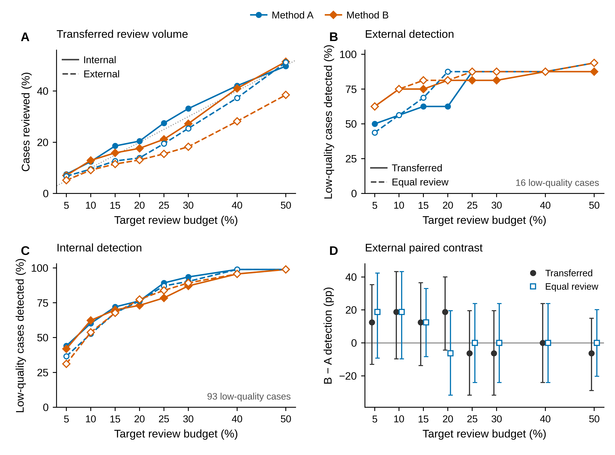
Figure S3. Review-budget transfer and detection across all eight evaluated budgets (5 %, 10 %, 15 %, 20 %, 25 %, 30 %, 40 %, and 50 %). (A) Observed review fractions after transferring development-calibrated thresholds to the internal holdout (filled markers, solid lines; n=851) and external cohort (open markers, dashed lines; n=252); the dotted diagonal marks equality with the target budget. (B,C) Observed low-quality detection on the external (16 low-quality cases) and internal (93 low-quality cases) cohorts. Filled markers/solid lines denote transferred thresholds, and open markers/dashed lines denote cohort-specific equal-review ranking. Method A uses blue circles and method B uses orange diamonds in A–C; shapes retain method identity in grayscale. (D) External paired B-minus-A detection differences (percentage points); points are observed contrasts, and vertical bars are the archived paired Newcombe 95 % confidence intervals. Dark circles denote transferred thresholds and blue open squares denote equal review; horizontal offsets are for legibility only. The equal-review count is cohort-specific and rounded as archived; at the 20 % budget, 50 of 252 external cases are reviewed per method. Lines in A–C connect observed budget settings and do not imply additional evaluations.
Post hoc calibration and sampling sensitivity
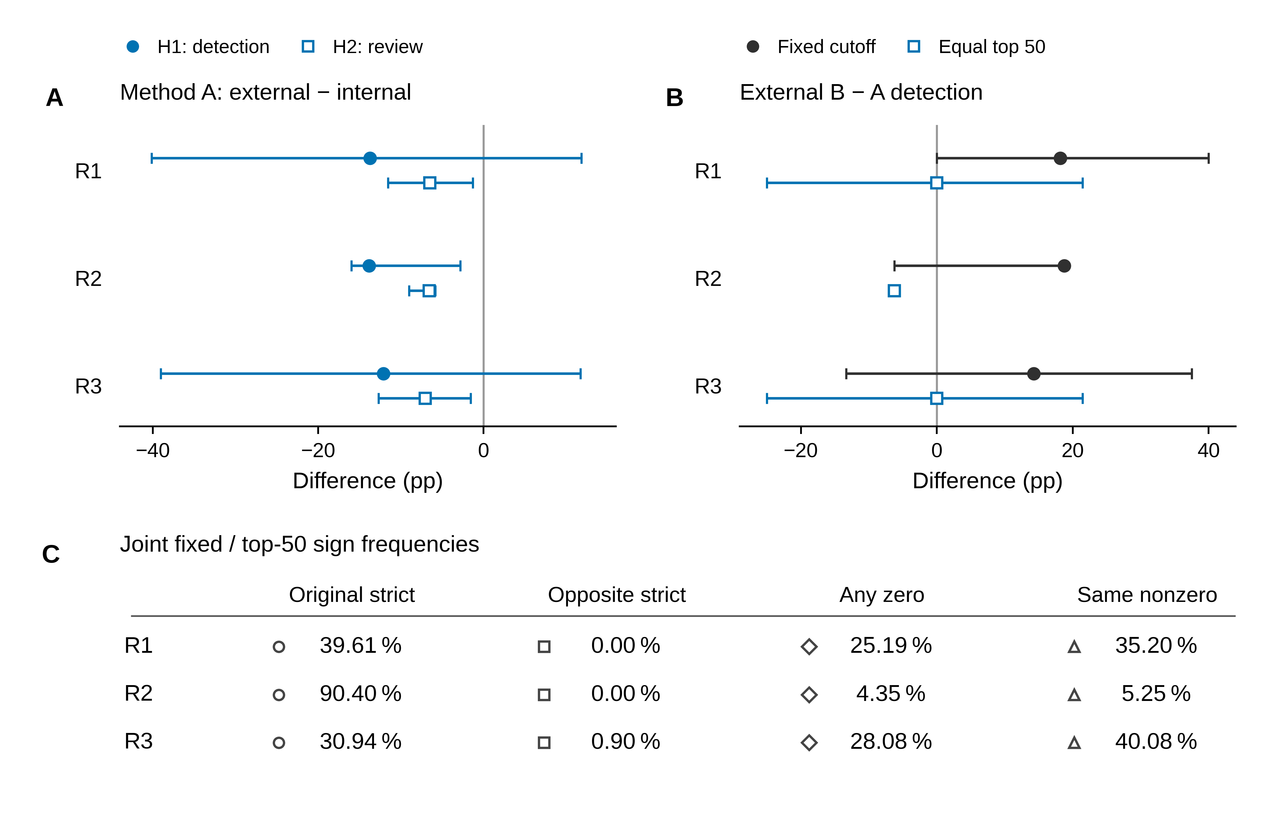
Figure S4. Exploratory bootstrap stability under three sources of variation. R1 resamples test patients at fixed development cutoffs; R2 resamples development patients for cutoff calibration while holding the test cohorts fixed; R3 resamples development and test patients. Each route has 10,000 archived patient-bootstrap replicates with method A, method B, and quality labels kept paired. (A) Method-A external-minus-internal contrasts for H1, low-quality detection (filled circles), and H2, review fraction (open squares). (B) External B-minus-A detection contrasts for the fixed-cutoff policy (dark circles) and equal top-50 review policy (blue open squares). In A and B, points are bootstrap medians and horizontal bars are unadjusted 2.5th–97.5th percentile intervals from the archived valid replicates; a collapsed interval is shown by its point, including the necessarily constant R2 equal-top-50 endpoint. (C) Exact empirical frequencies among jointly valid replicates, with marker shapes identifying four mutually exclusive sign categories. Original strict means fixed B−A >0 and top-50 B−A <0; opposite strict reverses both inequalities; any zero includes either contrast equal to zero; same nonzero means both contrasts share a nonzero sign. Frequencies are not p-values, posterior probabilities, or population probabilities. The observed external fixed-cutoff A-only detection cell is zero: R1 cannot resample an A-only detection and its fixed B−A distribution is therefore structurally nonnegative. Its [0,40] pp percentile interval does not exclude a population A advantage and does not replace the original paired Newcombe interval [−4.28,40.04] pp. Only 16 external low-quality patients inform detection; bootstrap replicates are not new patients.
Diagnostic composition accounting
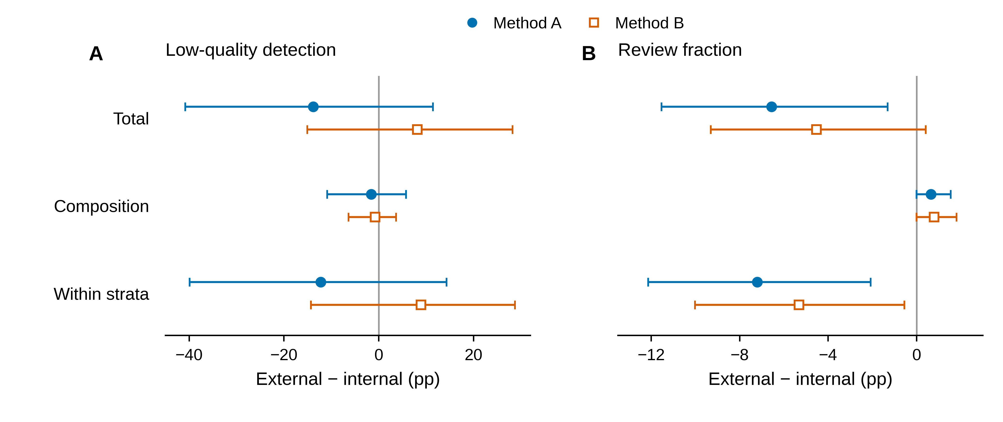
Figure S5. Descriptive symmetric Kitagawa decomposition of external-minus-internal differences at the locked development-calibrated cutoffs. (A) Low-quality detection. (B) Review fraction. For each outcome, the total observed difference is separated into a diagnostic-composition-associated term and a within-stratum-rate term using dataset-reported benign and malignant strata. Blue filled circles denote method A, and orange open squares denote method B; points are observed estimates, and horizontal bars are each term's own unadjusted bootstrap percentile 95 % interval. The symmetric formula averages internal and external stratum rates for the composition term and averages internal and external stratum weights for the within-stratum term. Detection weights use low-quality denominators; review weights use all-patient denominators. The two panels use separately labeled horizontal scales. There were 5,000 archived patient-bootstrap draws; detection components have 4,999 valid draws because one draw had an undefined external benign low-quality rate, while detection totals and all review terms have 5,000 valid draws. Observed terms add to their total; percentile-interval endpoints do not have to add. This is post hoc descriptive accounting, not causal attribution or a percent-explained analysis; two diagnostic strata do not remove other confounding. Only 16 external low-quality cases inform detection, and bootstrap draws are not independent new patients.
Targeted CPU replay: all six cases
Figure S6. Actual prompt-shift responses in the six-case CPU replay. S6A contains shared misses case089 (A), case175 (B), and case238 (C); S6B contains B-only detections case024 (D), case105 (E), and case222 (F). Each case panel shows the reference (blue) and initial CPU prediction (orange) at left. The right 2 × 2 grid shows actual predictions after left (top left), right (top right), up (bottom left), and down (bottom right) prompt shifts; orange denotes the displayed CPU prediction, blue the same reference, and dashed gray the actual prompt box. Each D value is the Dice between that shifted prediction and the initial CPU prediction, rather than its Dice against the reference. Row values give initial CPU Dice against the reference and risks A/B. All 30 nonempty prediction masks from the six existing patients are shown, with original RGB pixels, full fields of view, and unchanged mask geometry. The case175 masks touch the upper image boundary; the right-shift prediction is a narrow nonempty band. CPU masks are not the unarchived original CUDA masks, and original CUDA scores were not overwritten. These six cases are not additional independent patients.
Figure S6 is supplied in the separate publication-ready file BMT_supplementary_Figure_S6_v9.pdf. Panels A–C show the shared misses (S6A); panels D–F show B-only detections (S6B), with one complete case per page.

