2018/2019 SEMESTER TWO EXAMINATION

Diploma in Electrical and Electronic Engineering (DEEE)

2nd Year Full-Time (DEEE)

Diploma in Energy Systems and Management (DESM)

2nd Year Full-Time (DESM)

**ELECTRICAL INSTALLATION DESIGN**  Time Allowed : 2 hours

----------------------------------------------------------------------------------------------------------------

Instructions to Candidates:

1. The examination rules set out on the last page of the answer booklet are to be complied with.

2. This paper consists of TWO sections:

Section A : 6 Short Questions, 10 marks each.

Section B : 2 Long Questions, 20 marks each.

3. **ALL** questions are **COMPULSORY**.

1. All questions are to be answered in the answer booklet. Start each question in

Section A and Section B on a new page.

5. This examination paper consists of 4 pages with another 6 pages of Extracts from CP5 Tables making a total of 10 pages.

**SECTION A : [ 10 Marks Each ]**

1(a) A industrial building needs **1750kW** (not kVA) at **power factor of 0.85** lagging. State the voltage, phases, number of wires and frequency that Singapore Power Services Limited will likely provide. What type of earthing system must be used? What is the maximum current that can be drawn from the given supply voltage at 1750kW? (6 marks)

1(b) Draw the diagram of a single-phase electrical installation adopting the TT earthing system, clearly labelled all the parts. (4 marks)

2 Temporary Electrical Installations for Construction and building sites requires the use of Socket Outlet Assembly (SOA).

(a) State four other areas where SOA is also applicable.

(b) State the requirements relating to the enclosure of the assembly and type of protective devices used for the SOA.

(c) State the colours used for 230 volts and 110 volts industrial plugs and sockets.

(d) State the minimum Inspection frequency required for Construction sites. (10 marks)

3 Find a suitable conduit size for the installation of the following circuits: (Using the cable factor method.)

3 No. of single phase circuits consist of 1.5 mm2 single-core PVC insulated cable for the phase conductor and the protective conductor.

1 No. of three 4-wire phase circuits consist of 2.5 mm2 single-core PVC insulated cables with 1.5 mm2 single core PVC insulated cables for the protective conductor.

The conduit run is 6.7m with one 90o bend. (10 marks)

4(a) In a quiet area, the flat owner leaves his flat at 1.00pm and only returns at 1.00am, he decided to use a timer control circuit to gives the illusion of persons in the flat by switching on the light at 6.00pm and off at 11.00 pm. Help the owner to design such a control circuit where pressing the start button will cause the light to turn on after 5 hours and the light will turn off by itself after a further five hours. The stop button will reset the circuit. (6 marks)

4(b) Draw the lighting control circuit of switching two lamps simultaneous from three locations, label all components of the circuit. (4 marks)

5 An electrical distribution board has a single-line diagram as shown in Figure Q4(a). Determine the tripping times obtain from the Time/Current curve of the protective devices and state whether discrimination is achieved.

(i) When an overload current of 80A flowing in Load1 (4 marks)

(ii) When a fault current of 155A occurs at Point A (4 marks)

(iii) Which mechanism operates to clear the fault current in (i) (2 marks)

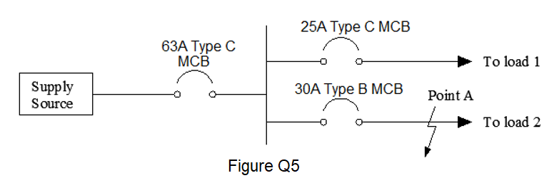

6(a) An electrical installation with many circuits was divided into four sections for the Insulation Resistance Test. The values obtained are 16 MΩ, 16 MΩ, 8 MΩ and 4 MΩ. What is the equivalent insulation resistance value for the installation, and is it acceptable? (3 marks)

6(b) Give an example of Electrical Separation in the context of electrical installation. State the main equipment used in Electrical Separation and what is being separated.

(3 marks)

6(c) In the earth electrode test done as per circuit shown in Figure Q6(c), the ammeter shows 5000mA, the voltmeter shows 10V, calculate the earth electrode resistance. Name any two types of earth electrodes that are acceptable for use in Singapore.

(4 marks)

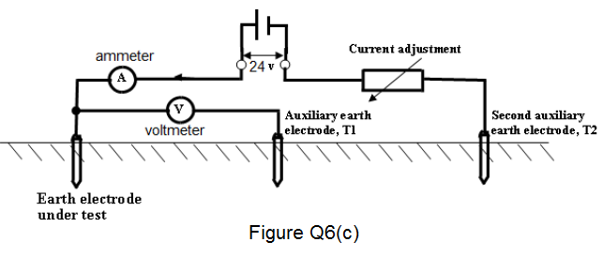

# **SECTION B : [ 20 Marks Each ]**

B1 A two-storey detached residential unit is taking supply from a three-phase 400V/230V 50 Hz supply. It has the following electrical loads:

- 10 nos. 2 x 32W fluorescent lamps

- 45 nos. 13A switched socket outlet connected in **3 ring circuits**, each protected by a 32A MCB (Estimated demand of each circuit is 3.5kW)

- 2 nos. instantaneous water heaters, each rated 3 kW

- 1 no. storage water heater rated 1.5kW

- 7.8kW cooker connected to cooker control unit with switched socket outlet

- 1500W audio video system connected to a 13A switched socket outlet

- Multi-split air-conditioning unit where the electrical load is to be considered as a three-phase motor, rated 8 kW with an efficiency of 88% and a power factor of 0.88.

Using the diversity factor given in Table 4B, draw a load list table as per sample below. (1 mark)

|  |  |  |  |
| --- | --- | --- | --- |
| **Description** | **Connected Load** | **D.F.** | **Current Demand** |
|  |  |  |  |

Hence calculate:

1. the **three phase** maximum demand
2. the suitable size of the main circuit breaker, assuming 10% spare capacity is allowed for future expansion

(Standard circuit breaker rating: 20A, 25A, 30A, 40A, 50A, 63A, 80A, 100A).

(19 marks)

B2(a) An electrical distribution board has a power requirement of 30kW at power factor of 0.88. The length of the cable is 70m from the main switchboard. It is to be wired in multi-core PVC insulated copper cables sharing a trunking with one other similar circuit. The ambient temperature can rise to 300 C. Determine:

1. The design current of the electrical distribution board, hence the nominal rating of the Type C MCB.

(Standard circuit breaker rating: 15A, 20A, 25A, 30A, 32A, 40A, 50A, 63A)

1. A suitable cross section area of the cable
2. The actual voltage drop and check whether the cable size selected can meet the CP5 requirement. Re-select cable size if necessary.

(11 marks)

B2(b) A single-phase 230V, cooker control unit is wired in single-core 4.0mm**2** PVC insulated copper conductor and 1.5mm2 PVC insulated copper conductor for circuit protective conductor. The circuit is protected by a 32A Type B MCB, the circuit length is 12 meters long. The value of ZE is given as 0.75 Ω. Determine if the given size of the circuit protective conductor meets both the shock protection and thermal constraint requirements. (Given K=115) (9 marks)

“ ******* End of Paper ******* ”

(Extracts from CP5 Tables pages 5 to 10)

|  |  |  |  |  |
| --- | --- | --- | --- | --- |
|  | **Table 12C** | | |  |
| **Cable factors for long straight runs or runs incorporating bends** | | | | |
|  | (Single core PVC cables) | | |  |
|  | Type of | Conductor cross- |  |  |
|  | Conductor | sectional area (mm2 ) | Factor |  |
|  | Solid or stranded | 1 | 16 |  |
|  | 1.5 | 22 |  |
|  | 2.5 | 30 |  |
|  | 4 | 43 |  |
|  | 6 | 58 |  |
|  | 10 | 105 |  |





**TABLE 4B1:Correction factors for groups of more than one circuit of single-core cables, or more than one multicore cable**



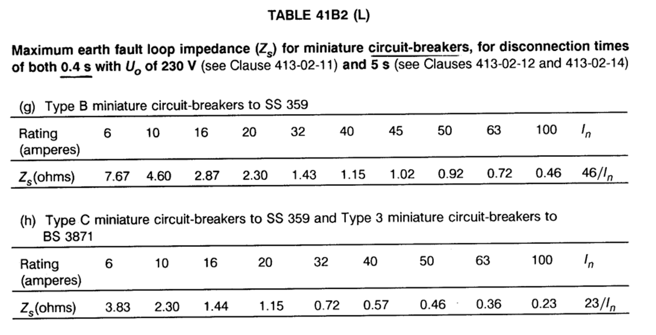

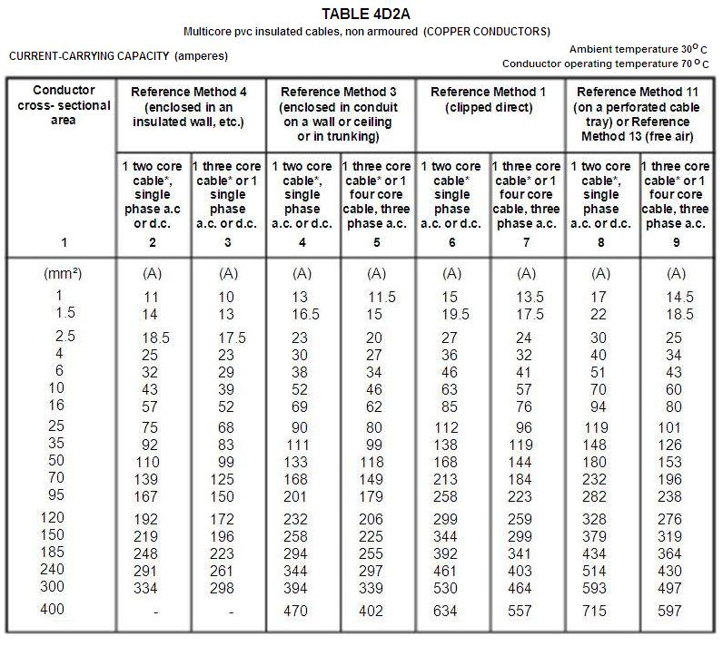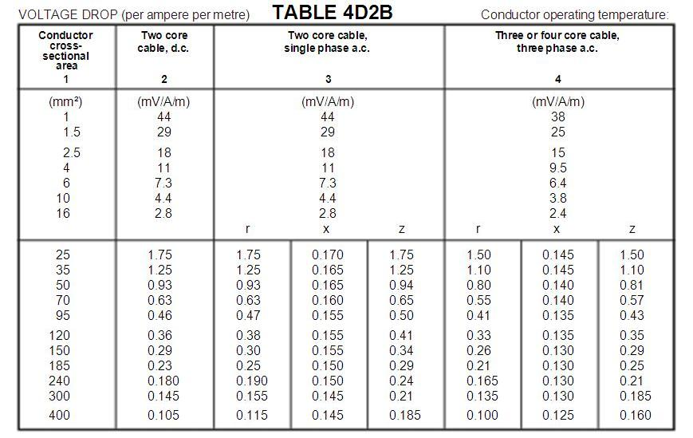

**Table 4B**

**Allowance for diversity**

|  |  |  |  |
| --- | --- | --- | --- |
| **Purpose of final circuit fed from conductors or switchgear to which diversity applies** | **Type of premises** | | |
| **Individual household installations, including individual dwellings of a block** | **Small shops, stores, offices and business premises** | **Small hotels, boarding houses, guest houses, etc.** |
| 1. Lighting | 66% of total current demand | 90% of total current demand | 75% of total current demand |
| 1. Heating and power   (but see 3 to 8  below) | 100% f.l. of total demand up to 10A + 50% of any current demand in excess of 10A | 100% f.l. of largest appliance + 75% f.l. of remaining appliances | 100% f.l. of largest appliance + 80% f.l. of 2nd largest appliance + 60% f.l. of remaining appliances |
| 1. Cooking   appliances | 10A + 30% f.l. of connected cooking appliances in excess of 10A + 5A if socket outlet incorporated in unit | 100% f.l. of largest appliances + 80% f.l. of 2nd largest appliance + 60% f.l. of remaining appliances | 100% f.l. of largest appliances + 80% f.l. of 2nd largest appliance + 60% f.l. of remaining appliances |
| Motors (other than lift motors which are subject to special consideration) |  | 100% f.l. of largest motor + 80% f.l. of 2nd largest motor + 60% f.l. of remaining motor | 100% f.l. of largest motor + 50% f.l. of remaining motor |
| 1. Water heater   (instantaneous type) | 100% f.l. of largest appliance + 100% f.l. of 2nd largest appliance + 25% f.l. of remaining appliances | 100% f.l. of largest appliance + 100% f.l. of 2nd largest appliance + 25% f.l. of remaining appliances | 100% f.l. of largest appliance + 100% f.l. of 2nd largest appliance + 25% f.l. of remaining appliances |
| 1. Water heater   (thermostatically controlled) | No diversity allowable | | |
| 7. Floor warming installations | (Reserved for future use) | | |
| 8.Thermal storage space  heating installations | (Reserved for future use) | | |
| 9. Standard  arrangement of  final circuits (13A switched socket outlets) | 100% of current demand of largest circuit + 40% of current demand of every other circuit | 100% of current demand of largest circuit + 50% of current demand of every other circuit | |
| 10. Socket outlets other  than include in 9  above and stationary  equipment other than  those listed above | 100% of current demand of largest point of utilisation + 40% of current demand of every other point of utilisation | 100% of current demand of largest point of utilisation + 75% of current demand of every other point of utilisation | 100% of current demand of largest point of utilisation + 75% of current demand of every point in main rooms (dining rooms, etc) + 40% of current demand of every other point of utilisation |

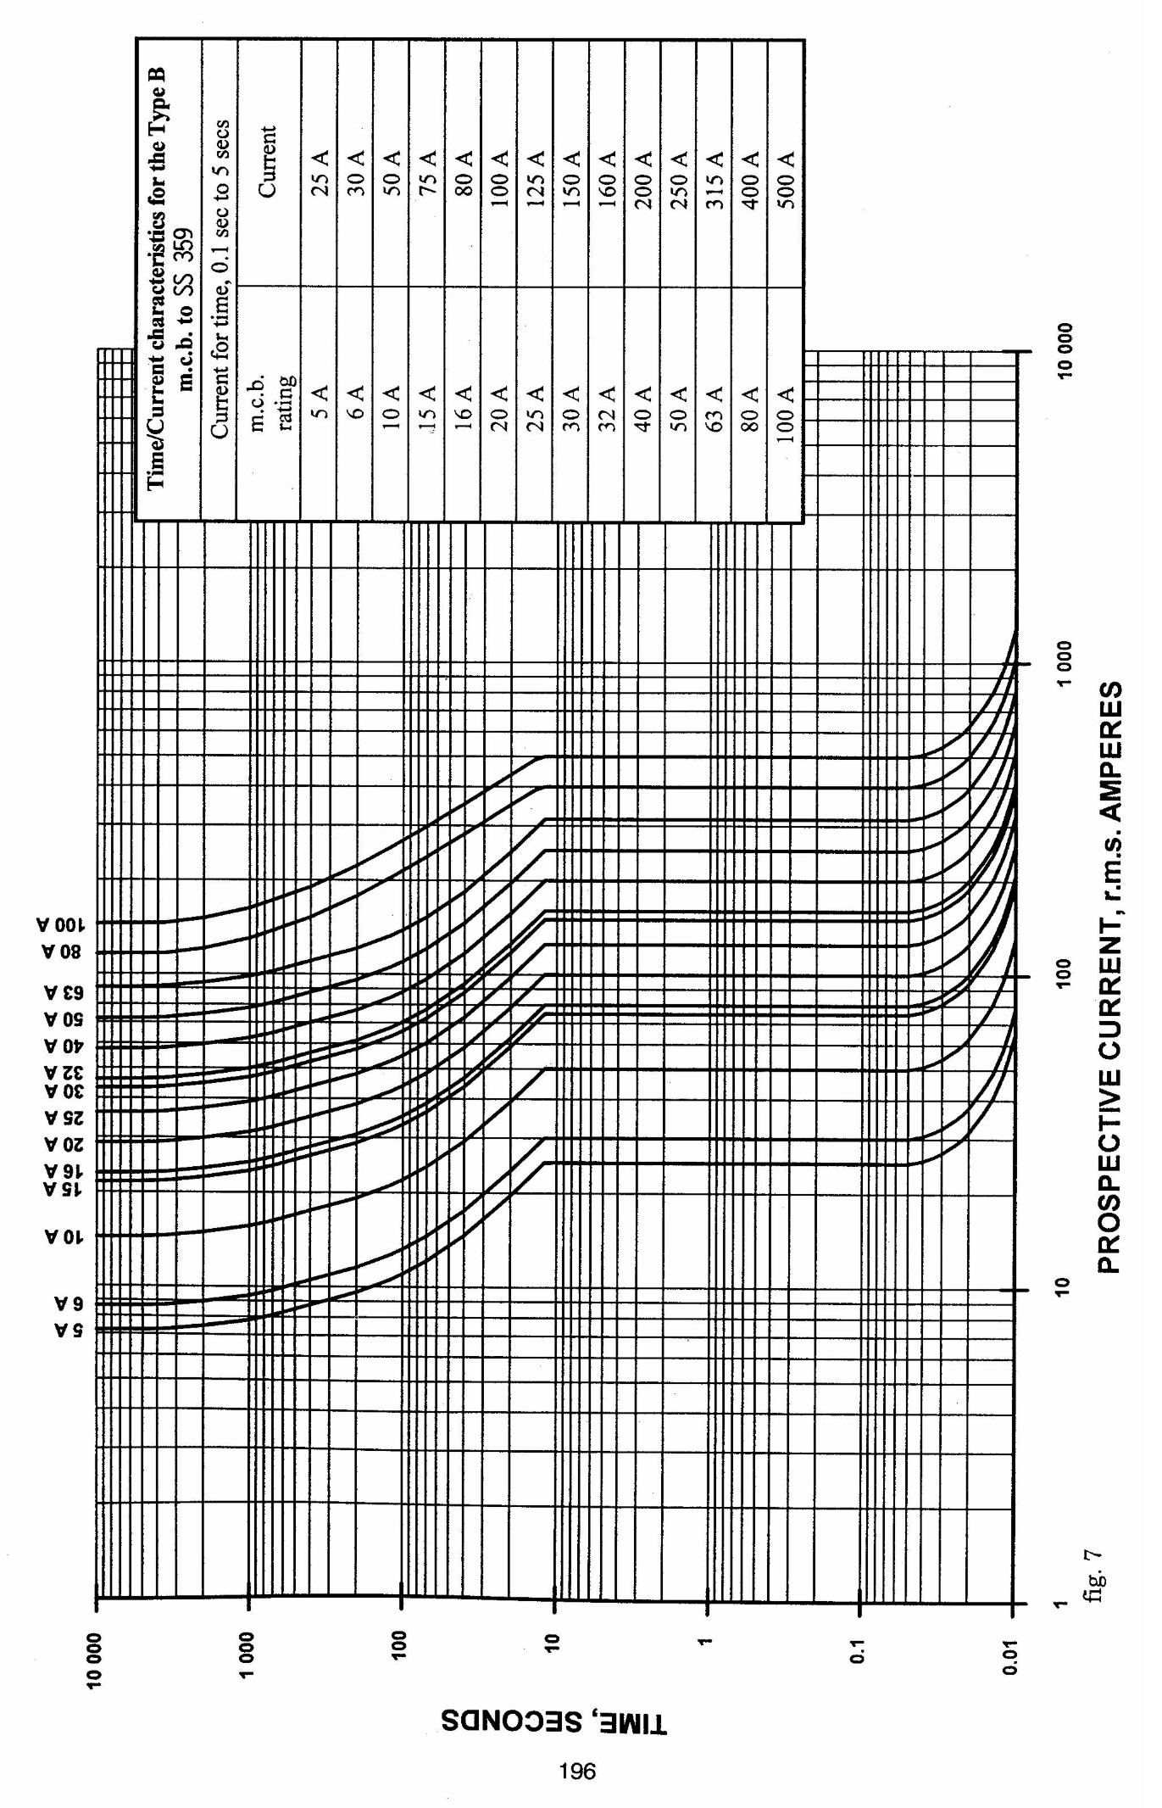

**Table 17A**

**Values of resistance/metre for copper and aluminium conductors**

**and of (R1 + R2)/metre at 20oC in milliohms/metre**

|  |  |  |  |
| --- | --- | --- | --- |
| Cross-sectional area (mm2) | | Resistance/metre or (R1 + R2 )/metre | |
| Phase conductor | Protective conductor | Plain copper (mΩ/m) | Aluminium |
| 1 | - | 18.10 |  |
| 1 | 1 | 36.20 |  |
| 1.5 | - | 12.10 |  |
| 1.5 | 1 | 30.20 |  |
| 1.5 | 1.5 | 24.20 |  |
| 2.5 | - | 7.41 |  |
| 2.5 | 1 | 25.51 |  |
| 2.5 | 1.5 | 19.51 |  |
| 2.5 | 2.5 | 14.82 |  |
| 4 | - | 4.61 |  |
| 4 | 1.5 | 16.71 |  |
| 4 | 2.5 | 12.02 |  |
| 4 | 4 | 9.22 |  |
| 6 | - | 3.08 |  |
| 6 | 2.5 | 10.49 |  |
| 6 | 4 | 7.69 |  |
| 6 | 6 | 6.16 |  |
| 10 | - | 1.83 |  |
| 10 | 4 | 6.44 |  |
| 10 | 6 | 4.91 |  |
| 10 | 10 | 3.66 |  |
| 16 | - | 1.15 | 1.91 |
| 16 | 6 | 4.23 | - |
| 16 | 10 | 2.98 | - |
| 16 | 16 | 2.30 | 3.82 |
| 25 | - | 0.727 | 1.2 |
| 25 | 10 | 2.557 | - |
| 25 | 16 | 1.877 | - |
| 25 | 25 | 1.454 | 2.4 |
| 35 | - | 0.524 | 0.868 |
| 35 | 16 | 1.674 | 2.778 |
| 35 | 25 | 1.251 | 2.068 |
| 35 | 35 | 1.048 | 1.736 |

Table 17B - Multipliers to be applied to Table 17A

|  |  |  |  |
| --- | --- | --- | --- |
| Insulation Material | p.v.c. | 850 C Rubber | 900 C Thermosetting |
| Multiplier | 1.38  (1.30) | 1.53  (1.42) | 1.60  (1.48) |
| Note : The values in brackets are applicable to the resistance of circuit protective  Conductors where Table 54B applies. | | | |

The multipliers given in Table 17B are based on the simplified formula given in BS 6360 for both copper and aluminium conductors namely that the resistance temperature coefficient is 0.004 per oC at 20oC.