2018/2019 SEMESTER ONE EXAMINATION

Diploma in Electrical and Electronic Engineering (DEEE)

2nd Year Full-Time (DEEE)

Diploma in Energy Systems and Management (DESM)

2nd Year Full-Time (DESM)

**ELECTRICAL INSTALLATION DESIGN**  Time Allowed: 2 hours

----------------------------------------------------------------------------------------------------------------

Instructions to Candidates:

1. The examination rules set out on the last page of the answer booklet are to be complied with.

2. This paper consists of TWO sections:

Section A: 6 Short Questions, 10 marks each.

Section B: 2 Long Questions, 20 marks each.

3. **ALL** questions are **COMPULSORY**.

1. All questions are to be answered in the answer booklet. Start each question in

Section A and Section B on a new page.

5. This examination paper consists of 4 pages with another 6 pages of Extracts from CP5 Tables making a total of 10 pages.

**SECTION A : [ 10 Marks Each ]**

1(a) A terrace house needs 22kVA of electricity at power factor of 0.8. State the voltage, frequency and number of wires that Singapore Power Services Limited will provide. What type of earthing system will be used? Calculate the maximum current that can be drawn from Singapore Power. (7 marks)

1(b) Sketch a single-phase electrical installation adopting the TNS earthing system, clearly labelled all parts. (3 marks)

2 Socket Outlet Assembly (SOA) are mandated for use in Temporary Electrical Installations.

(i) State the four areas where SOA is compulsory.

(ii) State the requirements relating to the enclosure of the assembly and type of protective devices used for the SOA.

(iii) State the maximum length for flexible cables used for handheld equipment when connecting to SOA.

(iv) Explain whether it is correct to loop from an existing industrial socket outlet fitted on the SOA to two 13A switched socket outlets.

(10 marks)

3(a) Determine the size (diameter) for the conduit as in Figure Q 3(a) needed to accommodate the following circuits. (Using the cable factor method.) (6 marks)

* + 1 numbers of single-phase circuit using 2.5 mm2 single core PVC-insulated stranded cables with 1.5mm2 single core PVC insulated cables for the protective conductors
  + 1 number of three-phase 3-wire circuit using 4.0 mm2 single core PVC-insulated stranded cables with 2.5mm2 single core PVC insulated cables for the protective conductors.

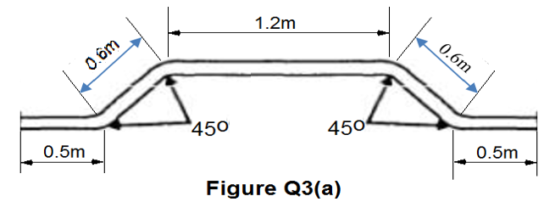

3(b) Can an ohmmeter be used to measure insulation resistance for electrical installation? The overall insulation resistance of the electrical installation with a total of 200 points (lighting and socket outlets) is 0.3 MΩ. Does the overall insulation resistance value comply with CP5:1998? (4 marks)

4 Design a manual traffic light control circuit which has the following operations.

The green light will always be on until the single push button is pressed.

Upon the pressing of the push button the green light will goes off after 10 seconds, the red light will be on for 25 seconds and then goes off and the green light on again.

The system will then be ready for the pressing of the push button again. (10 marks)

5 Refer to the single line diagram in Figure Q5 below:

(i) Determine the corresponding tripping time for the In Type C MCB and the 2xIn Type B MCB when a current of 4xIn flows in Load A and briefly explain whether discrimination is achieved. State the tripping mechanism(s) that will operates the MCBs under this condition. (6 marks)

* 1. If In = 20A determine the minimum cable size for load A and load B. Assume that ambient temperature is 30oC, no grouping and no thermal insulation. Multicore PVC insulated copper cable is to be used in surface conduit. (4 marks)

**(Only Type C MCB Time/current characteristic graph is provided)**

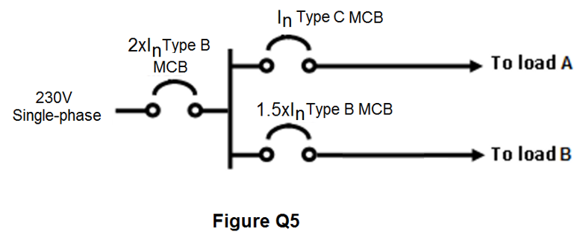

6(a) Give a brief explanation of Direct contact, Indirect contact and Electrical Separation in the context of electrical installation. (6 marks)

6(b) Determine the earth fault loop impedance of the circuit in Figure Q6 (b) at the 13A switched socket outlet. (4 marks)

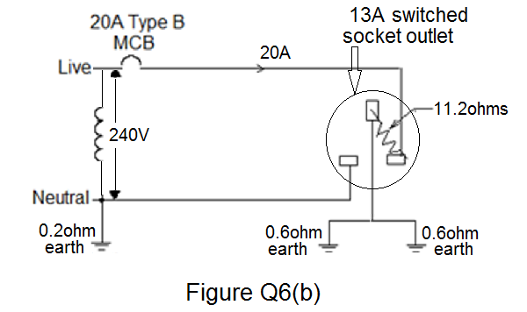

# **SECTION B : [ 20 Marks Each ]**

B1 An office unit is supplied by three-phase 400V/230V 50 Hz supply. It has the following electrical loads:

- 40 nos. 2 x 18W fluorescent lamps with 2x9W loss ballast pf =0.8

- 15 nos. of 50W, 50V tungsten halogen down lights

- **5 radial circuits** connected to 100 nos. 13A switched socket outlets, each protected by a 20A MCB (Estimated demand of each circuit is 3,000W)

- 2 nos. storage water heaters, each rated 1.5 kW

- 2 nos. of MULTI SPLIT air-conditioning units where the electrical load can be considered to be a three-phase motor, each rated 9.0 kW with an efficiency of 90% and a power factor of 0.85 running all the time at the same time.

Using the diversity factor given in Table 4B, draw a load list table as per sample below. (1 mark)

|  |  |  |  |
| --- | --- | --- | --- |
| **Description** | **Connected Load** | **D.F.** | **Current Demand** |
|  |  |  |  |

Hence calculate:

1. the **three phase** maximum demand
2. the suitable size of the main circuit breaker, assuming 10% spare capacity is allowed for future expansion

(Standard circuit breaker rating: 30A, 40A, 50A, 63A, 80A, 100A). (19 marks)

B2(a) A 3-phase, 400V motor control centre(MCC) has an estimated power of 32kW at power factor of 0.85. The length of the cable is 40m from the main switchboard and it is to be wired in multi-core PVC insulated copper cables sharing a trunking with one other similar circuits. The ambient temperature is 39oC. Determine:

1. The design current of the MCC, hence the nominal rating of a suitable Type C MCB (Standard MCB rating: 15A, 20A, 25A, 30A, 40A, 50A, 63A)
2. A suitable size of cable for the MCC.
3. The actual voltage drop and check whether the cable size selected can meet the CP5 requirement. Re-select cable size if necessary.

(11 marks)

B2(b) A single-phase 230V, induction motor is wired in single-core 2.5mm2 PVC insulated copper conductor and 1.5mm2 PVC insulated copper conductor for circuit protective conductor (CPC). The circuit is protected by a 32A BS88 fuse with a thermal overload device set at 20A, the circuit length is 30 meters long. The value of ZE is given as 0.8 Ω.

(i) Determine if the given size of CPC meets the requirement for shock protection, resize the CPC if necessary. (5 marks)

(ii) Calculate the actual earth fault loop impedance for the size of CPC selected and determine the earth fault current. Hence check whether the CPC selected can withstand the earth fault current. (Given k =115.) (4 marks)

“ ******* End of Paper ******* ”

(Extracts from CP5 Tables pages 5 to 10)

|  |  |  |  |  |
| --- | --- | --- | --- | --- |
|  | **Table 12C** | | |  |
| **Cable factors for long straight runs or runs incorporating bends** | | | | |
|  | (Single core PVC cables) | | |  |
|  | Type of | Conductor cross- |  |  |
|  | Conductor | sectional area (mm2 ) | Factor |  |
|  | Solid or stranded | 1 | 16 |  |
|  | 1.5 | 22 |  |
|  | 2.5 | 30 |  |
|  | 4 | 43 |  |
|  | 6 | 58 |  |
|  | 10 | 105 |  |



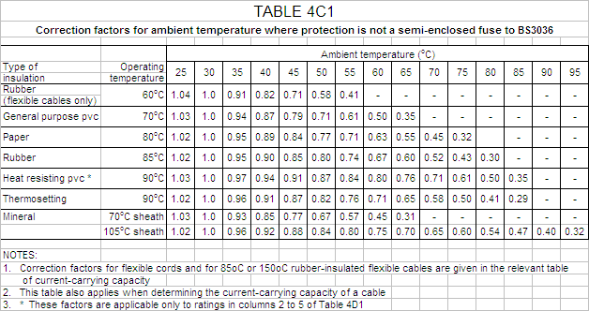

**TABLE 4B1:Correction factors for groups of more than one circuit of single-core cables, or more than one multicore cable**

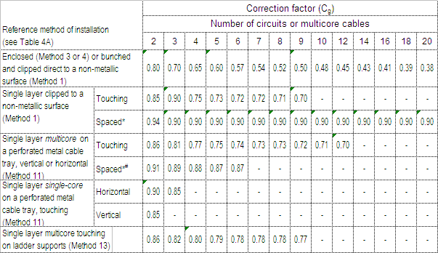

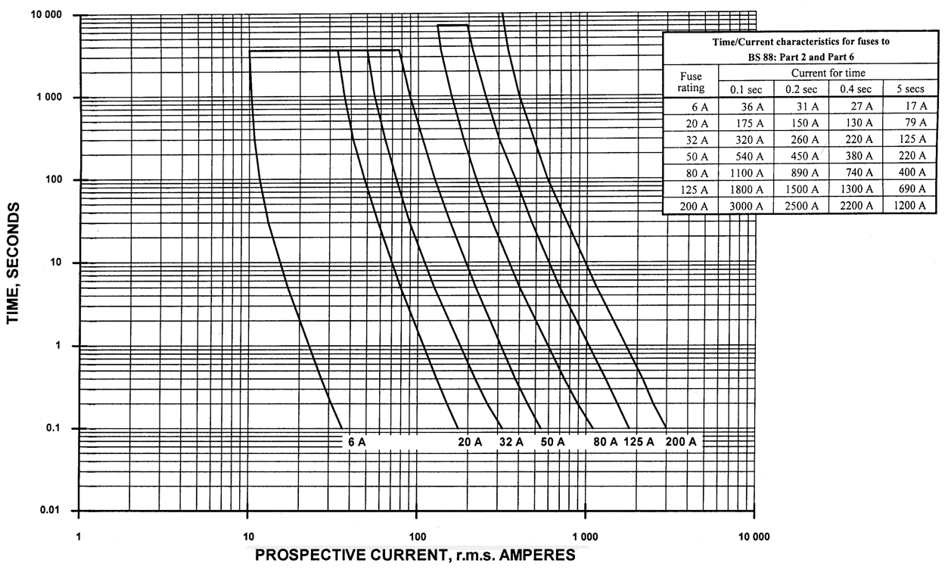

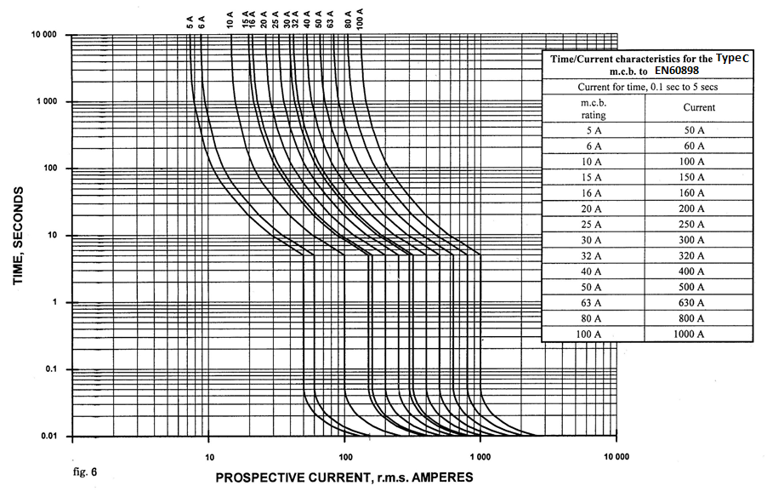

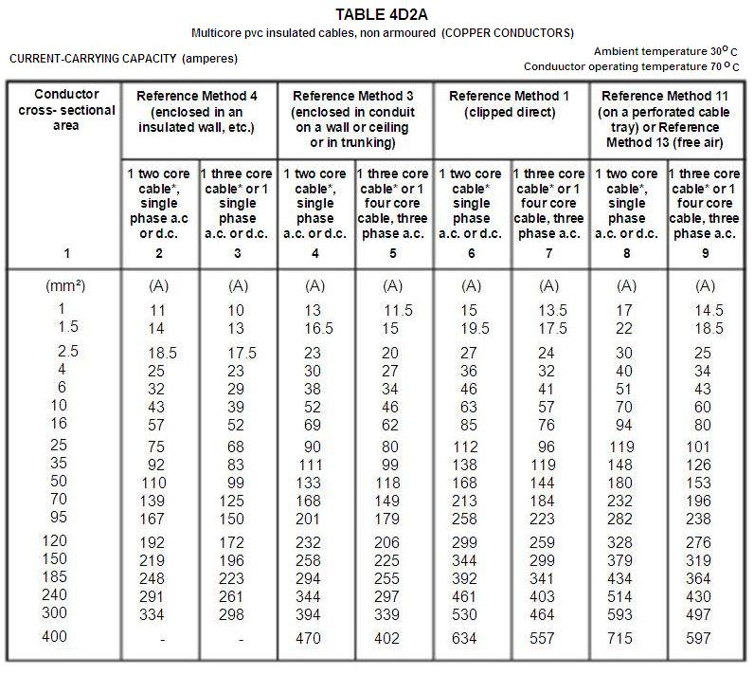

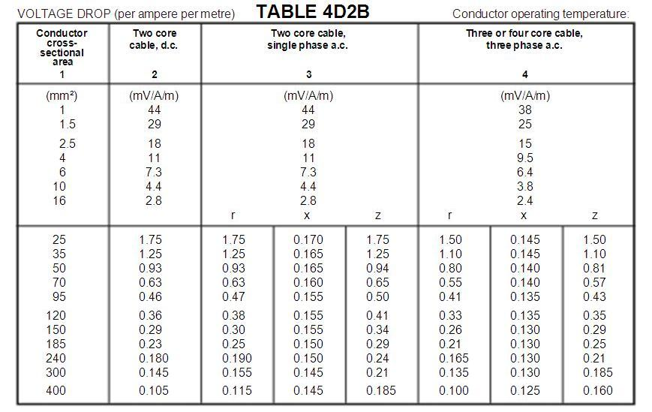

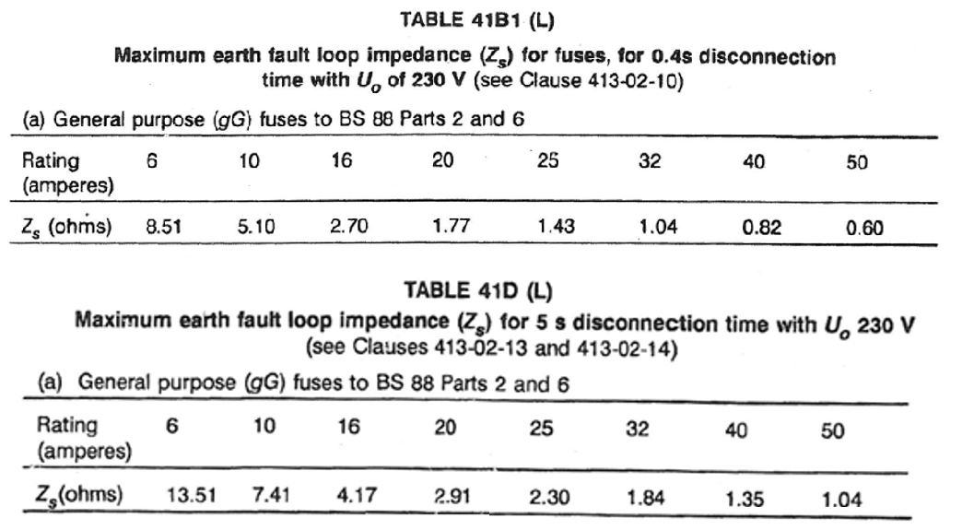

**Table 4B**

**Allowance for diversity**

|  |  |  |  |
| --- | --- | --- | --- |
| **Purpose of final circuit fed from conductors or switchgear to which diversity applies** | **Type of premises** | | |
| **Individual household installations, including individual dwellings of a block** | **Small shops, stores, offices and business premises** | **Small hotels, boarding houses, guest houses, etc.** |
| 1. Lighting | 66% of total current demand | 90% of total current demand | 75% of total current demand |
| 1. Heating and power   (but see 3 to 8  below) | 100% f.l. of total demand up to 10A + 50% of any current demand in excess of 10A | 100% f.l. of largest appliance + 75% f.l. of remaining appliances | 100% f.l. of largest appliance + 80% f.l. of 2nd largest appliance + 60% f.l. of remaining appliances |
| 1. Cooking   appliances | 10A + 30% f.l. of connected cooking appliances in excess of 10A + 5A if socket outlet incorporated in unit | 100% f.l. of largest appliances + 80% f.l. of 2nd largest appliance + 60% f.l. of remaining appliances | 100% f.l. of largest appliances + 80% f.l. of 2nd largest appliance + 60% f.l. of remaining appliances |
| Motors (other than lift motors which are subject to special consideration) |  | 100% f.l. of largest motor + 80% f.l. of 2nd largest motor + 60% f.l. of remaining motor | 100% f.l. of largest motor + 50% f.l. of remaining motor |
| 1. Water heater   (instantaneous type) | 100% f.l. of largest appliance + 100% f.l. of 2nd largest appliance + 25% f.l. of remaining appliances | 100% f.l. of largest appliance + 100% f.l. of 2nd largest appliance + 25% f.l. of remaining appliances | 100% f.l. of largest appliance + 100% f.l. of 2nd largest appliance + 25% f.l. of remaining appliances |
| 1. Water heater   (thermostatically controlled) | No diversity allowable | | |
| 7. Floor warming installations | (Reserved for future use) | | |
| 8.Thermal storage space  heating installations | (Reserved for future use) | | |
| 9. Standard  arrangement of  final circuits (13A switched socket outlets) | 100% of current demand of largest circuit + 40% of current demand of every other circuit | 100% of current demand of largest circuit + 50% of current demand of every other circuit | |
| 10. Socket outlets other  than include in 9  above and stationary  equipment other than  those listed above | 100% of current demand of largest point of utilisation + 40% of current demand of every other point of utilisation | 100% of current demand of largest point of utilisation + 75% of current demand of every other point of utilisation | 100% of current demand of largest point of utilisation + 75% of current demand of every point in main rooms (dining rooms, etc) + 40% of current demand of every other point of utilisation |

**Table 17A**

**Values of resistance/metre for copper and aluminium conductors**

**and of (R1 + R2)/metre at 20oC in milliohms/metre**

|  |  |  |  |
| --- | --- | --- | --- |
| Cross-sectional area (mm2) | | Resistance/metre or (R1 + R2 )/metre | |
| Phase conductor | Protective conductor | Plain copper (mΩ/m) | Aluminium |
| 1 | - | 18.10 |  |
| 1 | 1 | 36.20 |  |
| 1.5 | - | 12.10 |  |
| 1.5 | 1 | 30.20 |  |
| 1.5 | 1.5 | 24.20 |  |
| 2.5 | - | 7.41 |  |
| 2.5 | 1 | 25.51 |  |
| 2.5 | 1.5 | 19.51 |  |
| 2.5 | 2.5 | 14.82 |  |
| 4 | - | 4.61 |  |
| 4 | 1.5 | 16.71 |  |
| 4 | 2.5 | 12.02 |  |
| 4 | 4 | 9.22 |  |
| 6 | - | 3.08 |  |
| 6 | 2.5 | 10.49 |  |
| 6 | 4 | 7.69 |  |
| 6 | 6 | 6.16 |  |
| 10 | - | 1.83 |  |
| 10 | 4 | 6.44 |  |
| 10 | 6 | 4.91 |  |
| 10 | 10 | 3.66 |  |
| 16 | - | 1.15 | 1.91 |
| 16 | 6 | 4.23 | - |
| 16 | 10 | 2.98 | - |
| 16 | 16 | 2.30 | 3.82 |
| 25 | - | 0.727 | 1.2 |
| 25 | 10 | 2.557 | - |
| 25 | 16 | 1.877 | - |
| 25 | 25 | 1.454 | 2.4 |
| 35 | - | 0.524 | 0.868 |
| 35 | 16 | 1.674 | 2.778 |
| 35 | 25 | 1.251 | 2.068 |
| 35 | 35 | 1.048 | 1.736 |

Table 17B - Multipliers to be applied to Table 17A

|  |  |  |  |
| --- | --- | --- | --- |
| Insulation Material | p.v.c. | 850 C Rubber | 900 C Thermosetting |
| Multiplier | 1.38  (1.30) | 1.53  (1.42) | 1.60  (1.48) |
| Note : The values in brackets are applicable to the resistance of circuit protective  Conductors where Table 54B applies. | | | |

The multipliers given in Table 17B are based on the simplified formula given in BS 6360 for both copper and aluminium conductors namely that the resistance temperature coefficient is 0.004 per oC at 20oC.