**SECTION A: [10 Marks Each]**

1.     (a) A shopping centre needs 2500kVA of electricity.  State the voltage, frequency and number of wires that Singapore Power Services Limited will provide.  What type of earthing system will be used?  Determine the maximum current and power that can be drawn from Singapore Power at 2500kVA and power factor of 0.85 lagging.                                                                   (7 marks)

        (b)  Draw the diagram of a single-phase electrical installation adopting the TNS earthing system, clearly labelled all the parts.                             (3 marks)

2.     Socket Outlet Assembly (SOA) is mandated for use in Temporary Electrical Installations.                                                                                       (10 marks)

(i)     State any three areas where SOA. Is mandatory.

(ii)    State the requirements relating to the enclosure of the assembly and type of protective devices used for the SOA.

(iii)    State the colours used for 230 volts and 400 volts industrial plugs.

(iv)   State the Inspection frequency required of Temporary Electrical Installations at Construction Worksite.

3.     (a)An electrical installation with many circuits was divided into four sections for the Insulation Resistance Test. The values obtained are 8 MΩ, 8 MΩ, 4 MΩ and 2 MΩ. What is the equivalent insulation resistance value for the installation, and is it acceptable?                                              (4 marks)

3.     (b)  In an electrical installation protected by a 30mA RCCB, a neutral wire is shorted to the metal casing of an earthed steel trunking, briefly explain what will happens?                                                                              (2 marks)

3.     (c)  A large installation with 60 circuits and 500 socket outlets is lumped together and tested with an insulation resistance tester. The reading is 0.4 M. What is the minimum insulation resistance required by CP5:1998? Has the installation failed the test? Please give reason(s) for your answer.                                      (4 marks)

4.       An electrical distribution board has a single-line diagram as shown in Figure Q4. Determine the tripping times obtain from the Time/Current curve of the protective devices and state whether discrimination is achieved. (Only Type C graph given.)

          (i)       When an overload current of 80A flowing in Load1.          (4 marks)

          (ii)       When a fault current of 160A occurs at Point A.           (4 marks)

          (iii)      Which mechanism operates to clear the overload in part (i)?         (2 marks)

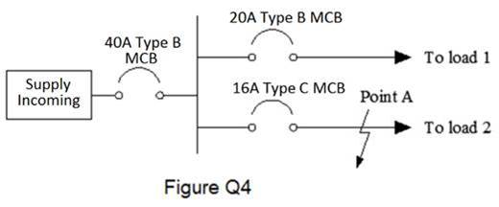

5.     (a) An office has a floor area of 180m2. A minimum of 40 numbers of 13A switch socket outlets are required and if radial circuit with protective device rating of 20A is to be used as per Table 5A of CP5:1998, determine the minimum number of circuits required.  If you intend to reduce the number of final circuits, what can be done?  Outline the changes to nominal rating of the protective device and the cable size, if any.                                   (6 marks)

5.     (b)  In the earth electrode test done as per circuit shown in Figure Q5 (b), the ammeter shows 500mA, the voltmeter shows 400mV, calculate the earth electrode resistance.  Name any two types of earth electrodes besides the earth rod that are acceptable for use in Singapore.                   (4 marks)

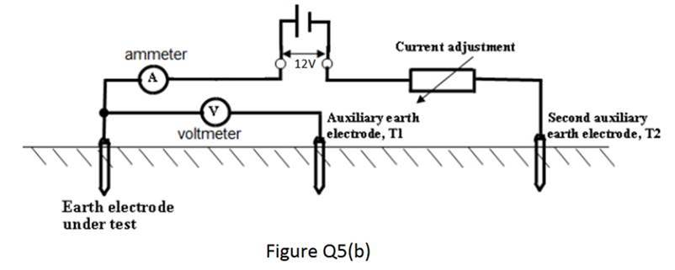

6(a)  Design a control circuit where pressing the start button will cause motor to turn-on, after 30mins the motor will automatically turn-off.  To turn-on the motor again, the stop button need to be pressed before pressing the start button again. (8 marks)

  (b)  State the main difference between control relay and the timer relay.  (2 marks)

**SECTION B: [ 20 Marks Each]**

B1      A factory receives a three-phase 400V/230V 50 Hz supply for its daily operation. It has recently bought a three-phase star-connected resistive load rated at 15kW and it is to be wired in single-core PVC insulated copper cables. For the length of its 45m run in metal trunking, it is grouped with one other similar circuit. The ambient temperature is 350 C. Determine:

1. the design current, hence the nominal rating of the Type B MCB (6 marks)

(Standard circuit breaker rating: 6A, 10A, 15A, 20A, 25A, 30A, 40A, 50A)

1. the suitable size of the cable                                                         (8 marks)
2. the actual voltage drop and check whether the cable size selected can meet the CP5 requirement. Re-select cable size if necessary.  (6 marks)

B2      A single-phase 230 V, 50 Hz, 4 kW 0.8pf electrical oven is wired in single-core 4 mm**2** PVC insulated copper conductor. The circuit is protected by a 32A Type B MCB, the circuit length is 30 meters long. The value of ZE is given as 0.60 Ω. Size of circuit protective conductor (CPC) selected is 2.5 mm2 PVC insulated copper conductor.  (Note only Type C MCB time/current graph given.)

(i)     Determine whether the size of 2.5mm2 meets the for shock protection requirement.                                                                        (8 marks)

(ii)    Calculate the actual earth fault loop impedance and determine the earth fault current.  Hence check whether the CPC selected can withstand the earth fault current. (Given K = 115)                                           (9 marks)

(iii)    State the measure likely to be used for protection against electric shock for the electrical oven in this problem.                                                   (3 marks)