**School of Digital Media & Infocomm Technology (DMIT)**

**ST2111 Mobile Application Development I**

**Practical 1**

**First JavaScript Program**

|  |
| --- |
| Objectives:  After completing this lab, you should be able to:   * Understand the structure of a JavaScript program * Write simple JavaScript statements * Understand the steps for installing JavaScript development environment * Install JavaScript development tools |

**Exercise 1: Install Mozilla Firefox and Firebug**

1. Download and install Firefox browser.
2. Navigate to <http://www.getfirebug.com> to download and install Firebug add-on.
3. Open Firebug. In Firefox menu click **Tools->Web Developer->Firebug.**

Note: If menu bar is not shown, right-click the top of Firefox window and check **menu bar**.

1. Notice that the Firebug window opens below the website. Any errors will be listed including the line number of the error (Figure A).

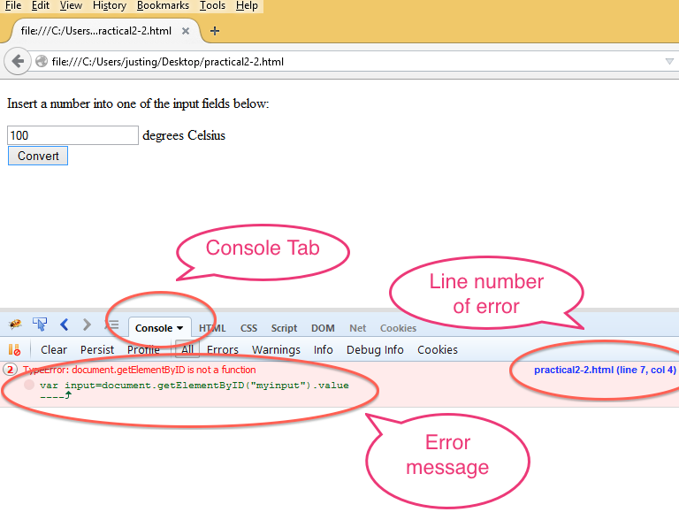

**Figure A**

**Exercise 2: Install Notepad ++**

1. Navigate to <http://notepad-plus-plus.org/> to download and install Notepad ++.
2. Visit the Notepad++ features page on their website. List three features which make the application more suitable to writing programs as compared to a text editor.

**Interesting instructions, however, I raise to you, Eclipse:**

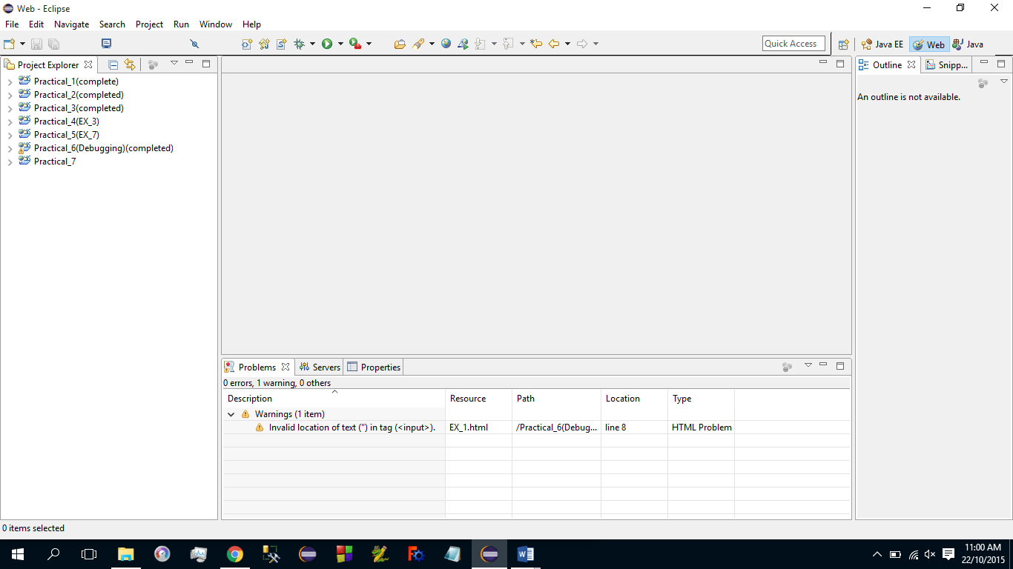

**Exercise 3: Write Your First JavaScript Program**

1. Create a folder called **MAD1**
2. Create a subdirectory inside **MAD1** called  **practical1-1**
3. Use Notepad++ to create two files: **container.html**, and **script.js** inside **practical1-1.**
4. Type **Listing A** inside **container.html**
5. Save your work
6. In File explorer, right click **container.html** file and open in the Firefox browser. What is the result displayed on the browser?
7. HTML in **Listing A** is an example of a markup language. What is the purpose of a markup language?
8. Open **script.js** in your text editor.
9. Type the code found in **Listing B** in **script.js**. Save the file.
10. Open **container.html** file in a browser. What is the result?

|  |
| --- |
| <html>  <head>  <title> Simple Page </title>  </head>  <body>  <p>This is a simple HTML page </p>  <script src=”script.js”></script>  </body>  </html> |

**Listing A**

|  |
| --- |
| alert(“hello world”); |

**Listing B**

Answer:

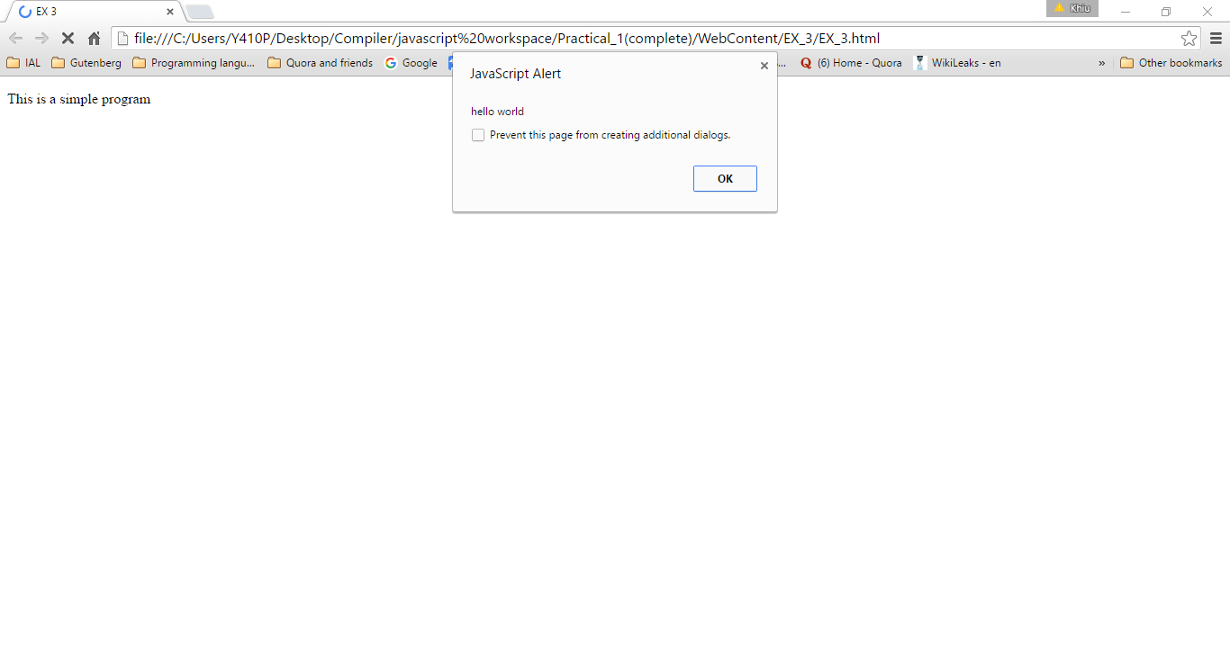

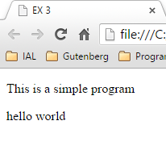

|  |  |
| --- | --- |
| HTML | <!DOCTYPE html>  <html>  <head>  <meta charset=*"ISO-8859-1"*>  <title>EX 3</title>  </head>  <body>  <p>This is a simple program</p>  <script type=*"text/javascript"* src=*"EX_3.js"*></script>  </body>  </html> |
| JS | /*  Name: EX_3  Purpose: Hello world function  */  alert("hello world");  document.write("hello world") |

**Exercise 4: Requesting Input with JavaScript**

1. Create a copy of the **practical1-1** in the same **MAD1** folder
2. Rename the copied folder as **practical1-2** folder
3. Using your text editor, modify **script.js** by typing the code found in **Listing C**
4. Open **container.html** in a web browser.
5. Type your name in the resulting text field.
6. Describe the output.
7. Explain in a few statements the function of the **prompt** and the **alert** statements.

|  |
| --- |
| var name=prompt(“What is your name?”);  alert(“Hello, “ + name); |

**Listing C**

Answer:

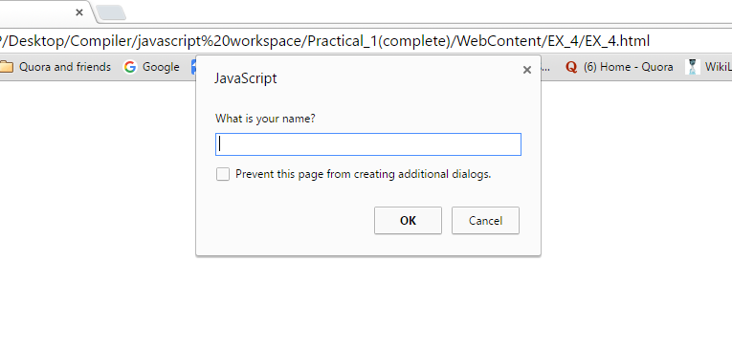

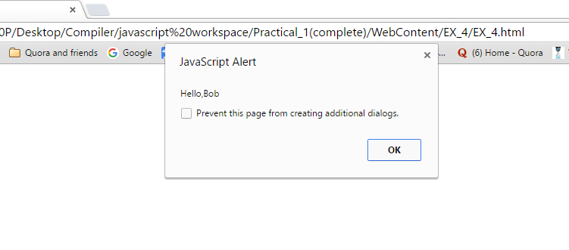

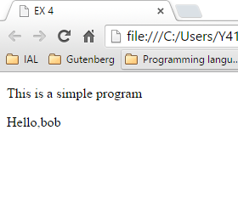

|  |  |
| --- | --- |
| HTML | <!DOCTYPE html>  <html>  <head>  <meta charset=*"ISO-8859-1"*>  <title>EX 4</title>  </head>  <body>  <p>This is a simple program</p>  <script type=*"text/javascript"* src=*"EX_4.js"*>  </script>  </body>  </html> |
| JS | /*  Name: EX_4  Purpose: Prompt and return name  */  **var** name=prompt("What is your name?");  alert("Hello,"+ name);  document.write("Hello,"+ name); |

**Exercise 5: Understanding JavaScript Variables**

1. Create a copy of the **practical1-1** in the same **MAD1** folder
2. Rename the copied folder as **practical1-3** folder
3. Using your text editor, replace code in **script.js** with the code found in **Listing D**
4. Open **container.html** in the browser. View the result.

|  |
| --- |
| var a;  alert("Original value of a: " + a);  a = 5;  a = 1000000;  a = 123.654;  a = -500;  alert("Final value of a: " + a);    var b = 123;  alert("b: " + b);  var c = "123";  alert("c: " + c);    var d = b + 10;  alert("d: " + d);  d = c + 10;  alert("d: " + d); |

**Listing D**

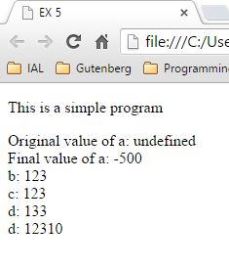

|  |  |
| --- | --- |
| **HTML** | <!DOCTYPE html>  <html>  <head>  <meta charset=*"ISO-8859-1"*>  <title>EX 5</title>  </head>  <body>  <p>This is a simple program</p>  <script type=*"text/javascript"* src=*"EX_5.js"*>  </script>  </body>  </html> |
| **JS** | /**  *  */  /*  Name: EX_5  Purpose: Understanding variables  */  **var** a;  alert("Original value of a: " + a);  document.write("Original value of a: " + a);  document.write("<br>")  a = 5;  a = 1000000;  a = 123.654;  a = -500;  alert("Final value of a: " + a);  document.write("Final value of a: " + a);  document.write("<br>")  **var** b = 123;  alert("b: " + b);  document.write("b: " + b);  document.write("<br>")  **var** c = "123";  alert("c: " + c);  document.write("c: " + c);  document.write("<br>")  **var** d = b + 10;  alert("d: " + d);  document.write("d: " + d);  document.write("<br>")  d = c + 10;  alert("d: " + d);  document.write("d: " + d); |

**Questions:**

* 1. Refer to Exercise 5. What will be the value of variable **a** once the program has **finished** executing?

Answer: a = -500

* 1. Explain the purpose of the **=** operator?

Answer: To assign value to a variable

* 1. What will be the value of **a** immediately after the statement **var a;**

Answer: null

* 1. Explain the purpose of the – operator in the statement **a= -500**;

Answer: To denote a negative number

* 1. Explain the difference between the literal **123** and **“123”.**

Answer: In the context of javascript the literal 123 would be a variable, while “123” would be a value to be assigned to a variable.