**School of Digital Media & Infocomm Technology (DMIT)**

**ST2111 Mobile Application Development I**

**Practical 1A**

**Install PhoneGap**

|  |
| --- |
| Objectives:  After completing this lab, you should be able to:   * Install Phonegap * Setup Android SDK * Create a mobile project. |

**Exercise 1: Install NodeJS**

1. PhoneGap requires NodeJS to be installed as a prerequisite.
2. Open a browser and visit [**http://nodejs.org/**](http://nodejs.org/)
3. Click the **install** button to begin installation.

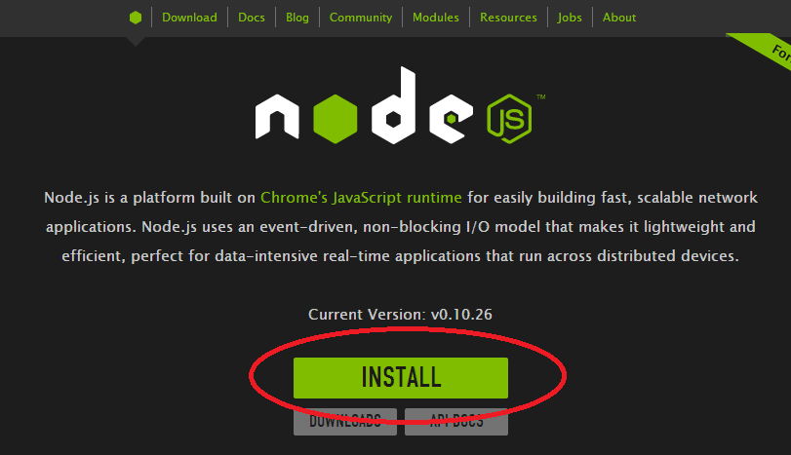

**Note:** You can verify the success of the installation by typing **node --version** on the command line.



**Exercise 2: Install PhoneGap**

1. From the Start screen click on **command prompt.** Type **npm install –g phonegap**
2. Press Enter.Wait until downloading of PhoneGap completes.

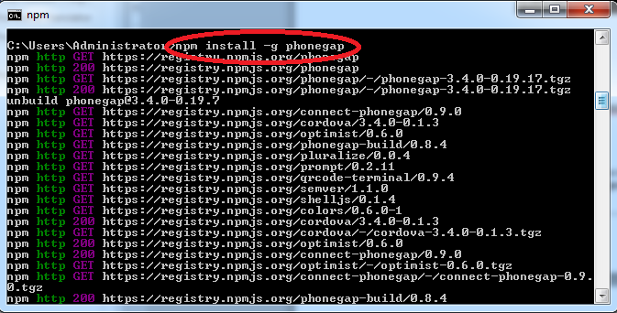

**Note:** You can verify the success of the installation by typing **phonegap –version** on the command line.

**Exercise 3: Verify Java**

1. Verify that Java is installed by going to the command prompt typing **java –version.** Java 1.7 is preferred. Android has some incompatiblity with Java 1.8.
2. If Java is not found, visit the Oracle website to download and install the latest version of Java: <http://www.oracle.com/technetwork/java/javase/downloads/index.html>

**Exercise 4: Install Android**

1. Open a browser and navigate to: [http://developer.android.com/sdk/index.html?hl=sk](http://developer.android.com/sdk/index.html?hl=sk%20%20)
2. Click the **Download the SDK**.
3. In the next page, select **I have read and agree with the above terms and conditions** and **32 bit**
4. Click the**Download the SDK ADT Bundle for Windows**button.
5. The ADT Bundle Zip file will be downloaded. Once completed, copy the zip file to c:\

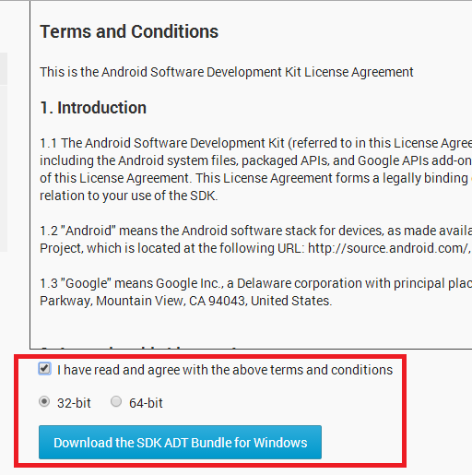

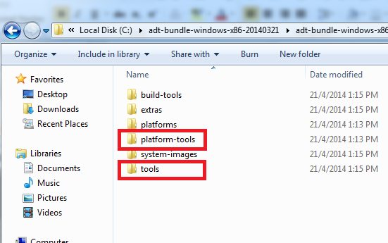

**Exercise 5: Add Android Directories to the System PATH environment variable**

Unzip the ADT bundle file. Note that the **sdk** folder is created. Inside the **sdk** folder are two sub-folders: **platform-tools** and**tools**. This two sub-folders have to be added to the PATH.

1. From the Desktop, right-click **This PC** and click **Properties**.
2. Click **Advanced System Settings** link in the left column.

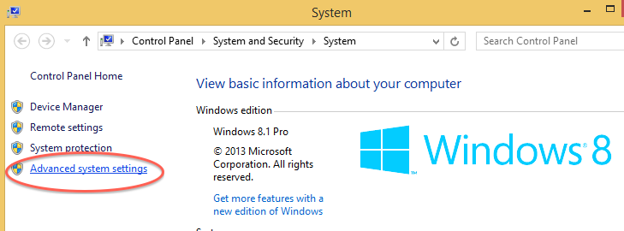

1. In the System Properties window click the **Environment Variables** button.
2. Select the **PATH** variable from the **System variables** section.

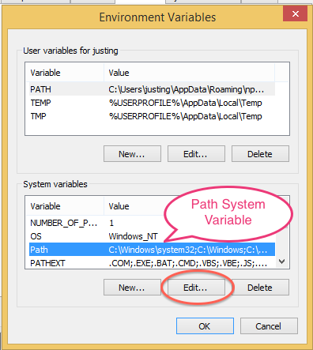

1. Select the **Edit** button.
2. In my example I will use **C:\android-sdk-win**as the directory the SDK is installed in. The directory names may vary.
3. Append the following directories to the text (**do not delete just append**):

**C:\android-sdk-win\platform-tools**

**C:\android-sdk-win\tools**

1. An example appended path will look like below:

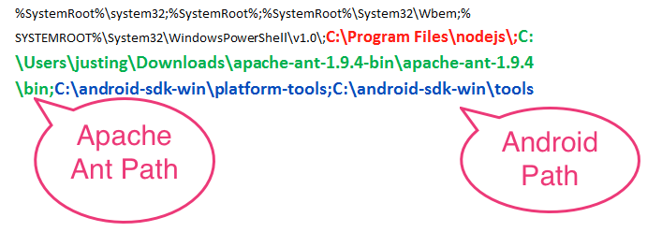

**Exercise 6: Install Android API 19**

1. From the command prompt type **android.**
2. The Android SDK manager will be launched.
3. Install Android API 19. This is required by PhoneGap to run.

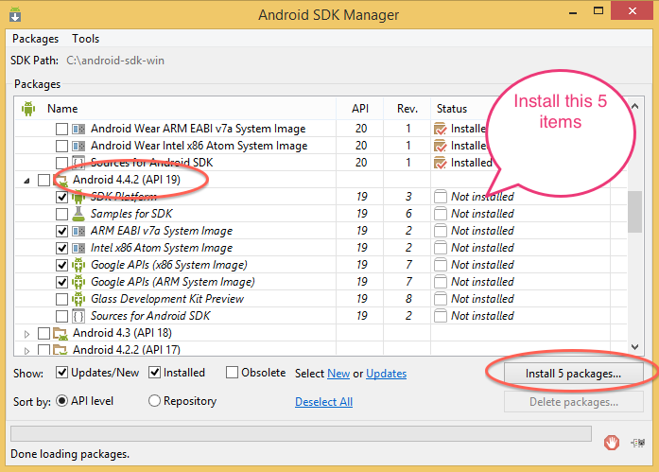

**Exercise 7: Setup Apache Ant**

1. Download Apache Ant from <http://ant.apache.org/bindownload>.

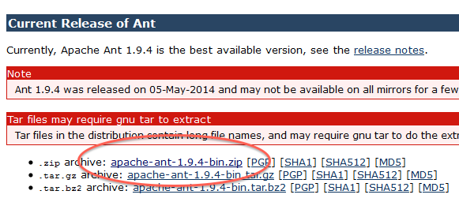

1. Unzip the file in a directory.
2. Place the **bin** directory into your system **PATH** variable.



1. Restart your PC.

**Exercise 8: Create Android Virtual Device (AVD)**

1. From the command prompt type **android.**
2. The Android SDK manager will be launched.
3. From Android SDK Manager menu select **Tools->Manage AVDs**

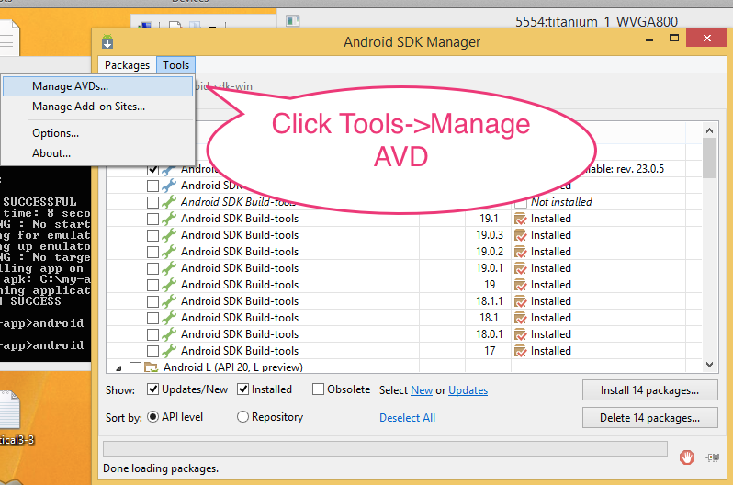

1. The AVD Manager is launched. Click **Create.**

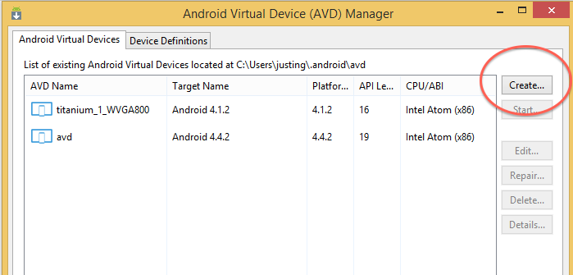

1. From the Create AVD window, modify the parameters based on the figure below. AVD Name: firstAVD, Device: Nexus 4, Target: Android 4.4.x, CPU/ABI: Intel or ARM, Skin: HVGA, RAM: 768, Use Host GPU: Checked

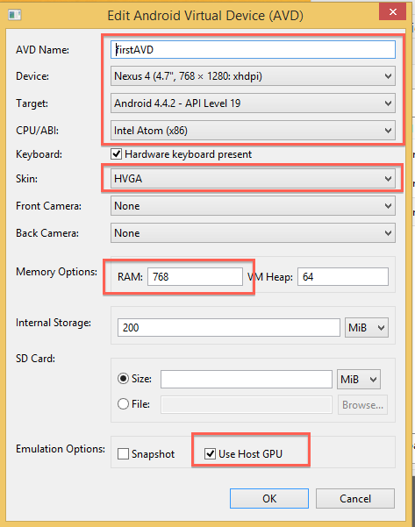

1. Click **ok**
2. Notice that your AVD is listed in the AVD manager.

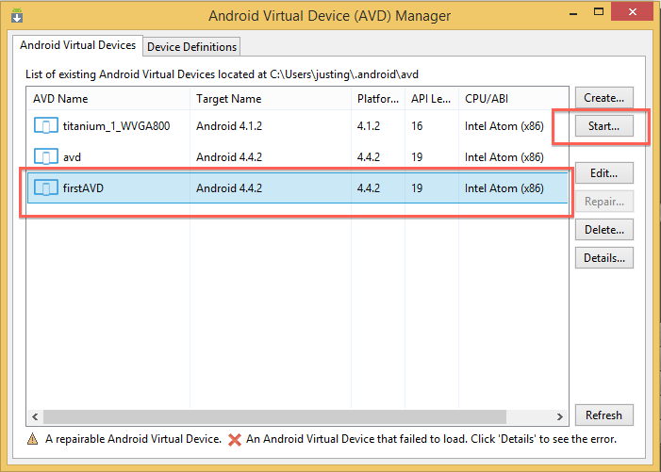

1. Click **Start**. AVD manager is launched.

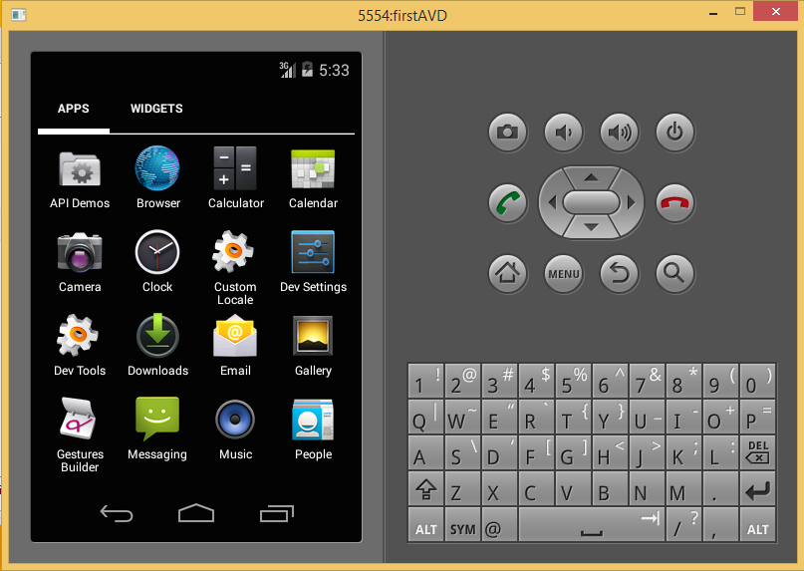

**Exercise 9: Create and Execute a PhoneGap Project**

1. From the Start screen click on the **command prompt** to go to the windows console.
2. type **cd\** to bring you to the root directory **c:\**
3. Type **phonegap create first-app** press *Enter*
4. Type**cd first-app** press Enter
5. Type **phonegap run android**
6. This may take a few minutes. The Android Emulator is launched (see a sample below) and the default PhoneGap project is running on the emulator. You may also view the webpage (index.html) in a browser.

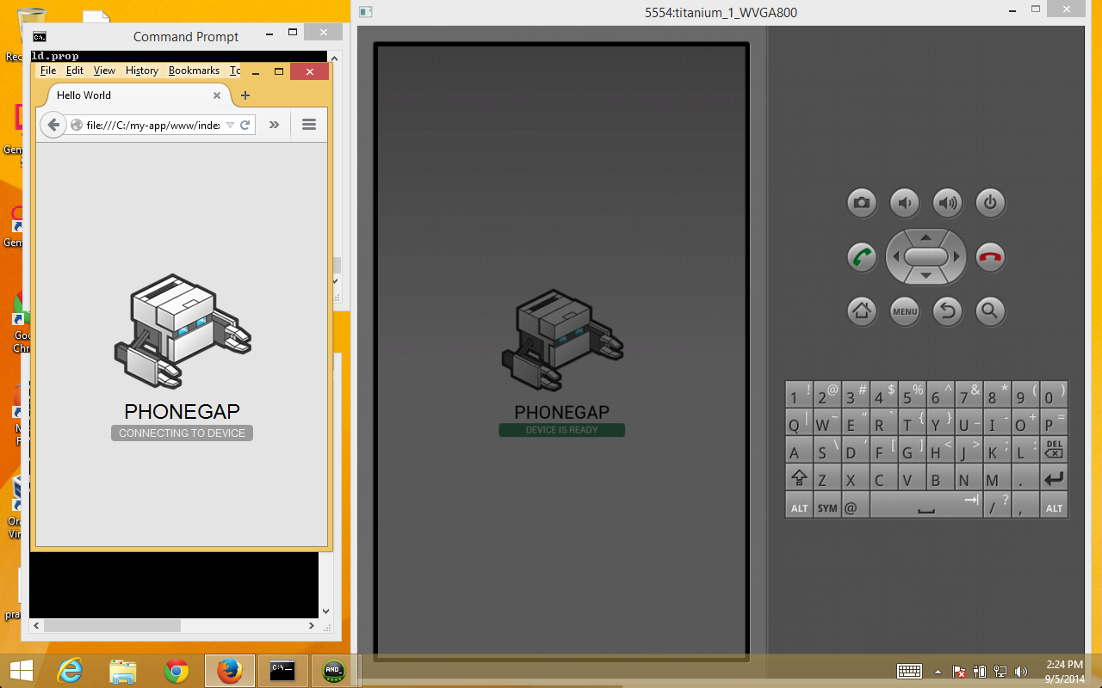

**Exercise 10: Modify PhoneGap Template**

1. Notice that creating a PhoneGap project includes a predefined index.html. You can test your JavaScript programs in the browser or in the Android emulator.
2. Navigate to the www folder and modify **index.html** with the code shown in **bold** in Listing A:

|  |
| --- |
| <html>  <head>  <meta charset="utf-8" />  <meta name="format-detection" content="telephone=no" />  <meta name="msapplication-tap-highlight" content="no" />  <!-- WARNING: for iOS 7, remove the width=device-width and height=device-height attributes. See https://issues.apache.org/jira/browse/CB-4323 -->  <meta name="viewport" content="user-scalable=no, initial-scale=1, maximum-scale=1, minimum-scale=1, width=device-width, height=device-height, target-densitydpi=device-dpi" />    <title>Hello World</title>  </head>  <body>  **<h3>My First Javascript</h3>**    <script type="text/javascript" src="cordova.js"></script>  <script type="text/javascript" src="js/index.js"></script>  <script type="text/javascript">  app.initialize();  </script>  **<script src="script.js"></script>**  </body>  </html> |

**Listing A. index.html**

1. Create a **script.js** page and copy into the same directory as **index.html**. Modify **script.js** with the code found in Listing B. Using the same steps as in Exercise 9, run the program in the Android emulator.

|  |
| --- |
| var num = 5;  var i = 0;    document.write('<table border="1" cellspacing="0">');  for(i=1;i<10;i++) {  document.write("<tr><td>" + num + " x " + i + " = " + num*i + "</td></tr>");  }    document.write("</table>"); |

**Listing B. script.js**

