**School of Digital Media & Infocomm Technology (DMIT)**

**ST2111 Mobile Application Development I**

**Practical 6**

**Debugging**

|  |
| --- |
| Objectives:  After completing this lab, you should be able to:   * learn how to use Firebug debugging tool * debug Javascript programs * list common errors in Javascript |

**Exercise 1: View commong Javascript errors using Firebug**

1. Create a copy of the **practical1-1** in the same **MAD1** folder
2. Rename the copied folder as **practical6-1**
3. Save the code in **Listing A** in **container.html** and **Listing B** in **script.js**.
4. Open the webpage in Firefox. Open Firebug (**Figure A**) and click the **Console** tab.
5. Each line in the function **convert** contains an error. List three error messages that Firebug will display. For each error message explain the cause of the error.

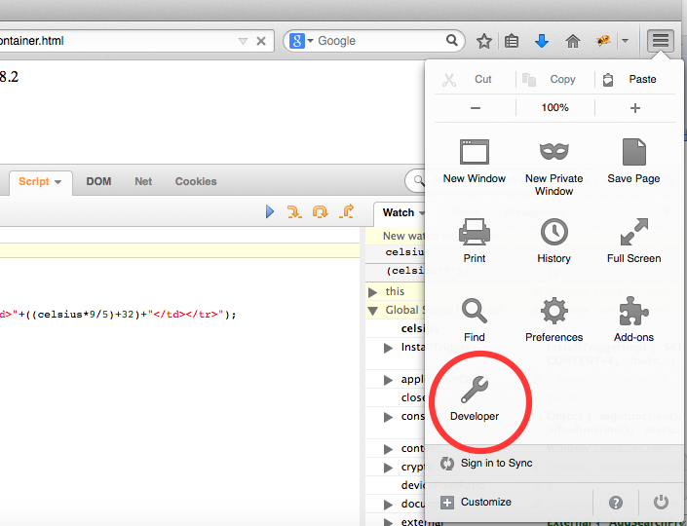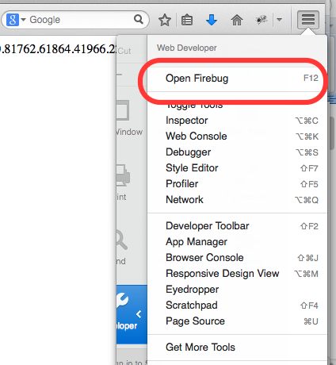

**Figure A. Open Firebug**

<html>

<head>

</head>

<body>

<script src=’script.js’></script>

<p>Insert a number into one of the input fields below:</p>

<input type="text" id="myinput" "> degrees Celsius<br>

<input type="button" value="Convert" onClick='convert()' />

</body>

</html>

**Listing A. container.html**

function convert() {

var input=document.getElementByID("myinput").value

var num=parsefloat(input);

var result = num * 9 / 5 + 32,

documen.write(result);

}

**Listing B. script.js**

Answer:

* 1. Convert is not defined.



* 1. Improper syntax on “var result”.





* 1. Extra “.





* 1. Also wrong spelling of common



**Exercise 2: Set Breakpoints and Step Into a Program**

1. Create a copy of the **practical1-1** in the same **MAD1** folder
2. Rename the copied folder as **practical6-2**
3. Save the code in **Listing A** in **container.html** and **Listing B** in **script.js**.
4. Open the webpage in Firefox. Ensure Firebug is opened and click the **Script** tab.
5. Set a breakpoint by clicking the line number (Figure B). Refresh the webpage. Notice that the program stops at the breakpoint.
6. Try the **Continue** button (F8). To continue program execution from the breakpoint, click the **Continue** button (Figure B).
7. Try the Step Into button (F11). To move to the next line click the **Step Into** button (Figure B).
8. Research on the internet. How do breakpoints help in debugging a program?

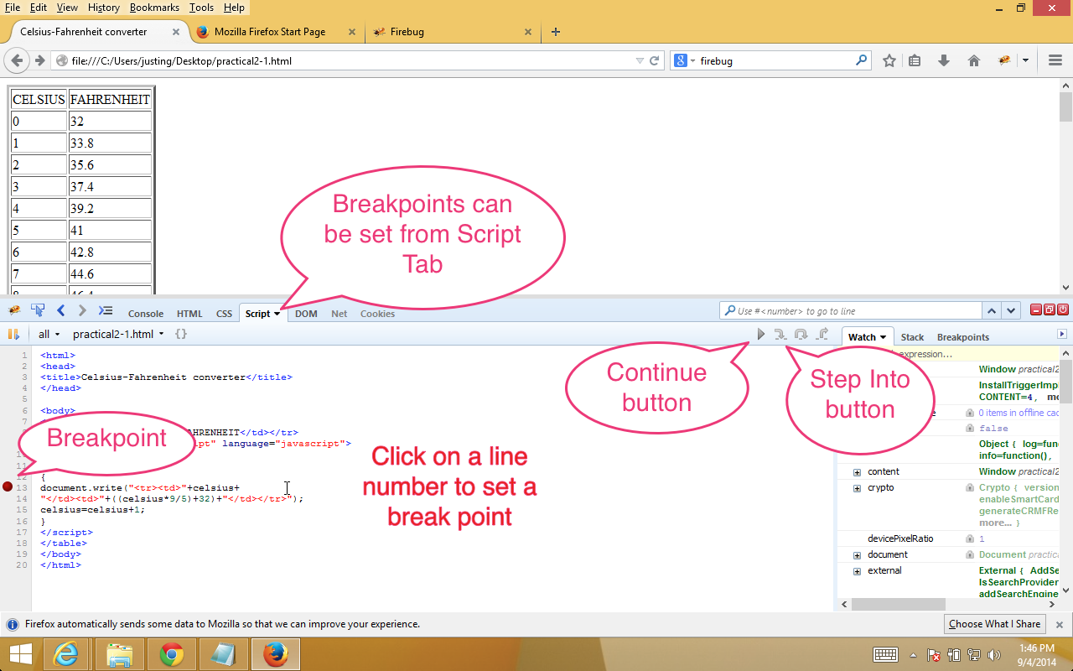

**Figure B**

<html>

<head>

<title>Celsius-Fahrenheit converter</title>

</head>

<body>

<script src=’script.js’></script>

<table border=3>

<tr><td>CELSIUS</td><td>FAHRENHEIT</td></tr>

</table>

</body>

</html>

**Listing B. container.html**

celsius=0;

while (celsius<=50)

{

//console.log(celsius);

document.write("<tr><td>"+celsius+"</td><td>"+((celsius*9/5)+32)+"</td></tr>");

celsius=celsius+1;

}

**Listing B. script.js**

Answer: Breakpoints allow engineers to debug code by section (as determined) by said engineer. This makes isolating errors easier, especially complex algorithms or programs are involved (i.e. Operating Systems).

**Exercise 3: Watching Variables**

1. Ensure **container.html** from Exercise 2 is opened in Firefox.
2. Ensure Firebug is opened and click the **Script** tab. Place a breakpoint inside the while loop.
3. We will observe the how the value of c**elsius** variable changes as the program is executed. Click the **Watch menu item->New Watch Expression**.
4. In the textbox type **celsius**.
5. Refresh the webpage. Notice that the program stops executing at the breakpoint.
6. Notice that the celsius variable is listed in the watch window with the value of 0.
7. Click the continue button. Notice that celsius button changes value increasing by 1 each time the loop is executed (Figure C).

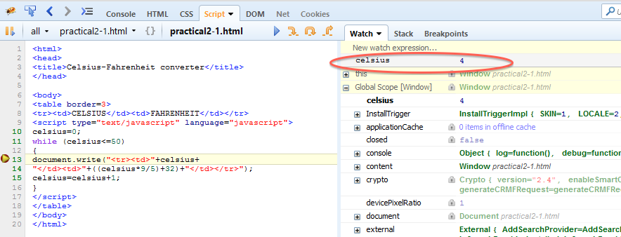

**Figure C**

**Exercise 4: Watching Variables using console.log**

1. Ensure **container.html** from Exercise 2 is opened in Firefox
2. Ensure Firebug is opened and click the **Script** tab. Place a breakpoint inside the while loop.
3. We will observe the how the value of c**elsius** variable changes as the program is executed using **console.log**. Uncomment **console.log(celsius);** by removing //
4. Refresh the webpage. Notice that the program stops executing at the breakpoint. Click **Console** tab.
5. Notice that the celsius variable is listed in the console window.
6. Click the **continue** button. Notice that celsius button changes value increasing by 1 each time the loop is executed.
7. Research on the internet. Explain how the watch variable can be useful for debugging your Javascript program.

Answer: This can be used to ensure that the desired variable is behaving as it is supposed to.

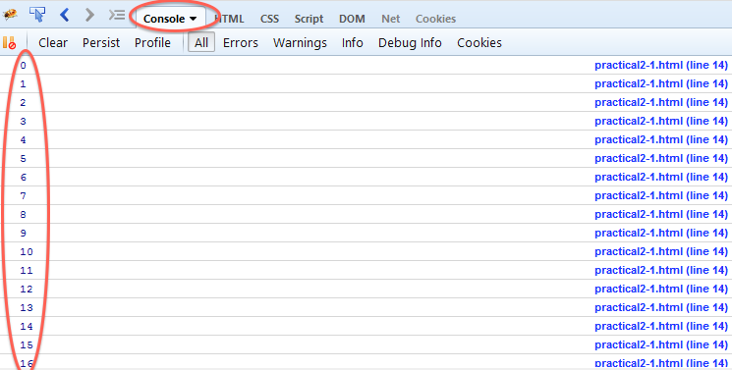

**Figure D**

**Exercise 5: Debugging Nested Loops**

1. Create a copy of the **practical1-1** in the same **MAD1** folder
2. Rename the copied folder as **practical6-5.**
3. Copy the code in **Listing C** to **script.js.**
4. The code in **Listing C** is supposed to display a multiplication table. Correct the errors in the program. You may use Firebug tools to aid in debugging the program.

// Use single-spaced text for Multiplication table

document.write("<CENTER><BLOCKQUOTE><STRONG><PRE><FONT COLOR='000080'>’)

for (i = 1, i <= 10; i++) {

for (j = 1; j < 10) {

total = i * j

total = " " + Total;

///add space before each number

// Add another space before single digits

if total < 10

{

total = " " + total;

}

// Display result

document.write(total);

} // end inner j loop

document.write(<BR>); // end of line break

} // end of i outer loop

document.write("</FONT></PRE></STRONG></BLOCKQUOTE></CENTER>’);

**Listing C**

Answer:

document.write("<CENTER>"+"<BLOCKQUOTE>"+"<STRONG>"+"<PRE>"+"<FONT COLOR='000080'>");

**for** (i = 1; i <= 10; i++) {

**for** (j = 1; j < 10;) {

total = i * j

total = " " + Total;

///add space before each number

// Add another space before single digits

**if** (total < 10){

total = " " + total;

}

// Display result

document.write(total);

} // end inner j loop

document.write("<BR>"); // end of line break

} // end of i outer loop

document.write("</FONT>"+"</PRE>"+"</STRONG>"+"</BLOCKQUOTE>"+"</CENTER>");