TATA ONLINE RETAIL 2011

Power BI Data Visualization — Project Report
Project Type: Data Analytics and Business Intelligence
Tool: Microsoft Power BI Desktop
Dataset: Online Retail Transactions, 2011

1. Executive Summary
This project explores retail transaction data from 2011 using Microsoft Power BI. The purpose is to transform raw transaction data into visual information that supports business understanding and decision-making.
The report focuses on four areas: monthly revenue trends, country performance, top customers by revenue, and geographic product demand.

2. Business Context and Objectives
Retail businesses need to understand how revenue changes over time, which markets generate sales, and which customers contribute most to revenue.
The project follows three tasks:
- Task 1 — Framing the Business Scenario: Define relevant questions from the perspectives of the CEO and the Chief Marketing Officer (CMO).
- Task 2 — Choosing the Right Visuals: Select suitable visual types for the business questions.
- Task 3 — Creating Effective Visuals: Develop a Power BI report to explore the data and communicate findings.

3. Data Preparation
Before developing the visuals, records with invalid transaction values were excluded using the following conditions:
- Quantity below 1.
- Unit Price below 0.
The United Kingdom was excluded from the country-ranking and geographic-demand visuals so that other markets could be examined separately.
These preparation steps help make the report more suitable for comparing revenue and product demand.

4. Report Pages and Visualizations

4.1 Monthly Revenue Analysis — 2011
Visual: Line chart
This page displays monthly revenue across 2011. A line chart is suitable for showing changes over time and helping identify peaks, declines, and possible seasonal patterns.
Business value: It helps stakeholders identify periods of strong or weak revenue and determine which months may require further investigation.

4.2 Top 10 Countries by Revenue and Quantity Sold
Visuals: Two horizontal bar charts
The first chart ranks countries by revenue, while the second ranks them by quantity sold. The United Kingdom is excluded from both views.
Business value: Comparing these two measures helps distinguish markets with high revenue from markets with high sales volume. The rankings can support further investigation of international market performance.

4.3 Top 10 Customers by Revenue
Visual: Horizontal bar chart
This page ranks the ten customers who generated the highest revenue.
Business value: It highlights high-revenue customers and provides a starting point for customer segmentation and retention analysis. Revenue alone does not measure profitability or customer loyalty.

4.4 Product Demand by Country
Visual: Geographic map
The map displays product demand by country, excluding the United Kingdom. Bubble sizes help users explore differences in demand across geographic markets.
Business value: The map provides a geographic overview that can guide further investigation into market opportunities and regional sales patterns.

5. Key Findings
The Power BI report revealed the following findings:
- Monthly revenue growth: Revenue increased from $759,138.38 in August to $1,058,590.17 in September 2011, representing a 39.45% increase.
- Highest-revenue month: November 2011 recorded total revenue of $1,509,496.33.
- Leading non-UK markets: The Netherlands ranked first by revenue at $285,446.34, followed by EIRE (Ireland) at $283,453.96 and Germany at $228,867.14.
- Highest-revenue customer: Customer ID 14646 generated $280,206.02 in revenue.
These findings highlight changes in monthly revenue, differences in international market performance, and the contribution of a high-value customer. The results should be interpreted in the context of the dataset and the report's data-preparation filters.

6. Recommendations
Based on the Power BI findings, the following actions are recommended:
- Investigate revenue growth: Examine the factors associated with the 39.45% increase in revenue from August to September 2011 and determine whether similar patterns occurred in other months.
- Evaluate international markets: Review performance in the Netherlands, EIRE (Ireland), and Germany to identify opportunities for further market analysis and potential business growth.
- Strengthen customer analysis: Investigate the purchasing patterns of high-revenue customers, including Customer ID 14646, to identify potential customer-retention and segmentation opportunities.
- Explore geographic demand: Use the geographic visualization to identify differences between markets and select countries for more detailed investigation.
- Validate reporting periods and data quality: Check data completeness and comparability across months, particularly when interpreting monthly revenue differences and possible seasonal patterns.
- These recommendations represent opportunities for further investigation. The visualizations show patterns and differences in the available data but do not, on their own, establish the causes of those patterns.

7. Limitations
- Descriptive analysis only: The report describes historical sales patterns and does not perform forecasting or establish causal relationships.
- Revenue is not profit: Revenue rankings do not measure profitability because product costs, operating expenses, and profit margins are not analyzed.
- Dependence on data preparation: Country and customer rankings may be affected by the selected period and the applied data-cleaning filters, including the exclusion of records with Quantity below 1 or Unit Price below 0.
- Geographic scope: The United Kingdom is excluded from the country-ranking and geographic-demand visualizations, so these views do not represent the complete set of country-level markets.
- Monthly comparability: December results should be interpreted cautiously if the dataset does not cover the full month. Comparisons between months may be affected by differences in data completeness.

8. Conclusion
This project demonstrates how Power BI can transform retail transaction data into meaningful business insights through data preparation, visualization, and descriptive analysis.
The report examines four key perspectives: monthly revenue trends, international country performance, high-revenue customers, and geographic product demand. The analysis identified a 39.45% revenue increase from August to September 2011, November as the highest-revenue month among the reported results, and the Netherlands as the leading non-UK country by revenue.
By combining clear visualizations with data-driven findings, the project provides a foundation for further investigation into sales performance, customer behavior, and international markets. The results also highlight the importance of data quality and careful interpretation when communicating business insights.

Appendix — Power BI Screenshots
Insert the following screenshots from the final Power BI report:
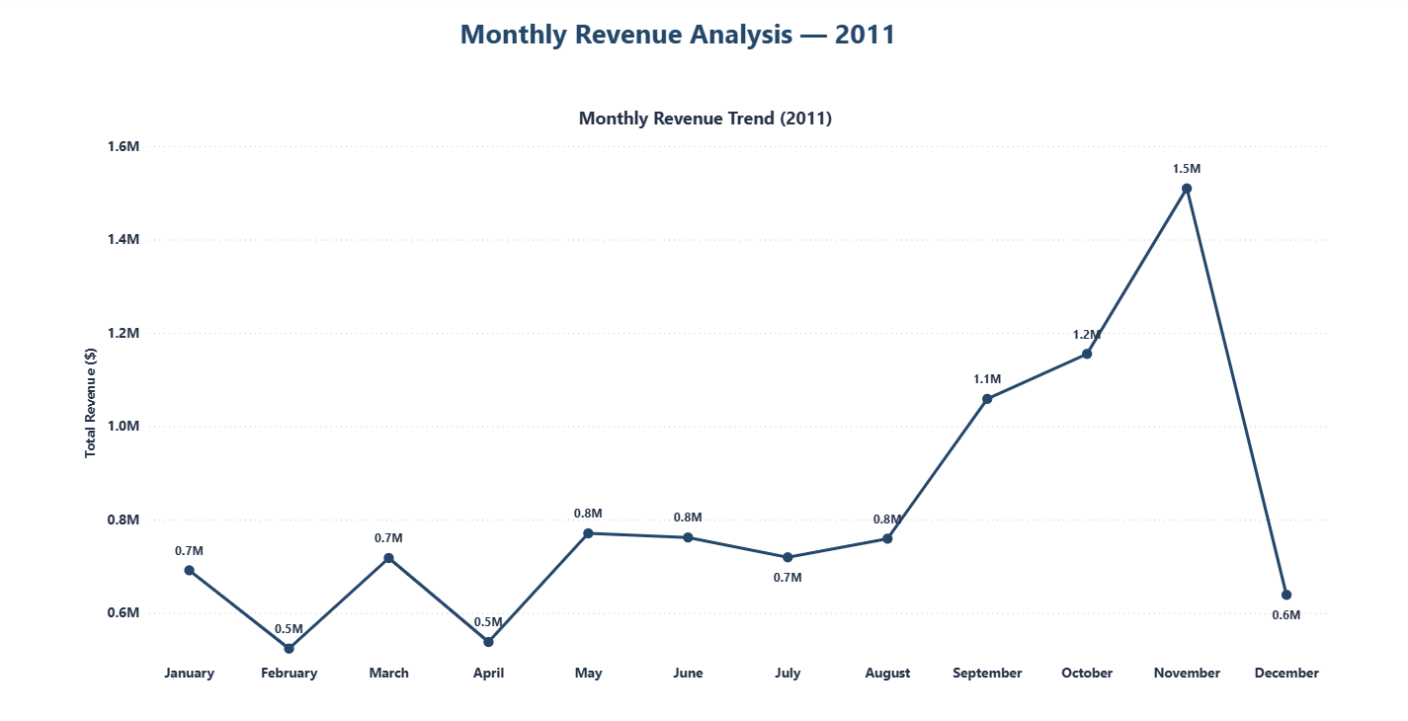
Figure 1.Monthly Revenue Analysis — 2011

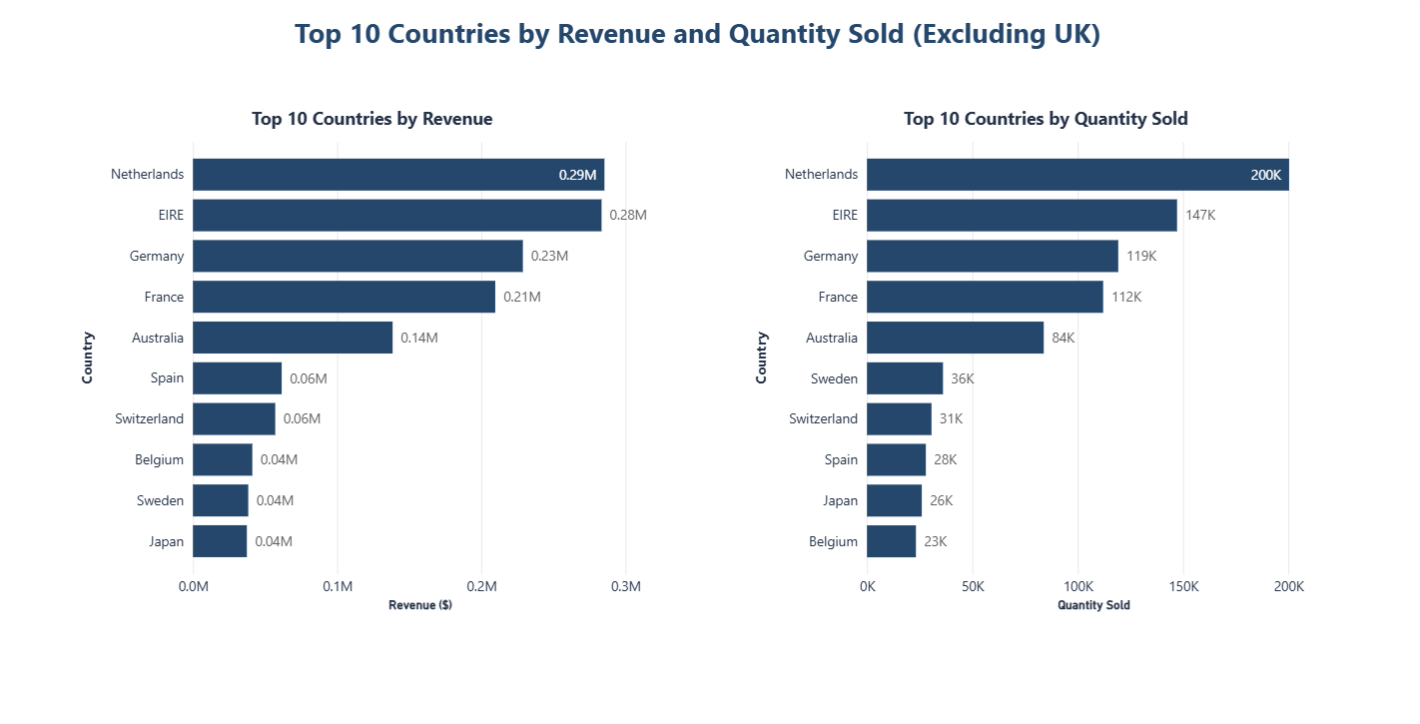
Figure 2.Top 10 Countries by Revenue and Quantity Sold (Excluding UK)

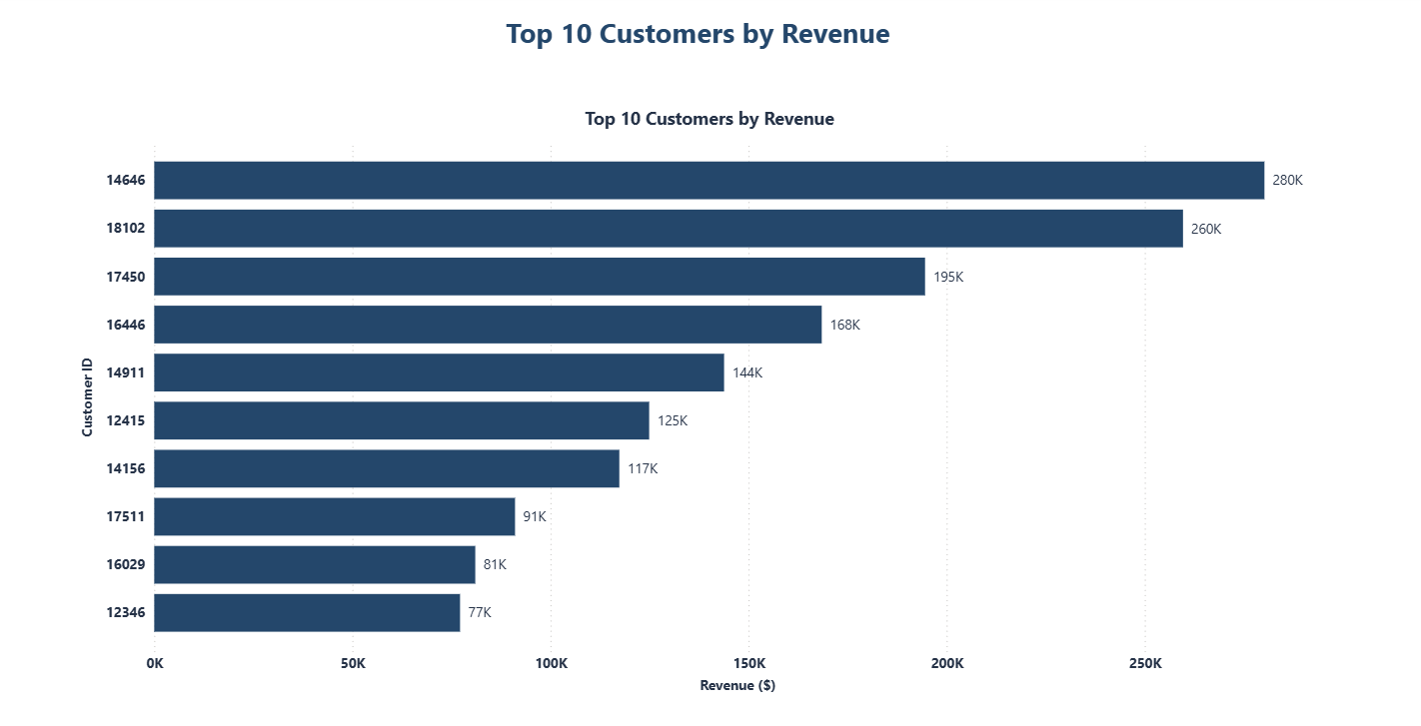
Figure 3.Top 10 Customers by Revenue

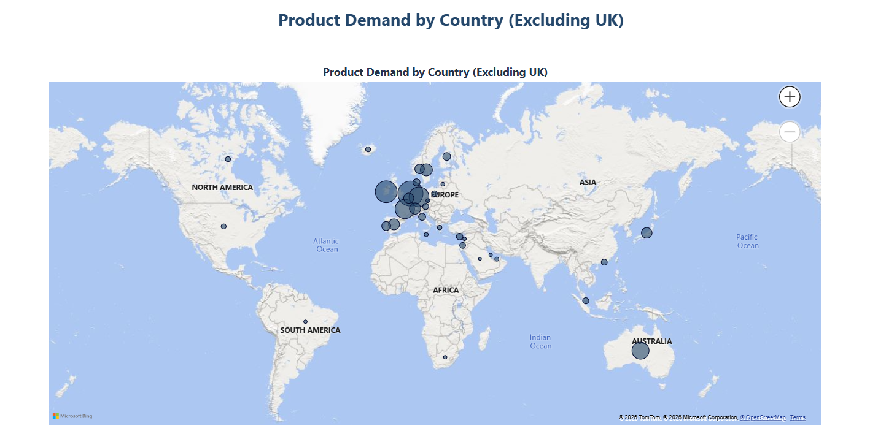
Figure 4.Product Demand by Country (Excluding UK)

Author: Khalil Azennoud
Project: Tata Online Retail 2011 — Data Visualization with Power BI

