|  |  |  |  |
| --- | --- | --- | --- |
|  |  |  |  |
| [Root, parsed] | [a, sentence] | Parsed-> Today | LEFT-ARC |
| [Root, parsed, a] | [sentence] |  | SHIFT |
| [Root, Parsed, a, sentence] | [] |  | SHIFT |
| [Root, Parsed, sentence] | [] | Sentence-> a | LEFT-ARC |
| [Root, Parsed] | [] | Parsed-> sentence | RIGHT-ARC |
| [Root] | [] | Root-> parsed | LEFT-ARC |

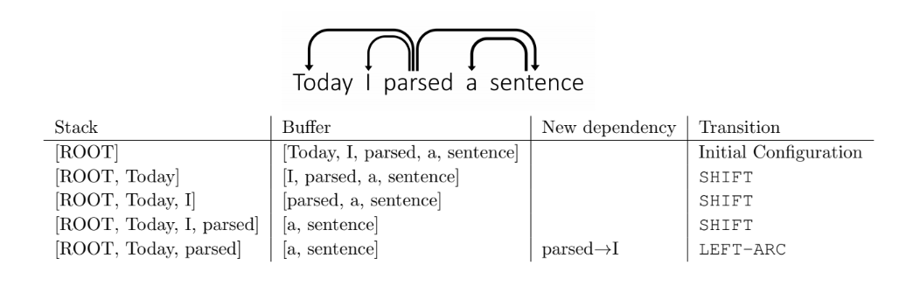**Assignment 3**

Khlod Mohamed Ali

5695