**INSTALLATION GUIDE**

# **Download and Extract File**

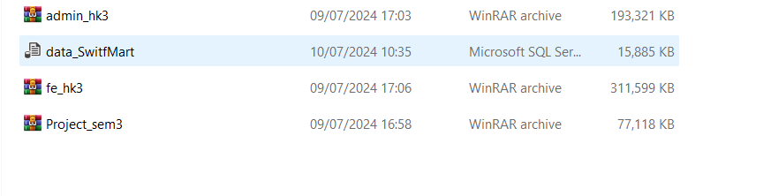You need to download and extract 3 files as shown in the image.

After extracting, you will get 3 folders as shown in the image.

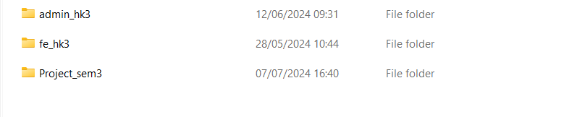

# **Admin/Super Admin**

To start the Admin page, you need to follow these steps.

## **2.1 Open your visual studio code and click on “Open Folder”**

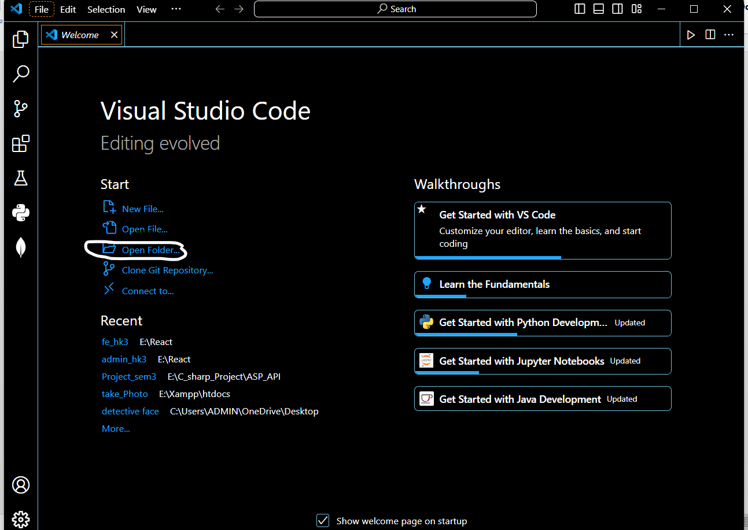

## **2.2 Select folder “admin_hk3”**

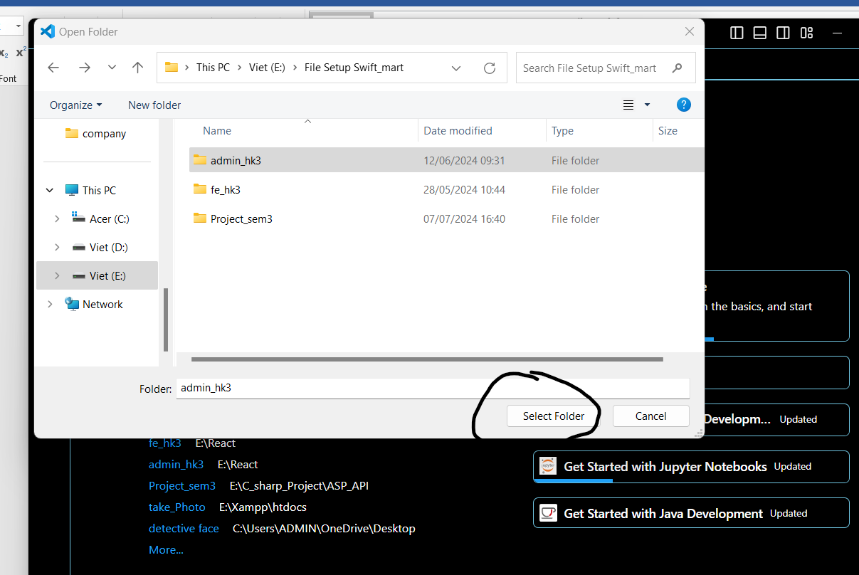

## **2.3 Open Terminal like this**

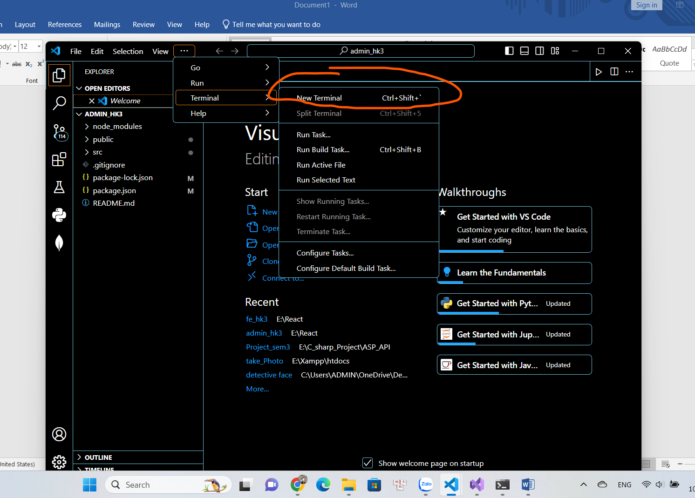

Enter the command.

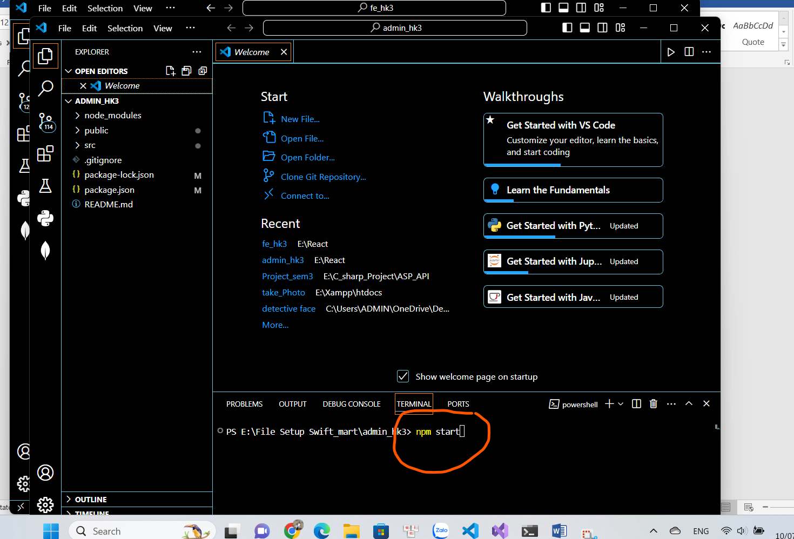

Then website will be start.

# **Customer/Guest**

To start the Admin page, you need to follow these steps.

## **3.1 Open your visual studio code and click on “Open Folder”**



## **3.2 Select folder “fe_hk3”**

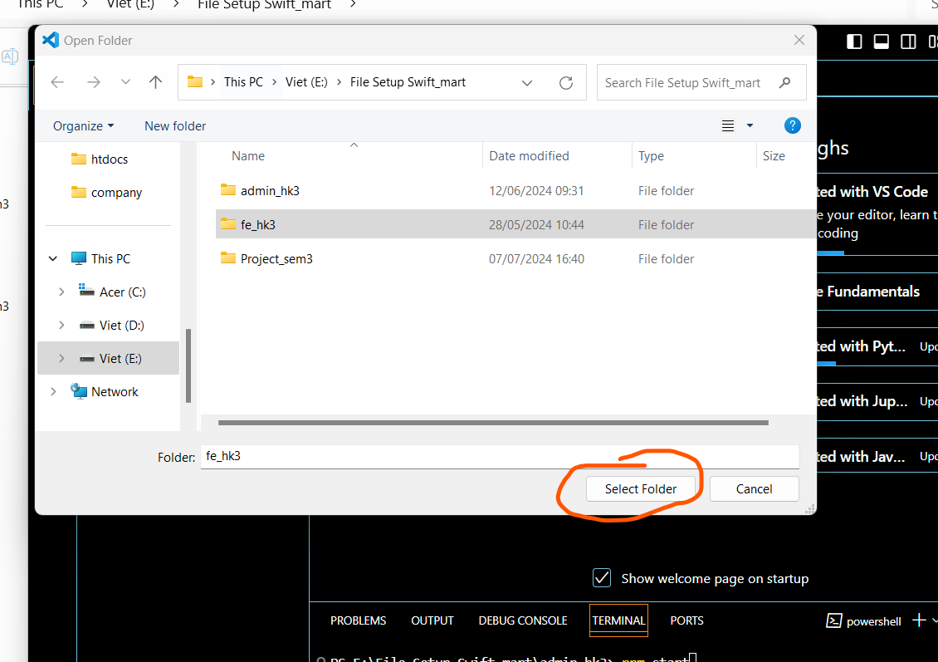

## **3.3 Open Terminal like this**

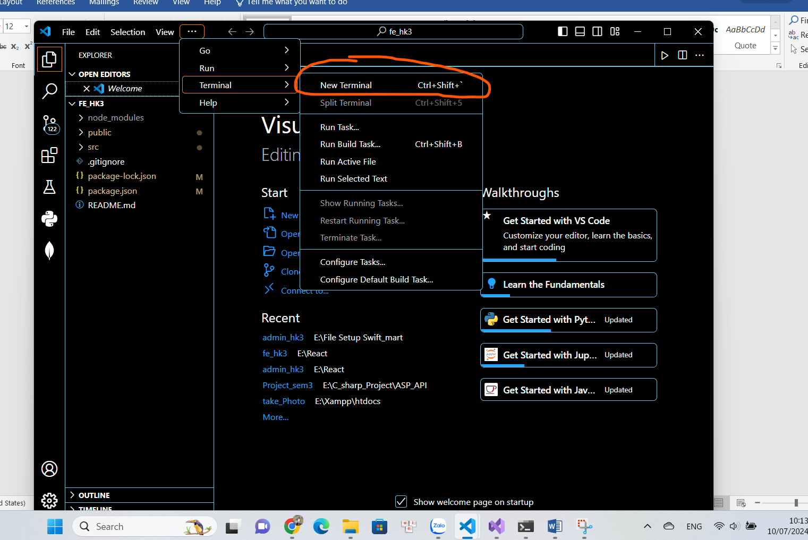

Enter the command.

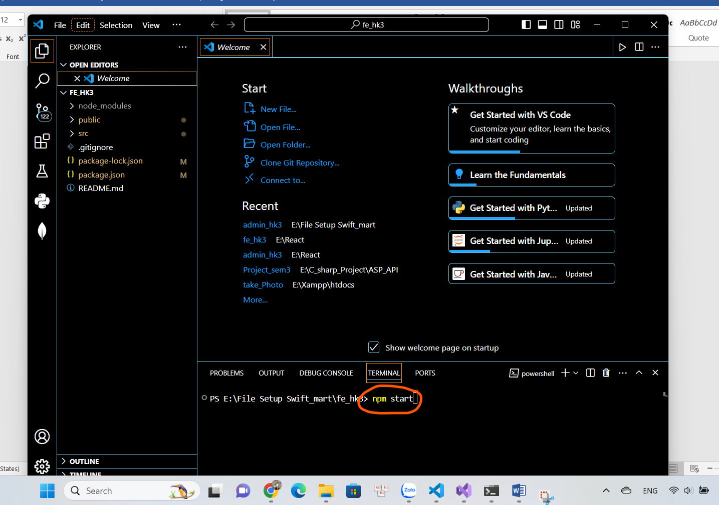

If a command line like this appears, enter “y”.

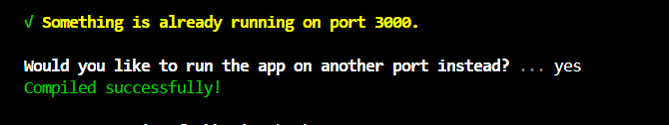

Then website will be start.

# **API Server**

To start API Server, open your visual studio (in this project we use version 2022 and .Net version 8.0).

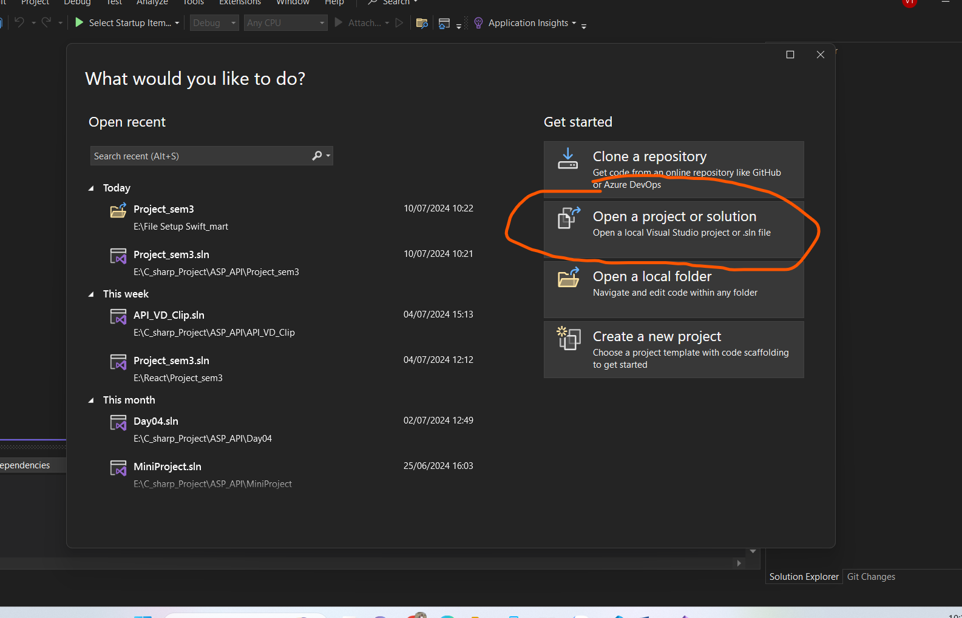

Select folder “Project_sem3”

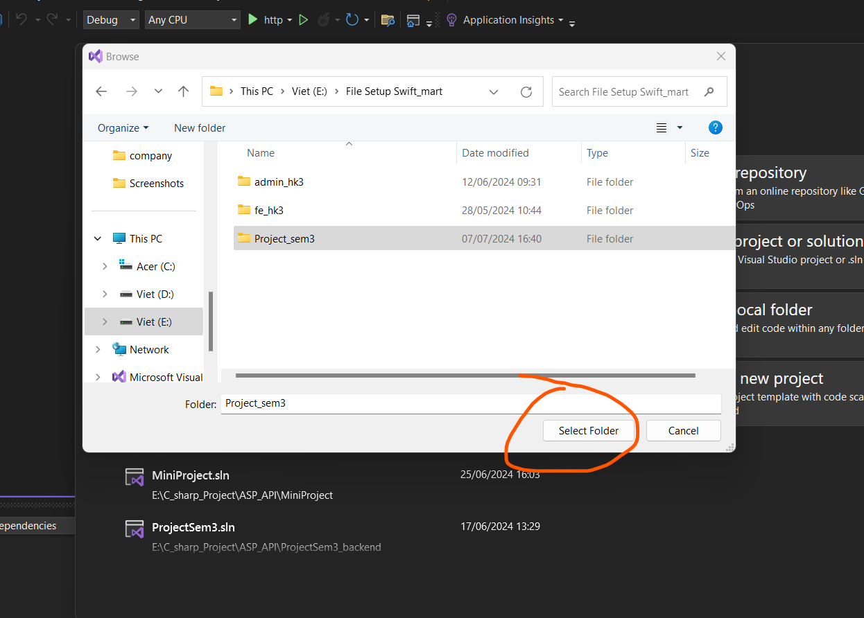

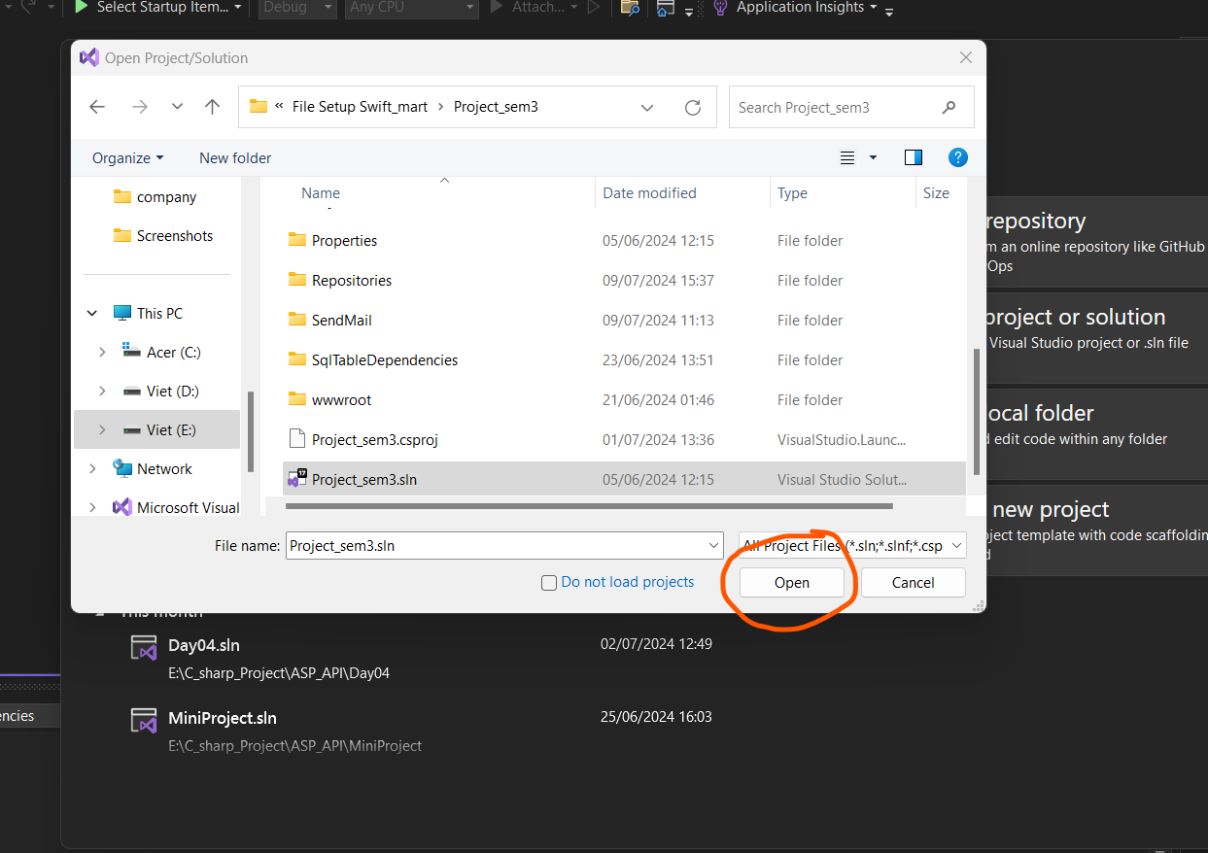

Now you need to your connectionString first

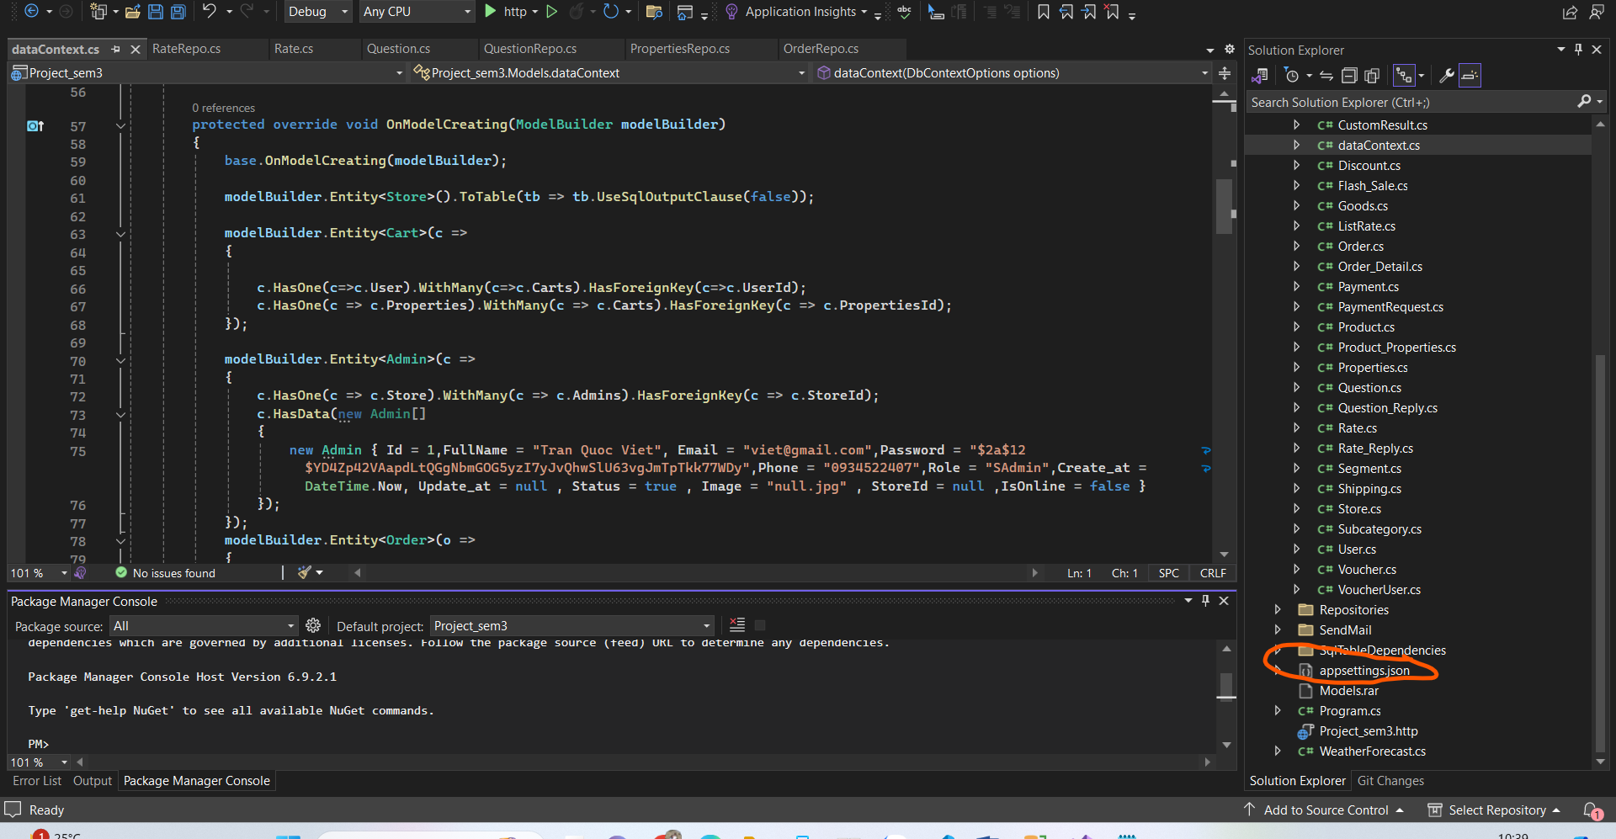

You need to select a database for storage for this project, and you also need to use your username and password to connect to the SQL Server.

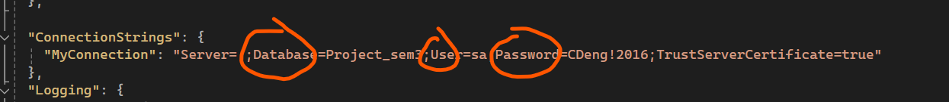

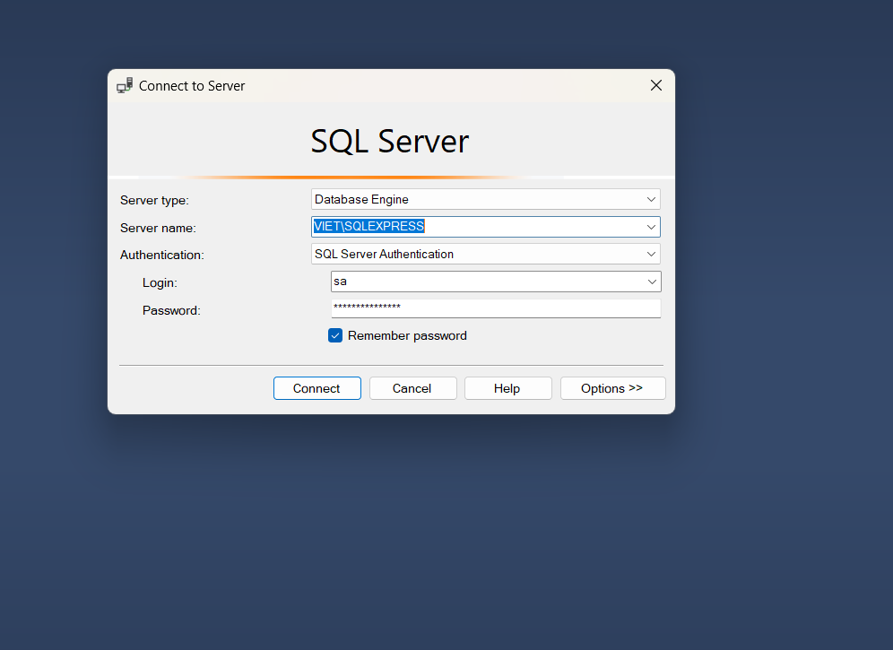

Then open Package Manager Console.

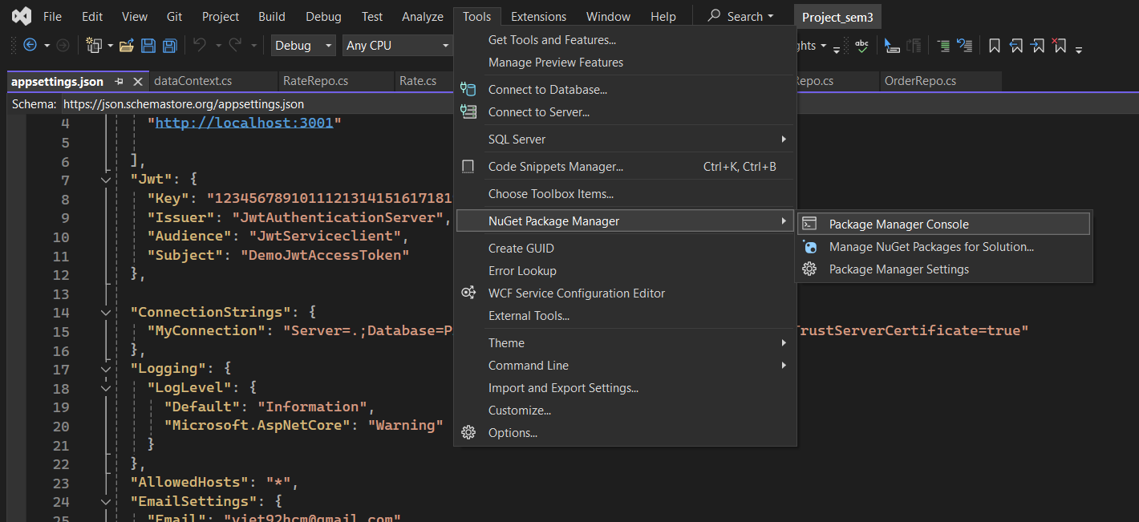

Run this command.

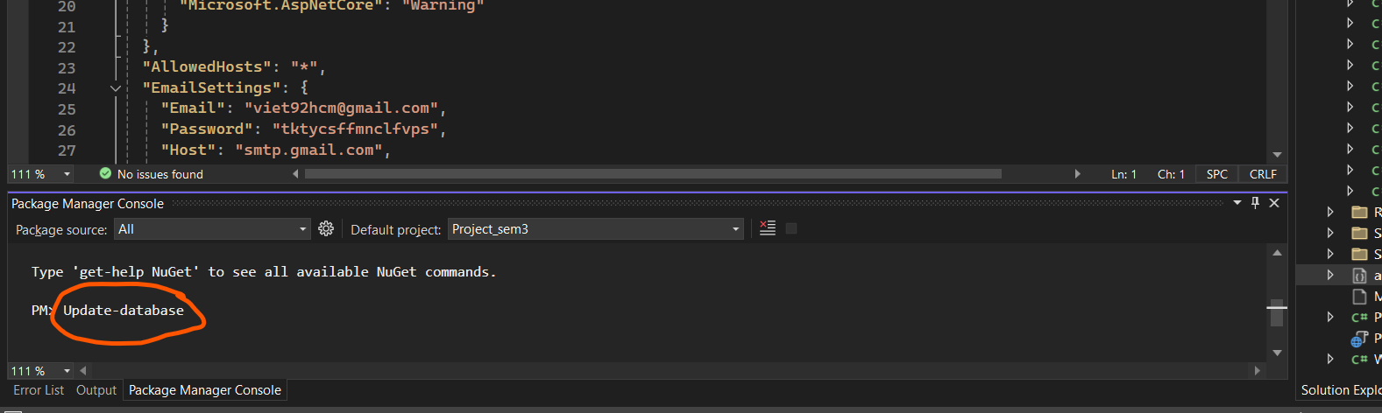

Then open this flie with SQl Server.

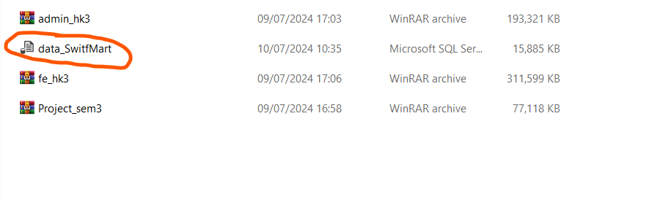

Change to your database name here, and Execute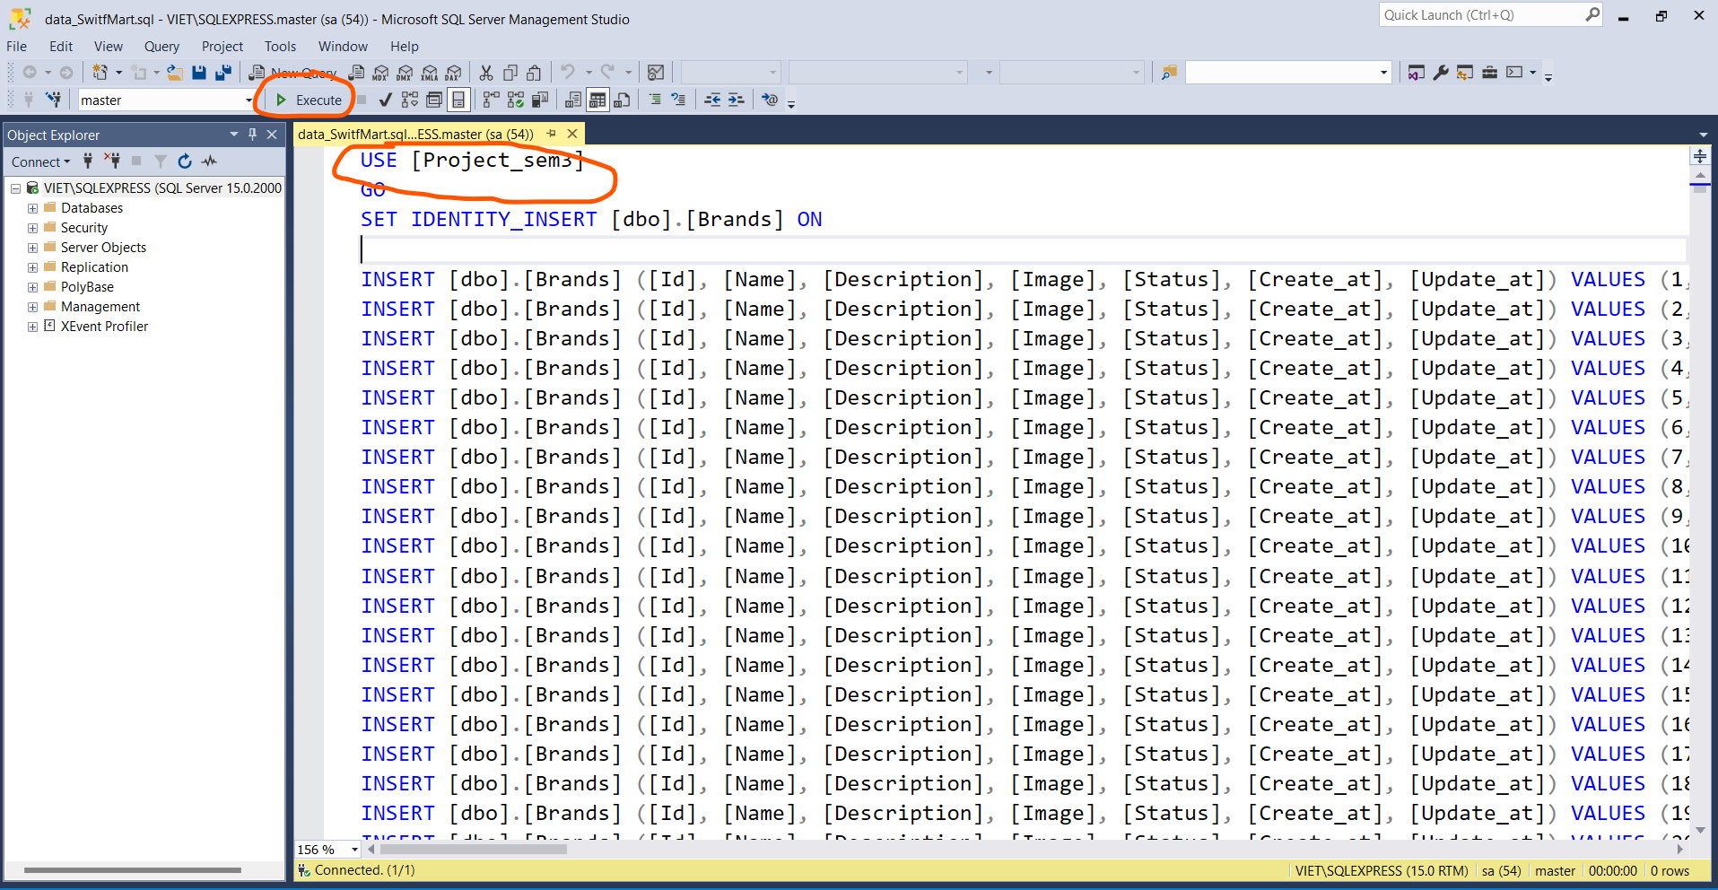

Now you can run visual studio.

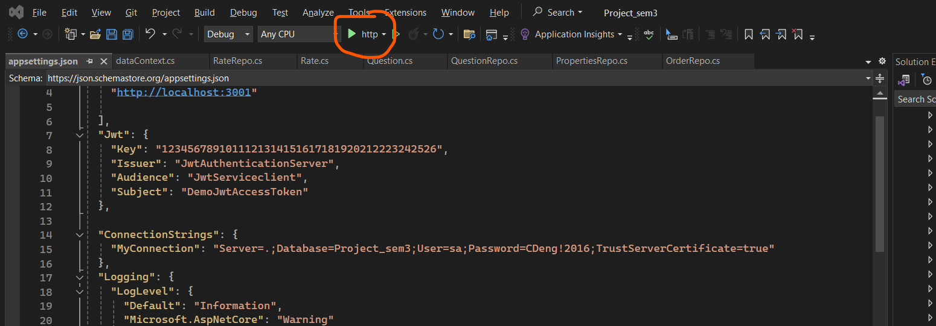

Those are all the steps you need to start the Swift-Mart project. Thanks for reading.