**Name**: Khlood Montaser abdelnabi

**B.N**: 328

**Topic**: Computer Architecture

**GitHub Link:** <https://github.com/khloodmo/ece001>

**GitHub Pages:** <https://khloodmo.github.io/ece001/>

*Computer Architecture:*

Computer architecture is a set of rules that explain how to link computer software and hardware together and interact to make the computer work. It determines not only how the computer works, but also the technologies the computer can use. Computers continue to be a large part of our lives, and computer engineers try to continue the development of new and better programs and technologies.

Computer engineering is a specification that describes how hardware and software technologies interact to create a platform or a computer system. When we think of the word architecture, we think of building a house or building, and also the computer architecture includes building a computer and everything that enters the computer system

*Applications of Computer Architecture:*

* Usage of computer in automation-embedded system
* In smart things (IOT)
* Financial-simulation business models and making predictions for decision support according to the given market state

*Screenshots:*

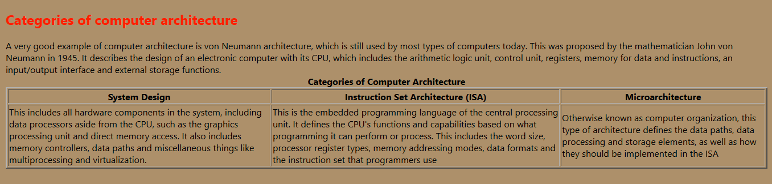

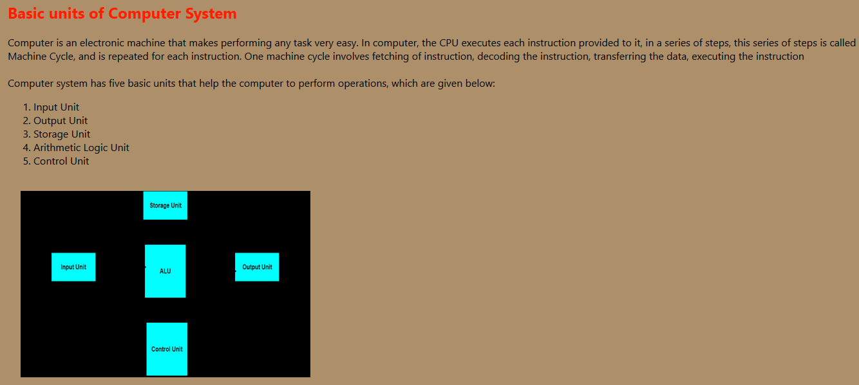

*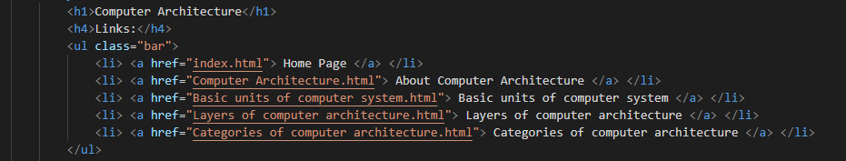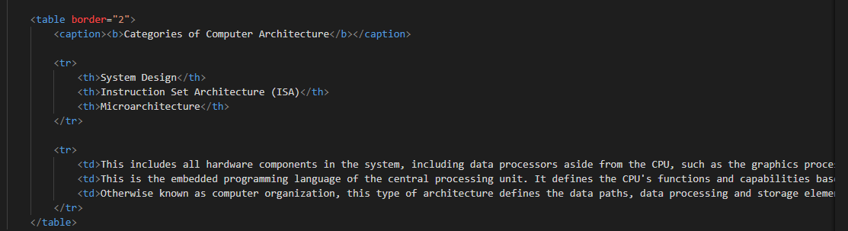Source Code:*

