EXAMPLE 3.21 From the samples x1(n) in Example 3.19a, reconstruct xa(t) and comment on the results.

Solution: Note that x1(n) was obtained by sampling xa(t) at Ts = 1/Fs = 0.0002 sec. We will use the grid spacing of 0.00005 sec over −0.005 ≤ t ≤ 0.005, which gives x(n) over −25 ≤ n ≤ 25.

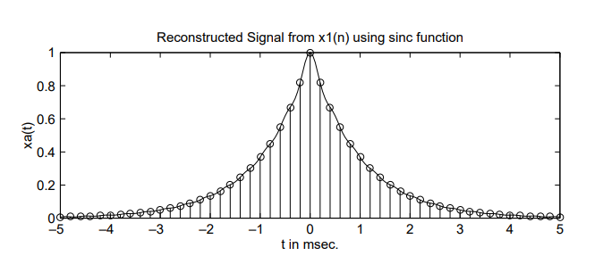

MATLAB script:

% Discrete-time Signal x1(n)

>> Ts = 0.0002; n = -25:1:25; nTs = n\*Ts; x = exp(-1000\*abs(nTs));

% Analog Signal reconstruction

>> Dt = 0.00005; t = -0.005:Dt:0.005; >> xa=x\* sinc(Fs\*(ones(length(n),1)\*t-nTs’\*ones(1,length(t))));

% check >> error = max(abs(xa - exp(-1000\*abs(t))))

error = 0.0363

The maximum error between the reconstructed and the actual analog signal is 0.0363, which is due to the fact that xa(t) is not strictly band-limited (and also we have a finite number of samples).

EXAMPLE 3.22 From the samples x2(n) in Example 3.17b reconstruct xa(t) and comment on the results.

solution In this case x2(n) was obtained by sampling xa(t) at Ts = 1/Fs = 0.001 sec. We will again use the grid spacing of 0.00005 sec over −0.005 ≤ t ≤ 0.005, which gives x(n) over −5 ≤ n ≤ 5

Matlab:

% Discrete-time Signal x2(n)

>> Ts = 0.001; n = -5:1:5; nTs = n\*Ts; x = exp(-1000\*abs(nTs));

% Analog Signal reconstruction >>

Dt = 0.00005; t = -0.005:Dt:0.005; >> xa=x\* sinc(Fs\*(ones(length(n),1)\*t-nTs’\*ones(1,length(t))));

% check >> error = max(abs(xa - exp(-1000\*abs(t))))

error = 0.1852

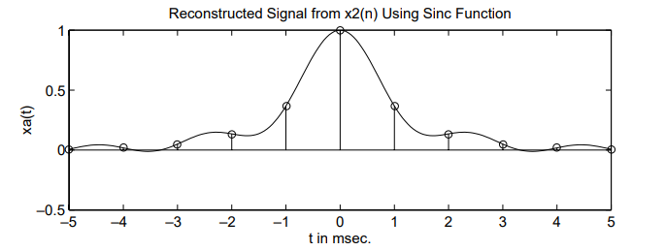

The maximum error between the reconstructed and the actual analog signals is 0.1852, which is significant and cannot be attributed to the nonband-limitedness of xa(t) alone. From Figure 3.17, observe that the reconstructed signal differs from the actual one in many places over the interpolated regions. This is the visual demonstration of aliasing in the time domain.