COCOONZ PRESCHOOL CRM
USER GUIDE & UAT TESTING MANUAL

Document Version: | v1.3-UAT
Release Date: | June 20, 2026
Prepared For: | Client Testing and Acceptance (UAT)
Prepared By: | Cocoonz Team

⚠ UAT RELEASE NOTICE
This release is provided exclusively for testing and validation purposes.
The system should be tested by authorized client personnel using the provided scenarios.
Implementation is NOT considered complete until:
1. Client testing is completed successfully.
2. Client validates and confirms all requirements are met.
3. Formal sign-off is received from the client's authorized project sponsor.
THIS IS A USER ACCEPTANCE TESTING (UAT) RELEASE. THE IMPLEMENTATION WILL BE CONSIDERED COMPLETE ONLY AFTER THE CLIENT TESTS ALL FEATURES AND PROVIDES FORMAL APPROVAL.

TABLE OF CONTENTS
1. Cover Page & UAT Notice ....................................................................................................................... Page Ref
2. System Overview & Scope Boundaries ....................................................................................................................... Page Ref
3. Test User Credentials ....................................................................................................................... Page Ref
4. Role Permissions Matrix ....................................................................................................................... Page Ref
5. Login & Session Guide ....................................................................................................................... Page Ref
6. Feature Walkthroughs & User Instructions ....................................................................................................................... Page Ref
7. Class Master Structure & Enforcements (CR-001) ....................................................................................................................... Page Ref
8. UAT Testing Scenarios & Scripts ....................................................................................................................... Page Ref
9. Formal Client Sign-Off Sheet ....................................................................................................................... Page Ref
10. Final Project Release Notice ....................................................................................................................... Page Ref

2. SYSTEM OVERVIEW & SCOPE BOUNDARIES
The Cocoonz Preschool CRM is designed to streamline administrative tasks, student enrollment tracking, staff records management, and fee collection processes. This system provides a centralised hub for branch operations, roles, and automated notifications.

In-Scope Modules (Ready for Client UAT)
- Dashboard: Centralised KPI metrics showing financial status, attendance rates, and student enrollments.
- Branch Management: Configuring multiple branch offices, physical address locations, and contact details.
- Class Management: Setting up class groups, academic years, sections, and division classifications.
- Student Management: Directory lists, adding profiles, updating student records, and deleting profiles.
- Fee Structures: Configuring structures for Tuition Fees, Admission Fees, etc. by academic year and branch.
- Fee Assignment: Attaching structure fees to students and executing automatic billing.
- Collections: Processing student partial or full payments and updating ledger tables.
- Receipt History: Storing receipt breakdowns and generated transaction codes.
- Due Management: Scanning outstanding ledger dues and generating reminder lists.
- Audit Reports: Generating Excel/PDF transaction lists and system activity logs.
- Notifications: Sending custom messages to communication channels (mocked SMS and WhatsApp).
- Roles & Users: Creating user logins and granting permissions based on roles.

Out-of-Scope Modules
- Attendance Tracking & Bulk Posting
- Staff Payroll & Salary Management
- Inventory & Asset Management
- School Transport & Vehicle Trips Tracking
- Parent Mobile Application interface
- LMS (Learning Management System) features

3. TEST USER CREDENTIALS
Please use the following login credentials to evaluate permissions and workflows during the UAT testing phase.
Role | Username | Password | Purpose / Access Scope
Super Admin | admin | password123 | Full configuration, system management, audit reports, user roles creation, and overrides.
Branch Admin | office_admin | password123 | Branch level operations, student management, admissions, and collections.
Accountant | accountant_user | password123 | Fee structure creation, collection recording, ledger postings, and receipt generation.
Teacher | teacher_user | password123 | View dashboard, search students, run attendance, read-only structures.
Note: These credentials are for testing purposes only and will be changed before production deployment.

4. ROLE PERMISSIONS MATRIX
The matrix below outlines active endpoints and frontend page access levels configured for each role group.
Module | Super Admin | Branch Admin | Accountant | Teacher
Dashboard Views | Full Access | Full Access | Full Access | Read-Only
Branch Config | Read / Write | No Access | No Access | No Access
Class Creation | Read / Write | Read / Write | No Access | No Access
Student Records | Full Access | Full Access | Read-Only | Read-Only
Fee Structures | Full Access | Read-Only | Full Access | Read-Only
Collect Payments | Yes | Yes | Yes | No
General Ledger | Yes | No | Yes | No
Audit Reports | Yes | No | No | No
Users Management | Full Access | No Access | No Access | No Access

5. LOGIN & SESSION GUIDE
System URL: http://localhost:3000 (Next.js) or http://localhost:8000/frontend/ (Legacy client view)
Login Steps:
- Open browser and type in the System URL.
- The browser automatically presents the authentication prompt.
- Enter test credentials (e.g. Username: admin, Password: password123).
- Click Login.
Expected Result: Authentication token is saved in cookie/local storage. Browser redirects the user to the active Command Center dashboard showing active modules.
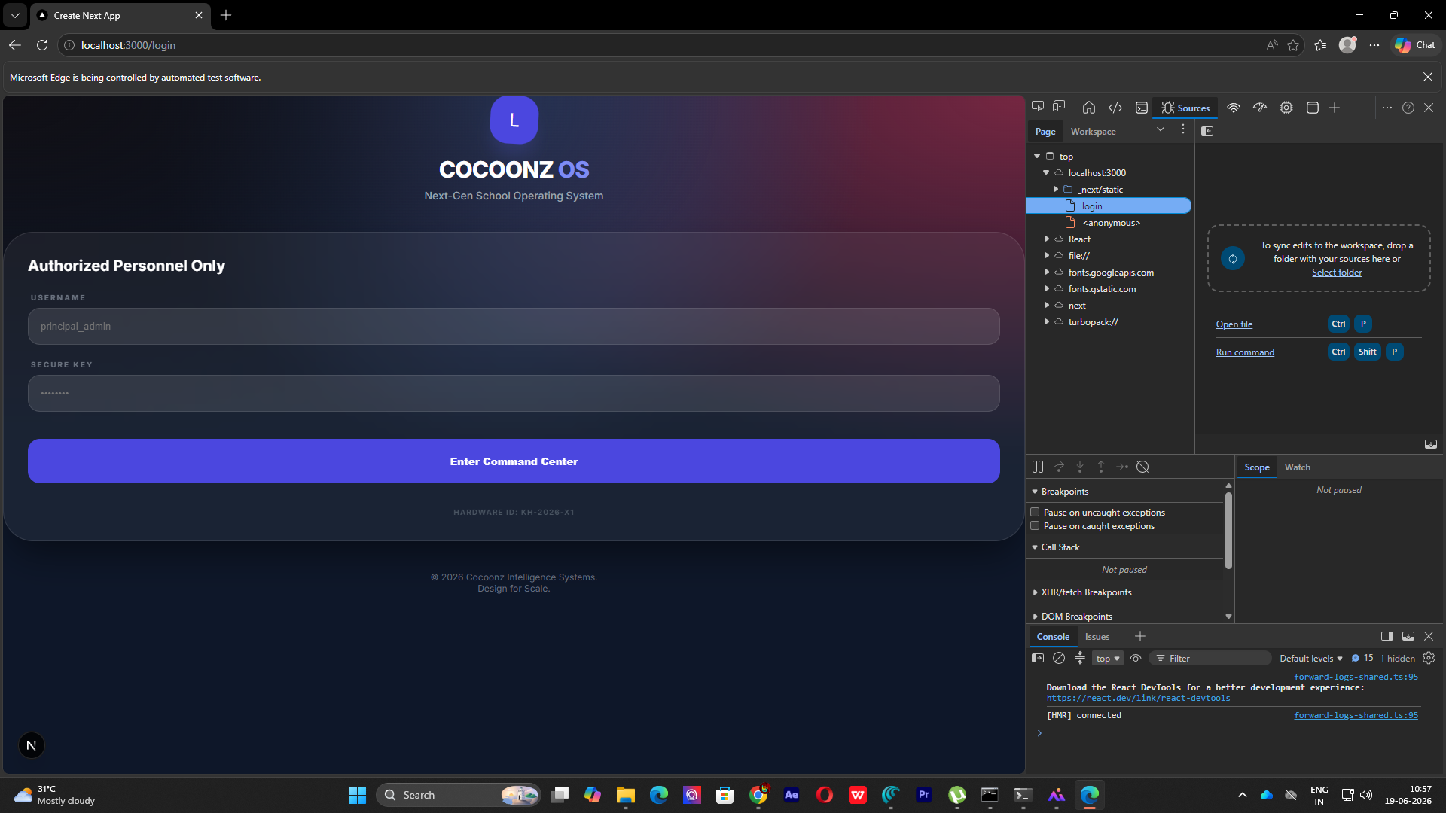
Figure 1: Desktop Login Interface showing secure credential verification screen.

6. FEATURE WALKTHROUGHS & USER INSTRUCTIONS

6.1 Dashboard
Purpose:
- Displays real-time aggregated metrics including student enrollment counts, financial liquidity, and attendance status.
Validation / Rules:
- Dashboard loads without console errors. Cards reflect real-time counts synced with backend database.
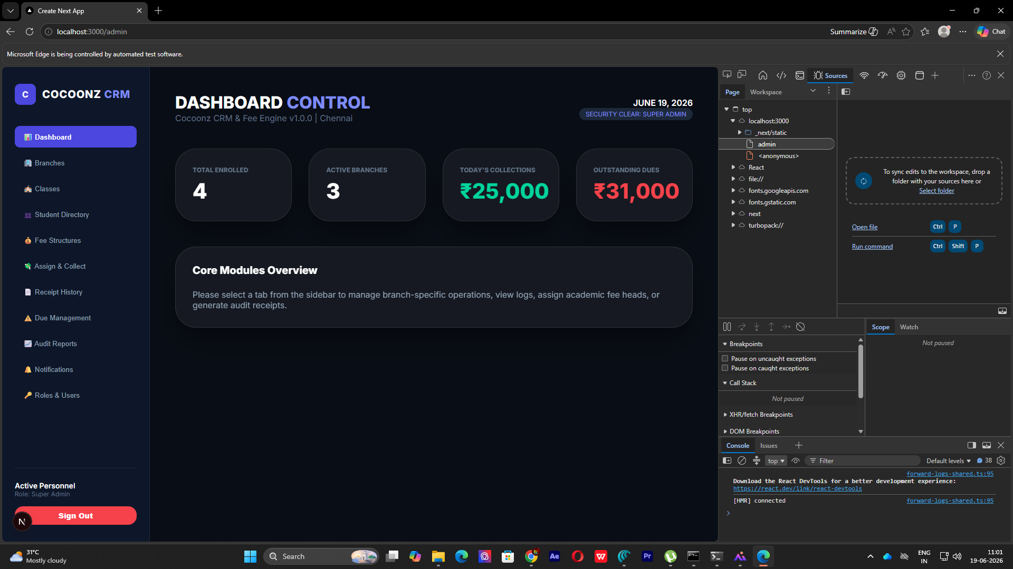
Walkthrough Screenshot for Dashboard

6.2 Branches
Purpose:
- Set up separate preschool branches.
Validation / Rules:
- Name, address, and email are required. Contact number must match phone formats (+91...). Duplicate branch names are rejected.
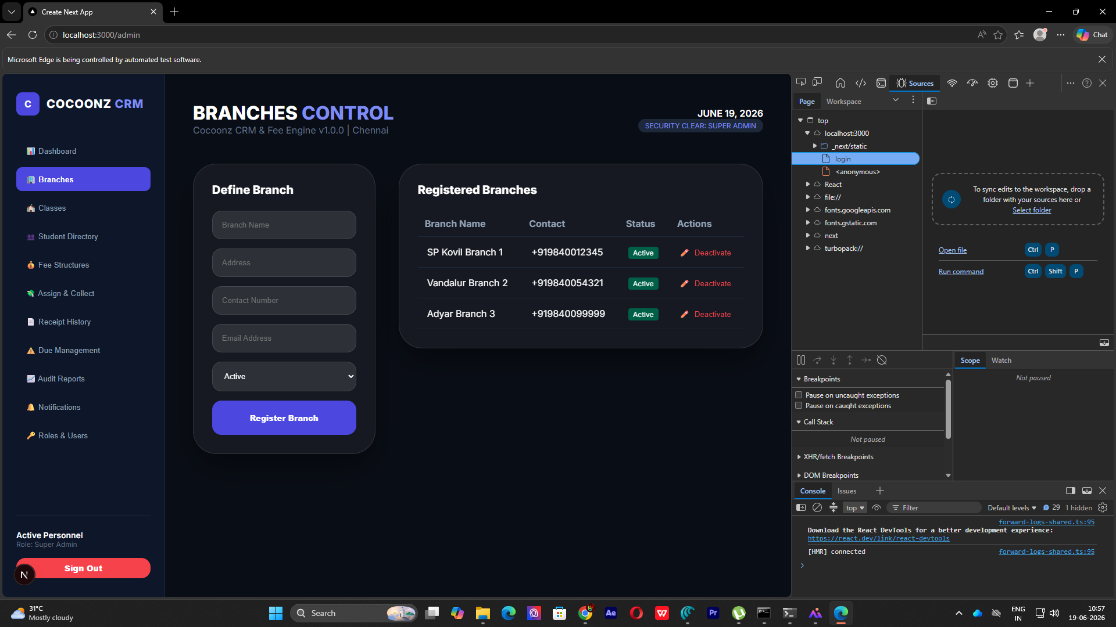
Walkthrough Screenshot for Branches

6.3 Classes
Purpose:
- Setup sections and align class names to divisions.
Validation / Rules:
- Under FIXED mode, class name must belong to whitelisted preschool/primary lists (rejected otherwise). Section name cannot be blank. Combination of Class Name + Section + Branch + Academic Year must be unique.
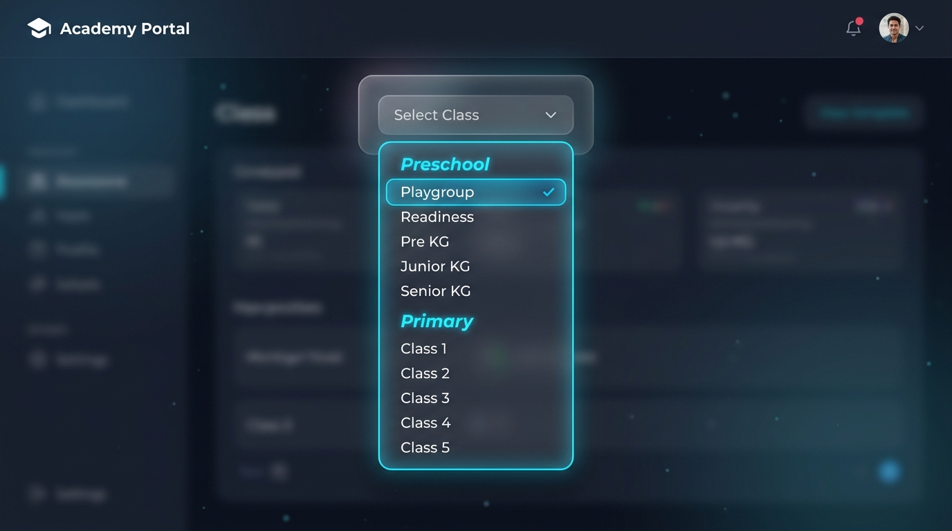
Walkthrough Screenshot for Classes

6.4 Students
Purpose:
- Register profiles and manage details.
Validation / Rules:
- Displays searchable datatable of all students registered. Includes options to admit new student, update record, or delete profile.
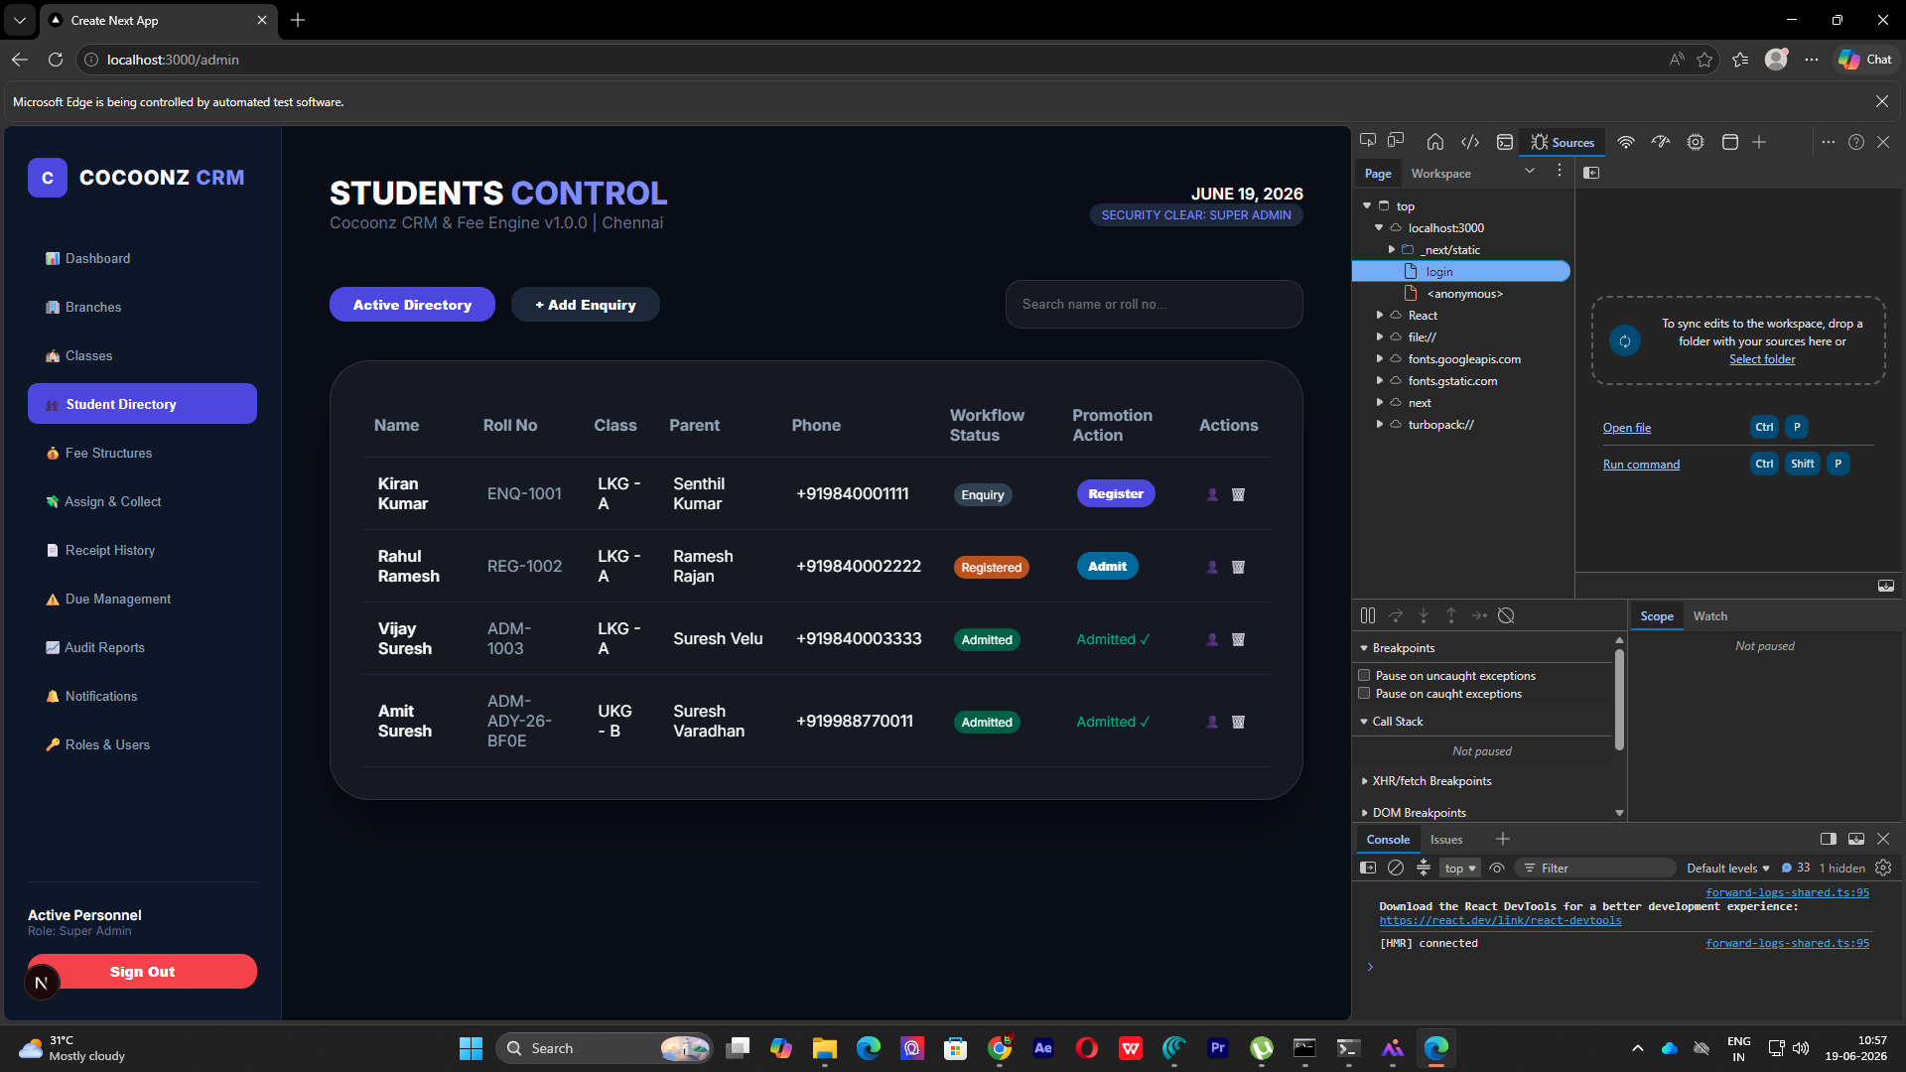
Walkthrough Screenshot for Students

6.5 Fee Assignment & Payment Collection
Purpose:
- Assign fees to students and record collections.
Validation / Rules:
- Displays student's ledger outline. Allows executing partial payment which instantly updates the outstanding balance.
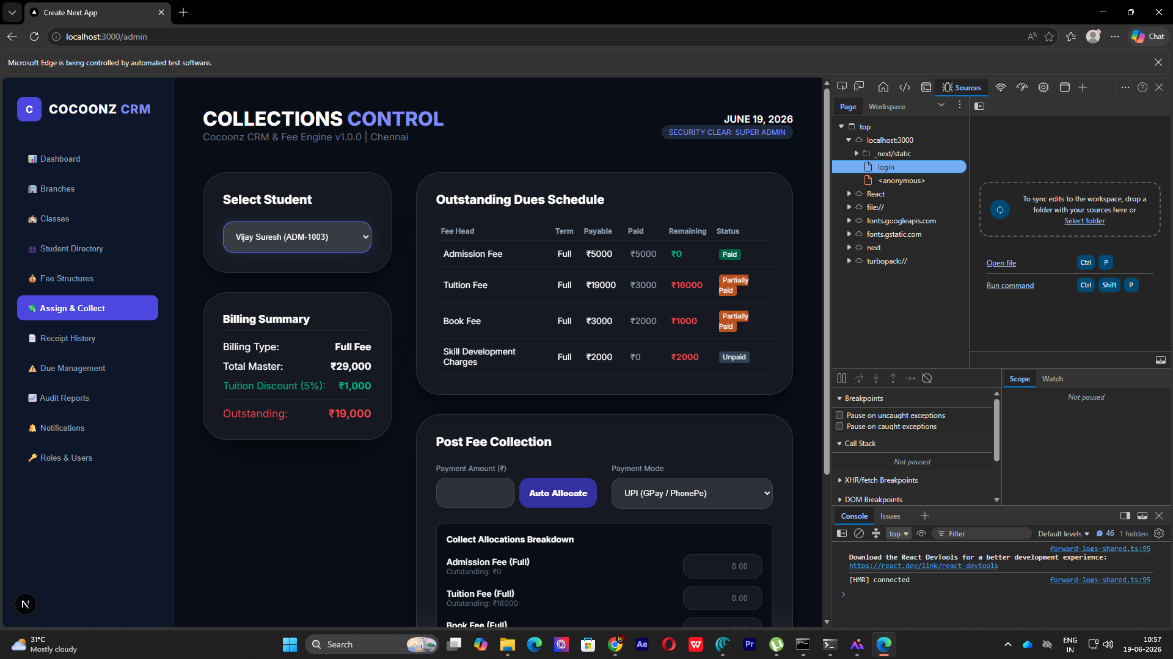
Walkthrough Screenshot for Fee

6. receipt Receipt History
Purpose:
- Track receipt codes and payment logs.
Validation / Rules:
- Select receipt to view a formatted transaction log detailing date, mode of pay, and amount.
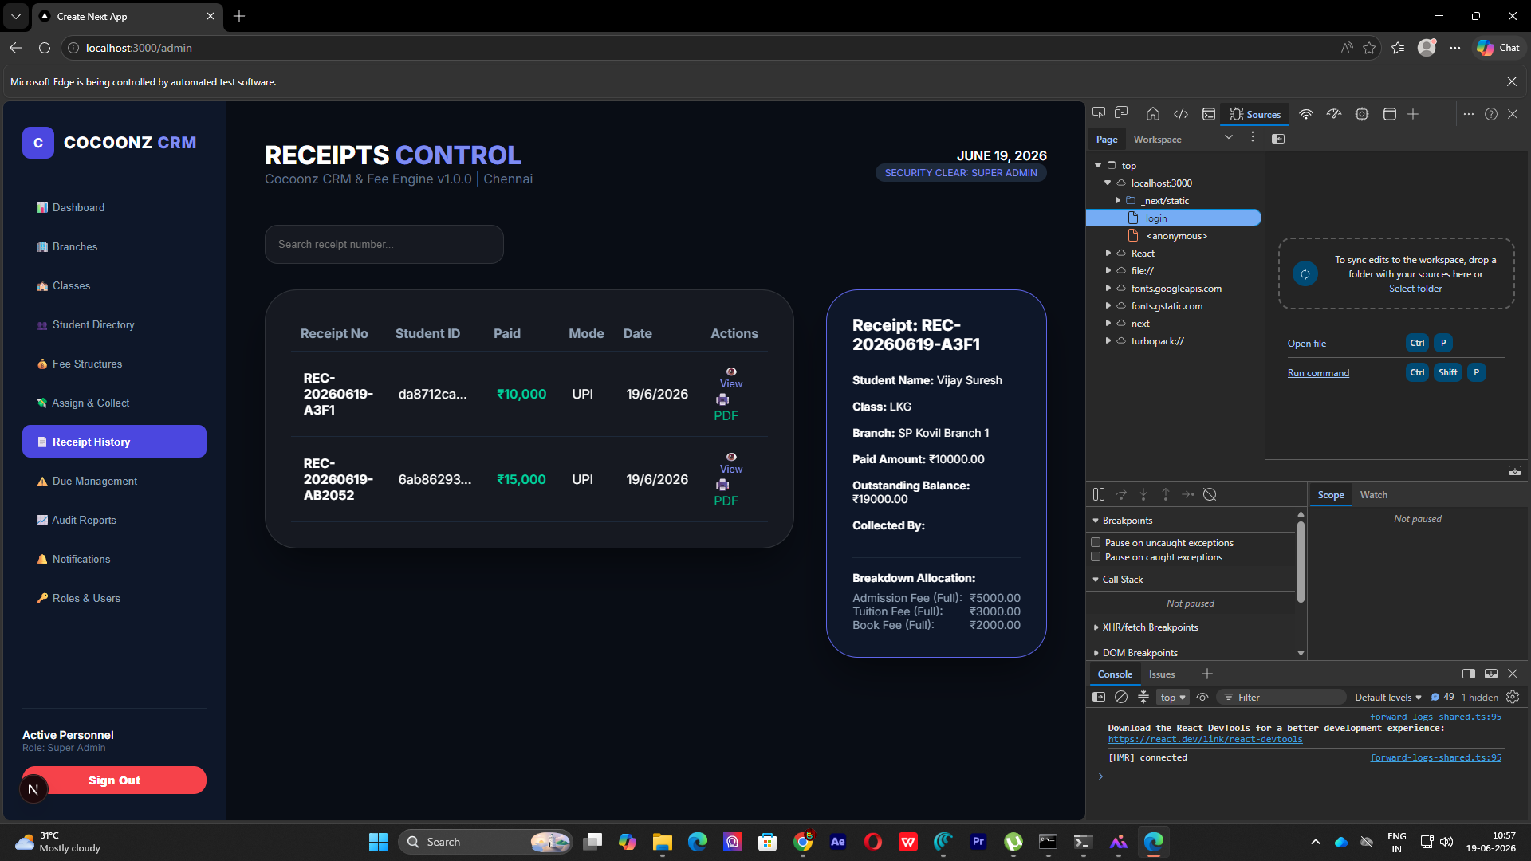
Walkthrough Screenshot for receipt

7. CLASS MASTER STRUCTURE & ENFORCEMENTS (CR-001)
Under the whitelisting restrictions of CR-001, class management behaves as follows:
Whitelisted Class Names:
- Preschool Division: Playgroup, Readiness, Pre KG, Junior KG, Senior KG
- Primary Division: Class 1, Class 2, Class 3, Class 4, Class 5
Behavioral Modes (CLASS_MASTER_MODE in .env):
- FIXED Mode: Setting CLASS_MASTER_MODE=FIXED. The system enforces strict validation. Creating classes outside the whitelists (e.g. Montessori, Toddler) returns a 400 Bad Request error. Division classifications ('Preschool' / 'Primary') are mapped and set automatically.
- CONFIGURABLE Mode: Setting CLASS_MASTER_MODE=CONFIGURABLE. Custom class names are allowed, and divisions can be explicitly configured.
Preservation Policy:
Historical classes (such as LKG, UKG, 1st Std, 2nd Std created before CR-001 implementation) are fully preserved in the database. Existing student assignments, fee invoices, receipts, and collections linked to these legacy classes remain intact and unaffected.

Figure 4: Standardised dropdown grouping classes by Division using optgroup elements.

8. UAT TESTING SCENARIOS & SCRIPTS
Perform the following scenario runs during UAT. Record status on the Sign-Off sheet.
ID | Description | Steps | Expected Outcome | Pass/Fail
TC-001 | Secure Login Validation | Submit invalid username/password to login. | System rejects request, returning HTTP 401 Unauthorized. | [ ]
TC-002 | Create Class: Playgroup (FIXED) | Set Mode=FIXED. Try to create class 'Playgroup'. | Success (HTTP 200). Division auto-saved as 'Preschool'. | [ ]
TC-003 | Create Class: Class 5 (FIXED) | Set Mode=FIXED. Try to create class 'Class 5'. | Success (HTTP 200). Division auto-saved as 'Primary'. | [ ]
TC-004 | Reject Invalid Class Name | Set Mode=FIXED. Try to create 'Montessori' or 'Toddler'. | Rejected (HTTP 400 Bad Request) with whitelisting validation errors. | [ ]
TC-005 | CONFIGURABLE Custom Class | Set Mode=CONFIGURABLE. Try to create 'Montessori'. | Success (HTTP 200). Custom class name is allowed. | [ ]
TC-006 | Admit Student Profile | Create student Arjun, assign class Playgroup, total fees 30000. | Success (HTTP 200). Student profile created and fee summary added. | [ ]
TC-007 | Record Partial Payment & Receipt | Post payment of 10000 for Arjun. Check transaction. | Success (HTTP 200). Balances update to paid=10000, pending=20000. Receipt code REC-TEST-999 issued. | [ ]
TC-008 | Ledger Auto-Posting | Check GeneralLedger table for recorded payment of 10000. | Success. Income fee transaction matching payment ID is logged. | [ ]
TC-009 | Role Access: Accountant Access | Login as Accountant. Try to create user. | Access Denied (HTTP 403 Forbidden). Restricted to Admins. | [ ]

9. FORMAL CLIENT SIGN-OFF SHEET
THIS IS A USER ACCEPTANCE TESTING (UAT) RELEASE. THE IMPLEMENTATION WILL BE CONSIDERED COMPLETE ONLY AFTER THE CLIENT TESTS ALL FEATURES AND PROVIDES FORMAL APPROVAL.
Project Title: | Cocoonz Preschool CRM Integration
UAT Version: | Release v1.3-UAT (Ready for Client UAT)
Client Org Name: | ____________________________________________
Tester Name & Title: | ____________________________________________
UAT Testing Period: | ____________________________________________
Tester Review Comments: | _____________________________________________________________________________  _____________________________________________________________________________
UAT Final Approval Status: | [ ] Approved & Ready for Production  [ ] Approved with Minor Core Adjustments  [ ] Requires Fixes & Re-Testing  [ ] Rejected
Authorized Signature: | ____________________________________________
Sign-Off Date: | ____________________

10. FINAL PROJECT RELEASE NOTICE
IMPORTANT DEVELOPMENT STATUS DECLARATION
This project is NOT considered completed based on internal development testing alone.
Full production completion will be recognized only after the client organization completes UAT, validates the business workflows, and confirms requirements are satisfied by signing the UAT Approval Sheet.
Any issues, exceptions, or feedback identified during the testing phase will be logged and resolved before project closure.
STATUS: Ready for Client UAT

