Hugh Johnson

Lab 1

In the first part of the lab, we were given source code to an ESP8266 project that reports temperature and humidity to a ThingsBoard dashboard. We were given source code for the MCU and a dashboard to import into our ThingsBoard account. All that was supposed to be required of us was to connect three pins on the ESP8266 to the DHT22, change the SSID and password for the WIFI, and put our individualized device token in the source code.

The source code that we were given was several years old. The syntax for the ThingsBoard library and other required libraries was deprecated. The source code would not compile with the newest Arduino IDE, using the newest ESP8266 board software, and the libraries.

I could either work backwards and try and figure out what old versions of software I needed to get the source code to compile, or I could simply ensure that I had the newest software installed and rewrite the project. I chose the latter.

Unlike the author of the original code, I included versions of each of the libraries in comments at the top of my source code for posterity. This enables folks duplicating my setup to successfully compile my code.

When trying to figure out how to communicate with ThingsBoard, I could not find what I consider sufficient API documentation for ThingsBoard, but there are good up-to-date examples on Github. I used the source code at the link below as an example of how to communicate w/ ThingsBoard from the ESP8266 via MQT.

<https://raw.githubusercontent.com/thingsboard/thingsboard-client-sdk/master/examples/0003-esp8266_esp32_send_data/0003-esp8266_esp32_send_data.ino>

The physical setup of the project was simple. The DHT22 sensor connected to the MCU via three pins: 3.3v, ground, and a data pin. The ESP8266 connected to the PC via USB. USB supplies 5v power to the MCU which gets stepped down to 3.3v as per the chip’s power requirements. USB is also used as a two-way data connection from PC to MCU.

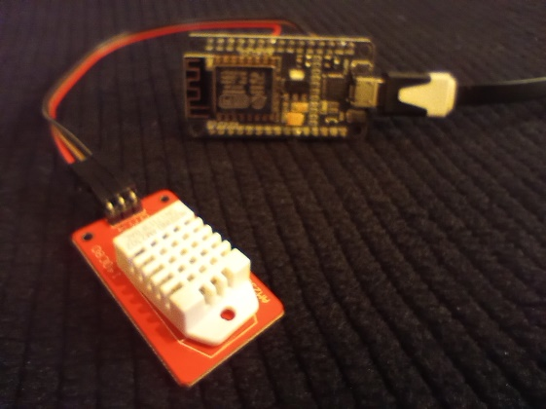

Data displayed as required on the ThingsBoard dashboard.

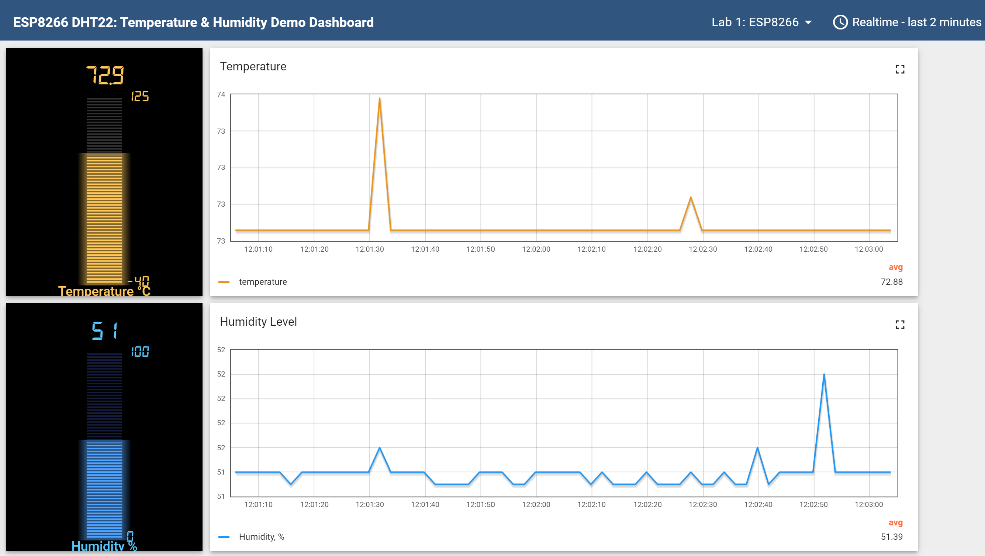

The second part of the lab was like the first part but a little more complicated. This part of the lab used an ESP32 and DHT22 sensor, but also had two groups of three LEDs. One group of LEDs were to be controlled (on-off) by simulated dip switches on a ThingsBoard dashboard, while the other group flashed at a speed controlled by a virtual knob on that same dashboard.

I had the same issue with software and library versions on this portion of the lab. I tackled the problem the same way. I used the example at this Github link for inspiration:

<https://raw.githubusercontent.com/thingsboard/thingsboard-client-sdk/master/examples/0010-esp8266_esp32_rpc/0010-esp8266_esp32_rpc.ino>

All one is really doing is using GETTERS and SETTERS via MQT remote procedure calls, ThingsBoard to ESP32, to control the lights.

Again, I documented the versions of software and libraries at the top of the source code for the project.

I used WOKWI diagram the project.

<https://wokwi.com/projects/407671274027447297>

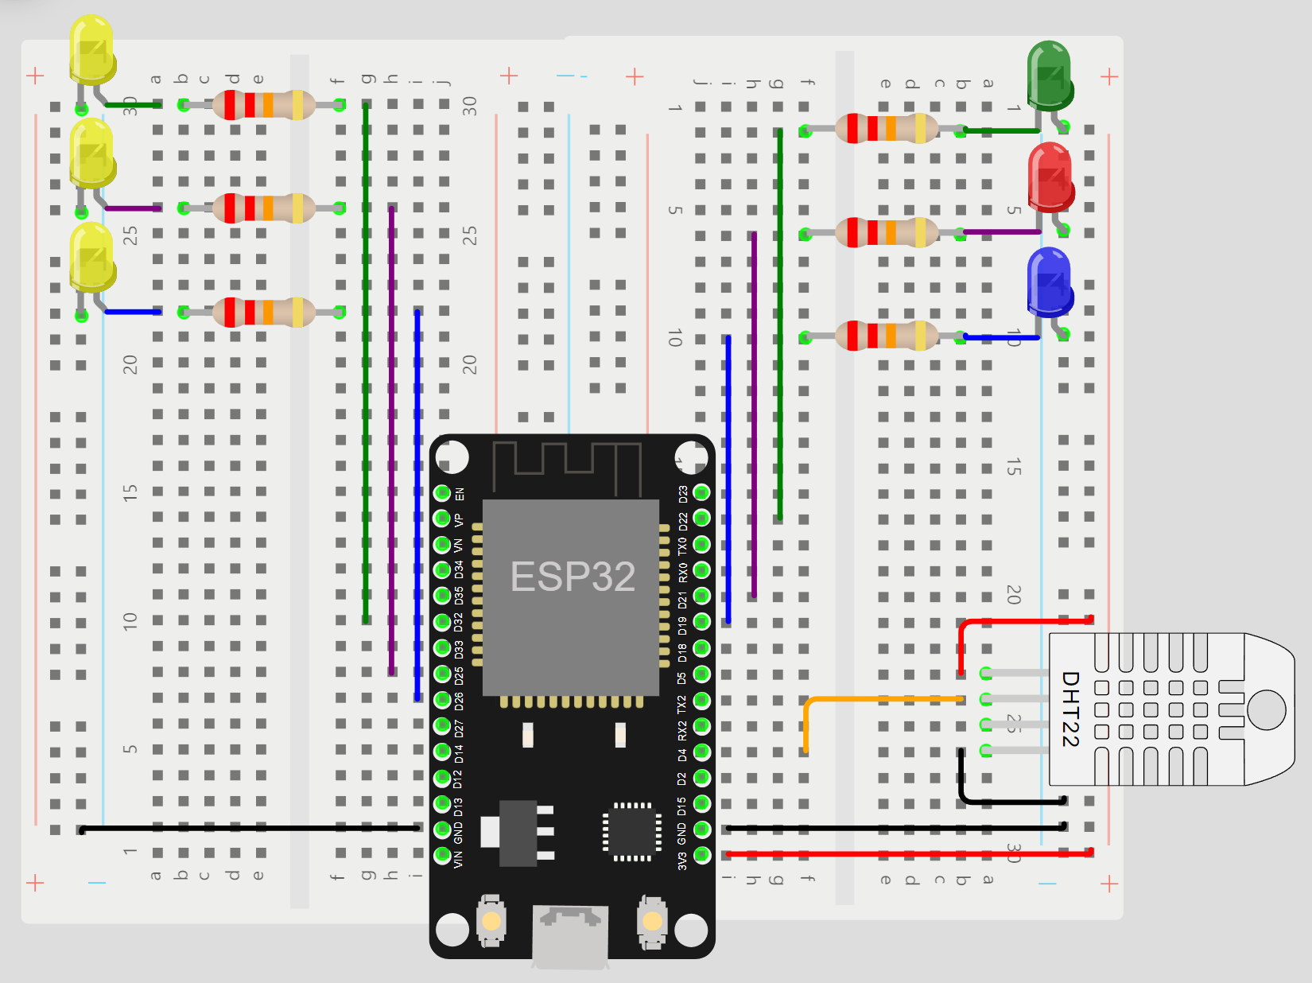

ThingsBoard Dashboard.

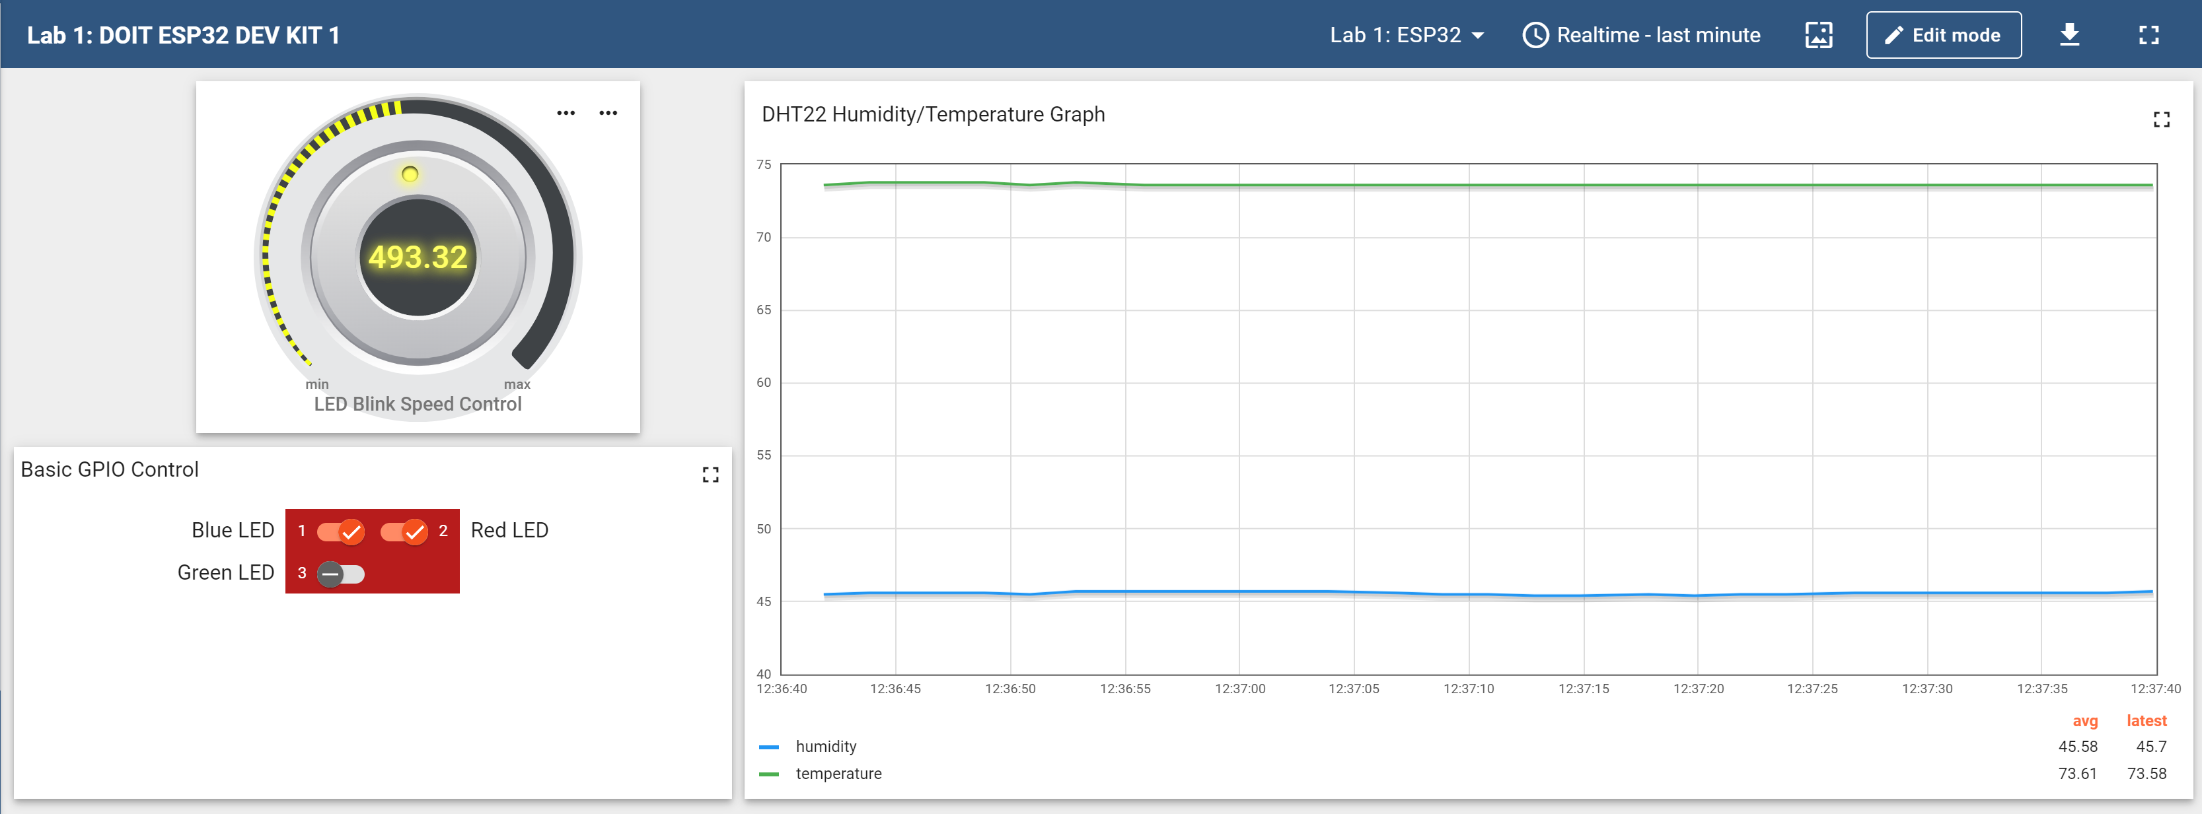

Since I changed the name of the GETTERS and SETTERS in my code, I had to make the respective change on the ThingsBoard API as shown on the images below.

