Assignment

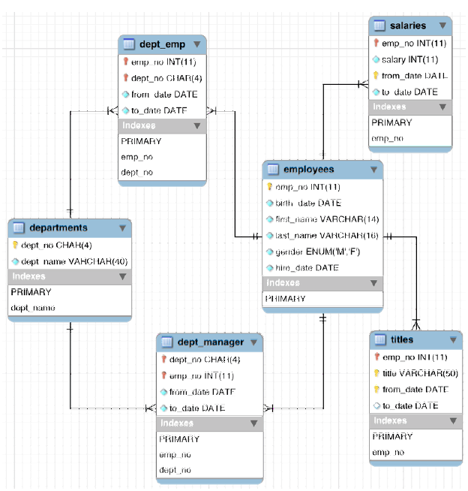

Create a database: EMPLOYEE with the schema as following (refer to the image above to know about datatype):

Employees(**emp_no**,birth_date,firstname,lastname, gender, hiredate)

Salaries(**emp_no**, salary, fro_date, to_date)

Dept_emp(**emp_no, dept_no**, from_date,to_date)

Departments(**dept_no**,dept_name)

Dept_manager(**dept_no,emp_no**, from_date,to_date)

Titles(**emp_no**,title, from_date,to_date)

Insert to the each table at least 10 records.

