**Read the below instructions carefully before you start.**

* Software Requirement: NetBeans 8.*, MS SQL Server 2008 R2+
* Download the given material then unzip.
* You receive folders: Q1_XXX (1) and Q2_XXX (2) … They are template for your corresponding exam questions. Q1_XXX used for question number 1 and Q2_XXX for question number 2 and so on. Open them as NetBeans project, replace XXX by [your student ID], e.g. Q1_SE1111, Q2_SE1111, Q3_SE1111. Change the context application to new name, e.g. /Q1_SE1111/Index.html instead of /Q1_XXX/Index.html. **Your work will not be considered for grading, if this condition is not satisfied**.
* Template project already contains the **DBContext.java** (3) to source package (**src\java\dal**) under folder (1),(2),.... You might need to rename a java package for (3), free to set the name of package.
* You **MUST** use **DBContext.java** for your database activities. Update your database connection string by filling values for instance variables in the **constructor**.
* All extra libraries (if needed) must be used by available NetBeans libraries only.

On completion, read submission guide carefully.

**Question 1**

You are asked to build a webpage to show the current date. The user can access your page via url: **/email**

Your Tasks include:

* **(1 point)** When the user access /email for the first time, the system displays the form as below figure.

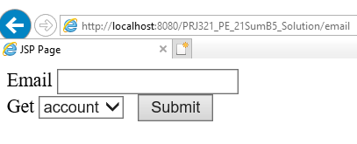

Figure 1 – The page on first visit

The dropdown list has two items as figure below

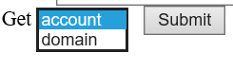

Figure 2 – Items of the dropdown list.

* **(2 point)** When the user clicks [Submit] button, the system display account or domain part of the entered email depending on the selected item of dropdownlist.

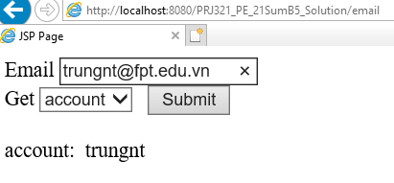

Figure 3 – The page is displayed after user choose “account” and then

click on button Submit.

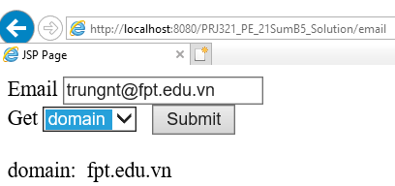

Figure 3 – The page is displayed after user choose “domain” and then

click on button Submit.

**(7 points)**

You are given a database described in Figure 1.

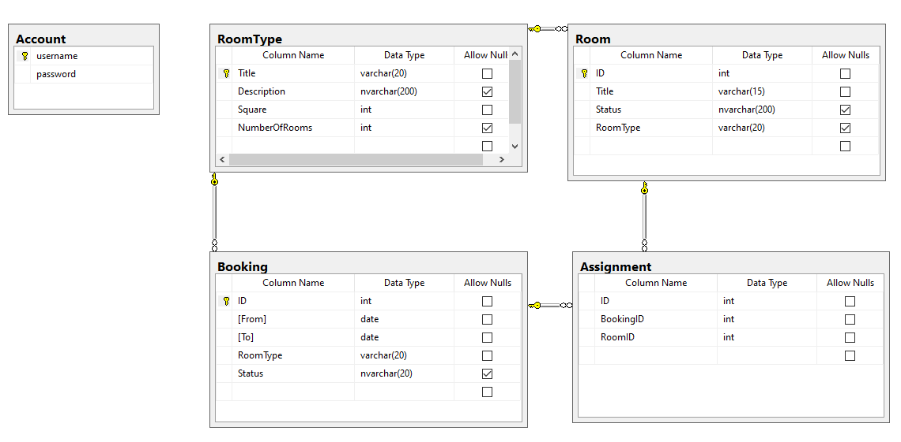

Figure 1: Database Schema

Your task is building a web application that has pages listed below

|  |  |  |
| --- | --- | --- |
| **Feature** | **URL** | **Description** |
| Authentication | /login | Login form, User does not have to be authenticated when visiting this.  User required to authenticated and authorized before visiting all other pages.  If you can't build the login page, you can still make other pages. Scores are calculated independently. |
| List | /rooms | Display all rooms from table Room in database.  This is the required-authenticated feature. |

Table 1: Features and URL

**Note that:** This web application are not allowed to have any url other than the ones listed above.

**Your tasks**

* The login form must like the Figure below:

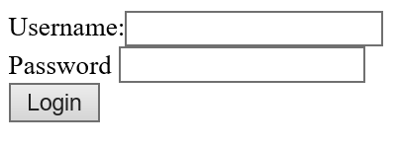

Figure 2: Login form

**(1 point)** User enters existed username and password in Account table, the system then performing authentication. If username or password is invalid, show message “Login failed” below the the form. If the login is successful, redirect user to the URL /rooms

* **(1 point)** If user access the required-authenticated feature URL without authentication. The system redirects the user to Authentication page at /login**.**
* **(1 point)** When the user access /rooms, the system displays the all of rooms in database like Figure 3 below.

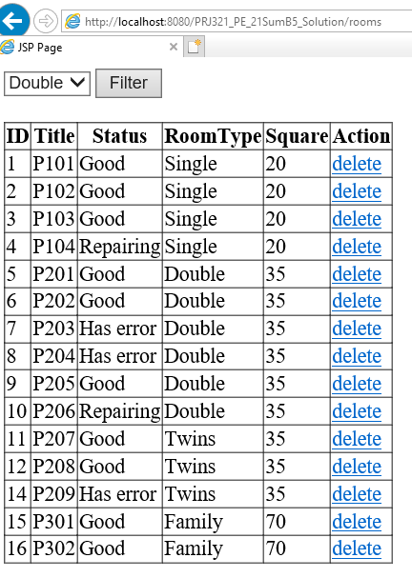

Figure 3: List of rooms

* **(1 point)** The dropdownlist in page /rooms has items that are loaded from table RoomType in database.
* **(1 point)** User can select room type in dropdownlist and then click on button Filter, list of rooms changes accordingly.
* **(2 point)** When user click on link *delete*, delete the corresponding room in database and reload page /rooms

**Note that,** if user is not authenticated, when they directly enter the URL of delete link in the address bar of browser, the system redirects them to page /login.