Add Certificate to use HTTPS to call Rest api with security in Axon active

## Step 1: ****Download the certificates through browser****

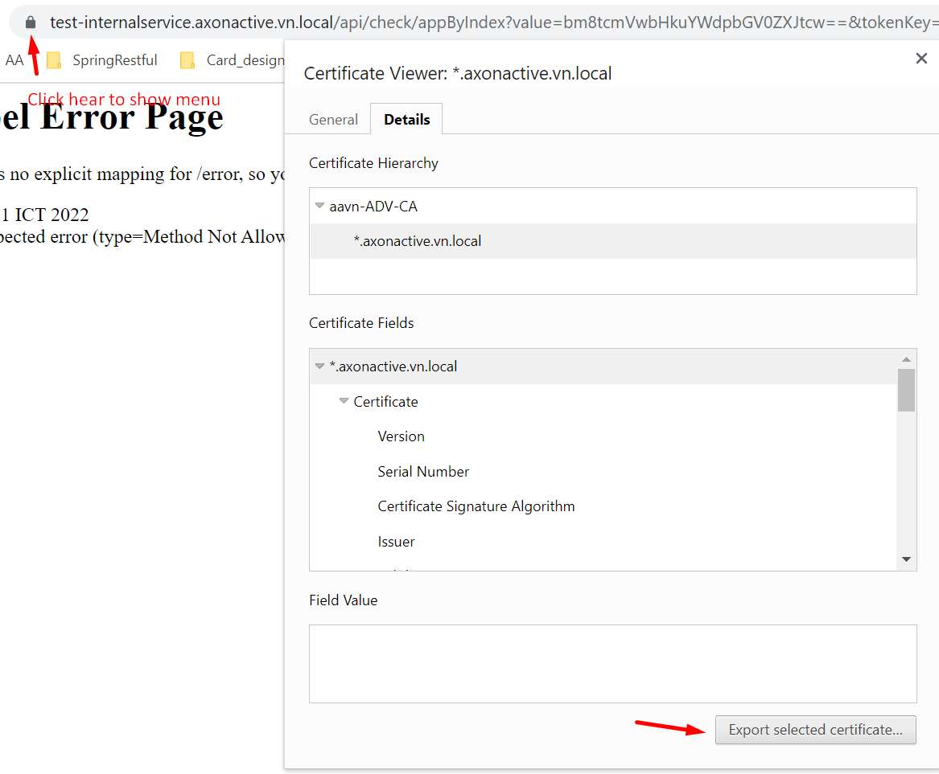

d:\aavn-ADV-CA.perm.crt

you and change the file extension to .cer or .perm (many names)

## Step 2: Import the certificate to your java keystore:

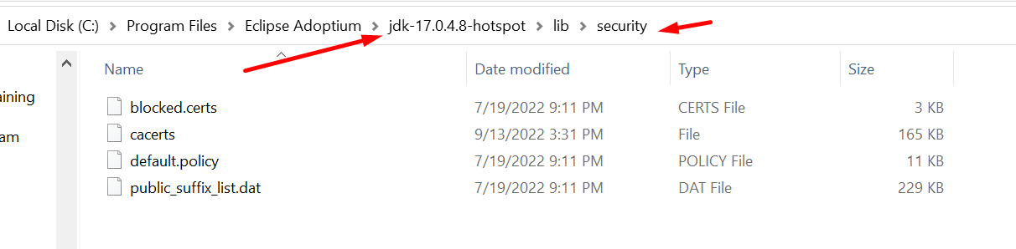

Go to Security folder of JDK and run the command to add .cer or .crt to JDK that we use in project allow to call with https:

(changeit is the default password of keytool)

keytool -importcert -file d:\aavn-ADV-CA.perm.crt -keystore cacerts -storepass changeit -alias "agile-term-local"

Ref:

<https://fullstackdeveloper.guru/2021/07/15/how-to-call-rest-api-protected-with-ssl-https-from-spring-boot/>