**Source code demo**

**Aspose Cells**

* **Write to .xlsx file:**

Open **output_xls.xls**:

To process other file formats, we just need to replace the file extension with an expected one.   
Ex: **workbook.save(“output.csv”);**

The same problem goes with other files, such as a **.csv** file here:

* **Read from .xlsx file:**

We have a file called **input_xlsx.xlsx**:

Then running this code in IntelliJ:

This is the result we will get in console window:

To read other file formats, we just need to replace the file extension with an expected one.   
Ex: **Workbook workbook = new Workbook (“input.csv”);**

* **Read from .xlsx file protected with password:**

Assume having file called **input_xlsx.xlsx** like this, with password to open is **abc123**

Running code below:

Then we will get the result like this:

If we enter the incorrect password, such as **abcd1234** :



The console window will show **Invalid password** error:

**EasyXLS:**

* **Read XLSX File**

I was create number.xlsx file in Desktop. I will read this file

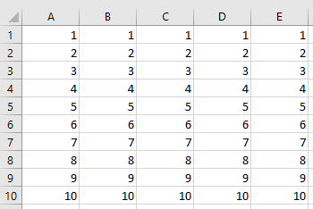

Running code below

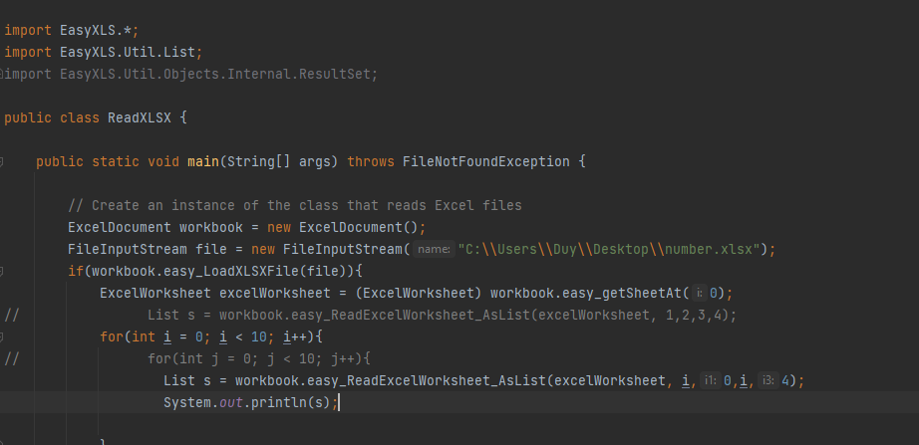

Then we will get the result like this:

* **Write XLSX File**

I will write something to number.xlsx File and export it which file name is number2.xlsx

This is my code:

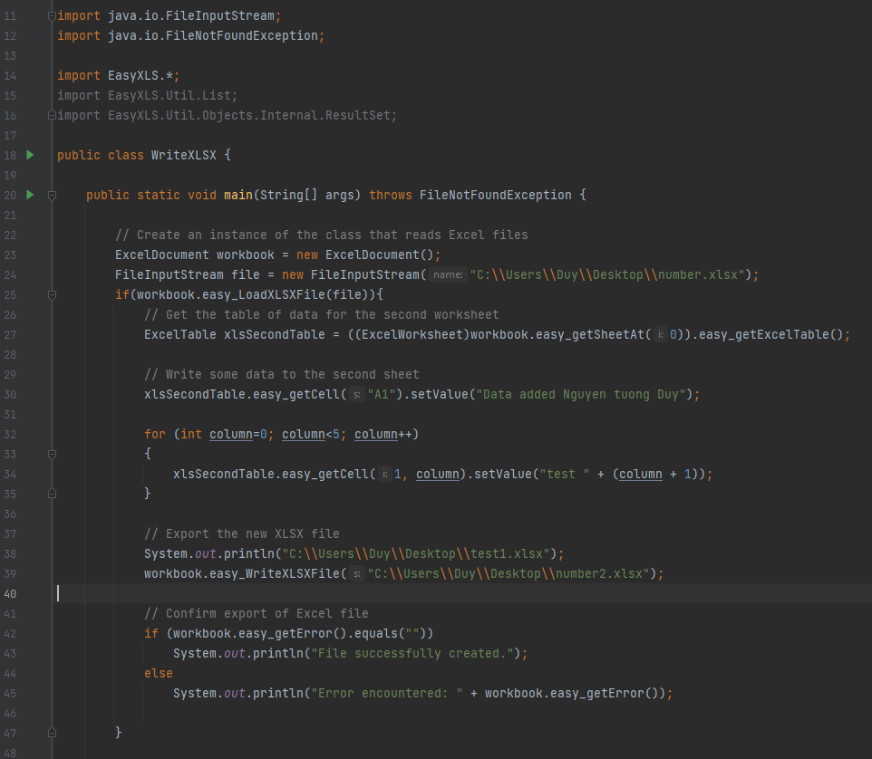

Run:

You will see number2.xlsx in desktop and open it

**ApachePOI:**

* **Read XLSX File**

I want to read this file name.xlsx

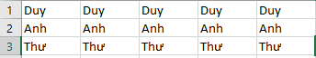

Source code:

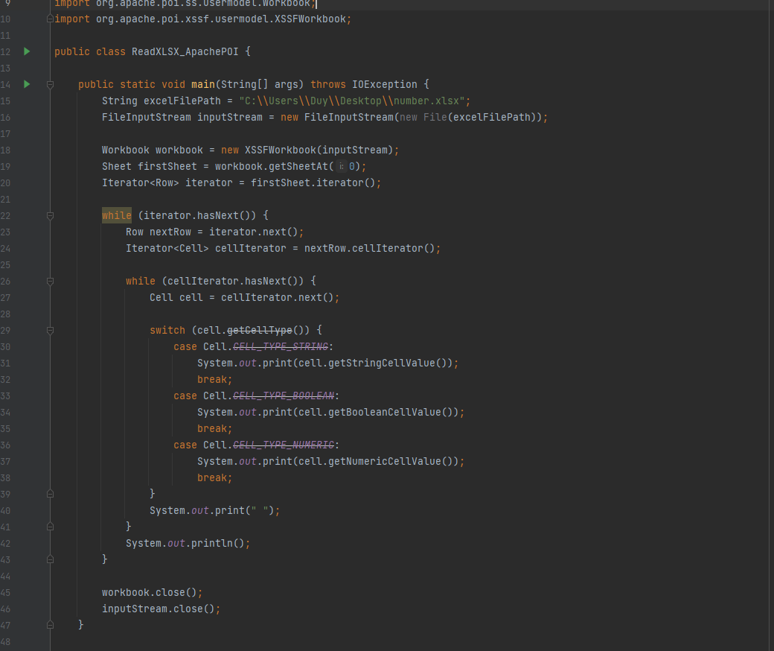

Run it and see the result

* Read XLSX File has password protected

I have file test.xlsx with password is 123

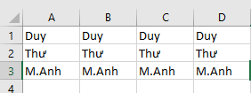

This is my code

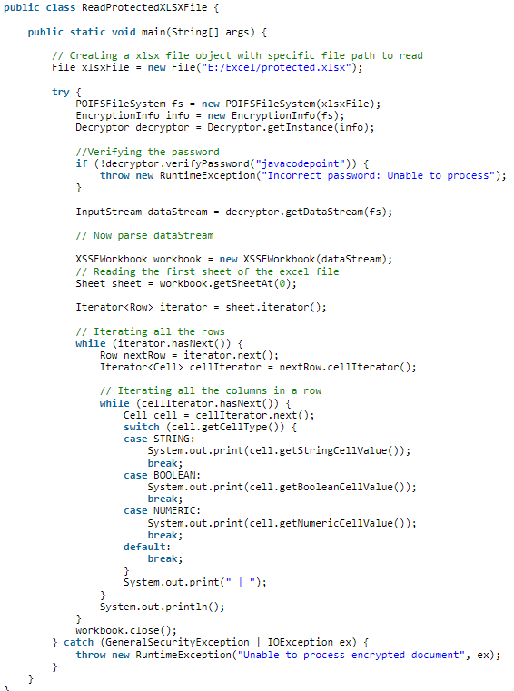

And run it

* 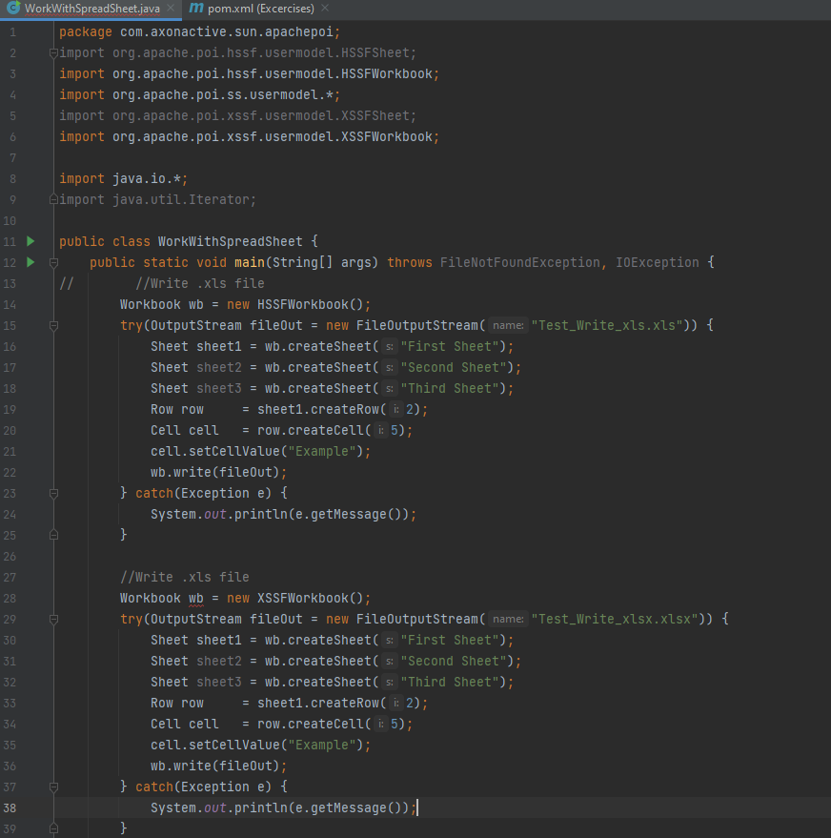**Write .xls and .xlsx file**

Result: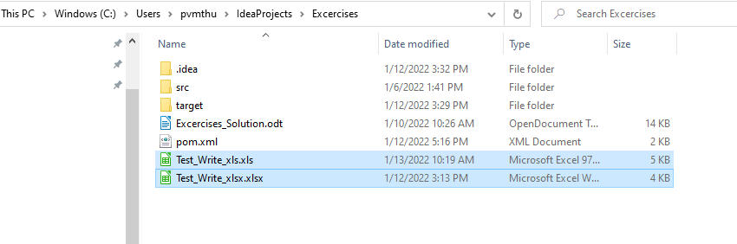

Open 2 this file:

