# Restore a Database using .bak file backup

(in thefollowing example we use test-20220424.bak file)



# Backup database in linux (server)

**Bakup data in Window** (Remember: **Postgres must has the same version**). Using pg_dump command:

pg_dump -h localhost -p 5433 -U admin testfmiphuxuanhuedb > /home/fmi/prod/db_backup/test-$(date +\%Y\%m\%d).bak

Error with wrong version:

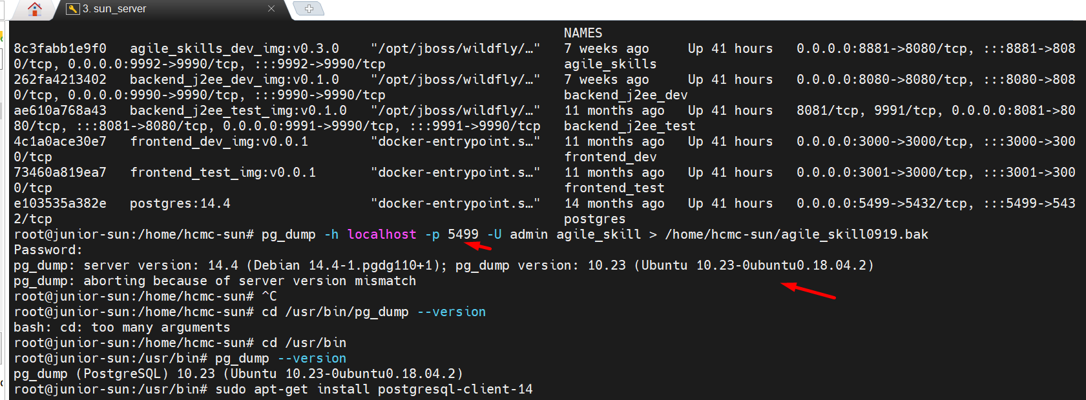

Upgrade version of pg_dump in Linux using following command:

sudo apt-get install postgresql-client-14

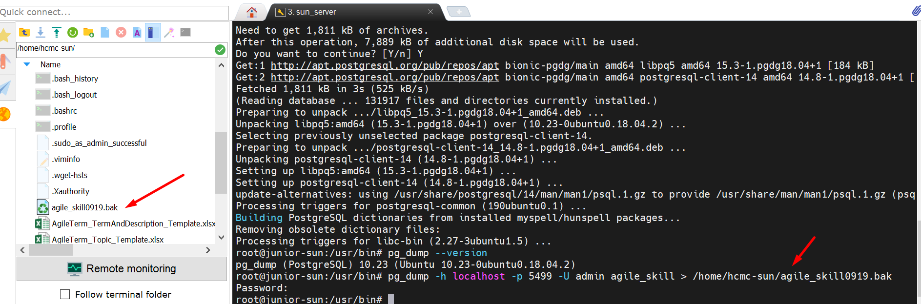

**Download this .bak file to your local computer:**

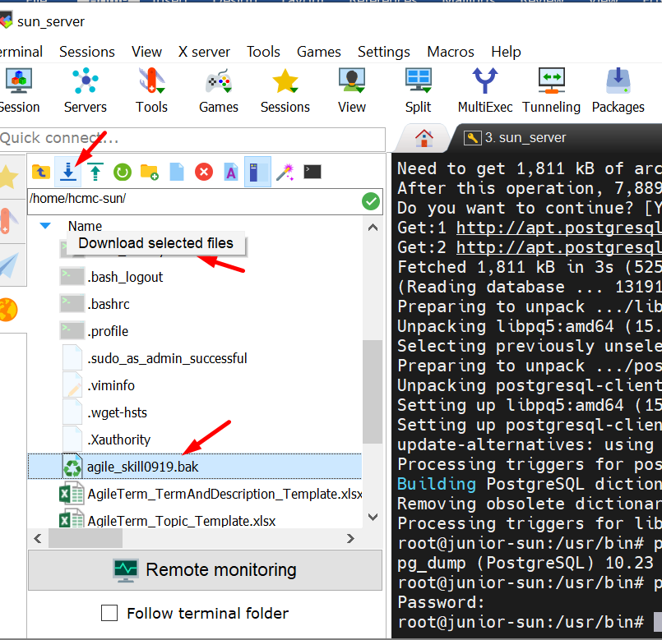

Create new database: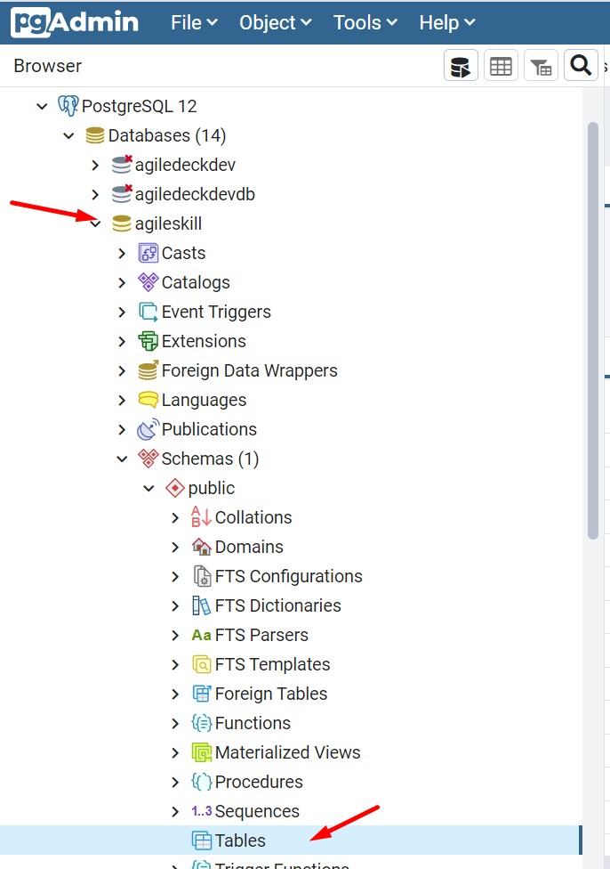

# Restore from .bak file using psql to a database in Window:

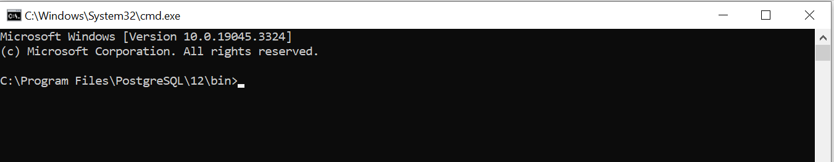

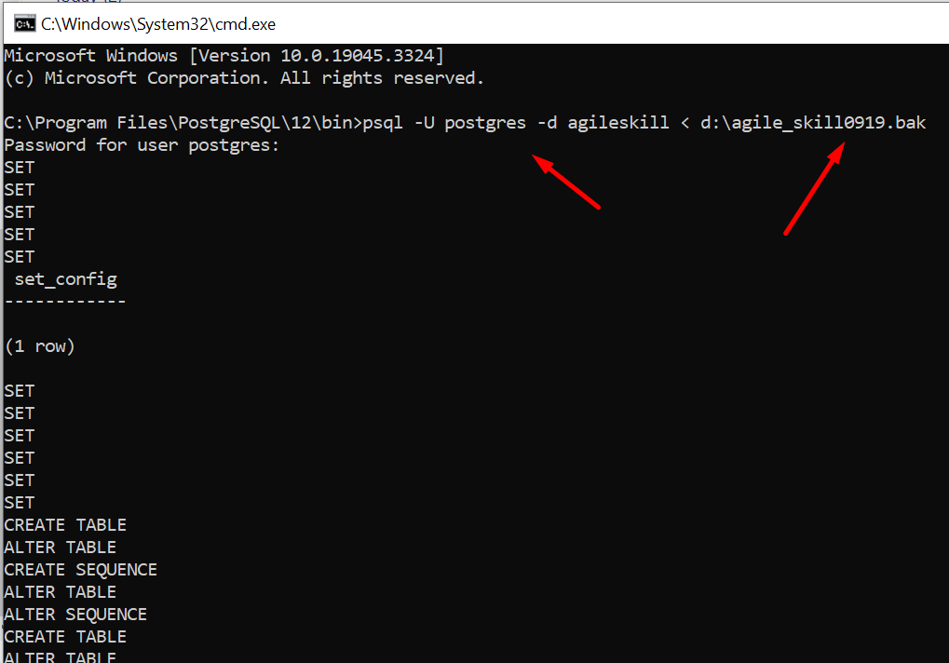

Result in aigleskill database:

# Restore .bak file using DBeaver tool:

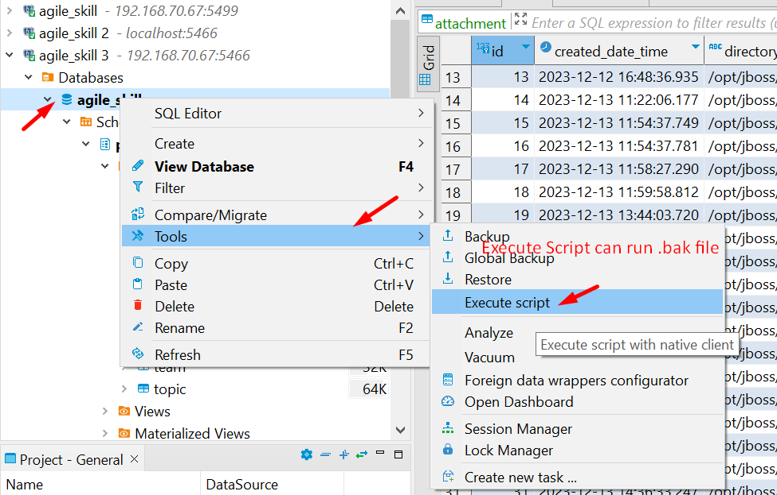

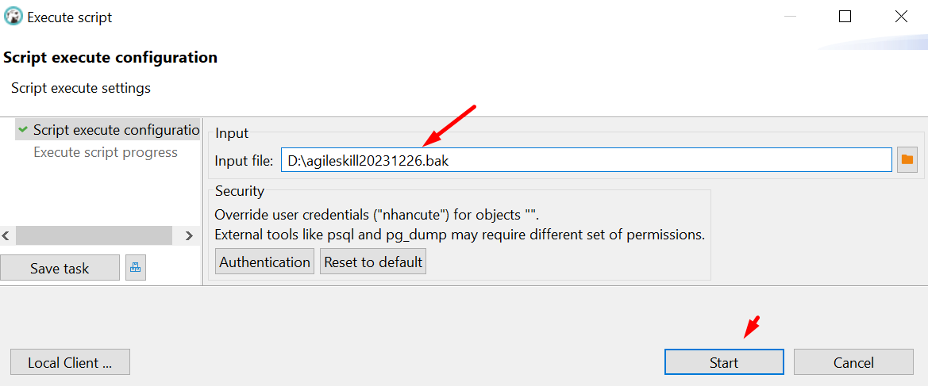

**Check Data after Restore:**

