Mapstruct

# Step 1: Add dependency & Maven Plugin

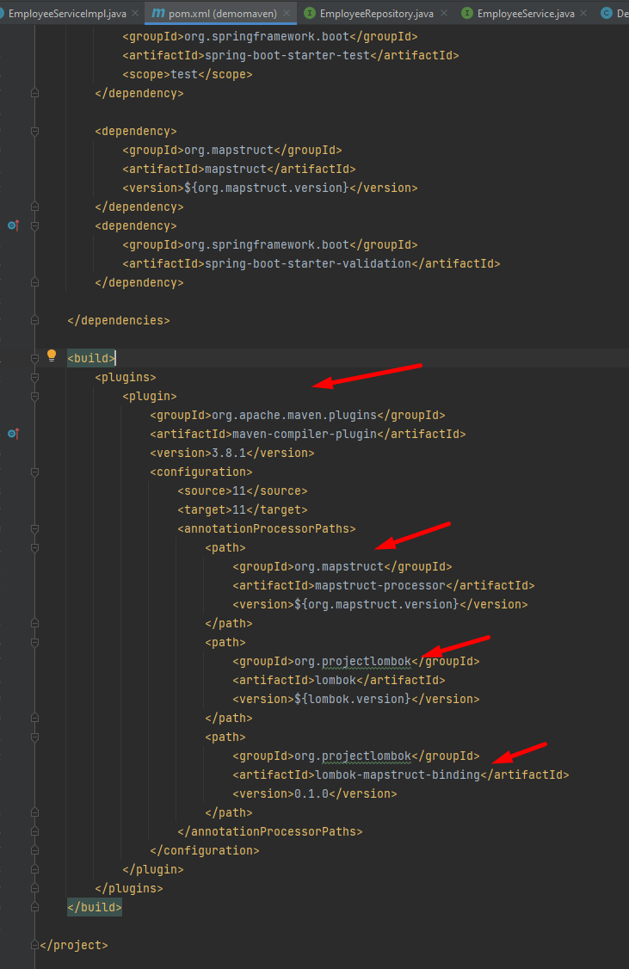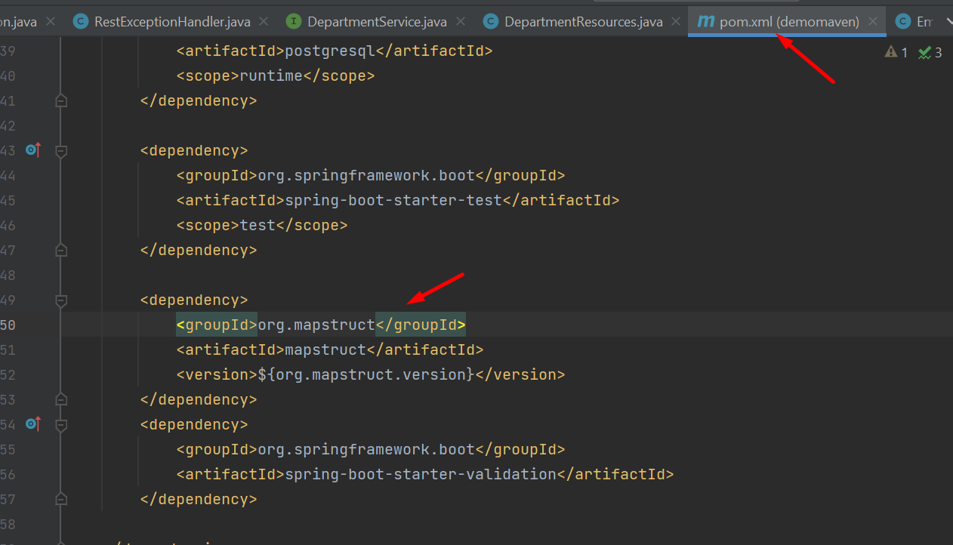

Note:

1. change <plugin> to maven.plugins

2. you have to add in <annotationProcessorPaths> 3 things like this image or Mapstruct and Lombok couldn’t work together.

# Step 2: Define Department mapper to map Entity to Dto:

## Using INSTANCE:

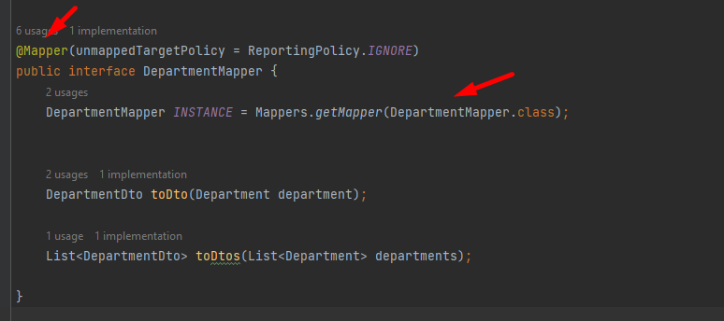

* Then using these Mapper class:

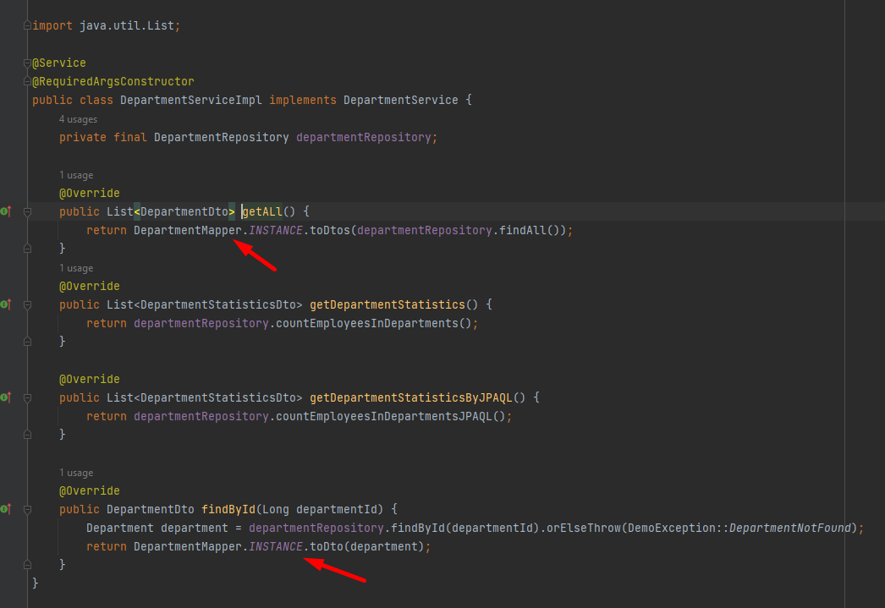

## Using componentModel

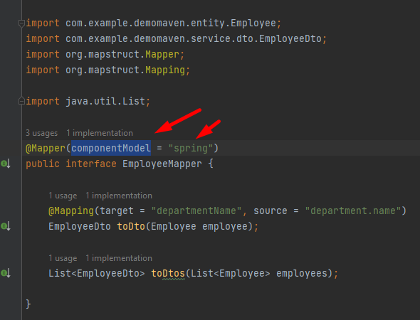

* Then Using Employee mapper( using requiredArgConstructor or using @Autowired)

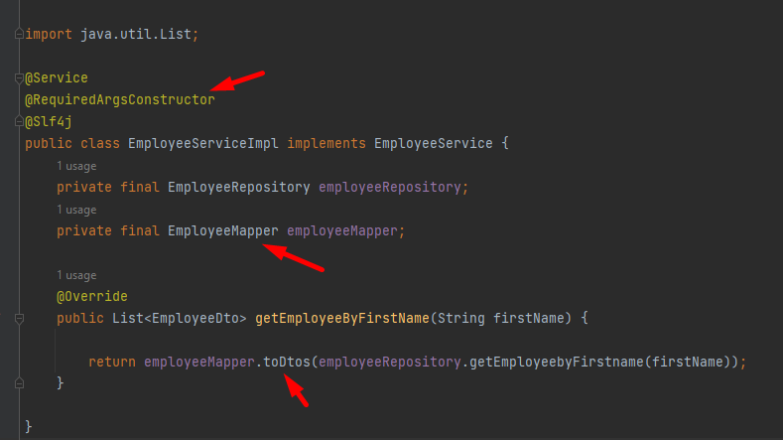

Enum converter

If you provide each value of an Emum a number, we need to provide constructor and getter for them:

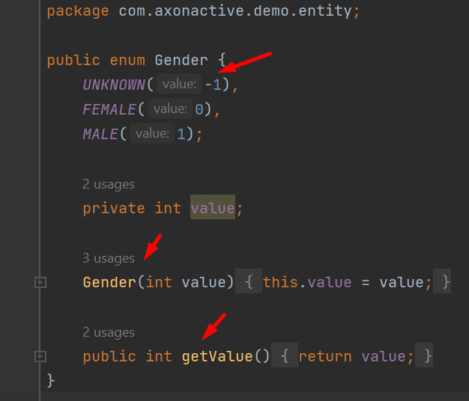

We need a converter class to convert integer value from DB to Gender String and vice versa:

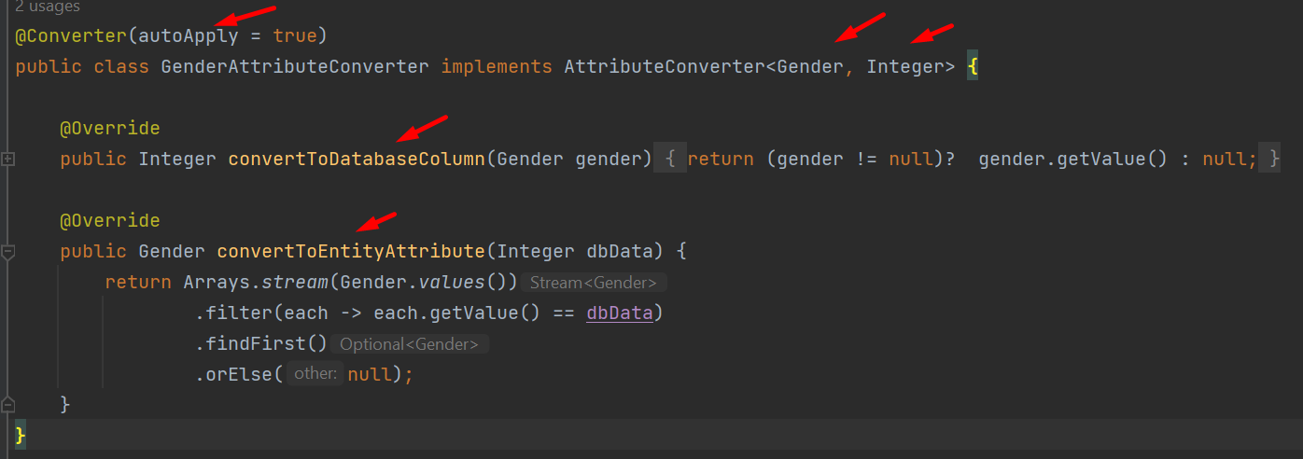

In any Entity that uses Gender, we need to identify that we use converter class to convert value for us

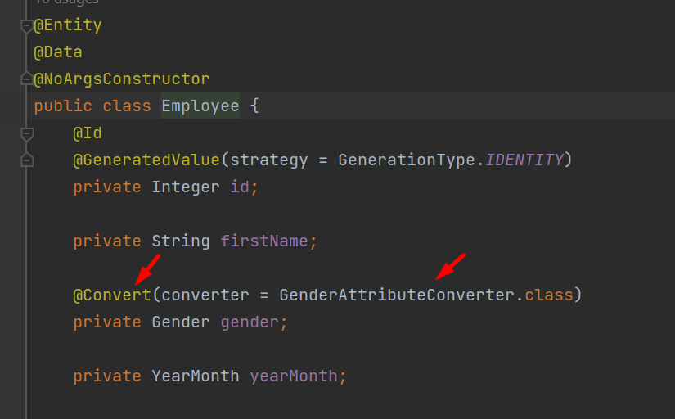

Basic Exception

# Step 1:

Add 3 standard exceptions such as notFound (for an entity not found), badRequest (for a wrong request from end users), internalServerError (for BackEnd errors):

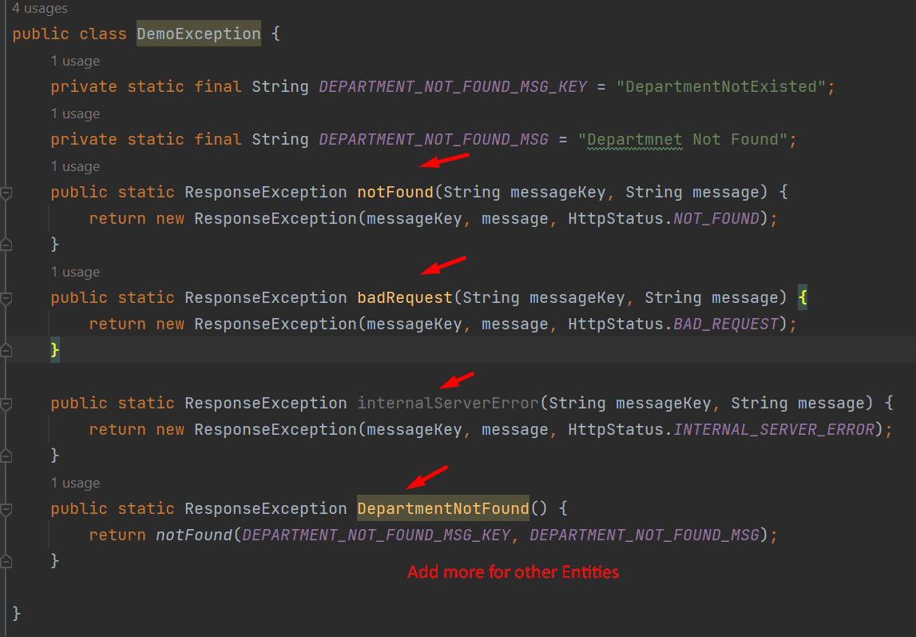

You can add more methods: EmployeeNotFound, ProjectNotFound,…

# Step 2:

Adding ResponseEntity class that extend RuntimeException with body including: key, message & HTTP status code

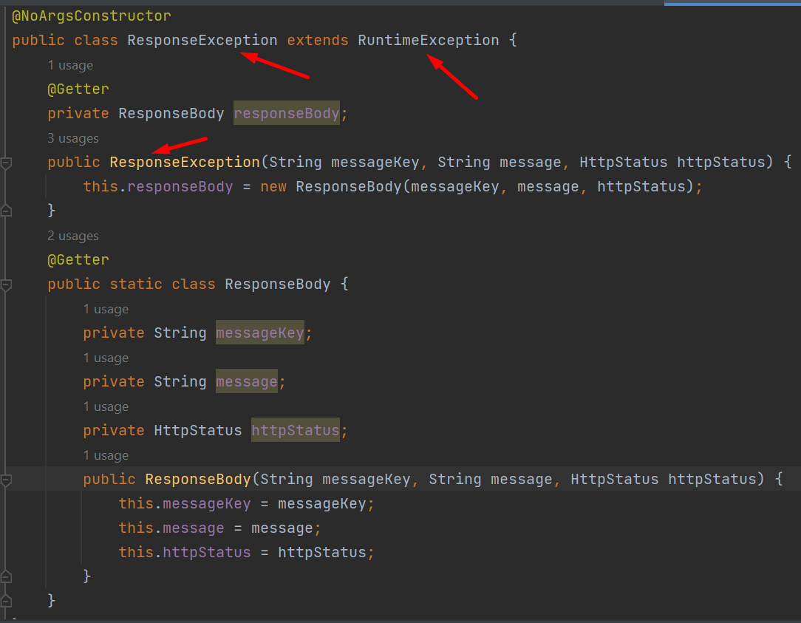

# Step 3:

Create RestExceptionHandler to handle the ResponseException

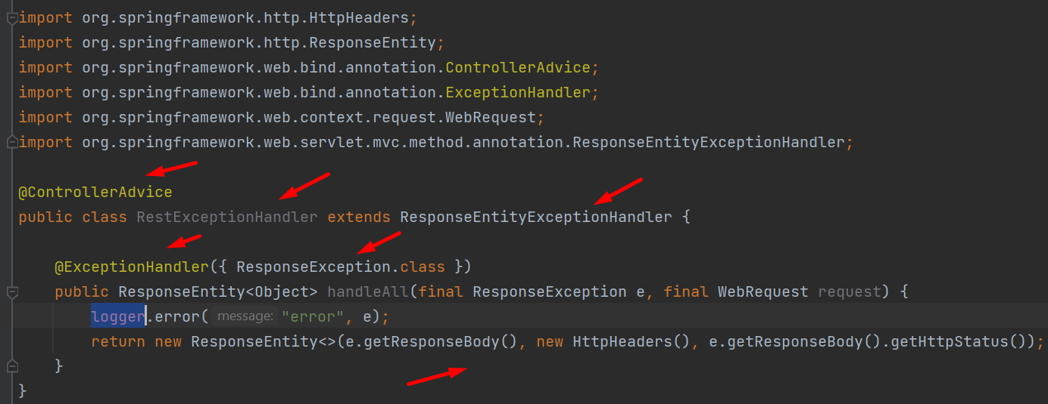

# Step 4:

Using DepartmentNotFound exception

