Prerequisite
- Docker
- Maven lifecycle

Create a pipeline on Jenkins:
Go to http://192.168.70.67:7070/
Username: admin
Password: admin
Click on New Item on side bar
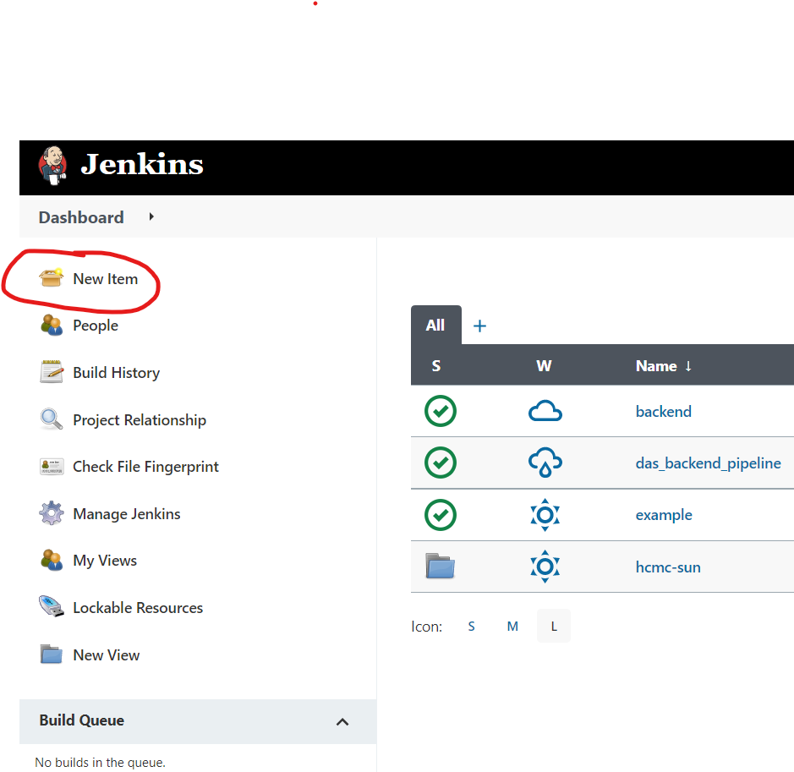
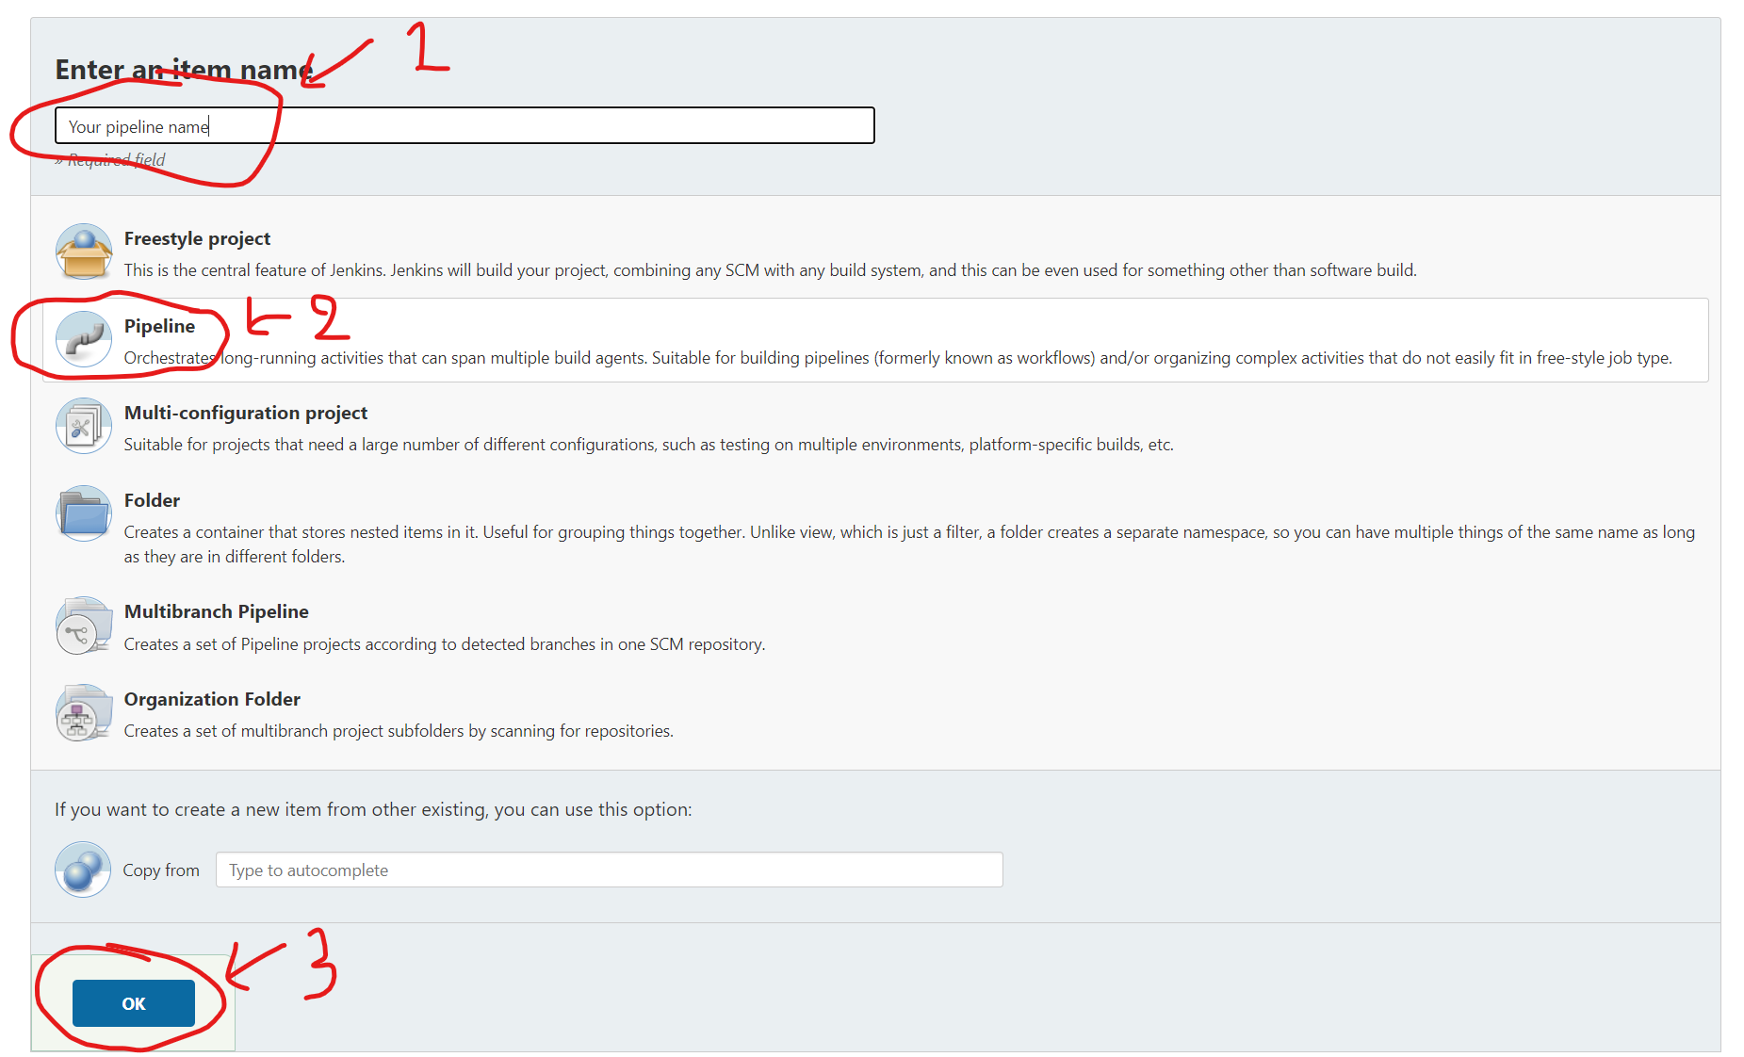
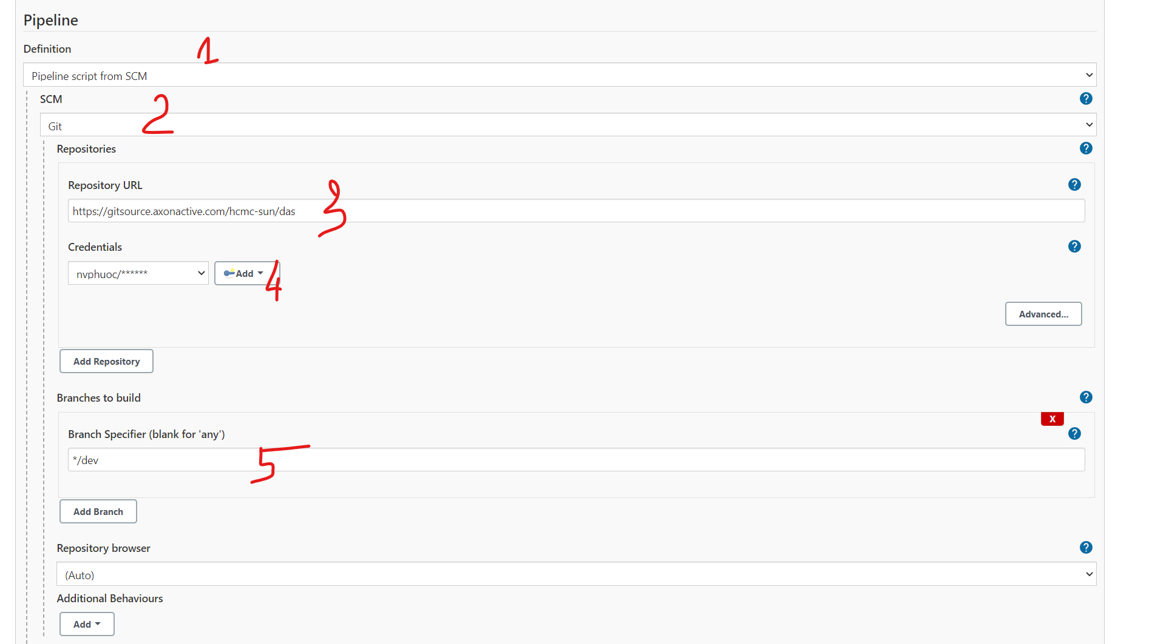
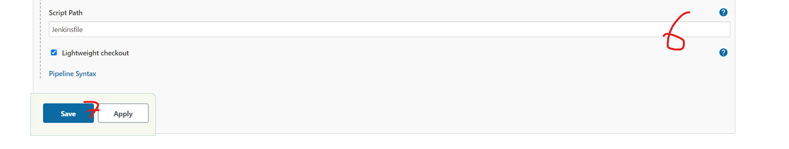
At number 6 is the path to your Jenkins script
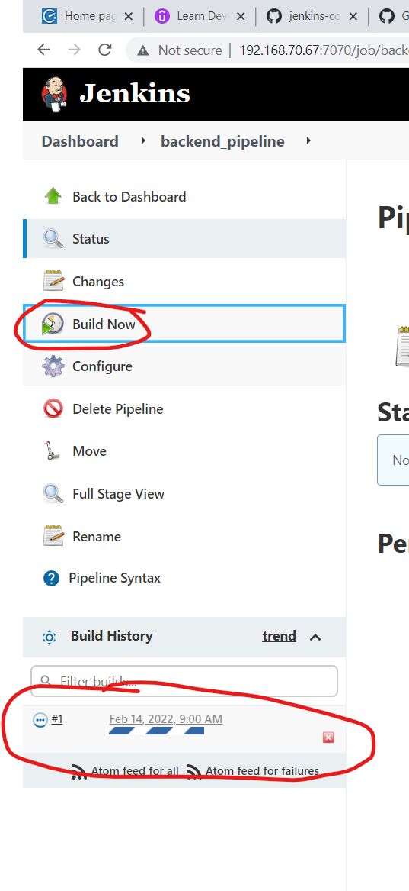

Click on the build at the bottom to see your build status and logs
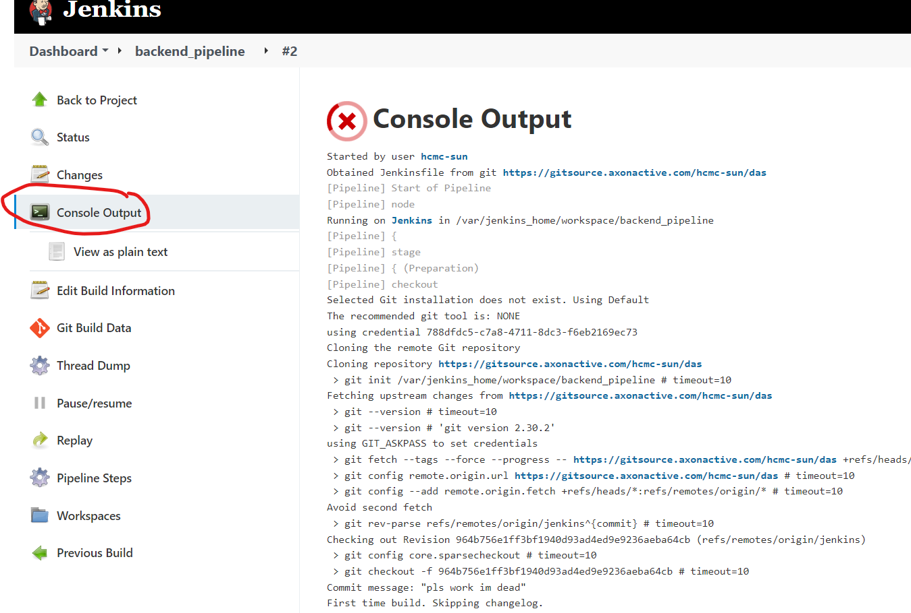
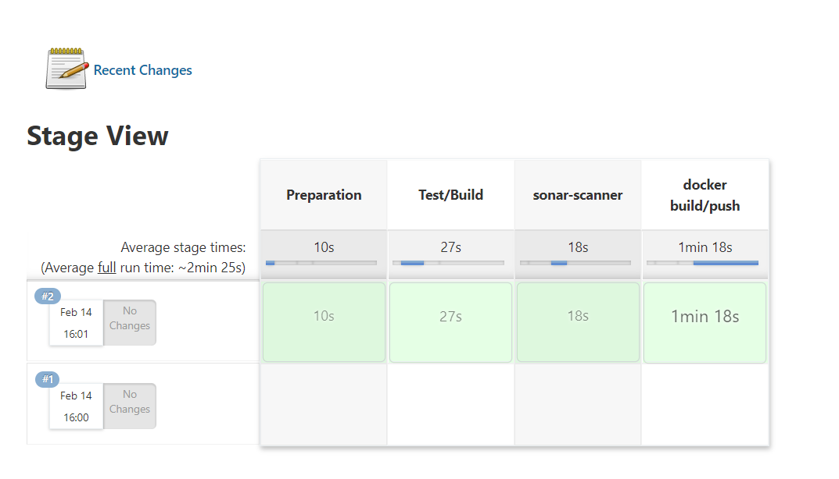
Build stages

Image push successfully to docker hub
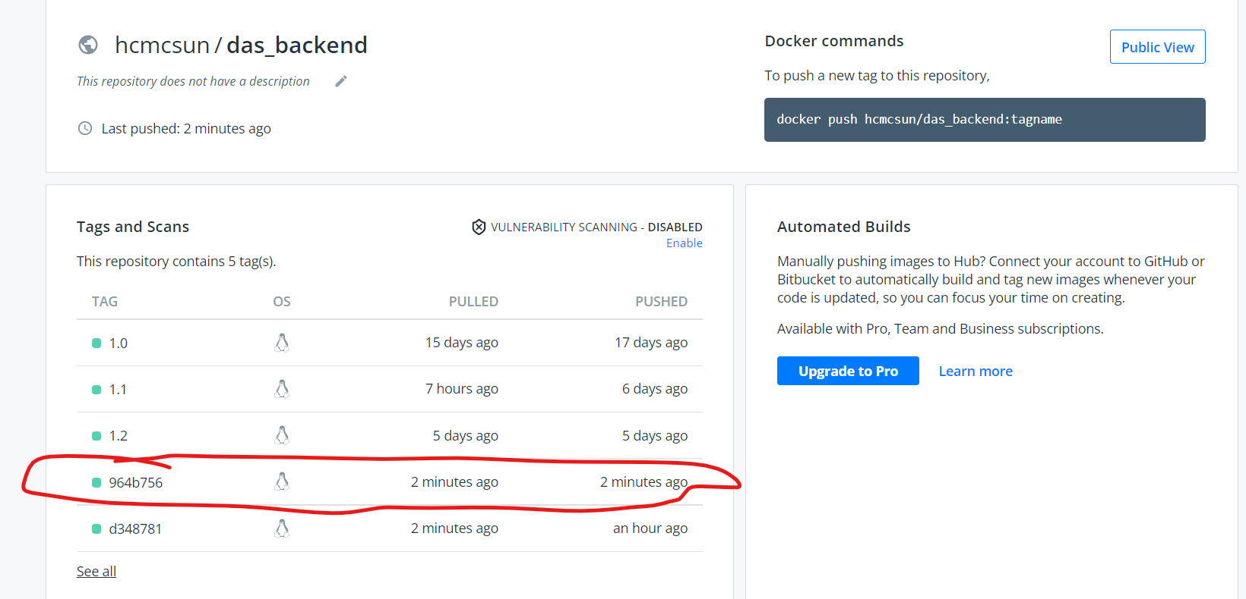

Go to http://192.168.70.67:9000/
Username: admin
Password: Admin@123
Check your project on sonarqube
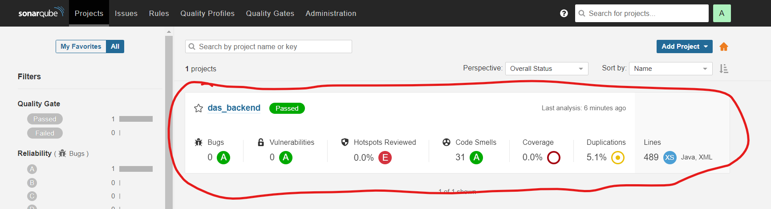

In pom.xml

Add build plugin to export jacoco test report.
<build>
<finalName>DataAdapterSystem_Service</finalName>
<plugins>
<plugin>
<groupId>org.apache.maven.plugins</groupId>
<artifactId>maven-surefire-plugin</artifactId>
<version>2.19.1</version>
<dependencies>
<dependency>
<groupId>org.junit.platform</groupId>
<artifactId>junit-platform-surefire-provider</artifactId>
<version>1.1.0</version>
</dependency>
<dependency>
<groupId>org.junit.jupiter</groupId>
<artifactId>junit-jupiter-engine</artifactId>
<version>5.1.0</version>
</dependency>
</dependencies>
</plugin>
<plugin>
<groupId>org.jacoco</groupId>
<artifactId>jacoco-maven-plugin</artifactId>
<version>${jacoco.version}</version>
<executions>
<execution>
<id>jacoco-initialize</id>
<goals>
<goal>prepare-agent</goal>
</goals>
</execution>
<execution>
<id>jacoco-site</id>
<phase>package</phase>
<goals>
<goal>report</goal>
</goals>
</execution>
</executions>
</plugin>
</plugins>
</build>

You can config your pipeline in the Jenkinsfile
Java EE pipline

node {
def commit_id
def mvnHome
stage('Preparation') {
checkout scm
sh "git rev-parse --short HEAD > .git/commit-id"
commit_id = readFile('.git/commit-id').trim()
mvnHome = tool 'Maven 3.8.4'
}

stage('Test/Build'){
sh "'${mvnHome}'/bin/mvn clean package"
}

stage('Push project to Sonar-scanner') {
def sonarqubeScannerHome = tool name: 'sonar', type: 'hudson.plugins.sonar.SonarRunnerInstallation'
withCredentials([string(credentialsId: 'sonar', variable: 'sonarLogin')]) {
sh "${sonarqubeScannerHome}/bin/sonar-scanner -e -Dsonar.host.url=http://192.168.70.67:9000 -Dsonar.login=${sonarLogin} -Dsonar.projectName=das_backend -Dsonar.projectVersion=${env.BUILD_NUMBER} -Dsonar.projectKey=DAS -Dsonar.sources=src/main/ -Dsonar.tests=src/test/ -Dsonar.language=java -Dsonar.java.binaries=target/classes -Dsonar.surefire.reportsPath=target/surefire-reports -Dsonar.jacoco.reportPath=target/jacoco.exec"
}
}

stage('Docker build/push') {
docker.withRegistry('https://index.docker.io/v2/', 'docker') {
def app = docker.build("hcmcsun/das_backend:${commit_id}", '.').push()
}
}

stage('Running docker container on dev sever') {
sh "docker rm -f backend_jenkins || true"
sh """docker run --detach --name=backend_jenkins -p 8081:8080 -p 9991:9990 -e JAVA_OPTS="-Xms1024M -Xmx4048M -XX:MaxPermSize=4048M -XX:MaxHeapSize=4048M" -e WAR_FILE=DataAdapterSystem_Service.war -e MYSQL_DAS_URI=192.168.70.67:3306 -e MYSQL_DAS_DATABASE=das_dev_db -e MYSQL_DAS_ROOT_PASSWORD=Admin@123 hcmcsun/das_backend:${commit_id}"""
}
}

Angular Code coverage config
coverageReporter: {
dir: require("path").join(__dirname, "./coverage/das-frontend"),
subdir: ".",
reporters: [{ type: "html" }, { type: "text-summary" }, { type: "lcov" }],
},
customLaunchers: {
ChromeHeadless: {
base: "Chrome",
flags: [
"--headless",
"--disable-gpu",
"--no-sandbox",
"--remote-debugging-port=9222",
],
},
},
reporters: ["progress", "kjhtml"],
port: 9876,
colors: true,
logLevel: config.LOG_INFO,
autoWatch: true,
browsers: ["ChromeHeadless"],
singleRun: false,
restartOnFileChange: true,
You can config your pipeline in the Jenkinsfile
Angular NodeJS pipeline
node {
def commit_id
stage('Preparation') {
checkout scm
sh "git rev-parse --short HEAD > .git/commit-id"
commit_id = readFile('.git/commit-id').trim()
}

stage('Test') {
nodejs(nodeJSInstallationName: 'NodeJS 17.5.0') {
sh "npm ci"
sh "npm run test"
}
}

stage('Docker build/push') {
docker.withRegistry('https://index.docker.io/v2/', 'docker') {
def app = docker.build("hcmcsun/das_frontend:${commit_id}", "--build-arg BACKEND=http://192.168.70.67:8081/DataAdapterSystem_Service .").push()
}
}

stage('Deploy to dev sever'){
sh "docker rm -f frontend_jenkins || true"
sh "docker run -d -p 4201:80 --name frontend_jenkins hcmcsun/das_frontend:${commit_id}"
}

stage('Genarate code coverage report') {
nodejs(nodeJSInstallationName: 'NodeJS 17.5.0') {
sh "ng test --code-coverage --watch=false"
}
}

stage('Push project to Sonar-scanner') {
def sonarqubeScannerHome = tool name: 'sonar', type: 'hudson.plugins.sonar.SonarRunnerInstallation'
withCredentials([string(credentialsId: 'sonar', variable: 'sonarLogin')]) {
sh "${sonarqubeScannerHome}/bin/sonar-scanner -e -Dsonar.host.url=http://192.168.70.67:9000 -Dsonar.login=${sonarLogin} -Dsonar.projectVersion=${env.BUILD_NUMBER}"}
}

}

