UNIVERSITY OF ECONOMICS AND LAW
FACULTY OF INFORMATION SYSTEMS

GRADUATION INTERNSHIP
REPORT

MAJOR IN MANAGEMENT INFORMATION SYSTEM

DEVELOPING A FOOD WEBSITE USING REACTJS

Company/Organization:
KYANON DIGITAL COMPANY LIMITED
Supervisor: M.A Lam Hong Thanh
Student:
Student ID: K194060850
Full name: Nguyen Dang Khoa
Class: K19406C

Ho Chi Minh City, February /2023

INTERNSHIP RESULT ASSESSMENT FORM
ID student: K194060850
Full name: NGUYEN DANG KHOA
Name of internship company: KYANON DIGITAL COMPANY LIMITED
Company address: 294-296 Truong Sa, Ward 2, Phu Nhuan District, HCMC
Company phone: (+84) 283 5171 080
Full name of company representative: LE QUOC ANH TUAN
Position: Director Phone:
Internship period: From 10-31-2022 to: 01-31-2023
* Please evaluate by marking X in the classification columns of the following table.
Notes:
Type A: 2 points; Type B: 1,5 points
Type C: 1 point; Type D: 0,5 point

Content of assessment | Rating
Content of assessment | A | B | C | D
1. Attitude and discipline
- Implement company’s policies
- Comply with working hours
- Communication attitude with colleagues and associates
- Property protection consciousness
- Be active at work
2. Advanced skills and qualifications
- Meet job requirements
- The spirit of learning and improving professional qualifications
- Be innovative and dynamic at work
3. Internship results
- Have practical application products that benefit the company
- The level of completion of the internship

COMMENTARY FORM OF THE INTERNSHIP COMPANY

……….., Date
CONFIRMATION OF THE COMPANY
Sign, write full name and stamp
INTERNSHIP REPORT RESULT ASSESSMENT FORM
(For instructor)
ID_student:
Full name:
Instructors:
STT | Criteria | Specific criteria | Point | Note
1 | Report Format (20%) | Presentation (5%)
1 | Report Format (20%) | Report structure (10%)
1 | Report Format (20%) | Writing style (5%)
2 | Report content (45%) | Analysis skill (5%)
2 | Report content (45%) | Objective (10%)
2 | Report content (45%) | Specialized knowledge results (30%)
3 | Student’s attitude (15%)
4 | Evaluation of enterprise (20%)
TOTAL

……….., Date
Instructors
Sign, write full name

COMMENTARY FORM OF INSTRUCTORS

Instructors
Sign, write full name

ACKNOWLEDGEMENTS
After more than three months of internship at Kyanon Digital Company Limited, I have learned a lot of knowledge and skills to solve problems in work and life. This will be a very meaningful time for me to experience the position of a Software Engineer Intern at this company. This job has helped me to form a sense of responsibility and initiative in solving all problems raised. In addition, it also motivates me to keep going in my career and pursue my goals.
First of all, I would like to thank the teachers in the Faculty of Systems for their dedication to imparting useful knowledge to me so that I can apply it today. I would like to thank Ms. Thanh for her advice and experience and for taking the time to help me complete this report.
Thank you to Mr. Dung and Mr. Kiet, who guided me and gave me the opportunity to participate in the company's projects so that I could complete the report in the best way. Thank you for your dedicated teaching during the internship period.
Finally, I would like to wish your company, colleagues, and teachers good health, success, and happiness in work and life.
Thanks, and best regards
Nguyen Dang Khoa.

WORKING SCHEDULE AND ASSIGNED TASKS
Time: 31/10/2022 – 31/01/2023
ID | Time | Task | Note
1 | 31/10 – 04/11 | - Onboarding Checklist  - ISO test  - Take part in Company Orientation  - Participate in an ongoing project of the company
2 | 07/11 – 11/11 | - Draw a roadmap about Source code, Roles, members, and a day of a front-end developer in the project  - Learn about the technologies being applied in the project
3 | 14/11 – 18/11 | - Study about JavaScript ES6 Basic & Advanced, Redux, Typescript, Next JS
4 | 21/11 – 25/11 | - Study about Styles (CSS, SCSS, SASS), Version & License in Develop
5 | 28/11 – 02/12 | - Build a Blog project to practice  - Learn about how to use CMS of project & get APIs from back-end
6 | 05/12 – 09/12 | - Participate in international projects for Singapore companies Develop new solutions as well as revamp, fix issues, and errors with existing applications
7 | 12/12 – 16/12 | - Participate in international projects for Singapore companies Develop new solutions as well as revamp, fix issues, and errors with existing applications
8 | 19/12 – 23/12 | - Participate in international projects for Singapore companies Develop new solutions as well as revamp, fix issues, and errors with existing applications
9 | 26/12 – 30/12 | - Participate in international projects for Singapore companies Develop new solutions as well as revamp, fix issues, and errors with existing applications
10 | 02/01 – 06/01 | - Participate in international projects for Singapore companies Develop new solutions as well as revamp, fix issues, and errors with existing applications
11 | 09/01 – 13/01 | - Participate in international projects for Singapore companies Develop new solutions as well as revamp, fix issues, and errors with existing applications
12 | 16/01 – 20/01 | - Participate in international projects for Singapore companies Develop new solutions as well as revamp, fix issues, and errors with existing applications
13 | 23/01 – 31/01 | - Tet Holiday  - Sign a contract to end the internship

CONTENTS
ACKNOWLEDGEMENTS 6
WORKING SCHEDULE AND ASSIGNED TASKS 7
CONTENTS 9
LIST OF FIGURES 11
LIST OF TABLES 12
LIST OF ACRONYMS 13
CHAPTER 1: TOPIC OVERVIEW 14
1.1. Reasons 14
1.2. Objectives 14
1.3. Objects And Scopes 15
1.4. Structure 15
CHAPTER 2: INTRODUCTION TO KYANON DIGITAL COMPANY LIMITED 16
2.1. Introduction to the company 16
2.2. Company Culture 16
2.3. Company Vision – Mission 17
2.4. Company History 17
CHAPTER 3: THEOETICAL BACKGROUND 18
3.1. Website And the Structure of The Website 18
3.1.1. What is the Website? 18
3.1.2. What is the structure of the website? 18
3.2. Front-end programming 20
3.3. Popular technologies used to program front end websites currently (used to create foody websites) 21
CHAPTER 4: BUILDING FOODY APP USING REACTJS 22
4.1. Why choose typescript instead of JavaScript to do this project? 22
4.2. Creating and Configuring a React JS Project with Typescript using “npx create-react-app” 22
4.2.1. Prerequisites 22
4.2.2. Installing the create-react-app CLI 23
4.2.3. Setting Up the Project 23
4.2.4. Installing Dependencies 24
4.2.5. Running the Project 24
4.2.6. Some other configurations 24
4.2.7. Conclusion 26
4.3. Foody app interface analysis 26
4.4. Break the project down into components and organize the source 28
4.5. Some typical code snippets 29
CHAPTER 5: DEPLOY FOODY APP ON VERCEL 33
5.1. Why Choose Vercel to Deploy a Food App Built with ReactJS? 33
5.2. Pull the source code to GitHub 34
5.3. Deplpoy project on vercel 35
CHAPTER 6: CONCLUSION 38
6.1. Benefits 38
6.2. Drawback 38
6.3. Future Works 39
Conclusion 40
REFERENCES 41

LIST OF FIGURES

Figure 1: Kyanon Digital Company Limited Logo 16
Figure 2: Download NodeJS New Version 23
Figure 3: Create New Empty ReactJS Project with Typescript 23
Figure 4: Initial settings for React Project in Package.json File 23
Figure 5: Install All Package by NPM Command 24
Figure 6: Run Project 24
Figure 7: Initial prettierrc Config 24
Figure 8: Typescript Configs in tsconfigs.json 25
Figure 9: Install SCSS Package by NPM Command 26
Figure 10: Foody-app UI 26
Figure 11: Components of Foody-app UI (Homepage) 27
Figure 12: Components of Foody-app UI (Modal) 28
Figure 13: Project Structures 28
Figure 14: Components in project Structures 29
Figure 15: Get The Item by The Id in The Cart 29
Figure 16: Add Cart Quantity 30
Figure 17: Increase Cart Quantity 30
Figure 18: Decrease Cart Quantity 31
Figure 19: Remove Item From Cart 31
Figure 20: useLocalStogare Custom Hook 32
Figure 21: Currency conversion 32

LIST OF ACRONYMS

QC | Quality Control
PM | Project Manager
CLI | Command Line Interface
IT | Information Technology
UI | User Interface

CHAPTER 1: TOPIC OVERVIEW

Reasons
Front-end website programming has become increasingly important in the modern digital age. With the rise of web-based applications and services, the demand for experienced and knowledgeable front end website developers has also risen. As a result, many students are now opting to choose front end website programming as their topic for their internship report.
The primary reason for this is the fact that a good grasp on front end website programming can open up many job opportunities in the future. Many companies are now looking for experienced web developers to help build and maintain the websites they need. As such, having a good understanding of front-end website programming is essential to succeeding in the job market.
Furthermore, front end website programming also provides an excellent opportunity to hone your problem-solving skills. Websites have a wide variety of components that need to be properly integrated and kept up to date. As such, developers must be able to think critically and solve complex problems in order to ensure the functionality and longevity of the website. This can be especially beneficial for those who are interested in pursuing a career in software engineering.
Finally, front-end website programming also allows for the chance to become creative. There are a variety of techniques and technologies that can be used to create visually appealing and user-friendly websites. This can be a great way to showcase one’s creative abilities and even to build an impressive portfolio.
Overall, front end website programming is an excellent topic to choose when writing an internship report. It provides a great opportunity to gain valuable knowledge that can be used to pursue a career in software engineering, to hone problem-solving skills, and to become more creative. As such, it is an excellent choice for any student looking to gain a better understanding of the industry.

Objectives
Choosing a topic for an internship report can be a daunting task. The report should provide a valuable contribution to the field and reflect the student's understanding of the material, as well as their ability to apply the theoretical and practical knowledge acquired during the internship. The objectives for the selection of the topic for the internship report on front-end website programming should be twofold:

- To develop a clear understanding of different web development paradigms, such as single-page applications, hybrid applications, responsive design, and other emerging technologies;
- To gain a comprehensive understanding of the fundamentals of front-end website programming, such as HTML and CSS, and be able to apply them in real-world scenarios.
An internship at Kyanon Digital Company Limited helps me to understand existing practices and standards in the field and familiarize me with front-end programming languages, and user experience aspects of the website this helps me to develop a lot and prepare a good premise for my future career.

Objects And Scopes
Objects: This topic focuses on introducing the intern company ABC, then on the technologies to build the current website, especially the front end. Finally, introduce a small project that features basic purchases as an exercise on the company before entering the actual project
Scope: Because of the limitation of the report, the report will focus on the big picture of an e-commerce similar website with an ordering feature “food app”

Structure
The report consists of 6 chapters as follows:
CHAPTER 1: TOPIC OVERVIEW
In this chapter, the report presents the following content: Overview of the Reasons, Objectives, objects and research scope of the topic; implementation plan and project structure.
CHAPTER 2: INTRODUCTION TO THE COMPANY AND PROJECT
Introduction about Kyanon Digital Company Limited.
CHAPTER 3: THEORETICAL BACKGROUND
About all the technologies used in the project as well as during the internship at the company
CHAPTER 4: BUILDING FOODY APP USING NEXTJS FRAMWORK
About the foody app project, a project I built myself to learn before entering actual projects at the company.
Organizational structure of source code and technologies used in the project
Typical code snippets and key features
CHAPTER 5: DEPLOY FOODY APP ON VERCEL
Give a reason why choose Vercel as to deploy the project
Instructions for deploying Foody app projects to Vercel
CHAPTER 6: CONCLUSION
Summarize and present some shortcomings that need improvement
Personal contributions and suggestions

CHAPTER 2: INTRODUCTION TO KYANON DIGITAL COMPANY LIMITED

Introduction to the company

Figure 1: Kyanon Digital Company Limited Logo
Kyanon Digital Company Limited was established in 2012, Kyanon Digital is a Vietnam-based tech powerhouse having offices in HCMC/Vietnam and Singapore. Kyanon Digital is trusted by international clients for its commitment to success and engineering excellence.
"Kyanon"-A Magic Crossbow
Behind Kyanon Digital Company Limited is a story inspired by the Vietnamese historic legend of “My Chau – Trong Thuy”, which tells of how a magic crossbow helped King An Duong Vuong and his countrymen become invincible.
Kyanon translates to “a crossbow”, a magic weapon that the company believes in. It is the tool that allows our Warrior Archers (employees of Kyanon Digital Company Limited) to conquer any target with ease.

Company Culture
Kyanon Digital People’s DNA is ‘ARCHERS’. It's a combination of 7 keywords: Agility, Reliability, Craft, Harmony, Enthusiasm, Resilience, Sustainability
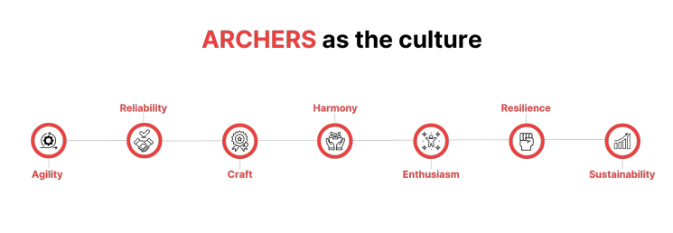
Figure 2: Archers as the culture

Company Vision
- To establish Kyanon Digital as a thought leader in the digital transformation industry in the South East Asia.
- To be a tech incubator, owning intrapreneurship programs that bring out innovative capabilities required for this digital era.
- To constantly train our teams to maintain digital supremacy.
- To build a great dojo where great Archers proudly engage and devote themselves.

Company History
Milestones in Kyanon Digital Company Limited growth story:
- Inception (2012): Provided digital production services such as building web/apps for MNCs.
- Expansion (2016):
  - Became the tech partner for several agencies, brands, and tech start-ups in Vietnam.
  - Invested in human capital – expanded to 100+ engineers to serve clients.
- Global Footprint (2017):
  - Opened an office in Singapore.
  - Focused on digital transformation projects.
  - Acquired global clients from Singapore, France, Australia, the US, etc.
- Recognition (2020+):
  - Listed among the TOP 10 ICT Companies of the year 2020 in Vietnam.
  - Recognized by the industry as a Digital Transformation & Innovation company.
  - Grew as a Human-centric organization with 180+ champion Archers.

CHAPTER 3: THEOETICAL BACKGROUND

Website And the Structure of The Website

What is the Website?
Website is a collection of sub-sites, including text, images, videos, flash, etc. WEBSITE is only located in a domain name or subdomain hosted on servers running online on the World-Wide transmission of the Internet.
Websites generally include the following basic components:
Domain name (domain): Considered as the website address. Assuming the website is a store, the domain name is the address name of that store. Therefore, to access the website, you must type the domain name address on the browser to be able to go to that website.
Web hosting: After having a domain name. Your next job is to rent a server. That's called web hosting. The server will store all the information, images and documents of the website so that it can produce results that match the user's query.
Source Code: This is considered the source code of the website. If the domain name is the address, the web hosting is the land, the source code is the brick and concrete to build the website. And you have a website, which is a complete home.

What is the structure of the website?
Header: This element is located at the top of the web page and is displayed on all pages of the website.
Site ID: Is the identifier for the website, easier to understand than the website name. Site ID is usually located in the left-hand corner. The most visible is the logo image or a short slogan for the website.
Home link: Home link, also known as the link to the homepage, when you click on this link, it will go to the homepage of the website.
- What is the homepage? Home page is the first page you see when accessing a website address like Bigweb.com.vn…
- What is the link? link, also known as link, link can be placed inside an image or text that when you click on it will be redirected to another web page link.
- Home links can be done in two ways:
  - Embedded in the website logo.
  - Attached to the text, you can see it most easily such as the word Home or Home, etc.
Navigation menu: A container that contains a collection of links to the main pages on the website. Usually, the menu will be placed inside the header. The menu is designed to be easy to see, helping users quickly go to the main pages on the website. For example, you see the menu may include the following links such as: Home, Products, Contact, About ...
Search box (Search box): For websites with a lot of articles or products, the search box helps users find information on the website quickly. In the header, the search box is usually placed in the right corner and is made simple so that it does not take up much space. It only includes a box to enter the keyword to search and a search button. If you think of a search box with more functions such as searching by product category, color ... (often called advanced search), think about putting it in the Scan columns.
Cart: For sales websites, you will notice a shopping cart icon placed on the right corner. The shopping cart can display information such as: the number of selected products, how much is the total amount? When users click on it, they will be redirected to the shopping cart page to view the details of the products ordered.
Slider: This element is usually placed below the header. Popular sliders are images, including many different images but not all displayed on the website. Slider will have a navigation button, so you can move through other slides. Also slides can be videos. The beautifully designed slider will draw your customers in on the first visit to the website.
Scan columns: Why is it called "scan columns", scanning is like you using your eyes to browse through each part of the web page, specifically here the columns. The concept of scan columns has been around for a long time, previously used in book publishing. Nowadays, scan columns are widely applied in website design. The common types of column division you often encounter such as dividing 2 columns, 3 columns ...
- Scan column usually takes up not too much width, it can contain the following elements:
  - Navigation menu
  - Advanced search box
  - Featured products and articles
  - Contact Info
  - Advertising banner
Banners: There are some cases of confusion between banner and header. Actually banner and header are completely different. The word banner is used in advertising such as product advertising, event advertising ... Banners will usually be images, designed to attract customers. Popular banner placements include the top of the page (above the header) or the scan column. In addition, you can see banner ads in video clips like YouTube for example.
Content area: This is the main body of the website and contains the most information. The content presented is easy to see, good information will retain your customers longer.
- The content section usually contains the following elements:

  - Page title: usually placed at the beginning of the body of content. The title is usually in big and bold font to let the user know what the site is about.
  - Breadcrumb navigation (Breadcrumb trails): is a hierarchical navigation bar, which helps users know where they are on the website and can move between items on the website quickly. You will notice that news sites often have this navigation bar and it is placed at the top of the page content. For example: News → Sports…
  - Main content: this can contain any information, usually the website will have an admin section, also known as a CMS, so you can enter this content.
  - Paging navigation: for sites that contain a lot of content, such as a product listing or article listing, pagination is intended to reduce the load on the site so it loads faster., it also helps non-geek users

Front-end programming
Front-end programming is the process of writing programming code to create a user-facing aspect of a website or web application. Front-end programming focuses on the visuals and interactive elements that a user will experience when they visit a web page.
Front-end web development involves the use of HTML, CSS, JavaScript, and other programming languages to create the user interface and control how a website looks and functions. HTML provides structure and meaning to the content of a web page, while CSS provides styling. JavaScript is used to add dynamic elements and interactivity to the page.
Developers also use frameworks such as Bootstrap and jQuery to simplify the development of complex web designs, as well as to build responsive web applications. Responsive web design refers to web page layouts and designs that adapt to the size of the user’s device, such as their desktop, tablet, or mobile phone.
Front-end programming is a key part of modern web development, as it is what makes a website look and feel good to the user. A good front-end developer will have a strong understanding of HTML, CSS, JavaScript, and other key programming languages, as well as the ability to build designs that look great on all types of devices.

Popular technologies used to program front end websites currently (used to create foody websites)
Web programming languages are languages used to create websites and web applications. To build a website or application, programmers use programming languages such as HTML, CSS, JavaScript, ReactJS, Next JS, Redux.
- HTML stands for Hypertext Markup Language, it is the coding language for building and creating web pages. HTML is the main tool for building structure, containing content, and allowing other parts to be integrated into a web page
- CSS (Cascading Style Sheets) is code for visual representation and formatting of web pages. Using CSS, developers can adjust the color, font, text size, images, layout and other parts of the web page.
- SCSS (Sassy CSS) is a CSS pre-processor that makes it easier to write and maintain CSS code. It allows the use of nested syntax, variables, mathematical operations, and functions to produce CSS. It also supports the use of existing CSS libraries.
- JavaScript is a popular programming language used in web development. JavaScript can be used to create dynamic web pages, valid forms, process data, integrate APIs, and other tasks.
- TypeScript is an open-source language developed and maintained by Microsoft. It is a superset of JavaScript and adds optional static typing and object-oriented features to the language. It compiles to plain JavaScript and can be used to develop large-scale web applications. It can also be used in other environments such as Node.js and React Native.
- ReactJS is a JavaScript library used to build web applications and websites. It provides an easy way to use components, to process logic, and to create user interfaces.
- Redux is a state management library for JavaScript applications. Redux makes it easy to manage the state of an application so that the data is consistent across different components.

CHAPTER 4: BUILDING FOODY APP USING REACTJS

Why choose typescript instead of JavaScript to do this project?
Typescript is a typed superset of JavaScript that compiles to plain JavaScript. It provides optional static typing and class-based object-oriented programming to JavaScript. ReactJS is a JavaScript library for building user interfaces. Using TypeScript with React enables developers to use both technologies together and get the benefits of a strongly typed language and a modern library. TypeScript helps to catch errors early and keep code maintainable, while ReactJS helps developers to create high-performing user interfaces.
Because some of the above advantages of TypeScript as well as the requirements of the company, it is not mandatory to use JavaScript or TypeScript, so I decided to use the built-in typescript to improve my knowledge before entering the company's actual projects because the base The company uses both types depending on the time of project initiation as well as customer requirements.

Creating and Configuring a React JS Project with Typescript using “npx create-react-app”
ReactJS is a powerful JavaScript library for building user interfaces and creating modern, interactive web applications. When combined with Typescript, it provides a robust development platform for creating large-scale projects. This guide will walk you through the steps required to create and configure a ReactJS project with Typescript using npx create-react-app.
    - Prerequisites
Before you begin, you need to have a few prerequisites in place. First, you must have an up-to-date version of Node.js installed on your computer. You can download the latest version of Node.js from https://nodejs.org/en/
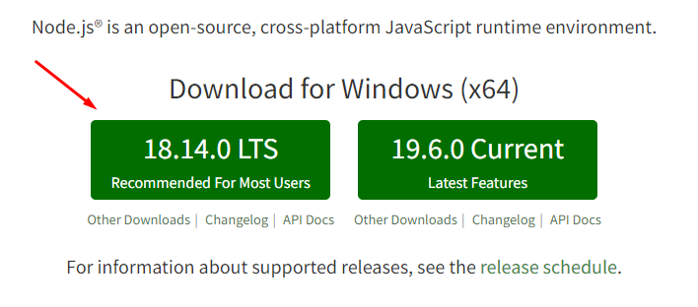
Figure 3: Download NodeJS New Version
Second, you must also have a package manager installed on your computer. The most popular package managers are npm and yarn. You can download the latest version of npm from https://www.npmjs.com/get-npm , and the latest version of yarn from https://classic.yarnpkg.com/en/docs/install/.

Installing the create-react-app CLI
The create-react-app CLI is the most straightforward way to create and configure a ReactJS project with Typescript. To install the create-react-app CLI, you need to run the following command from your command line:
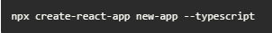
Figure 4: Create New Empty ReactJS Project with Typescript
This command will install the create-react-app CLI and create a new ReactJS project with Typescript in the directory new-app.

Setting Up the Project
Once the project has been created, you can open it in your favorite code editor. Open the package.json file in the root of your project, and add the following lines:
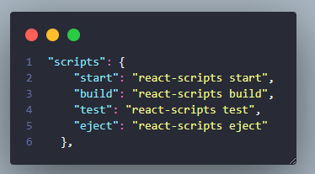
Figure 5: Initial settings for React Project in Package.json File
These lines will enable the scripts that you need to start, build, and test your project.

Installing Dependencies
Now that you have set up your project, you need to install the necessary dependencies. You can use npm or yarn to install the dependencies. For example, if you are using npm, you can run the following command to install all the necessary dependencies:
Figure 6: Install All Package by NPM Command

Running the Project
Once the dependencies have been installed, you can start your project by running the following command:

Figure 7: Run Project
This command will start the development server and will open your project in the browser.

Some other configurations
Add a .prettierrc file to configure some settings on vs code to help sync when developing new developers as well as many different devices:
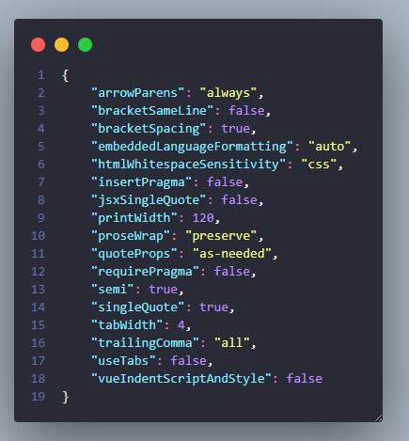
Figure 8: Initial prettierrc Config

Configuration File: tsconfig.json in React TypeScript
TypeScript is a superset of JavaScript that adds optional static typing and a powerful set of tools to the language. In React projects, TypeScript is used to provide type-safety and to enable better code completion and refactoring.

The configuration file for TypeScript projects is tsconfig.json. This file contains options for TypeScript compiler.
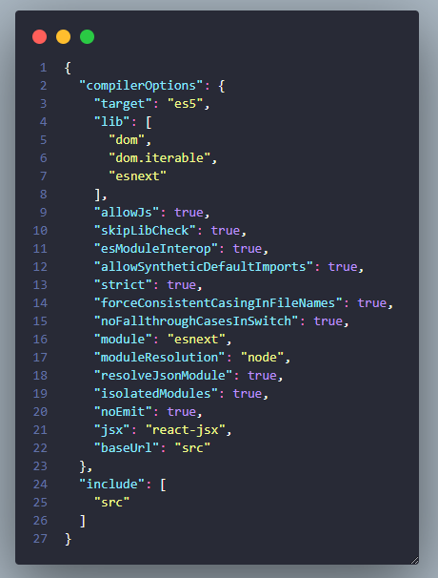
Figure 9: Typescript Configs in tsconfigs.json
The options mentioned above are the most commonly used options in a tsconfig.json file. The include and exclude sections tell the compiler which files and folders to include or exclude when processing the project.
For a more detailed description of all the options, please refer to the TypeScript documentation.
To get started with SCSS, you will need to install the preprocessor using either npm or yarn.
Install SCSS with npm
To install SCSS with npm, run the following command in your terminal:
Figure 10: Install SCSS Package by NPM Command

Conclusion
In this guide, we have gone through the steps required to create and configure a ReactJS project with Typescript using npx create-react-app. We have also discussed the prerequisites, installing the create-react-app CLI, setting up the project, installing the dependencies, and running the project.

Foody app interface analysis
This is the UI of the foody-app website, in general, the website is just a simple Homepage page with components such as Header, Buttons, Card, Product Item, and Modal. About the main feature, the website has the main feature that is Add to Cart, which is an important feature in handling projects about buying and selling products, Regarding the Add to Cart feature, there will be many ways to handle examples. such as Rest API for Backend to process and return results, Use Redux to create a User-side Store to store cart values, Use LocalStorage or SessionStorage to store the user-side. Due to the limitation of time and project size, it is not possible to build the underlying backend system for this processing, so in this project, only LocalStorage is used instead of building the backend system. In section 4.5 below there are some example code snippets on how to use LocalStorage and shopping cart logic.
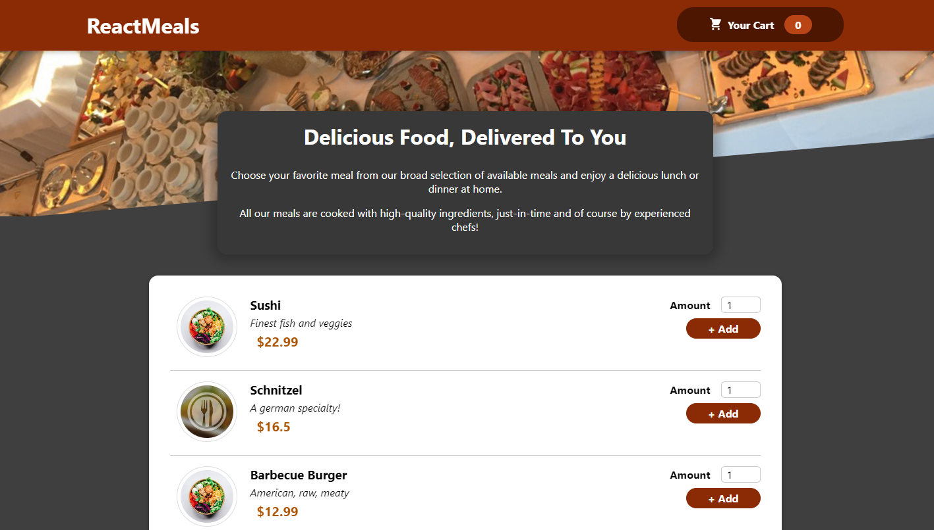
Figure 11: Foody-app UI
These are the components in the Homepage UI such as: Card, Header, Add to cart Button, ProductItem,etc.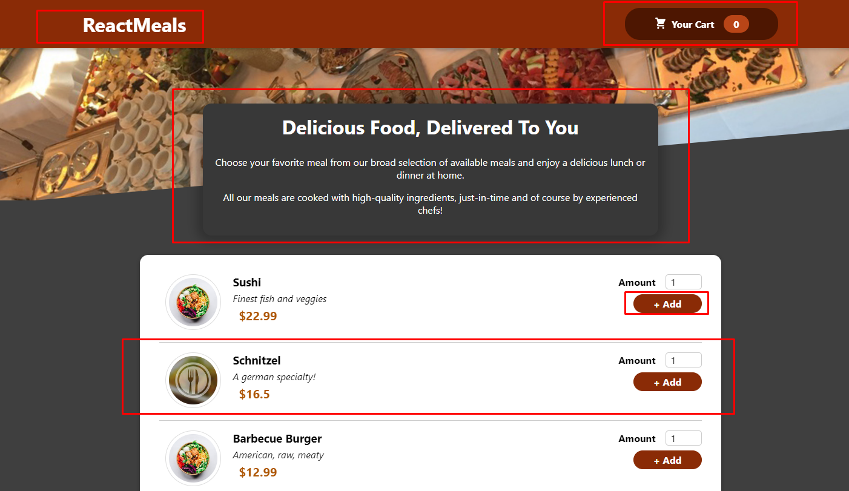
Figure 12: Components of Foody-app UI (Homepage)
These are the components in the Modal UI when clicking Add to Cart Button, here there are components such as: 2 Button Close and Order, Product Item, Increase/Decrease Button.
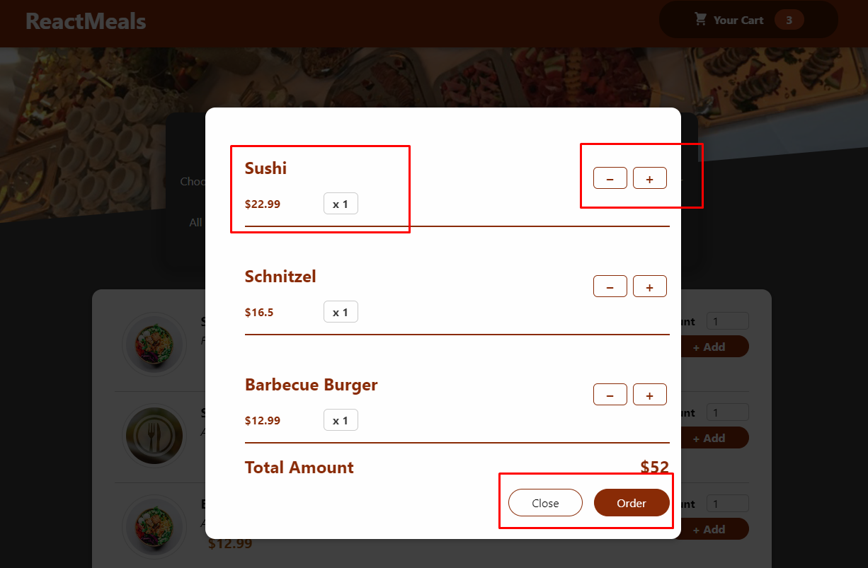
Figure 13: Components of Foody-app UI (Modal)

Break the project down into components and organize the source
After creating an empty project with create-react-app and configuring some basic components, from the src folder create additional folders like:
- Assets: Contains all the components that need to be stored such as images, fonts, icons, etc.
- Components: Contains the components analyzed in section 4.3 (a great application of ReactJS)
- Constans: Since there is no API call data from the backend, this section contains dummy product data
- Hook: Create custom hooks (here has a custom hook, useLocalStorage), not in ReactJS's default hooks
- Pages: contains the pages of the interface, but in this project, there is only one page, the homepage
- Types: defines data types for Variable values, great use of typescript
- Utilities: contains special functions, here there is a currency conversion function
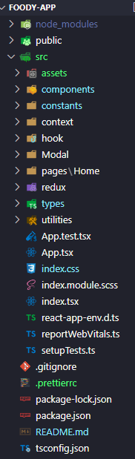
Figure 14: Project Structures
The idea of ReactJS is to break down the original UI into components that can be reused anywhere. As analyzed in section 4.3, we can separate the interface into the following components: AvailableMeals, Card, Input, MealItem, MealItemForm, Header, MealsSummary, and Modal. As shown below:
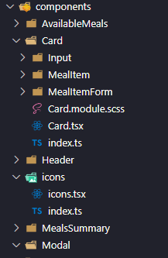
Figure 15: Components in project Structures

Some typical code snippets
Link source code: https://github.com/khoa25200/foody-app
Here are some typical code snippets that I've picked out:
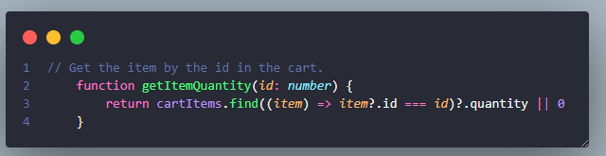
Figure 16: Get The Item by The Id in The Cart
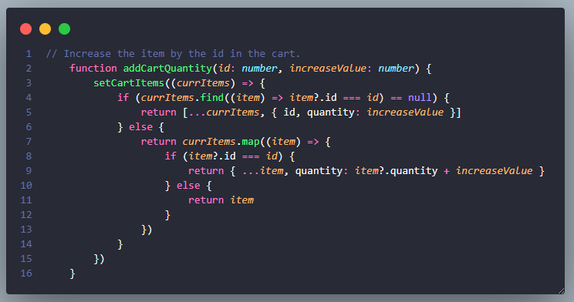
Figure 17: Add Cart Quantity
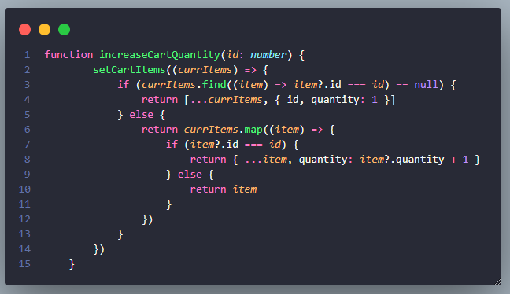
Figure 18: Increase Cart Quantity
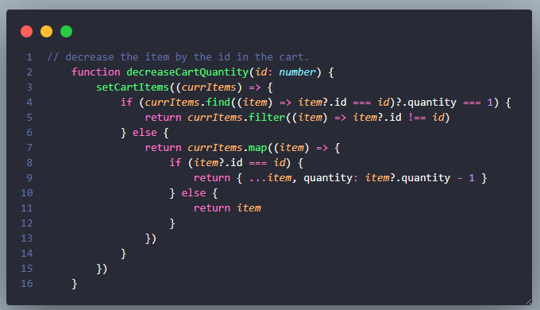
Figure 19: Decrease Cart Quantity

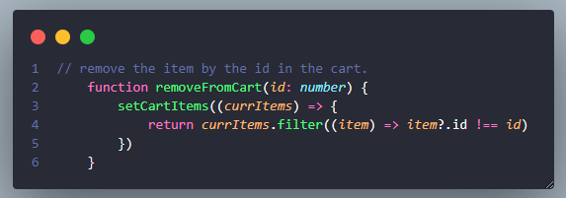
Figure 20: Remove Item From Cart
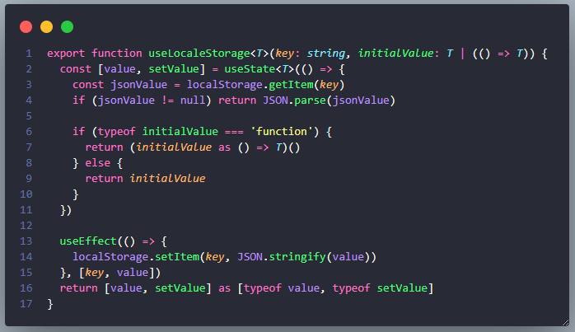
Figure 21: useLocalStogare Custom Hook
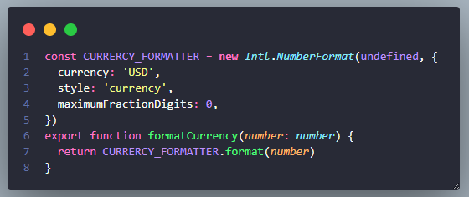
Figure 22: Currency conversion
  - Foody app
This is the interface after the project has been built, although there are many shortcomings in UI, features, as well as bugs, but in the end, the project has successfully worked. More source code as well as, a live demo of my project can be found here:
Link source code: https://github.com/khoa25200/foody-app
Link live demo: https://foody-app-delta.vercel.app/

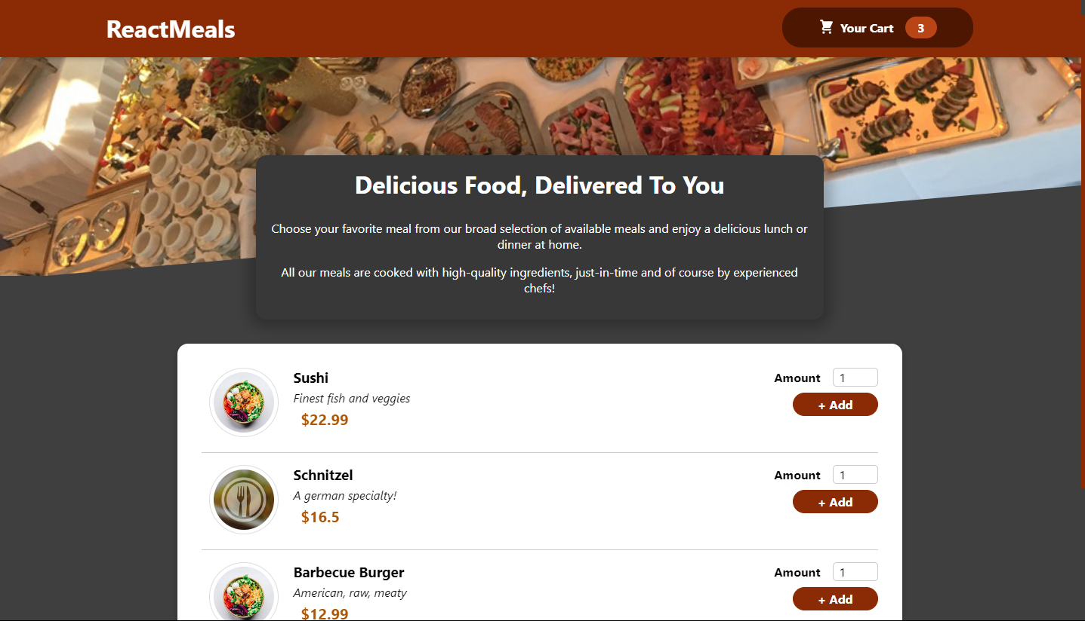
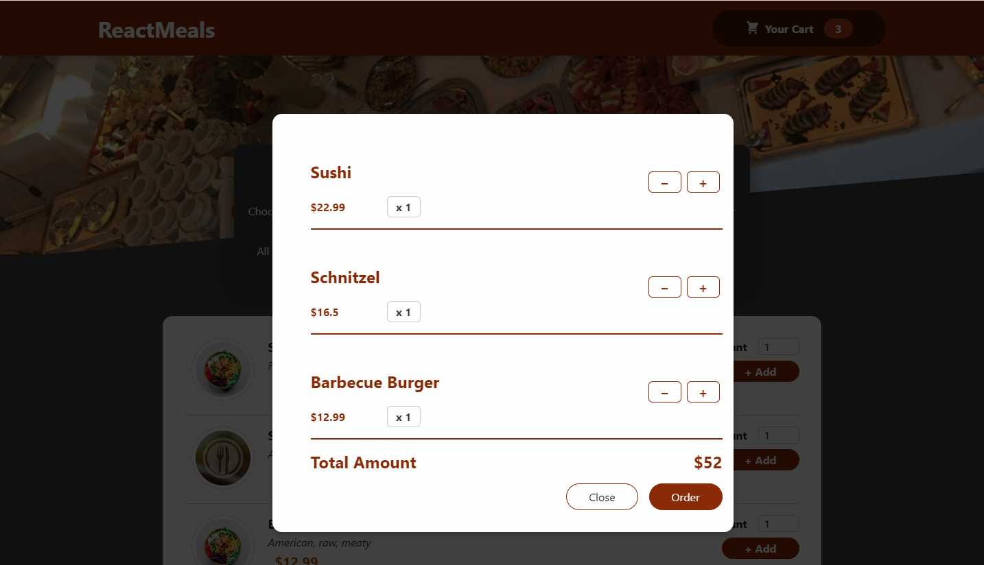

CHAPTER 5: DEPLOY FOODY APP ON VERCEL

Why Choose Vercel to Deploy a Food App Built with ReactJS?
Vercel is an excellent choice for deploying a food app built with ReactJS. This is a popular and reliable platform used by many developers around the world, and it offers a host of benefits that make it an ideal choice for deploying web applications.
First and foremost, Vercel is easy to use. It has a straightforward user interface that makes it very simple to set up and manage the deployment of ReactJS applications. Even if you don't have any prior experience with web development, you can quickly get up to speed and deploy your food app with Vercel.
In addition, Vercel is incredibly fast. It's built on the idea of "zero-configuration deployment," meaning that you don't have to spend hours tweaking settings or writing complicated configuration files. Vercel takes care of all this, so you can deploy your food app with lightning speed.
Vercel also comes with built-in scalability. This means that as you gain more users and traffic, Vercel will automatically scale up your application to meet the increased demand. You don't have to worry about manually scaling up the server or running any complex maintenance operations, as Vercel takes care of it all without any extra effort on your part.

Finally, Vercel is highly secure. It has a robust security infrastructure in place that ensures that your app's data is safe and secure. Vercel also includes built-in support for HTTPS, which is essential for any web application that handles sensitive data.
Overall, Vercel is a fantastic choice for deploying a food app built with ReactJS. It's easy to use, fast and secure, and it offers built-in scalability and support for HTTPS. If you're looking for a reliable and efficient platform for deploying your web application, Vercel is an excellent choice.

Pull the source code to GitHub
First, you must have a GitHub account and make sure to have git installed on your computer, if you don't have git installed on your computer, you can download and install it at https://git-scm.com/downloads
Then, create a new repository on GitHub, and name it 'foody-app'.
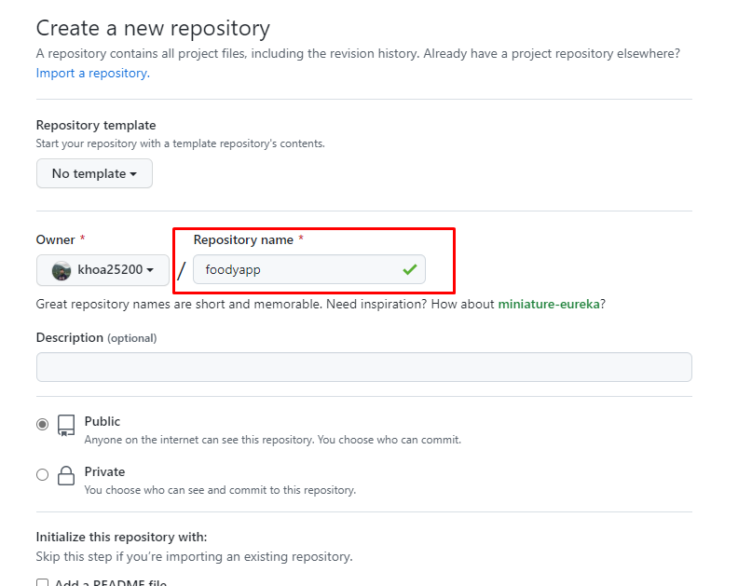
Open up your terminal and navigate to the folder containing your source code.
Type the following commands in your terminal:
git init
git add .
git commit -m "Initial commit"
git remote add origin <your-repository-url>
git push -u origin master
You should now see the source code for your project on the GitHub page for your repository.
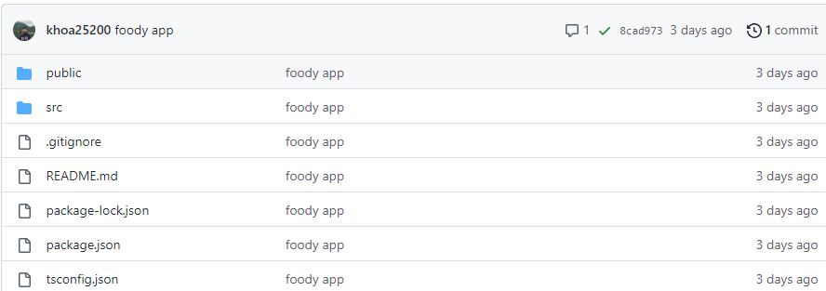

  - Deploy project on vercel
Like Github, you need to have a Vercel account first, you can register for a Vercel account at https://vercel.com/signup (recommended you should use your GitHub account to log in to Vercel to be contacted. link the source code available on Github)
After logging in and linking to your GitHub account, click on the 'Project' button on the right to select the source code on Github to deploy, as shown below:

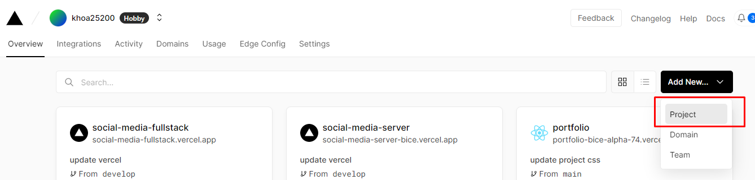
Select the source code, specifically here find the repository named "foody-app" that has been located on GitHub.
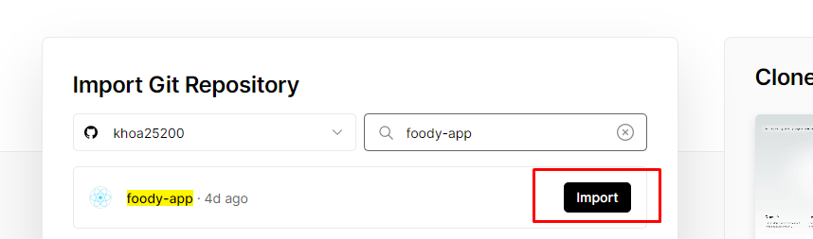
Here are some configurations before deploying, can change the Project Name, Framework (Create React App), etc.

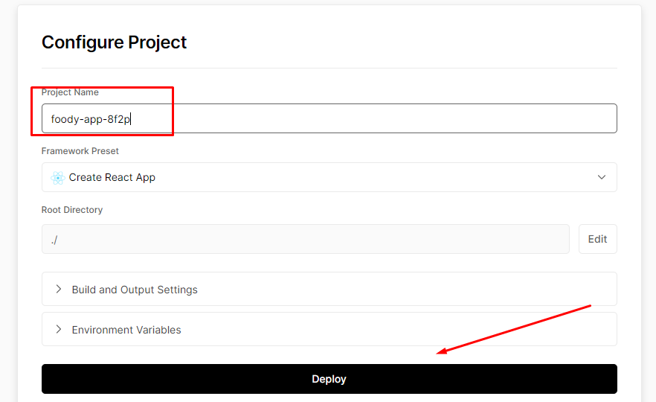
This is the interface after successful Deploy:

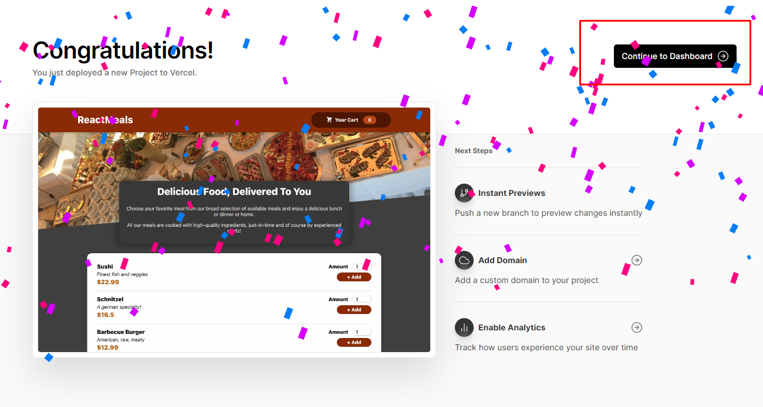
Click on the links below and enjoy the results. Vercel has a very convenient "Auto Deploy" feature, which means that after any changes are made on the Main branch in GitHub, it will automatically Deploy again without us doing any more, ensuring that the website always updated.
Watch live demo Foody-app website has been deployed to Vercel: https://foody-app-delta.vercel.app/
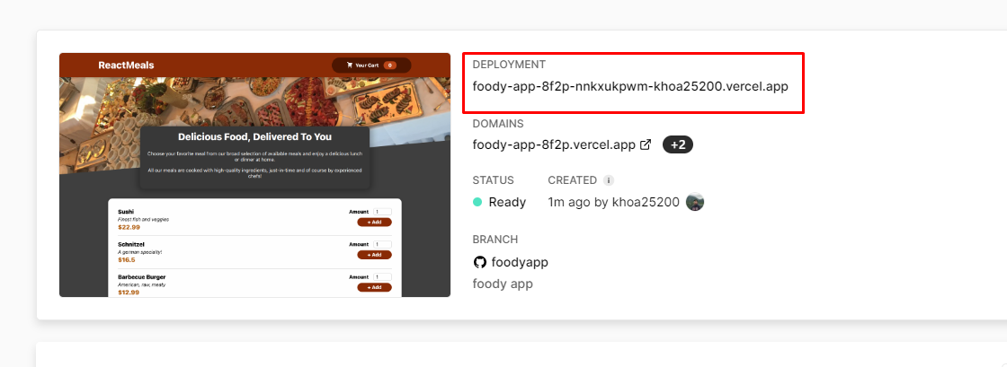

CHAPTER 6: CONCLUSION

Benefits
Working with a professional and experienced team of developers can help you gain valuable skills in the field of web development.
Having an opportunity to work on real-world projects can give you a great sense of accomplishment.
Being able to learn from experienced developers who have been in the industry for years can help you sharpen your skills and gain valuable new knowledge.
Working with a large company or organization can also provide access to resources that may be difficult or expensive to obtain on your own.
Having access to modern tools and technologies can help you stay up to date with the latest trends in the industry.
Working as part of a team can help you learn how to use version control systems and participate in code reviews.
Networking with other developers and building relationships can lead to potential job opportunities after the internship is complete.

Drawback
Working in a professional environment can be a bit overwhelming, especially if you are inexperienced.
Internships may require a certain number of hours each week, which can be difficult to manage if you have other commitments.
Internships may also require you to work with a specific set of technologies or languages, which can be challenging if you don’t have experience with that particular technology.
As an intern, you may not have as much freedom to explore and develop your own projects.
You may not get as much feedback or guidance from experienced developers as you’d like.
Internships can also be very competitive, and you may not get the opportunity to work on the most interesting projects.
Working as an intern can also be unpaid, so you may have to supplement your income with a part-time job or other sources.

Future Works
The internship has been an opportunity to gain experience in the field of front-end development. The intern has gained a wealth of knowledge and skills, such as HTML, CSS, JavaScript, and React. The intern has also learned the key concepts of web development, such as workflow, debugging, and UX design.
In the future, I will continue to develop my skills in web development. This could include learning more in-depth topics, such as server-side programming, or learning more advanced topics, such as mobile application development. I could also look to explore other areas of web development, such as e-commerce, and user experience design.
I could also look to further build on my existing skill set. This could include learning more on the development side, such as further improving the intern's coding skills by learning new libraries and frameworks or learning more on the design side, such as further researching the principles of user experience and design.
Additionally, I could look to expand my knowledge by taking on side projects, such as creating my own website or mobile app. This could help them gain more experience in the field, and allow me to apply the lessons I have learned from the internship. I could also look to participate in coding challenges or hackathons, and use this as an opportunity to network with other developers and get feedback on their work.
Overall, the internship has provided the intern with a great opportunity to gain experience in the field of web development. With the knowledge, skills, and experience that the intern has gained, I can continue to build on these skills in the future and stay ahead of the game.

Conclusion
Overall, the internship experience was a great learning experience with hands-on experience in the field of front-end website programming and food application building. The knowledge gained during this period has become a great asset and I am confident it will be beneficial for the rest of my career. During this internship, I was able to develop a strong understanding of the development processes, learn to work within a team environment, and develop a better understanding of the technologies.
I am thankful to have had the opportunity to work with a team of experienced professionals and gain valuable insights from them. The guidance from my seniors has been invaluable and will continue to be a great source of guidance for me in the future. Through this internship, I was also able to understand how to work within tight deadlines and build projects quickly and effectively.
The most important takeaway from this internship was the knowledge and skills I acquired in the area of front-end website programming and food application building. By developing projects from scratch, I was able to understand the core concepts of each technology and was able to apply them to future projects. Overall, I am confident that I have acquired the necessary skills and knowledge that will help me in the future, and am excited to continue my journey in the field of frontend website programming and food application building.

REFERENCES
[1] Works Cited “Documentation - ESLint - Pluggable JavaScript Linter.” Eslint.org, eslint.org/docs.
[2] “GitHub.com Help Documentation.” Docs.github.com, docs.github.com/en.
“Kyanon Digital - Digital Transformation & Agile Engineering.” Kyanon Digital, 5 Oct. 2020, kyanon.digital. Accessed 8 Mar. 2023.
[3] Node.js Foundation. “Node.js.” Node.js, 2019, nodejs.org.
[4] React. “React – a JavaScript Library for Building User Interfaces.” Reactjs.org, 2022, reactjs.org.
[5] “Vercel – Introduction to Vercel.” Vercel Documentation, vercel.com/docs.
[6] W3Schools. “W3Schools Online Web Tutorials.” W3schools.com, W3Schools, 1998, www.w3schools.com.

