9router:
Link truy cập: http://103.216.119.96:20128/
API Endpoint: http://103.216.119.96:20128/v1
API key: sk-7bb39f8a2677ab80-1rz83a-597ec6bf
Name: openclaw_TOM
Netlify:
NETLIFY_TOKEN= nfp_6qajAw4EGHg4WjmLE2ci1J4FdQ4aLEJBa8be (cũ openclawtom)

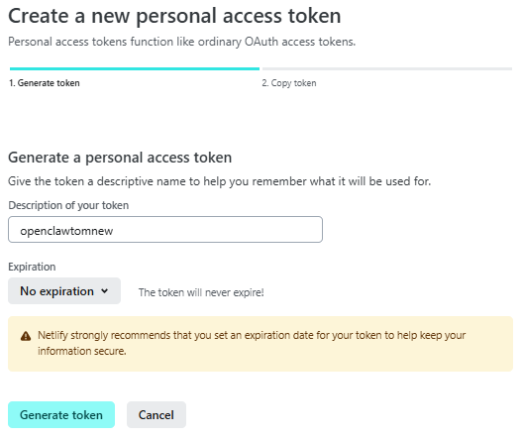
nfp_1WBb8x9pNe4XsH8oKP7axCFMKPKVi7vR83a4 (mới lập: openclawtomnew)
