**Dang Anh Khoa / khoadang1808@gmail.com**

**1. Monetization Model**

Booking.com (B.com) is an intermediary for hotels. As travelers prefer visiting one website to find and compare several hotels instead of opening several hotel websites, B.com specializes in being the "best platform" for finding and booking hotels.  
For every night that B.com sells for a hotel, they get a 15%-20% commission.  
  
In order for B.com to attract more and more customers, they engage heavily in Search Engine Marketing (that is to be in the top results when someone types "Hotel in Los Angeles" in Google), like this they are above hotel websites and "force" travelers to book through them and generate a commission.  
  
B.com belongs to the Priceline group, which operates several similar travel websites like Agoda.com, Priceline.com, etc. Although they also provide flights and car rentals, Hotel sales are still their biggest revenue generator.

**2. Why did you choose this theme?**

Personally, I really like Traveling. Because, I'm still young and want to discover a lot of cultures of many cities and countries in Vietnam and the world. Booking a hotel is one of the most things that I have to prepare carefully before going.

**3. User Understanding - Demographic**

1. Aged from 18 to 28 years old (Millennials) and 29 to 50 years old (Generation X)
2. The group usually travel.

**4. User Understanding - What are they like in person? (Persona)**

1. Khoa is a 27 year-old traveller who love traveling.
2. He uses Booking app for finding hotels in the countries that he want to go.
3. He cares about the place that he will stay during a trip.
4. He wants the hotel that he books will be the one of impressive things in the place he will come.

**5. User Understanding - What are their pain points?**

1. Sometimes booking just has few of reviews or no reviews from the hotel that he wants to book.
2. Sometimes the images of hotels are incorrect or lack of images.

**6. Product Goal**

1. Get more real informations of hotels.
2. Increase the amount of reviews from users.

### 7. Map the Challenge

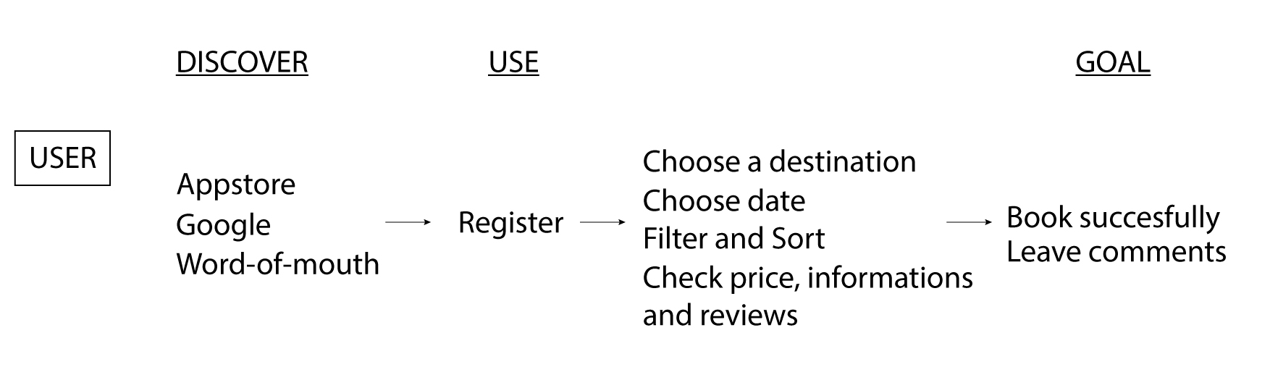

### 8. How Might We Notes Organized on the Map

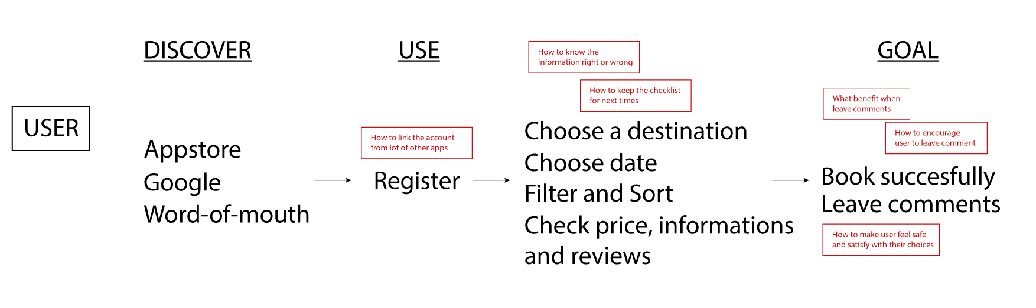

### 9. Pick a Target

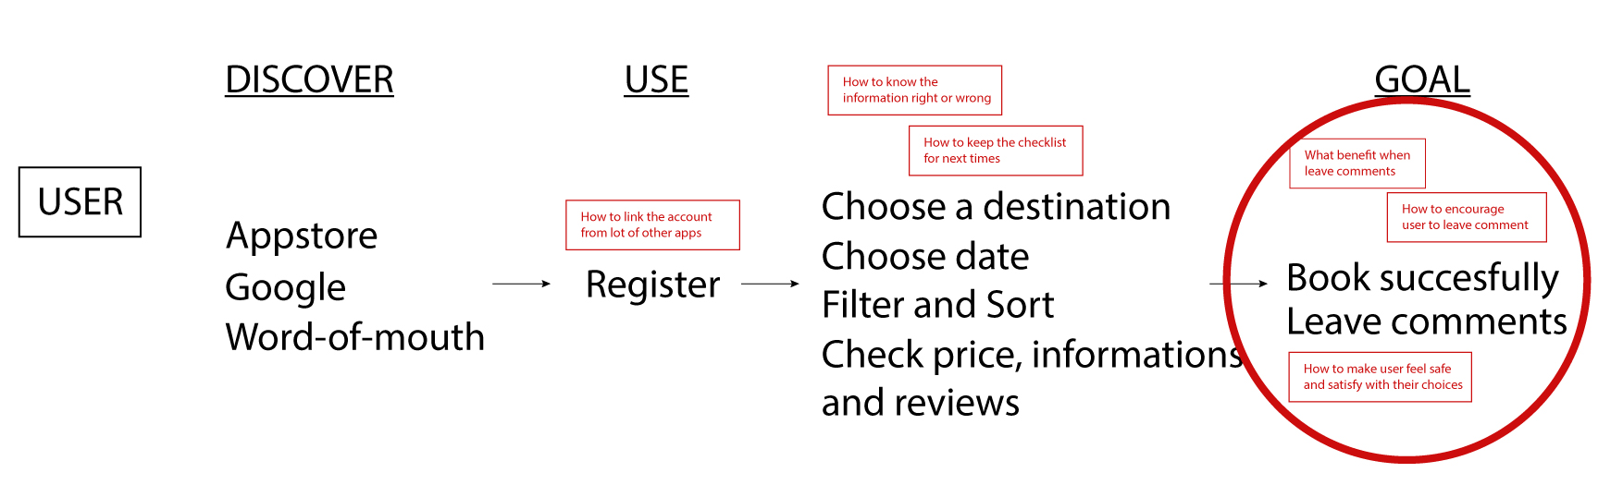

### 10. Brainstorm your Crazy 8

