**Trần Đăng Khoa**

**B2014926**

**M02**

**Repo:** [**https://github.com/23-24Sem1Courses/ct313hm02-contactbook-bekhoadangtran.git**](https://github.com/23-24Sem1Courses/ct313hm02-contactbook-bekhoadangtran.git)

[**https://github.com/23-24Sem1-Courses/ct313hm02-contactbook-fe-khoadangtran.git**](https://github.com/23-24Sem1-Courses/ct313hm02-contactbook-fe-khoadangtran.git)

**CT313H: WEB TECHNOLOGIES AND SERVICES**

# Building Contactbook App - Backend - Part 1

You will build a contact management app as a SPA app. The tech stack includes *Nodejs/Express, Knex.js, MySQL/MariaDB* for backend (API server) and *Vue.js* for frontend (GUI). In the first two lab sessions, you will build the API server for the app.

The API server must support the following requests:

*POST /api/contacts*: creates a new contact

*GET /api/contacts*: returns all contacts from the database. This endpoint supports the following optional parameters:

*favorite* and *name* are for querying favorite contacts and contacts filtered by name. For example, *GET*

*/api/contacts?favorite&name=duy* returns favorite contacts named "duy"

*page* and *limit* are for pagination

*DELETE /api/contacts*: deletes all contacts in the database

*GET /api/contacts/<contact-id>*: gets a contact with a specific ID

*PUT /api/contacts/<contact-id>*: updates a contact with a specific ID

*DELETE /api/contacts/<contact-id>*: deletes a contact with a specific ID

All requests for undefined URLs will result in a 404 error with the message "Resource not found"

A contact has the following information: *name (string), email (string), address (string), phone (string), favorite (boolean)*. **Data format used for client-server communication is JSON**. The source code is managed by git and uploaded to GitHub.

This step-by-step guide will help implement all the above requirements. However, students are free to make their own implementation as long as the requirements are met.

**Requirements for the lab report**:

The submitted report file is a PDF file containing images showing the results of your works (e.g., images showing the implemented functionalities, successful and failed scenarios, results of the operations, ...). **You should NOT screenshoot the source code**.

**You only need to create ONE report for the whole four lab sessions**. At the end of each lab session, students need to (1) submit the work-in-progress report and (2) push the code to the GitHub repository given by the instructor.

The report should also filled with student information (student ID, student name, class ID) and the links to

the GitHub repositories. Plagiarism will result in 0.

## Step 0: Install node and git

Download and install nodejs: https://nodejs.org/en/download/. You can download and install nodejs directly or use nvm (https://github.com/coreybutler/nvm-windows).

Download and install git: https://git-scm.com/download/win. When you are installing git on Windows, please check the option to install **Git Credential Manager (GCM)**. This option will help you log in to GitHub easier from command-line.

Verify your setup by typing the node and git commands in a terminal:

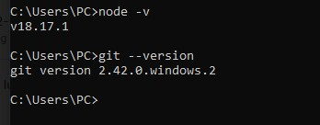

(In case that you can't run the commands in a termial, verify that the PATH environment variable on your machine includes the paths to node and git binaries).

## Step 1: Create a node project

Clone the GitHub repo to your local machine:

git clone <đường-link-đến-repo-GitHub-đã-nhận> contactbook-backend

(Of course, you can use whatever name you like but it shouldn't include spaces or special, non-ascii characters).

GitHub will ask for login information. If you have installed **Git Credential Manager (GCM)**, the login will be done via the browser. In case you forget or cannot install GCM, you need to create a personal access token (PAT) on GitHub and use it as a password (checkout a separate guide on how to create a PAT token). Another option is to use GitHub Desktop.

Go to the project directory and init a nodejs project:

cd contactbook-backend npm init -y



A *package.json* file will be created in the project directory.

## Step 2: Manage the source code with git and GitHub

Download a *.gitignore* file: npx gitignore node . The *.gitignore* file list files and directories that will be ignored by git (e.g., *node_modules*).

In the project directory, run git status . Git shows that *.gitignore* and *package.json* files are currently not managed by git.

Ask git to manage these files: git add .gitignore package.json Run git status to verify:

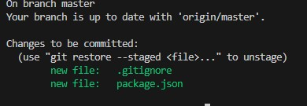

Run git commit -m "Project setup" to save the changes. The -m option allows to specify a comment for the commit.

If it's the first time git commit is used on the machine, git will ask for a name and an email address. Run the following two git config commands to give git your name and email address:

git config --global user.email "you@example.com" git config --global user.name "Your Name"

Rerun the git commit command.

Push local commits to GitHub as follows:

git push origin master

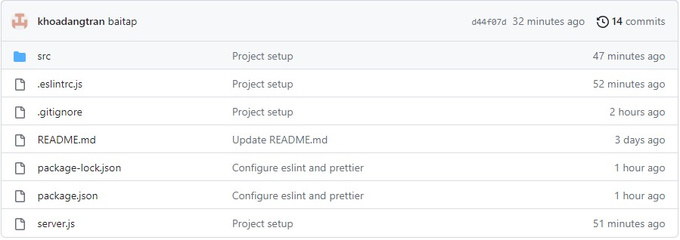

in which, origin is the default name given to the remote git repo on GitHub when the repo is cloned.

Verify that the files are uploaded to GitHub.

## Step 3: Setup Visual Studio Code and ESLint and Prettier

ESLint is a tool that statically analyzes JavaScript code and helps find and fix problems in the source code. Install ESLint extension for Visual Studio Code.

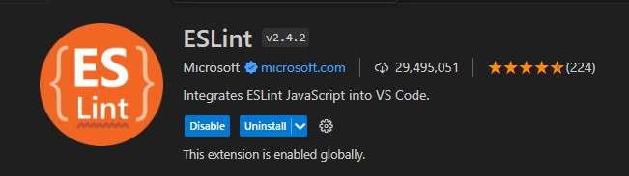

Prettier is a tool to automatically format the source code. Install Prettier extension for VSCode.

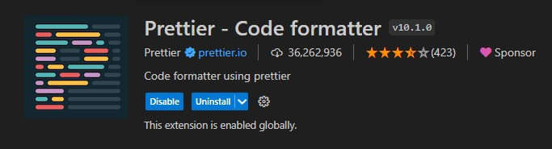

Configure VSCode to automatically format the source code on save or paste: Go to File > Settings, search for "format" and then check "Editor: Format on Paste" and "Editor: Format on Save":

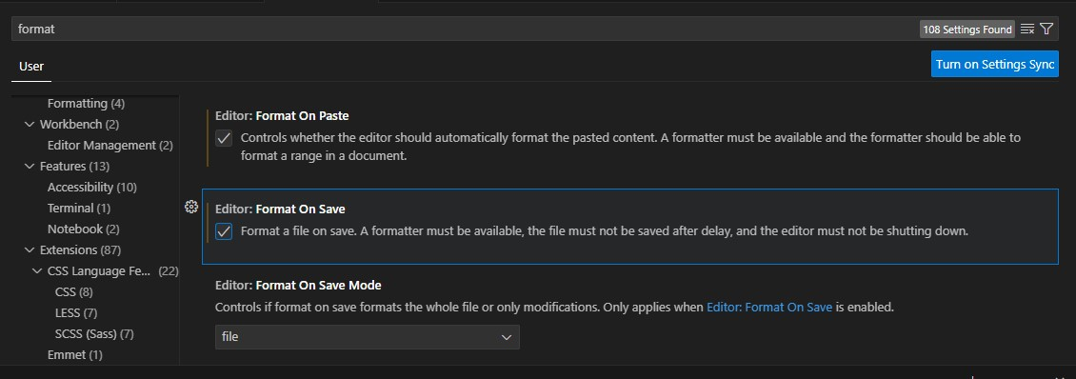

In order for eslint and prettier work with VSCode, you also need to install eslint and prettier packages globally or locally in each project. In the project directory, install the following packages:

npm i -D eslint prettier eslint-config-prettier

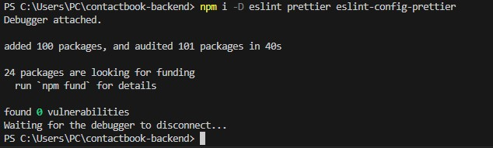

(Eslint rules may conflict with prettier rules. To avoid this, you can install eslint-config prettier package. This package turns off all eslint rules related to formatting the source code).

Then create a file named *.eslintrc.js* in the project directory as follows:

module.exports = { env: { node: true, commonjs: true, es2021: true,

},

extends: ['eslint:recommended', 'prettier'],

};

(The *.eslintrc.js* file can be generated by issuing the command: npx eslint --init and answering some configuration questions).

Commit changes to git:

# Add changes from previously committed files to git git add -u

# Add .eslintrc.js to git git add .eslintrc.js

# Save changes git commit -m "Configure eslint and prettier"



## Step 4: Install Express

Install the following packages: npm install express cors .

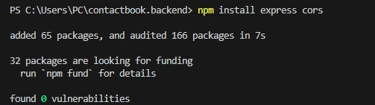

In the project directory, create a *src* directory and a *src/app.js* file:

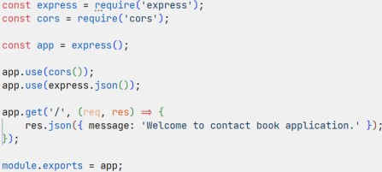

Install dotenv package: npm i dotenv . This package loads environment variables defined in a .env file to processs.env object. In the project directory, create a .env file containing environment variables used by the server (note that the .env file will not be managed by git):

PORT=3000

In the project directory, create *server.js* to run the app:

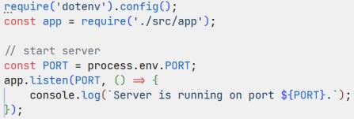

Open a terminal in the project directory and start the server: node server.js . Access to http://localhost:3000/ to verify the result.



Install nodemon to help monitor changes in the source code and restart the server automatically:

npm install nodemon --save-dev

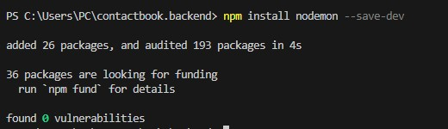

Open *package.json* and change the "scripts" section as follows:

...

"scripts": {

"start": "nodemon server.js"

},

...

With the above configuration, the server can be started by issuing the command npm run start instead of node server.js and every time a project file changes, nodemon will restart the server for us.

Commit changes to git repo:

# Add changes from previously committed files to git git add -u

# Add newly created files and directories to git git add src/ server.js package-lock.json

# Save changes

git commit -m "Install express and show a welcome message"

Before commiting changes, it's good idea to check if there are missing files by running git status .



## Step 5: Define controller and routes

Create *src*, *src/controllers* directories and *src/controllers/contacts.controller.js* file as follows:

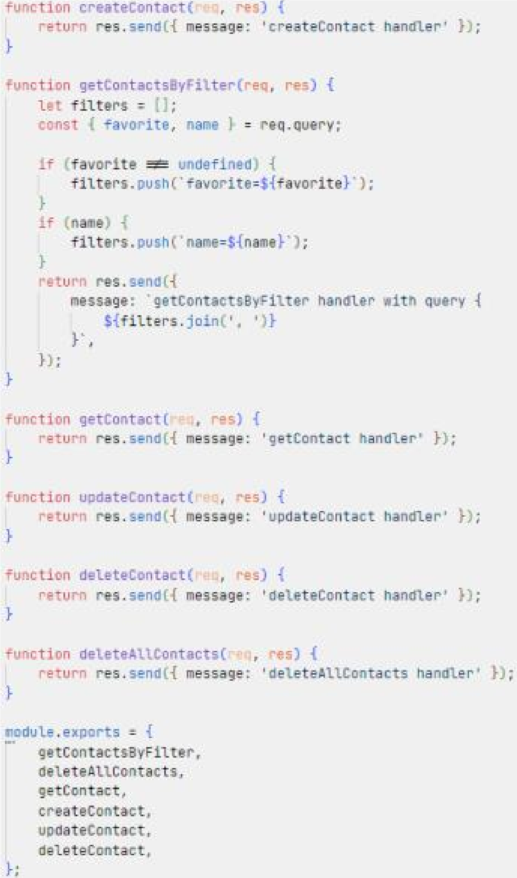

Create *src/routes* directory and *src/routes/contacts.router.js* file:

const express = require('express'); const contactsController = require('../controllers/contacts.controller'); const router =

express.Router();

router

.route('/')

.get(contactsController.getContactsByFilter)

.post(contactsController.createContact)

.delete(contactsController.deleteAllContacts) router

.route('/:id')

.get(contactsController.getContact)

.put(contactsController.updateContact)

.delete(contactsController.deleteContact)

module.exports = router;

In the above code, we define routes for managing contacts required by the app. Each route is a combination of a path, a HTTP method (GET, POST, PATCH, PUT, DELETE) and a handler. Next, register the routes to the express app by updating *src/app.js* as follows:

...

const contactsRouter = require('./routes/contacts.router');

...

app.get('/', (req, res) => {

res.json({ message: 'Welcome to contactbook application.' });

});

app.use('/api/contacts', contactsRouter);

module.exports = app;

URIs for contact resource will be started with */api/contacts*. For example, to ask the server to return a list of favorite contacts, client needs to issue a HTTP GET request to */api/contacts?favorite*.

Use a HTTP client to verify all the defined routes.

If the code works correctly, commit changes to git:

git add -u git add src/

git commit -m "Define routes for managing contacts"

## Step 6: Implement error handlers

Create *src/api-error.js* file:

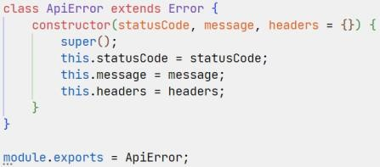

Create *src/controller/errors.controller.js* file:

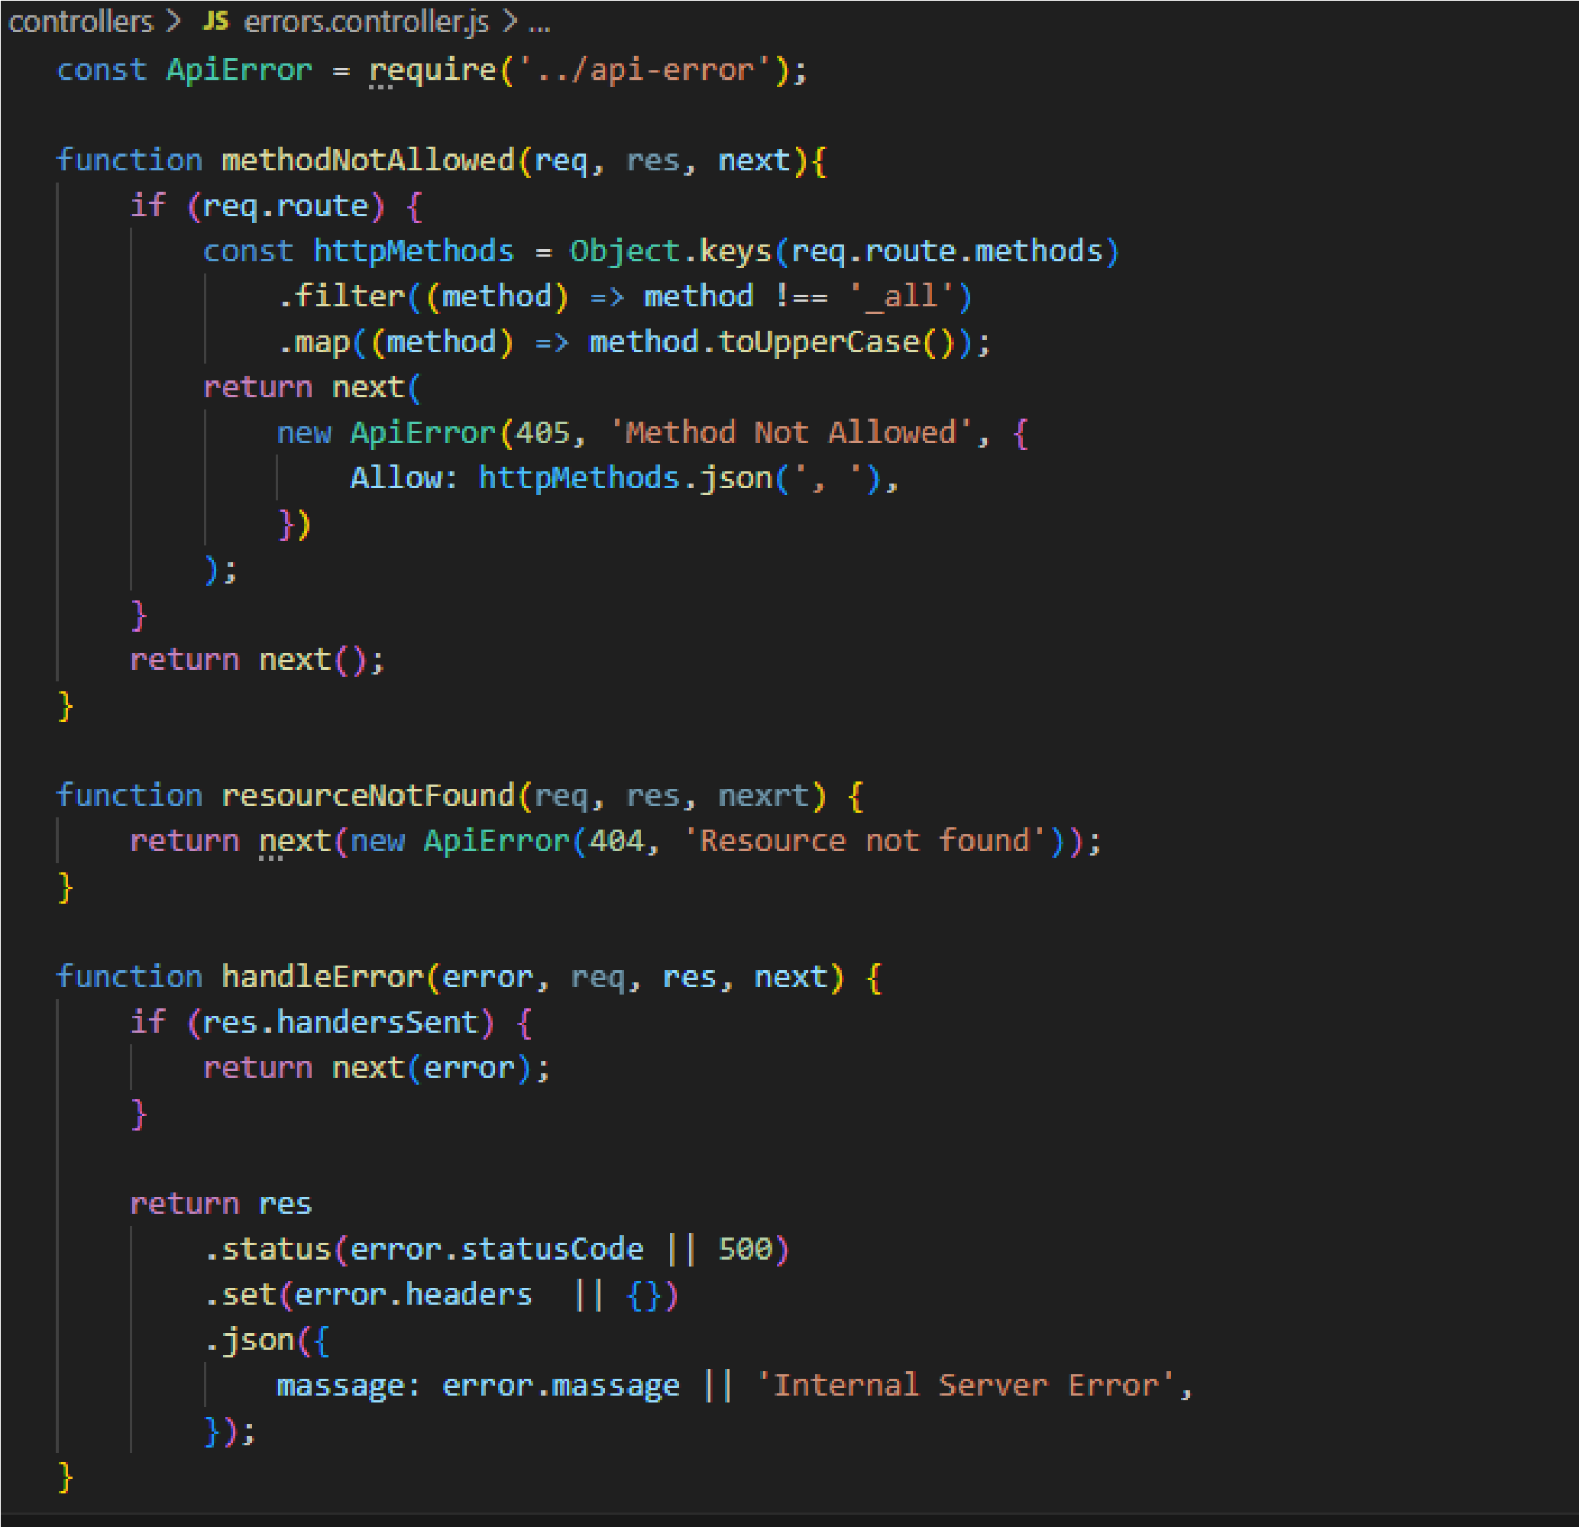

Open *src/routes/contacts.router.js* and add error handling middlewares as follows:

... const { methodNotAllowed } = require('../controllers/errors.controller'); ...

router

.route('/')

...

.all(methodNotAllowed);

router

.route('/:id')

...

.all(methodNotAllowed);

Edit *src/app.js* to add error handling middlewares:

...

const { resourceNotFound,

handleError

} = require('./controllers/errors.controller');

...

app.use('/api/contacts', contactsRouter);

// Handle 404 response app.use(resourceNotFound);

// Define error-handling middleware last app.use(handleError);

...

Use a HTTP client and verify the followings:

Send a GET request to an unknown path, verify that the response is a 404 error with the "Resource Not Found" message.

Send a request to a known path but with an unsupported HTTP method (e.g., PUT /api/contacts), verify that the response is a 405 error with the "Method Not Allowed" message.

Commit changes to git and GitHub:

git add -u

git add src/controllers/errors.controller.js src/api-error.js

git commit -m "Implement an error handling middlewares" git push origin master # Upload local commits to GitHub

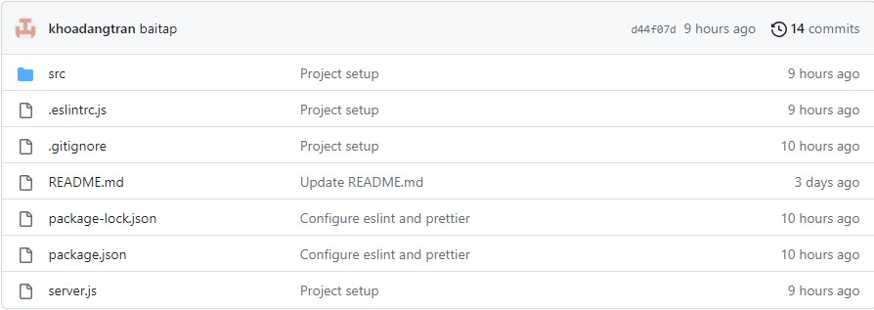

## Step 7: Prepare database

Install MySQL or MariaDB on your machine if needed.

Use a MySQL client (phpMyAdmin, HeidiSQL, ...) to create a database named *ct313h_labs*. Next, create a contacts table as follows (you can also leverage knex migration for this task):

CREATE TABLE `contacts` (

`id` INT(10) UNSIGNED NOT NULL AUTO_INCREMENT,

`name` VARCHAR(255) NOT NULL,

`email` TEXT NULL DEFAULT NULL,

`address` VARCHAR(255) NULL DEFAULT NULL, `phone` TINYTEXT NOT NULL,

`favorite` TINYINT(1) UNSIGNED NOT NULL DEFAULT '0', PRIMARY KEY (`id`) USING BTREE

) ENGINE=InnoDB DEFAULT CHARSET=utf8mb4 COLLATE=utf8mb4_general_ci;

Install knex , mysql and faker-js (checkout fake-js API here):

npm install knex mysql npm install @faker-js/faker --save-dev

Edit *.env* and add the database connection parameters:

PORT=3000

DB_HOST=localhost

DB_PORT=3306

DB_USER=root

DB_PASS=root

DB_NAME=ct313h_labs

Make sure to update the above parameters (user/password) according to your database setup.

In the project directory, create directory *seeds* and run npx knex init to create *knexfile.js* file. Edit *knexfile.js* as follows:

require('dotenv').config(); const { DB_HOST, DB_PORT, DB_USER, DB_PASS, DB_NAME } = process.env;

/**

* @type { import("knex").Knex.Config }

*/ module.exports = { client: 'mysql', connection: { host: DB_HOST, port: DB_PORT, user: DB_USER, password: DB_PASS, database: DB_NAME,

},

pool: { min: 0, max: 10 }, seeds: { directory: './seeds',

},

};

Run npx knex seed:make contacts_seed to create a seeding script for contacts table (*./seeds/contacts_seed.js*). Edit the seeding script as follows:

const { faker } = require('@faker-js/faker');

function createContact() { return { name: faker.person.fullName(), email: faker.internet.email(), address: faker.location.streetAddress(), phone: faker.phone.number('09########'), favorite: faker.number.int({ min: 0, max: 1,

}),

};

}

/**

* @param { import("knex").Knex } knex
* @returns { Promise<void> }

*/ exports.seed = async function (knex) { await knex('contacts').del();

await knex('contacts').insert(Array(100).fill().map(createContact)); };

Run the seeding scripts in the seeds directory by the command: npx knex seed:run . Verify that fake data are inserted into the database.

After verification, commit changes to git and GitHub:

git add -u git add seeds knexfile.js git commit -m "Setup knex.js and insert fake data"

git push origin master # Upload local commits to GitHubThe directory

struture for the project currently is as follows:

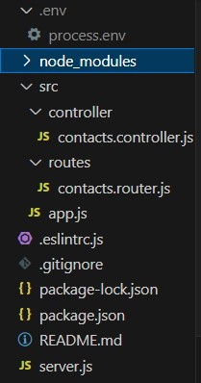

# WEB TECHNOLOGIES AND SERVICES Building Contactbook App - Backend - Part 2 Implement route handlers

Define a module that creates a knex object representing the connection to the database in *src/database/knex.js*:

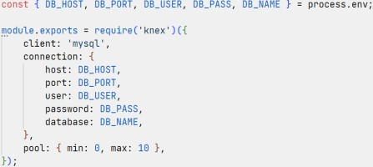

Create *src/services/contacts.service.js* file to define a set of functions for accessing the database:

const knex = require('../database/knex');

function makeContactsService() {

//Define functions for accessing the database return {

};

}

module.exports = createContactsService;

# Implement createContact handler

Edit *src/controllers/contacts.controller.js*:

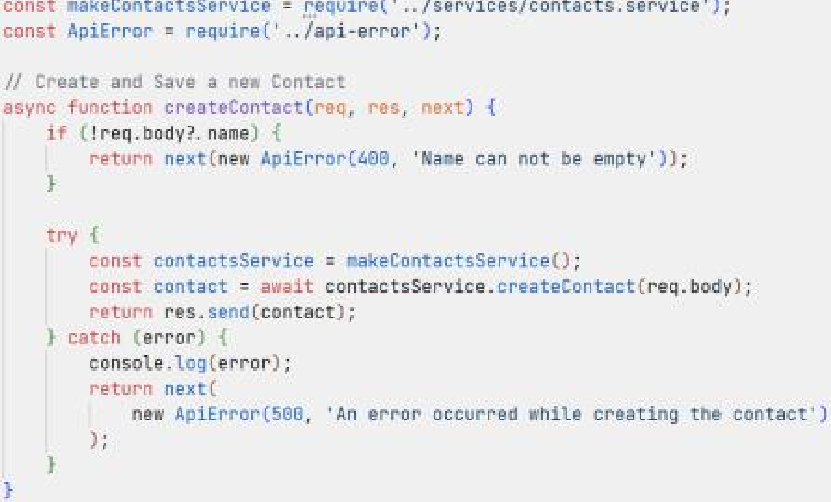

In case of error, the call *next(error)* will transfer the execution to the error handling middleware defined in *src/app.js* will be called.

*contactsService.createContact()* stores the submitted contact to the database. The function *createContact()* is defined (in *src/services/contacts.service.js*) as follows:

const knex = require('../database/knex');

function makeContactsService() { function readContact(payload) { const contact = { name: payload.name, email: payload.email, address: payload.address, phone: payload.phone,

favorite: payload.favorite,

};

// Remove undefined fields

Object.keys(contact).forEach(

(key) => contact[key] === undefined && delete contact[key]

);

return contact;

}

async function createContact(payload) { const contact = readContact(payload); const [id] = await knex('contacts').insert(contact);

return { id, ...contact };

}

return {

createContact,

};

}

module.exports = createContactsService;

Use a HTTP client to verify the handler works as expected.

In order to send JSON data to the server with a HTTP client, make sure to set the header "Content-Type: application/json" and put JSON data in the request body, for example:

*Put JSON data inside Body*

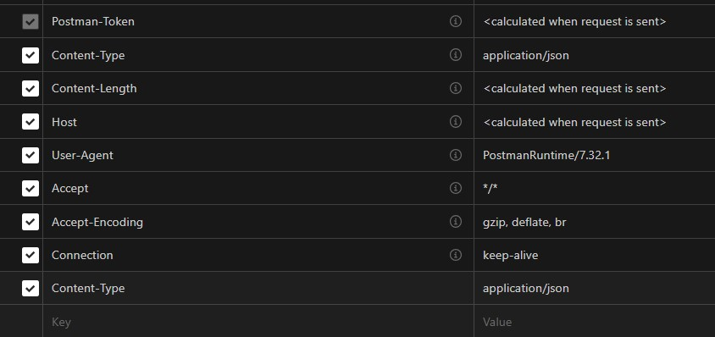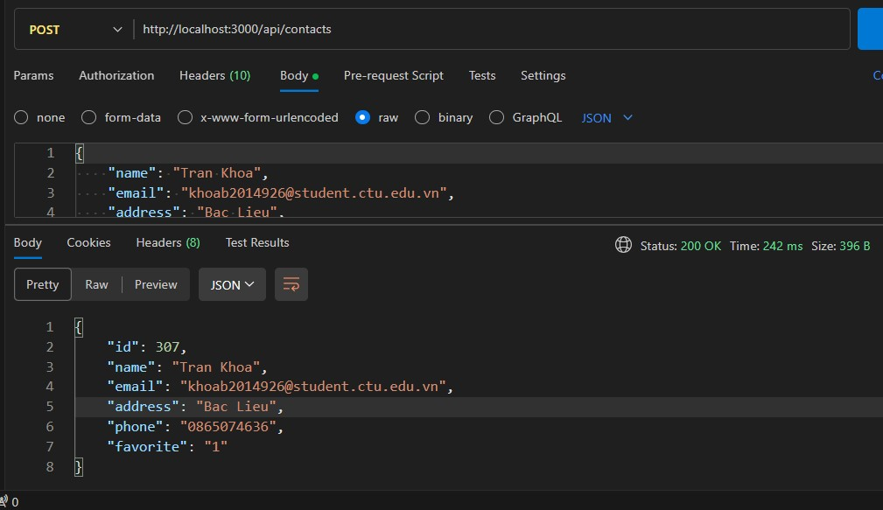

# Implement getContactsByFilter handler

Edit *src/controllers/contacts.controller.js*:

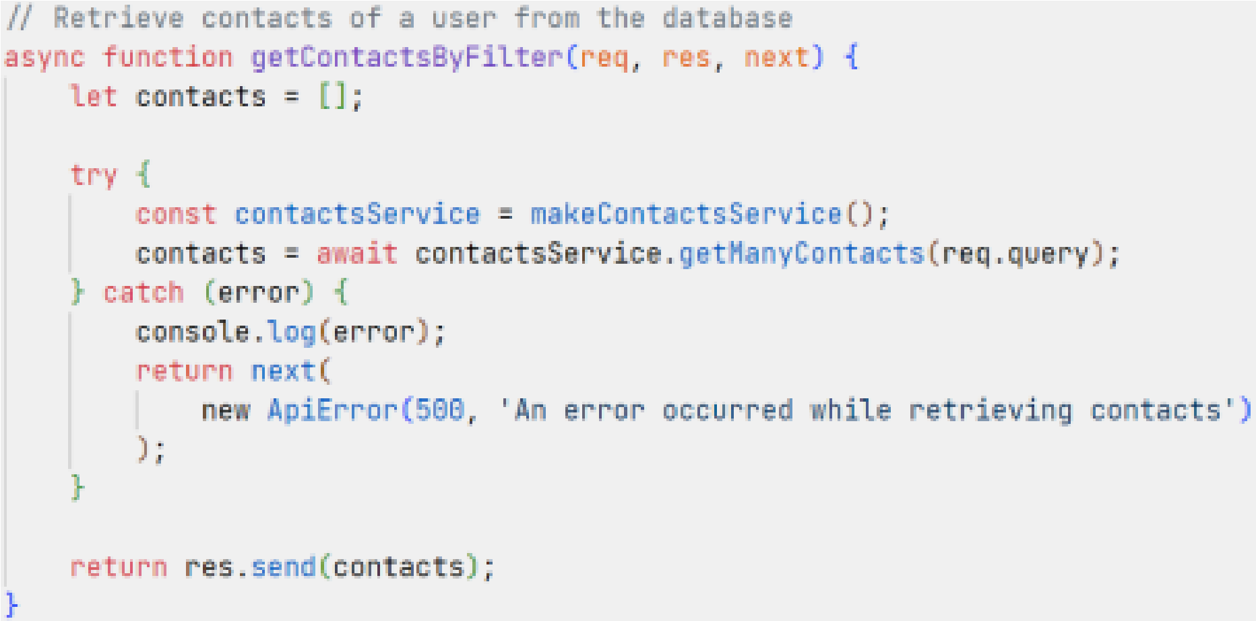

*contactsService.getManyContacts(query)* returns contacts filtered the *query* (name and favorite). This function can be defined as follows:

...

function makeContactsService()

{ ...

async function getManyContacts(query) { const { name, favorite } = query;

return knex('contacts')

.where((builder) => { if (name) { builder.where('name', 'like', `%${name}%`);

}

if (favorite !== undefined) { builder.where('favorite', 1);

}

})

.select('*');

}

return { createContact,

getManyContacts,

};

}

...

Use a HTTP client to verify the handler works as expected.

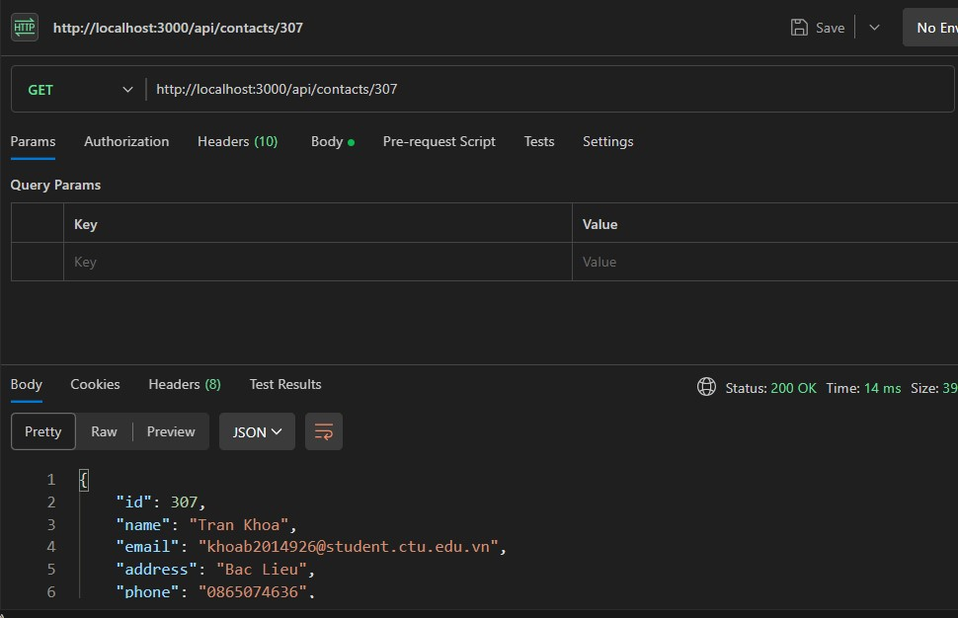

Paginate records for *getManyContacts(query)*:

Define a class named *Paginator* (in *src/services/paginator.js*):

class Paginator { constructor(page = 1, limit = 5) { this.limit = parseInt(limit, 10); if (isNaN(this.limit) || this.limit < 1) {

this.limit = 5;

}

this.page = parseInt(page, 10); if (isNaN(this.limit) || this.page < 1) {

this.page = 1;

}

this.offset = (this.page - 1) * this.limit;

}

getMetadata(totalRecords) { if (totalRecords === 0) { return {};

}

let totalPages = Math.ceil(totalRecords / this.limit);

return { totalRecords, firstPage: 1, lastPage: totalPages,

page: this.page, limit: this.limit,

};

}

}

module.exports = Paginator;

Edit *getManyContacts(query)* (in *src/services/contacts.service.js*) as follows:

async function getManyContacts(query) { const { name, favorite, page = 1, limit = 5 } = query;

const paginator = new Paginator(page, limit);

let results = await knex('contacts')

.where((builder) => { if (name) { builder.where('name', 'like', `%${name}%`);

}

if (favorite !== undefined) { builder.where('favorite', 1);

}

})

.select( knex.raw('count(id) OVER() AS recordsCount'),

'id',

'name',

'email',

'address',

'phone',

'favorite'

)

.limit(paginator.limit)

.offset(paginator.offset);

let totalRecords = 0;

results = results.map((result) => { totalRecords = result.recordsCount;

delete result.recordsCount;

return result;

});

return {

metadata: paginator.getMetadata(totalRecords),

contacts: results,

}; }

Use a HTTP client to verify the handler works correctly with different sets of page and limit parameters.

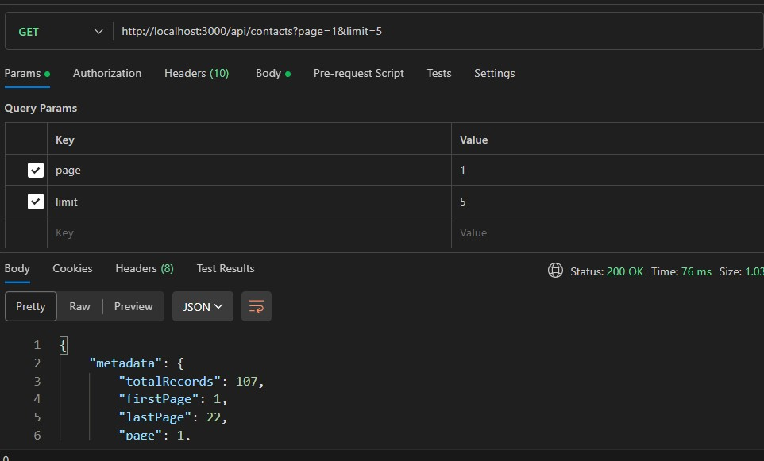

# Implement getContact handler

Edit *src/controllers/contacts.controller.js*:

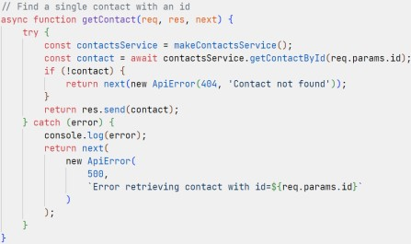 *contactsService.getContactById(id)* searches a contact by ID. The function *getContactById(id)* can be defined as follows:

...

function makeContactsService() {

...

async function getContactById(id) {

return knex('contacts').where('id', id).select('*').first();

}

return { createContact, getManyContacts,

getContactById,

};

}

...

Use a HTTP client to verify the handler works correctly.



# Implement updateContact handler

Edit *src/controllers/contacts.controller.js*:

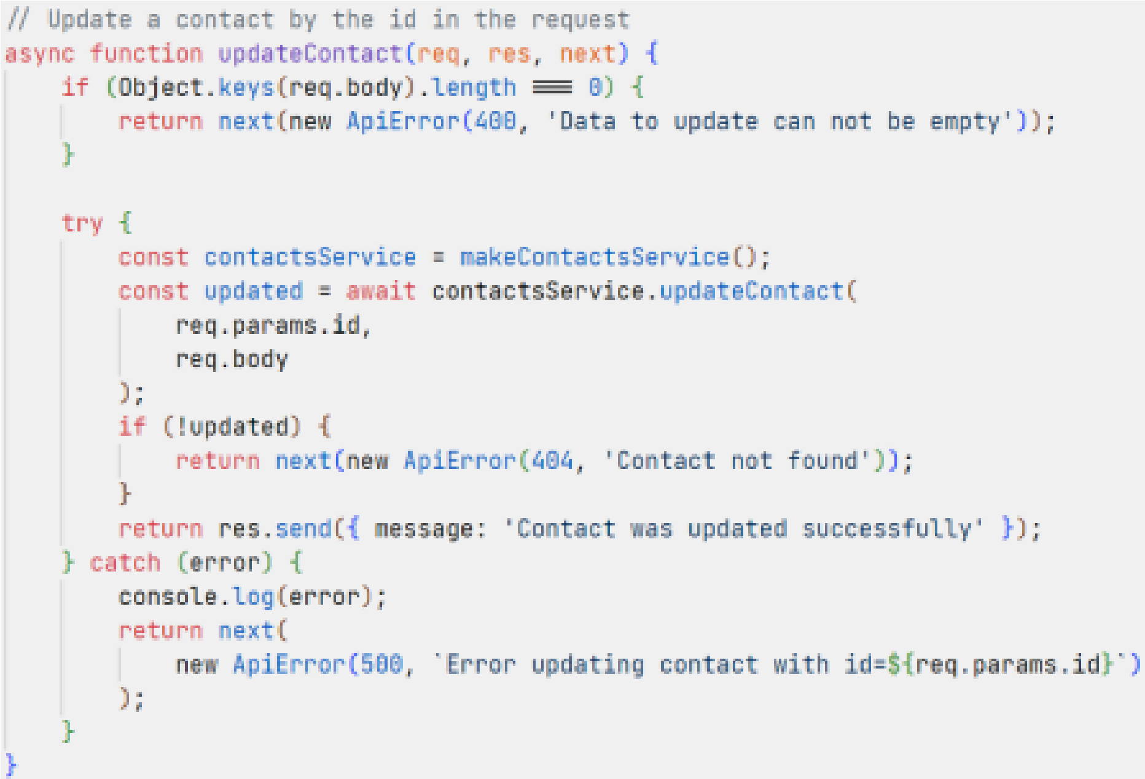

*contactsService.updateContact(id, payload)* searches contact by ID and update this contact with *payload*. The function *updateContact(id, payload)* can be defined as follows:

...

function makeContactsService() {

...

async function updateContact(id, payload) { const update = readContact(payload); return knex('contacts').where('id', id).update(update);

}

return { createContact, getManyContacts, getContactById,

updateContact,

};

}

...

Use a HTTP client to verify the handler works correctly.

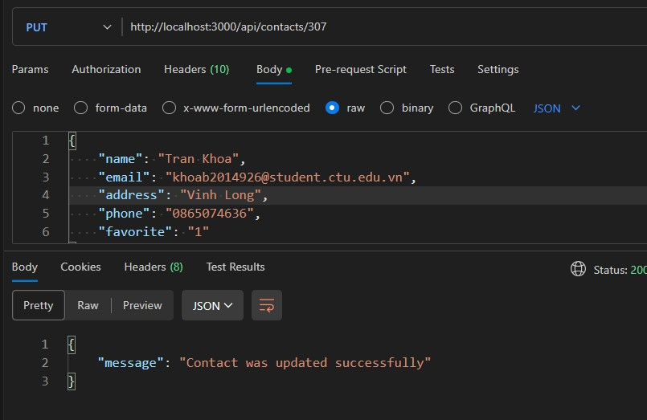

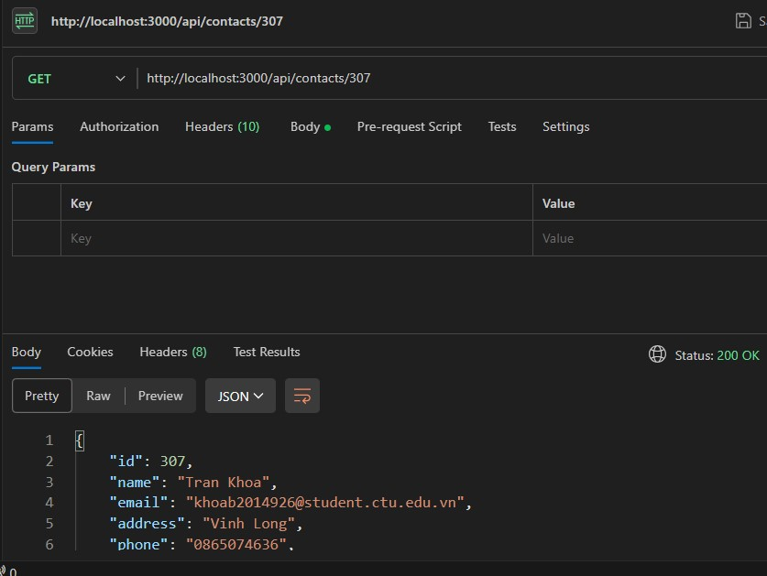

# Implement deleteContact handler

Edit *src/controllers/contacts.controller.js*:

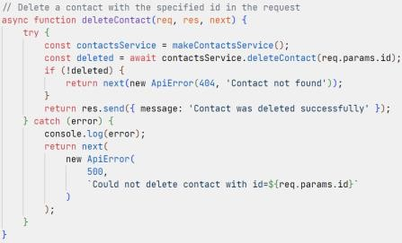 *contactsService.deleteContact(id)* searches contact by ID and deletes this contact. The function *deleteContact(id)* can be defined as follows:

...

function makeContactsService() {

...

async function deleteContact(id) { return knex('contacts').where('id', id).del();

}

return { createContact, getManyContacts, getContactById, updateContact, deleteContact,

};

}

...

Use a HTTP client to verify the handler works correctly.

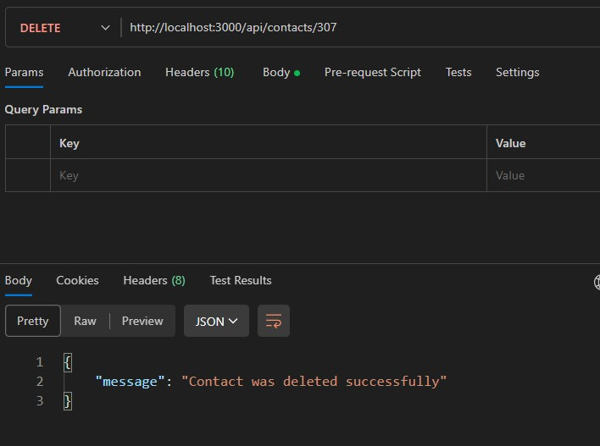

# Implement deleteAllContacts handler

Edit *src/controllers/contacts.controller.js*:

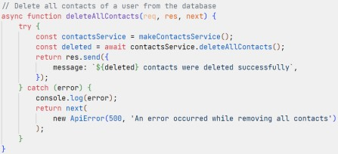 *contactsService.deleteAllContacts()* removes all contacts. The function *deleteAllContacts()* can be defined as follows:

...

function makeContactsService() {

...

async function deleteAllContacts() { return knex('contacts').del();

}

return { createContact, getManyContacts, getContactById, updateContact, deleteContact,

deleteAllContacts,

};

}

...

Use a HTTP client to verify the handler works correctly.

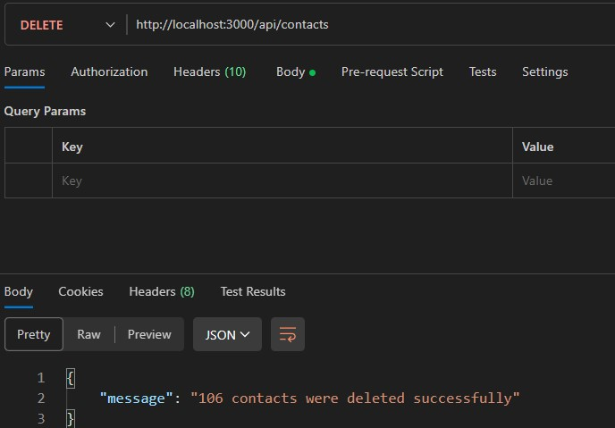

Make sure all handlers work correctly, then commit changes to git and GitHub:

git add -u

git add src/database src/services git commit -m "Implement handlers" git push origin master ## Upload local commits to GitHub

The directory struture for the project currently is as follows:

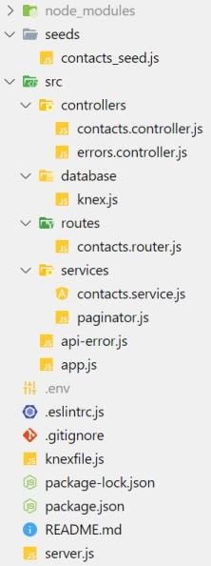

**CT313H: WEB TECHNOLOGIES AND SERVICES**

**Building Contactbook App - Frontend**

You will build a contact management app as a SPA app. The tech stack includes *Nodejs/Express, Knex.js, MySQL/MariaDB* for backend (API server) and *Vue.js* for frontend (GUI). In the next two lab sessions, you will build the app frontend.

The app is built as a SPA with Vue.js and has the following features:

A page showing a list of contacts, support pagination and the ability to filter any piece of information of a contact (name, email, phone, address, favorite) on each page of contacts.

A page to edit a contact.

A page to add a new contact.

Support for deleting a contact, all contacts.

A 404 error page for unknown paths.

The app uses the HTTP API built in the first two lab sessions. The source code is managed by git and uploaded to GitHub.

This step-by-step tutorial will help implement all the above requirements. However, students are free to make their own implementation as long as the requirements are met.

**Requirements for the lab report**:

The submitted report file is a PDF file containing images showing the results of your works. Each functionality on a page may need several images to illustrate (e.g., images showing the implemented functionalities, successful and failed scenarios, results of the operations, ...). **You should NOT screenshoot the source code**.

**You only need to create ONE report for the whole four lab sessions**. At the end of each lab session, students need to (1) submit the work-in-progress report and (2) push the code to the GitHub repository given by the instructor.

The report should also filled with student information (student ID, student name, class ID) and the links to the GitHub repositories.

Plagiarism will result in 0.

**Step 0: Before getting started...**

For easier debugging, Vue.js devtools extension should be installed in the browser. The HTTP API server built in the first two lab sessions should work correctly.

**Step 1: Clone the repo from GitHub**

Clone the GitHub repo to your machine:

git clone <đường-link-đến-repo-GitHub-đã-nhận> contactbook-frontendInstall dependencies and

run the project in dev mode:

cd contactbook-frontend

npm install

npm run dev

Open a browser, go to http://localhost:5173/ to see the result.

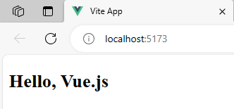

**Step 2: Setup VSCode**

Install Vue Language Features (Volar) extension for VSCode.

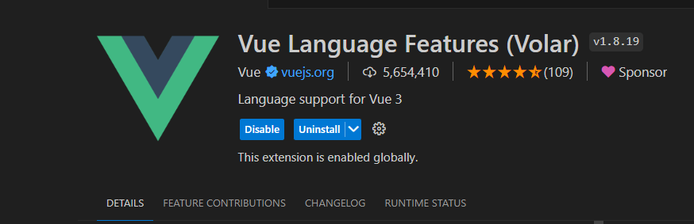

Install ESLint, Prettier extensions for VSCode if needed.

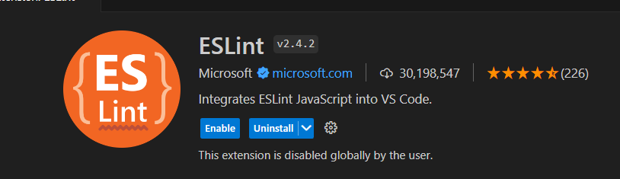

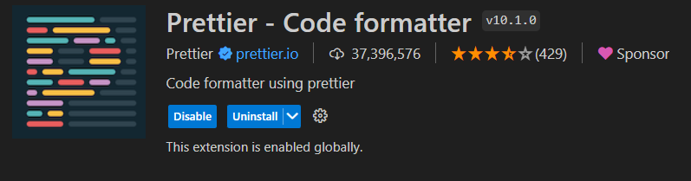

Configure VSCode to automatically format the source code on save or paste: Go to File > Settings, search for "format" and then check "Editor: Format on Paste" and "Editor: Format on Save":

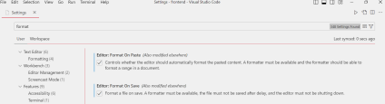In the project directory, add *jsconfig.json* file. This file helps VSCode understand the project structure:

{

"compilerOptions": {

"baseUrl": "./",

"paths": {

"@/*": ["src/*"]

}

}

}

Commit changes and push to GitHub:

cd contactbook-frontend

git add -A

git commit -m "Setup VSCode"

git push origin master

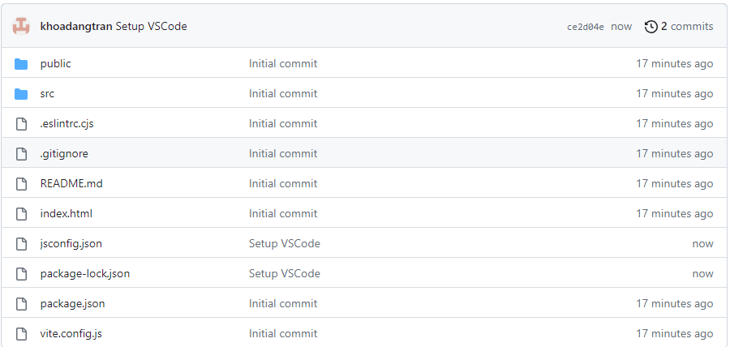

**Step 3: Create functions to get data from server**

In the project directory, configure proxy to the API server in *vite.config.js*:

export default defineConfig({

...

server: {

proxy: {

'/api': {

target: 'http://localhost:3000/',

changeOrigin: true,

},

},

},

});

The above configuration means that when there is a HTTP request with an URI starting with */api* coming from the app (http://localhost:5173/), the target host of the request will be replaced with the address of the API server (http://localhost:3000/). For example, a request to http://localhost:5173/api/contacts will become a request to http://localhost:3000/api/contacts.

Create *src/services/contacts.service.js* as follows:

function makeContactsService() {

const baseUrl = '/api/contacts';

const headers = {

'Content-Type': 'application/json',

};

async function getContacts(page, limit = 5) {

let url = `${baseUrl}?page=${page}&limit=${limit}`;

return await fetch(url).then((res) => res.json());

}

async function createContact(contact) {

return await fetch(baseUrl, {

method: 'POST',

headers,

body: JSON.stringify(contact),

}).then((res) => res.json());

}

async function deleteAllContacts() {

return await fetch(baseUrl, {

method: 'DELETE',

}).then((res) => res.json());

}

async function getContact(id) {

return await fetch(`${baseUrl}/${id}`).then((res) => res.json()); }

async function updateContact(id, contact) {

return await fetch(`${baseUrl}/${id}`, {

method: 'PUT',

headers,

body: JSON.stringify(contact),

}).then((res) => res.json());

}

async function deleteContact(id) {

return await fetch(`${baseUrl}/${id}`, {

method: 'DELETE',

}).then((res) => res.json());

}

return {

getContacts,

deleteAllContacts,

getContact,

createContact,

updateContact,

deleteContact,

};

}

export default makeContactsService();

The *contacts.service.js* module defines functions interacting with the API server (built in lab sessions 1 and 2) by issuing the corresponding HTTP requests.

**Step 4: Implement a page showing a list of contacts**

The UI presented in this tutorial is as follows:

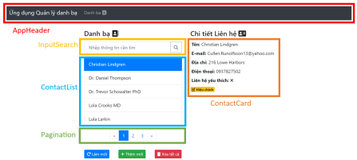Install Bootstrap 4 and Font Awesome:

npm i bootstrap@4 jquery popper.js @fortawesome/fontawesome-free Edit *src/main.js* to

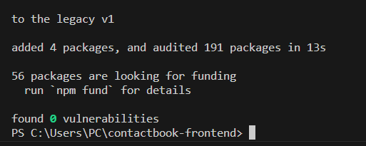 import Bootstrap and Font Awesome:

import { createApp } from 'vue';

import 'bootstrap/dist/css/bootstrap.min.css';

import '@fortawesome/fontawesome-free/css/all.min.css';

import App from './App.vue';

...

Install vue-router : npm i vue-router@4 , and create *src/router/index.js* as follows:

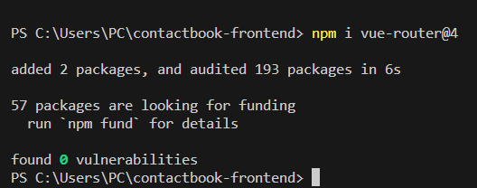

import { createWebHistory, createRouter } from 'vue-router';

import ContactBook from '@/views/ContactBook.vue';

const routes = [

{

path: '/',

name: 'contactbook',

component: ContactBook,

},

];

const router = createRouter({

history: createWebHistory(import.meta.env.BASE_URL),

routes,

});

export default router;

The *import.meta.env* object contains environment variables for the app managed by Vite. *env.BASE_URL* returns the base URL of the app on the web server. This value comes from the "base" option in the *vite.config.js* file ("/" by default - the app is deployed right in the document root on the web server).

Open *src/main.js* and add the router to the app:

...

import router from './router';

createApp(App)

.use(router)

.mount('#app');

Define a placeholder page in *src/views/ContactBook.vue* as follows:

<template>

<h2>ContactBook page</h2>

</template>

The root component in *src/App.vue* is updated as follows:

<script setup>

import AppHeader from '@/components/AppHeader.vue';

</script>

<template>

<AppHeader />

<div class="container mt-3">

<router-view />

</div>

</template>

<style>

.page {

max-width: 400px;

margin: auto;

}

</style>

*AppHeader* component (*src/components/AppHeader.vue*) defines the app navigation bar:

<template>

<nav class="navbar navbar-expand navbar-dark bg-dark">

<a

href="/"

class="navbar-brand"

>Ứng dụng Quản lý danh bạ</a>

<div class="mr-auto navbar-nav">

<li class="nav-item">

<router-link

:to="{ name: 'contactbook' }"

class="nav-link"

>

Danh bạ

<i class="fas fa-address-book"></i>

</router-link>

</li>

</div>

</nav>

</template>

Go to http://localhost:5173/ to check the page showing the string "ContactBook page".

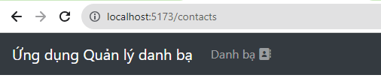

As shown in the figure, the *ContactBook* page use 4 components: *InputSearch*, *ContactList*, *ContactCard* and *Pagination*. Let's create these components:

1. *InputSearch* component (*src/components/InputSearch.vue*):

<script setup>

defineProps({

modelValue: { type: String, default: '' },

});

const $emit = defineEmits(['submit', 'update:modelValue']);

</script>

<template>

<div class="input-group">

<input

type="text"

class="form-control px-3"

placeholder="Nhập thông tin cần tìm"

:value="modelValue"

@input="(e) => $emit('update:modelValue', e.target.value)"

@keyup.enter="$emit('submit')"

/>

<div class="input-group-append">

<button

class="btn btn-outline-secondary"

type="button"

@click="$emit('submit')"

>

<i class="fas fa-search"></i>

</button>

</div>

</div>

</template>

The component has a property named *modelValue*. This property is bound to the input value. An event named *update:modelValue* is emitted when the input value changes. These conditions enable the use of v-model on *InputSearch* to create a two-way binding, i.e., *<InputSearch v model="..." />*.

2. *ContactList* component (*src/components/ContactList.vue*):

<script setup>

defineProps({

contacts: { type: Array, default: () => [] },

selectedIndex: { type: Number, default: -1 },

});

const $emit = defineEmits(['update:selectedIndex']);

</script>

<template>

<ul class="list-group">

<li

class="list-group-item px-3"

v-for="(contact, index) in contacts"

:class="{ active: index === selectedIndex }"

:key="contact.id"

@click="$emit('update:selectedIndex', index)"

>

{{ contact.name }}

</li>

</ul>

</template>

The component has a property named *activeIndex*. An event named *update:activeIndex* is emitted when a list element is selected. These conditions enable the use of v-model on *ContactList* to create a two-way binding, i.e., *<ContactList v-model:activeIndex="..." />*.

3. *ContactCard* component (*src/components/ContactCard.vue*):

<script setup>

defineProps({

contact: { type: Object, required: true },

});

</script>

<template>

<div>

<div class="p-1">

<strong>Tên:</strong>

{{ contact.name }}

</div>

<div class="p-1">

<strong>E-mail:</strong>

{{ contact.email }}

</div>

<div class="p-1">

<strong>Địa chỉ:</strong>

{{ contact.address }}

</div>

<div class="p-1">

<strong>Điện thoại:</strong>

{{ contact.phone }}

</div>

<div class="p-1">

<strong>Liên hệ yêu thích:&nbsp;</strong> <i

v-if="contact.favorite"

class="fas fa-check"

></i>

<i

v-else

class="fas fa-times"

></i>

</div>

</div>

</template>

4. *Pagination* componenent (*src/components/Pagination.vue*):

<script setup>

import { computed } from 'vue';

const props = defineProps({

totalPages: {

type: Number,

required: true,

},

length: {

type: Number,

default: 3,

},

currentPage: {

type: Number,

default: 1,

},

});

const $emit = defineEmits(['update:currentPage']);

const pages = computed(() => {

const pages = [];

const half = Math.floor(props.length / 2); let start = props.currentPage - half;

let end = props.currentPage + half;

if (start <= 0) {

start = 1;

end = props.length;

}

if (end > props.totalPages) {

end = props.totalPages;

start = end - props.length + 1;

if (start <= 0) start = 1;

}

for (let i = start; i <= end; i++) {

pages.push(i);

}

return pages;

});

</script>

<template>

<nav>

<ul class="pagination">

<li

class="page-item"

:class="{ disabled: currentPage == 1 }"

>

<a

role="button"

class="page-link"

@click.prevent="$emit('update:currentPage', currentPage - 1)" >

<span>&laquo;</span>

</a>

</li>

<li

v-for="page in pages"

:key="page"

class="page-item"

:class="{ active: currentPage == page }"

>

<a

role="button"

class="page-link"

@click.prevent="$emit('update:currentPage', page)"

>{{ page }}</a

>

</li>

<li

class="page-item"

:class="{ disabled: currentPage == totalPages }"

>

<a

role="button"

class="page-link"

@click.prevent="$emit('update:currentPage', currentPage + 1)" >

<span>&raquo;</span>

</a>

</li>

</ul>

</nav>

</template>

Edit *src/views/ContactBook.vue* to define a page showing a list of contacts:

<script setup>

import { ref, computed, onMounted, watch } from 'vue';

import { useRouter } from 'vue-router';

import ContactCard from '@/components/ContactCard.vue';

import InputSearch from '@/components/InputSearch.vue';

import ContactList from '@/components/ContactList.vue';

import Pagination from '@/components/Pagination.vue';

import contactsService from '@/services/contacts.service';

// The full code will be presented below

</script>

<template>

<div class="page row mb-5">

<div class="mt-3 col-md-6">

<h4>

Danh bạ

<i class="fas fa-address-book"></i>

</h4>

<div class="my-3">

<InputSearch v-model="searchText" />

</div>

<ContactList

v-if="filteredContacts.length > 0"

:contacts="filteredContacts"

v-model:selectedIndex="selectedIndex"

/>

<p v-else>

Không có liên hệ nào.

</p>

<div class="mt-3 d-flex justify-content-center align-items-center"> <Pagination

:totalPages="totalPages"

v-model:currentPage="currentPage"

/>

</div>

<div class="mt-3 row justify-content-around align-items-center"> <button

class="btn btn-sm btn-primary"

@click="retrieveContacts(currentPage)"

>

<i class="fas fa-redo"></i> Làm mới

</button>

<button

class="btn btn-sm btn-success"

@click="goToAddContact"

>

<i class="fas fa-plus"></i> Thêm mới

</button>

<button

class="btn btn-sm btn-danger"

@click="onDeleteContacts"

>

<i class="fas fa-trash"></i> Xóa tất cả

</button>

</div>

</div>

<div class="mt-3 col-md-6">

<div v-if="selectedContact">

<h4>

Chi tiết Liên hệ

<i class="fas fa-address-card"></i>

</h4>

<ContactCard :contact="selectedContact" />

</div>

</div>

</div>

</template>

<style scoped>

.page {

text-align: left;

max-width: 750px;

}

</style>

The *ContactBook* page has the following variables:

*totalPages*: stores the total pages (in this case, paginating records happens on the server). *currentPage*: stores the current page.

*contacts*: stores a list of contacts on a page. This list is loaded with the data from the server when *ContactBook* is mounted.

*selectedIndex*: index of the selected contact in the list. *selectedIndex* identifies the contact object passed to *ContactCard* for displaying detailed information.

*searchText*: stores text entered from the search box.

The *ContactBook* page relies on *contactsService* for accessing data on the server:

// src/views/ContactBook.vue

<script setup>

...

const $router = useRouter();

const totalPages = ref(1);

const currentPage = ref(1);

const contacts = ref([]);

const selectedIndex = ref(-1);

const searchText = ref('');

// Map each contact to a string for searching

const searchableContacts = computed(() =>

contacts.value.map((contact) => {

const { name, email, address, phone } = contact;

return [name, email, address, phone].join('');

})

);

// Contacts filtered by searchText

const filteredContacts = computed(() => {

if (!searchText.value) return contacts.value;

return contacts.value.filter((contact, index) =>

searchableContacts.value[index].includes(searchText.value) );

});

const selectedContact = computed(() => {

if (selectedIndex.value < 0) return null;

return filteredContacts.value[selectedIndex.value]; });

// Get contacts for a specific pages and order them by name async function retrieveContacts(page) {

try {

const chunk = await contactsService.getContacts(page); totalPages.value = chunk.metadata.lastPage ?? 1;

contacts.value = chunk.contacts.sort((current, next) => current.name.localeCompare(next.name)

);

selectedIndex.value = -1;

} catch (error) {

console.log(error);

}

}

// Handle delete all contacts event

async function onDeleteContacts() {

if (confirm('Bạn muốn xóa tất cả Liên hệ?')) {

try {

await contactsService.deleteAllContacts();

totalPages.value = 1;

currentPage.value = 1;

contacts.value = [];

selectedIndex.value = -1;

} catch (error) {

console.log(error);

}

}

}

function goToAddContact() {

$router.push({ name: 'contact.add' });

}

// When this component is mounted, load the first page of contacts onMounted(() => retrieveContacts(1));

// Whenever searchText changes, reset selectedIndex

watch(searchText, () => (selectedIndex.value = -1));

// When currentPage changes, fetch contacts for currentPage

watchEffect(() => retrieveContacts(currentPage.value));

</script>

Start the API server at port 3000 and then start the Vue app: npm run dev (if it's not started yet). Open a browser, go to http://localhost:5173/ and verify that: (1) a list of contacts is shown, (2) the detailed information of a contact is shown when selecting a contact in the list, and (3) the search functionality works correctly. If the database contains no data, add some example data (use a HTTP client to send requests to the API server).

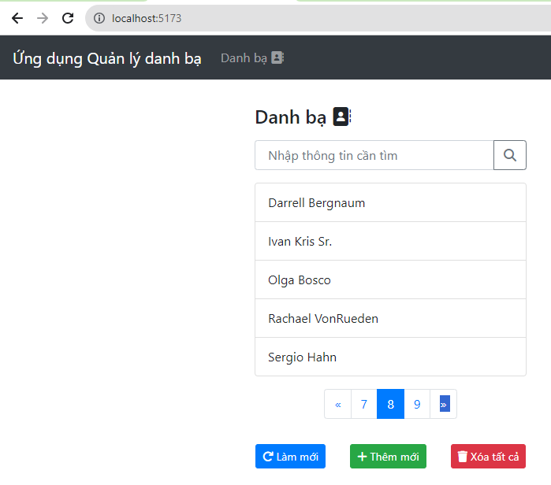

After making sure the code works, commit changes to git and upload to GitHub:

git add -u

git add .env src/components/ src/router/ src/services/ src/views/

git commit -m "Create a contact listing page"

git push origin master

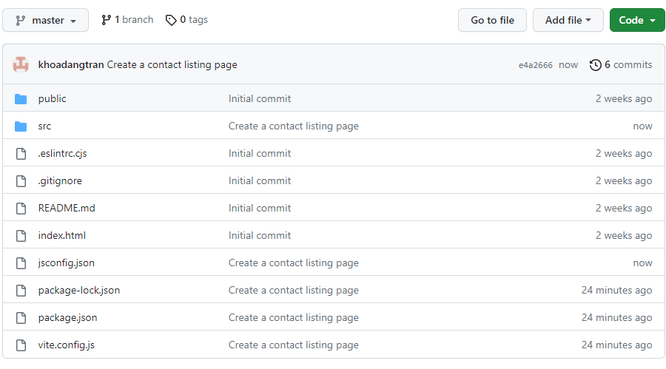

**Step 5: Create a 404 error page**

Add a route definition matching all the paths (*src/router/index.js*):

...

const routes = [

...

{

path: '/:pathMatch(.*)*',

name: 'notfound',

component: () => import('@/views/NotFound.vue'),

},

];

...

Create the *NotFound* page in *src/views/NotFound.vue*:

<template>

<div class="page">

<p>

Oops, không thể tìm thấy trang. Trở về

<router-link to="/">

trang chủ.

</router-link>

</p>

</div>

</template>

Open a browser, access to an unknown path and check that the error page is shown. Commit changes and upload to GitHub:

git add src/router/index.js src/views/NotFound.vue

git commit -m "Implement the 404 page"

git push origin master

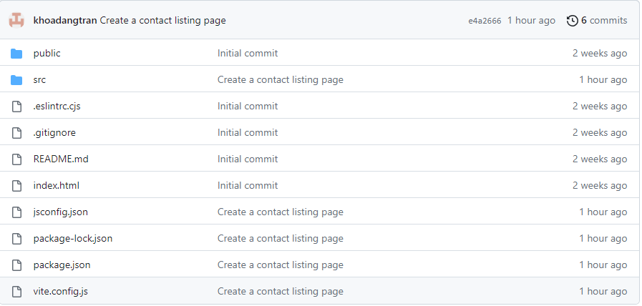

**Step 6: Create form for adding and updating a contact**

The edit page and the add page need a form namely *ContactForm*. *ContactForm* receives a contact object as its property. If the contact object exists on the server (i.e., the id field has a valid value) then *ContacForm* will be in edit mode. On the other hand, it will be in add mode. Only in edit mode, the delete button on the form is shown.

When working with form in Vue, you can use vee-validate and yup to easily validate the form data. vee-validate provides customized form and input components supporting data validation by rules. yup helps create these validation rules.

**Please not that the use of** vee-validate **and** yup **is not required, you can use normal form and input tags and standard JavaScript code for form validation.**

Install vee-validate and yup : npm i vee-validate yup .

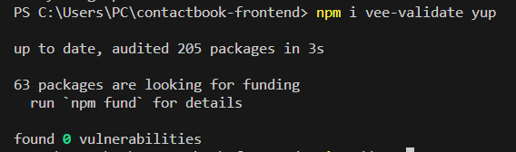

Create/edit *ContactForm.vue* in *src/components/* as follows:

<script setup>

import { ref } from 'vue';

import * as yup from 'yup';

import { Form, Field, ErrorMessage } from 'vee-validate';

const props = defineProps({

initialContact: { type: Object, required: true },

});

const $emit = defineEmits(['submit:contact', 'delete:contact']);

const contactFormSchema = yup.object().shape({

name: yup

.string()

.required('Tên phải có giá trị.')

.min(2, 'Tên phải ít nhất 2 ký tự.')

.max(50, 'Tên có nhiều nhất 50 ký tự.'),

email: yup

.string()

.email('E-mail không đúng.')

.max(50, 'E-mail tối đa 50 ký tự.'),

address: yup.string().max(100, 'Địa chỉ tối đa 100 ký tự.'), phone: yup

.string()

.matches(

/(03|05|07|08|09|01[2|6|8|9])+([0-9]{8})\b/g,

'Số điện thoại không hợp lệ.'

),

});

const editedContact = ref({ ...props.initialContact });

function submitContact() {

$emit('submit:contact', editedContact.value);

}

function deleteContact() {

$emit('delete:contact', editedContact.value.id);

}

</script>

<template>

<Form

@submit="submitContact"

:validation-schema="contactFormSchema"

>

<div class="form-group">

<label for="name">Tên</label>

<Field

name="name"

type="text"

class="form-control"

v-model="editedContact.name"

/>

<ErrorMessage name="name" class="error-feedback" /> </div>

<div class="form-group">

<label for="email">E-mail</label>

<Field

name="email"

type="email"

class="form-control"

v-model="editedContact.email"

/>

<ErrorMessage name="email" class="error-feedback" /> </div>

<div class="form-group">

<label for="address">Địa chỉ</label>

<Field

name="address"

type="text"

class="form-control"

v-model="editedContact.address"

/>

<ErrorMessage name="address" class="error-feedback" />

</div>

<div class="form-group">

<label for="phone">Điện thoại</label>

<Field

name="phone"

type="tel"

class="form-control"

v-model="editedContact.phone"

/>

<ErrorMessage name="phone" class="error-feedback" />

</div>

<div class="form-group form-check">

<Field

name="favorite"

type="checkbox"

class="form-check-input"

v-model="editedContact.favorite"

:value="1"

:unchecked-value="0"

/>

<label for="favorite" class="form-check-label">

<strong>Liên hệ yêu thích</strong>

</label>

</div>

<div class="form-group">

<button class="btn btn-primary">Lưu</button>

<button

v-if="editedContact.id"

type="button"

class="ml-2 btn btn-danger"

@click="deleteContact"

>

Xóa

</button>

</div>

</Form>

</template>

<style scoped>

@import '@/assets/form.css';

</style>

In above code, we defined a schema containing validation rules for input data in the form ( :validation-schema="contactFormSchema" ). Also note that *ContactForm* can emit two events: *submit:contact* and *delete:contact*.

**Step 7: Create an edit page**

The UI of the page is as follows:

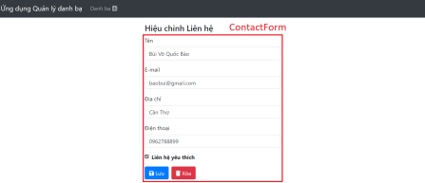Create *src/views/ContactEdit.vue* as follows:

<script setup>

import { ref } from 'vue';

import { useRouter, useRoute } from 'vue-router';

import ContactForm from '@/components/ContactForm.vue';

import contactsService from '@/services/contacts.service';

const props = defineProps({

contactId: { type: String, required: true },

});

const $router = useRouter();

const $route = useRoute();

const contact = ref(null);

const message = ref('');

async function getContact(id) {

try {

contact.value = await contactsService.getContact(id);

} catch (error) {

console.log(error);

// Redirect to NotFound page and keep URL intact

$router.push({

name: 'notfound',

params: { pathMatch: $route.path.split('/').slice(1) },

query: $route.query,

hash: $route.hash,

});

}

}

async function onUpdateContact(editedContact) {

try {

await contactsService.updateContact(editedContact.id, editedContact); message.value = 'Liên hệ được cập nhật thành công.';

} catch (error) {

console.log(error);

}

}

async function onDeleteContact(id) {

if (confirm('Bạn muốn xóa Liên hệ này?')) {

try {

await contactsService.deleteContact(id);

$router.push({ name: 'contactbook' });

} catch (error) {

console.log(error);

}

}

}

getContact(props.contactId);

</script>

<template>

<div v-if="contact" class="page">

<h4>Hiệu chỉnh Liên hệ</h4>

<ContactForm

:initial-contact="contact"

@submit:contact="onUpdateContact"

@delete:contact="onDeleteContact"

/>

<p>{{ message }}</p>

</div>

</template>

The path for accessing to the edit page is /contacts/:id with id as the id of the contact. Before the page is shown, the id property is used to fetch contact data from the server.

Add a route definition for *ContactEdit* in *src/router/index.js*:

...

const routes = [

...

{

path: '/contacts/:id',

name: 'contact.edit',

component: () => import('@/views/ContactEdit.vue'),

props: (route) => ({ contactId: route.params.id })

},

];

...

Add a link to the edit page in ContactBook (*src/views/ContactBook.vue*), just below ContactCard:

...

<ContactCard :contact="selectedContact" />

<router-link

:to="{

name: 'contact.edit',

params: { id: selectedContact.id },

}"

>

<span class="mt-2 badge badge-warning">

<i class="fas fa-edit"></i> Hiệu chỉnh</span>

</router-link>

...

Make sure the code works. Commit changes and upload to GitHub:

git add -u

git add src/assets/ src/components/ContactForm.vue src/views/ContactEdit.vue

git commit -m "Create an edit page"

git push origin master



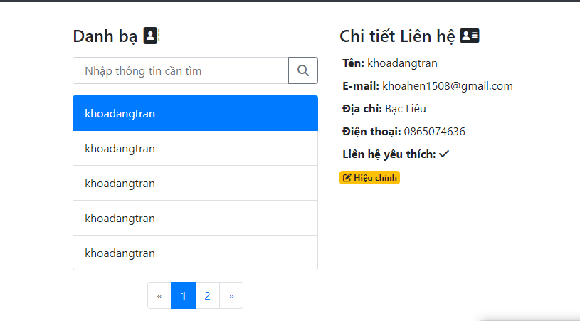

**Step 8: Create an add page**

This page is similar to the edit page, so do it on your own:

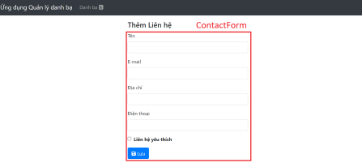Make sure the add page works correctly and then commits changes to GitHub.

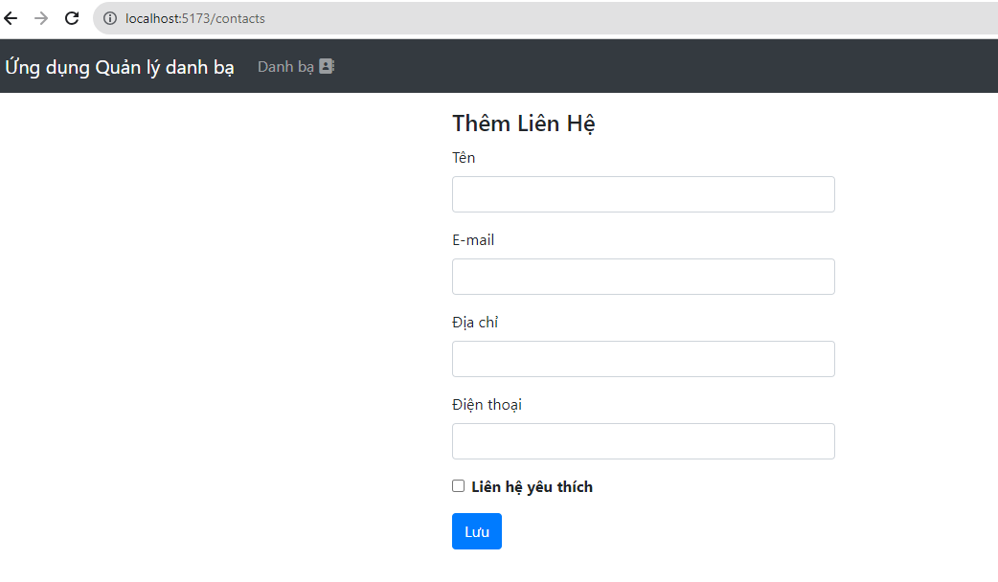

The directory structure of the project is as follows:

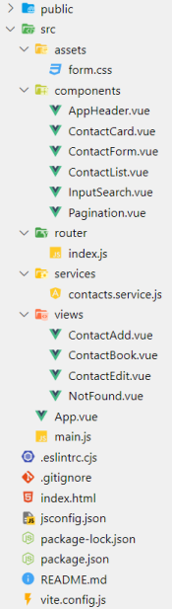

**Step 9: Manage server state with @tanstack/vue-query**

Instead of directly call server APIs inside components, update the project to use @tanstack/vue-query to fetch and modify server state (e.g., contact resources).