**LAB 5**

**CI/CD PIPELINE USING JENKINS, GITHUB AND DOCKER**

|  |
| --- |
| Fullname: Tran Dang Khoa  Student ID: B2014926 |

* Note: screenshots need to be clear and good-looking; submissions must be in PDF format.

1. **Manually dockerize a Flask project**
   1. **Deploy a Flask application**

- Create a sample Flask application:

|  |
| --- |
| $mkdir cicd_tutorial ; cd cicd_tutorial  $nano flask_docker.py |
|  |

flask_docker.py

|  |
| --- |
| from flask import Flask app = Flask(__name__)  @app.route('/') def hello_world():  return 'Hello FOSS'  if __name__ == '__main__':  app.run(debug=True,host='0.0.0.0') |
|  |

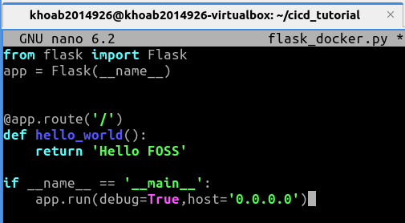

- Install pip (package installer for Python), and then the Flask framework

|  |
| --- |
| $sudo apt install python3-pip -y  $pip3 install flask |

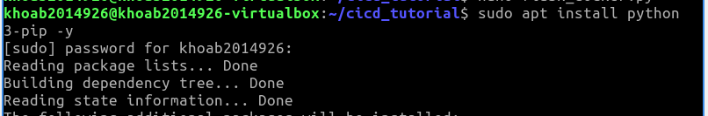

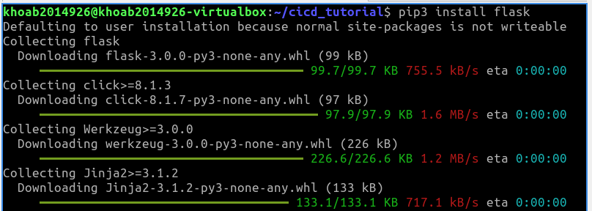

- We can test it out by running:

|  |
| --- |
| $python3 flask_docker.py  * Running on http://0.0.0.0:5000/ (Press CTRL+C to quit)  * Restarting with stat  * Debugger is active!  * Debugger PIN: 135-043-124 |

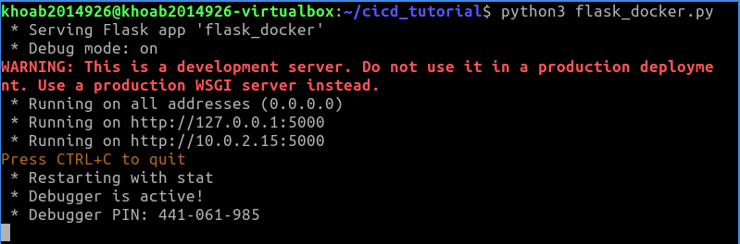

- Access the application from a browser (http://localhost:5000), (take a screenshot)

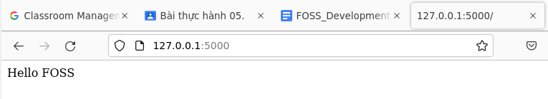

* 1. **Dockerize a Flask application using Dockerfile**

**-** Update the apt package index and install Docker

|  |
| --- |
| $sudo apt update $sudo apt install docker.io -y |

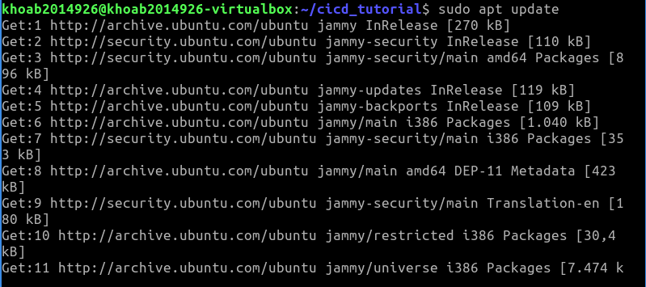

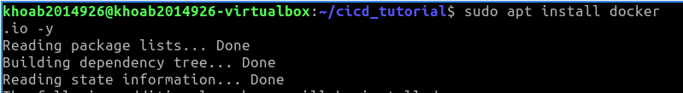

- Add current user to the docker group:

|  |
| --- |
| $sudo usermod -aG docker ${USER} $su - ${USER} |

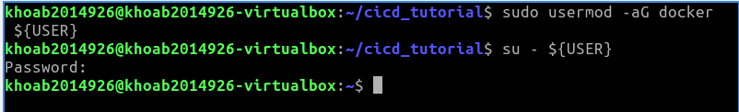

- Check whether you can access and download images from Docker Hub

|  |
| --- |
| $docker run hello-world |

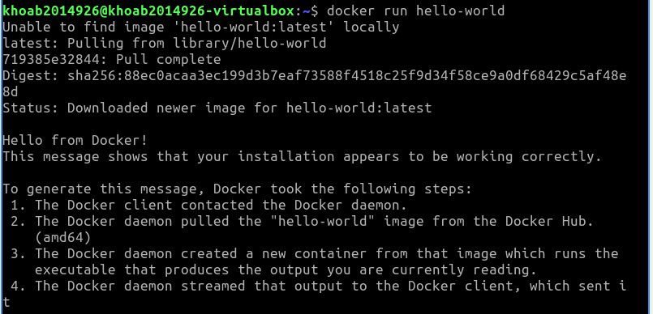

The output will indicate that Docker is working correctly:

Hello from Docker!

This message shows that your installation appears to be working correctly.

- Create a requirements.txt file

|  |
| --- |
| $nano requirements.txt |



requirements.txt

|  |
| --- |
| Flask==2.2.2 |

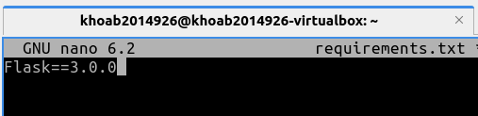

- Create a Dockerfile file

|  |
| --- |
| $nano Dockerfile |



Dockerfile

|  |
| --- |
| FROM ubuntu:latest MAINTAINER Tuan Thai "tuanthai@example.com" RUN apt update -y RUN apt install -y python3-pip python3-dev build-essential ADD . /flask_app WORKDIR /flask_app RUN pip3 install -r requirements.txt ENTRYPOINT ["python3"] CMD ["flask_docker.py"] |

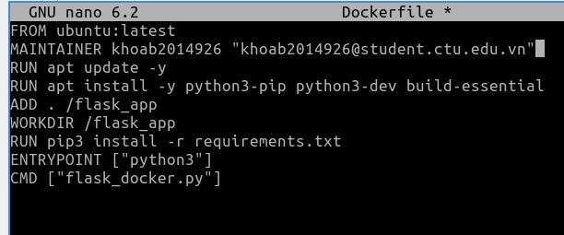

- Create a Docker image whose name is "my-flask-image:latest", using the Dockerfile

|  |
| --- |
| $docker build -t my-flask-image:latest . |

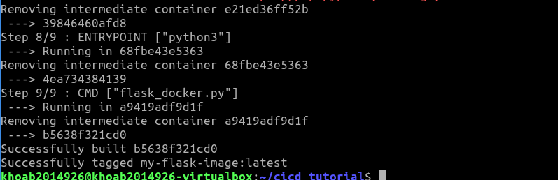

- Then see if your image is in Docker (take a screenshot)

|  |
| --- |
| $docker images |

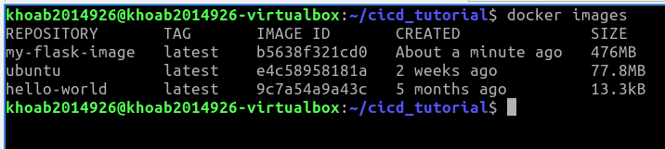

- Run your image (take a screenshot)

|  |
| --- |
| $docker run -d -p 5000:5000 my-flask-image  $docker ps |

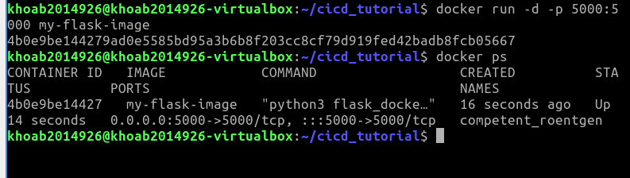

- Access the application from a browser (<http://localhost:5000>)

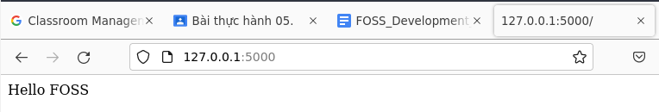

1. **Automatically dockerize a Flask project using Jenkins**
   1. **Push your code to a Github repository**

- Create an account (or login) to GitHub at <https://github.com>

- Create a new repository, name it as "cicd_tutorial". Get the repository URL (for example: <https://github.com/TuanThai/cicd_tutorial.git>)

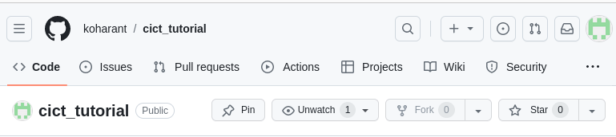

- Install and setup git on your computer (remember to set your name/email)

|  |
| --- |
| $sudo apt update ; sudo apt install git -y  $git config --global user.name "Firstname Lastname"  $git config --global user.email "example@.ctu.edu.vn" |

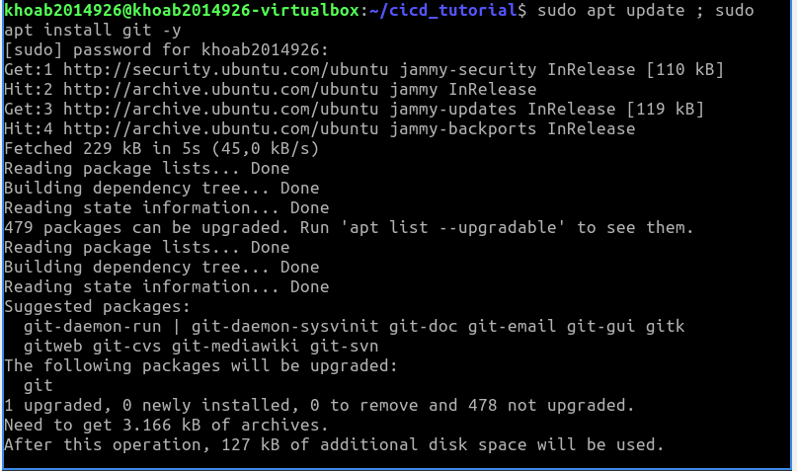

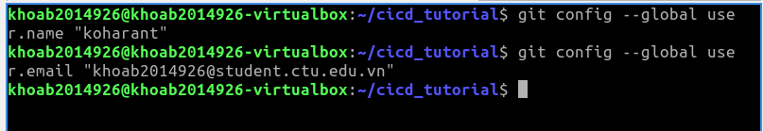

- Initialize git, commit and push your flask project files to Github

|  |
| --- |
| $mv ~/cicd_tutorial  $git init  $git add .  $git commit -m "first commit"  $git remote add origin <your repository URL>  $git push -u origin master |

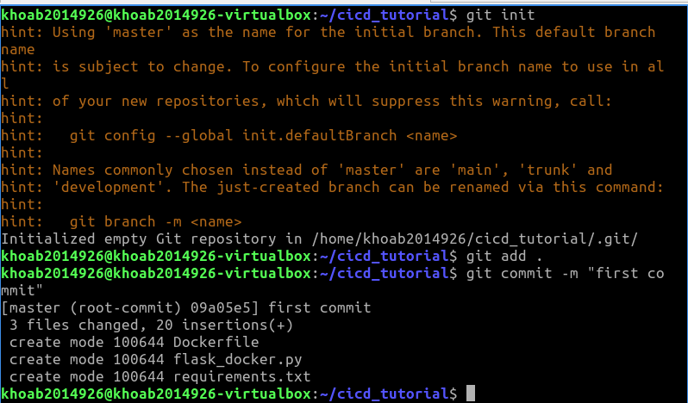



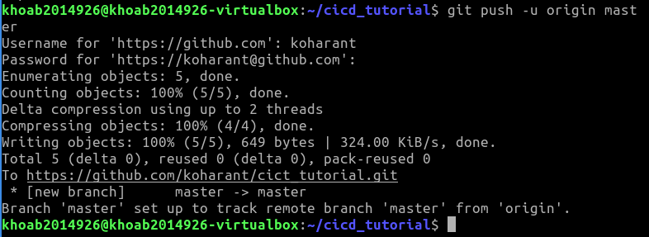

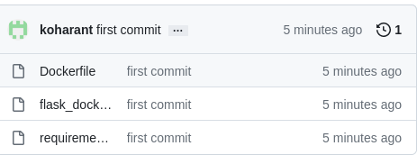

* 1. **Install and configure Jenkins**

- Install Java and Jenkins

|  |
| --- |
| $sudo apt install openjdk-11-jdk -y  $wget -q -O - https://pkg.jenkins.io/debian-stable/jenkins.io.key | sudo apt-key add -  $sudo sh -c 'echo deb http://pkg.jenkins.io/debian-stable binary/ > /etc/apt/sources.list.d/jenkins.list'  $sudo apt update ; sudo apt install jenkins -y |

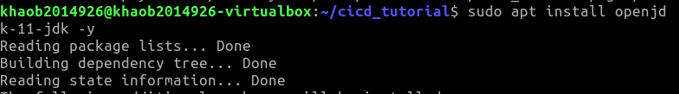

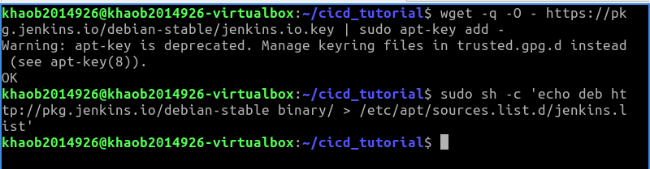

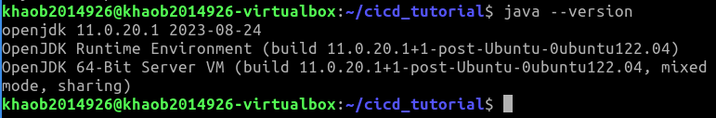

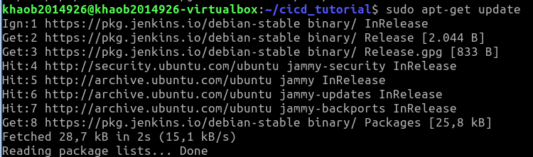

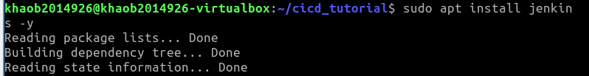

- Launch Jenkins

|  |
| --- |
| $sudo usermod -aG docker jenkins  $sudo systemctl restart jenkins.service |

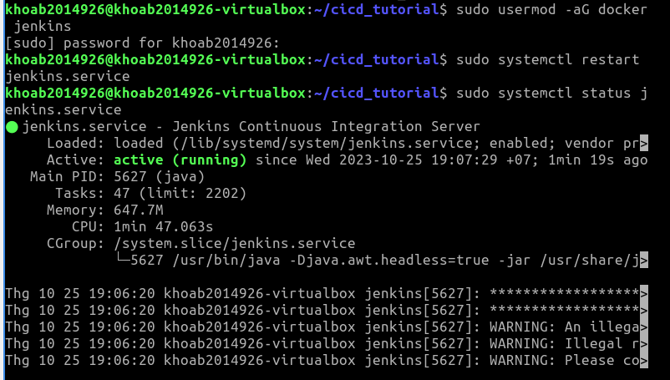- Access Jenkins using a web browser (<http://localhost:8080>). Unlock Jenkins, install suggested plugins, create the first admin user.

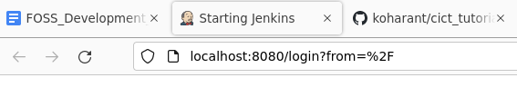

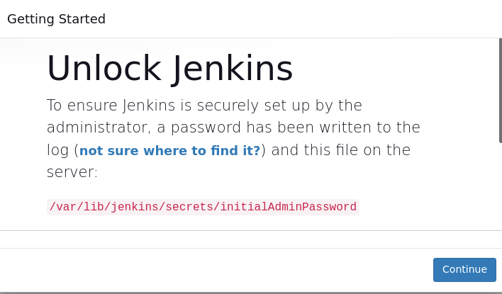

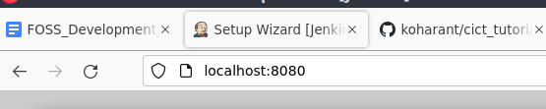

* 1. **Using Jenkins to automatically dockerize your application**

- On Jenkins dashboard, cick "Create a new job", then choose "Freestyle project". Name your project as "my_flask_project"

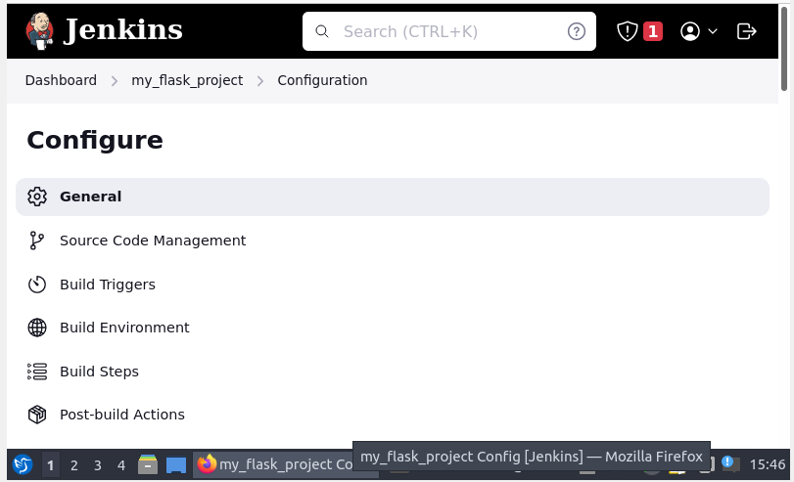

- Under "Source Code Ma nagement" choose "Git", fill in your GitHub repository URL

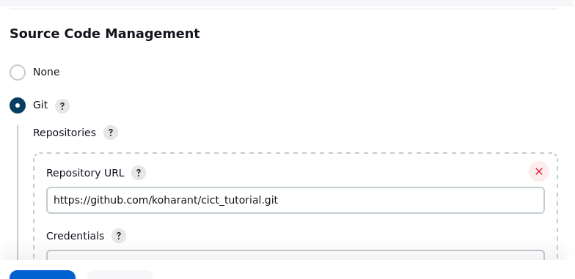

- Under "Build Triggers" select "Build periodically", fill in "* * * * *" (build your project every minute)

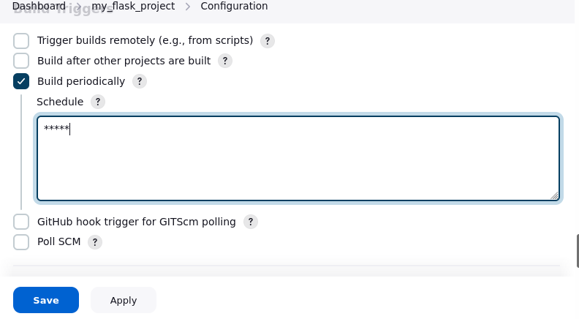

|  |
| --- |
| * * * * * |

- Under "Build" we will "Add build step", and select "Execute shell". Then fill in "docker build -t my-flask-image:latest ."

|  |
| --- |
| docker build -t my-flask-image:latest . |

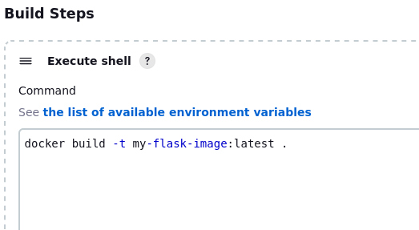

- Save your project. Then look at "Build history" to see that your project is built every minute.

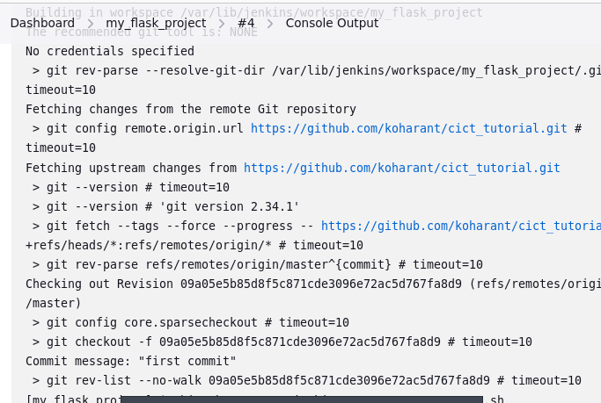

- Then see if your image is in Docker (take a screenshot)

|  |
| --- |
| $docker images |

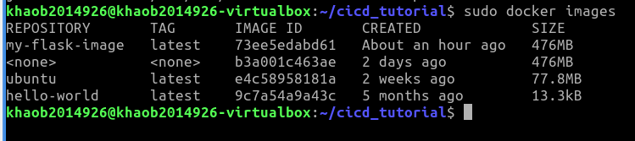

- Modify your Flask application:

|  |
| --- |
| $nano flask_docker.py |

|  |
| --- |
| from flask import Flask app = Flask(__name__) @app.route('/')  def hello_world():  return 'Hello FOSS, Hello CI/CD using Jenkins' if __name__ == '__main__':  app.run(debug=True,host='0.0.0.0') |

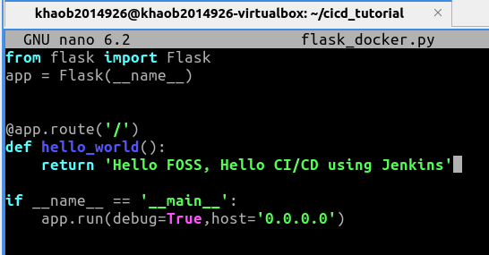

- Commit and push your project files to GitHub

|  |
| --- |
| $git add .  $git commit -m "second commit"  $git push origin master |



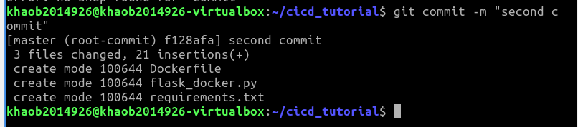

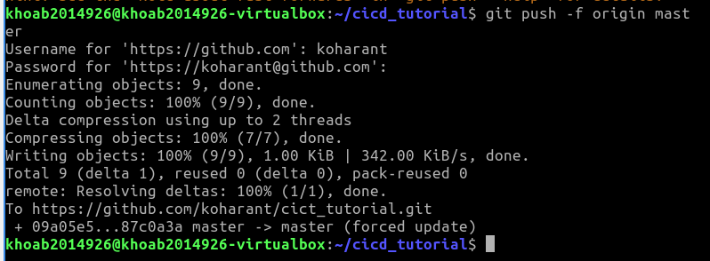

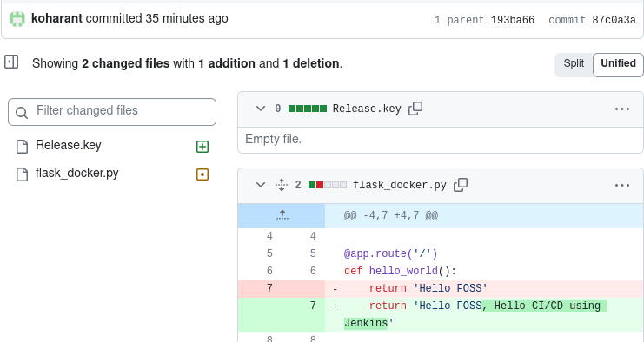- Wait 1 minute, then run your image

|  |
| --- |
| $docker run -d -p 5000:5000 my-flask-image  $docker ps |

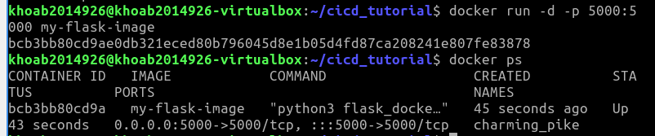

- Access the application from a browser (http://localhost:5000) (take a screenshot)

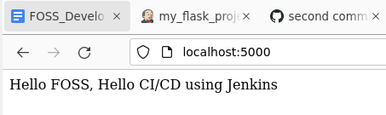

- On your Jenkins project configure, under "Build Triggers", do not forget to deselect "Build periodically"

---END---