**Lab 2**

**Creating and Managing Active Directory Users, Computers, groups and organizational unit**

# EXERCISE 1: CREATING COMPUTER OBJECTS

In this exercise, you use the **Active Directory Users and Computers** console to create an OU and a computer object. ***Create OU***

1. On the DC1 computer, in the **Active Directory Users and Computers** console, Rightclick on ***your domain***, then select **New** -> **Organizational** **Unit**. The New Object - Organizational Unit appears
2. In the Name text box, type **Workstation** ***Create computer object***
3. On the DC1 computer, which has the **Server Manager** console open. Select **Tools** -> **Active Directory Users and Computers**.
4. In the left pane, expand ***your domain*** node, if needed, and select the **Workstation** container.
5. Right-click the **Workstation** container and, from the context menu, click **New** -> **Computer**. The New Object – Computer Wizard appears.
6. In the **Computer name** text box, type **pc0**.
7. Under **User or group**, click **Change**. The Select User or Group dialog box appears.
8. In the Enter the object name to select text box, type **Domain Computers** and click OK. 7. Click OK. The wizard creates the computer object



# EXERCISE 2: CREATING ORGANIZATIONAL UNIT AND A SINGLE USER

In this exercise, you use the Active Directory Users and Computers console to create an OU and a domain user account. ***Create OU***

1. On the DC1 computer, in the Active Directory Users and Computers console, Rightclick on ***your domain***, then select **New** -> **Organizational** **Unit**. The New Object - Organizational Unit appears
2. In the Name text box, type **People Organizational Unit** ***Create a User***
3. On the DC1 computer, in the Active Directory Users and Computers console, select the People Organizational Unit.
4. From the Action menu, select New > User. The New Object – User Wizard appears 3. In the First name text box, type *<Your first name>* and in the Last name text box, type <*Your last name*>.
5. In the User logon name text box, type <*your login name*> and click Next. The second page of the New Object – User Wizard appears

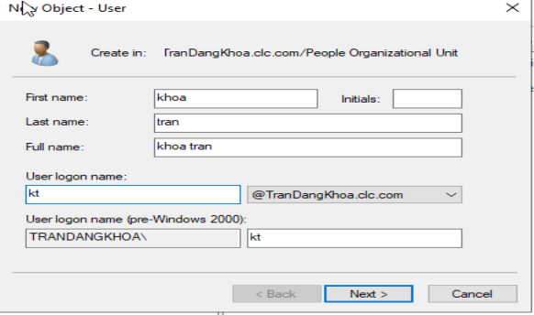

1. In the Password and Confirm password fields, type password.
2. Clear the User must change password at next logon check box and click Next. A confirmation page listing the settings you configured appears.
3. Click Finish.

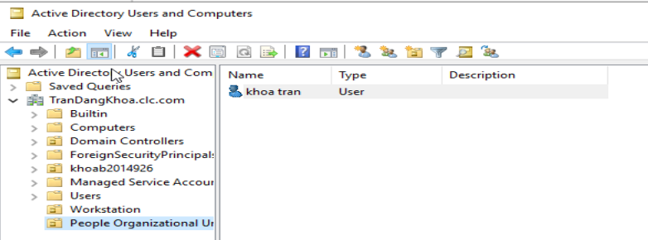

# EXERCISE 3: USING ACTIVE DIRECTORY ADMINISTRATIVE CENTER

1. On the DC1 computer, in the **Server Manager** console, select **Tools > Active Directory Administrative Center**. The Active Directory Administrative Center console appears.
2. In the left pane, select ***Your domain*** (local) node and, in the center pane, double-click the Computers container. The contents of the Computers container appears in the center pane.
3. In the right pane, select New -> Computer. The Create Computer dialog box appears
4. In the Computer name text box, type **Wkstn8**.
5. Under Member of, click Add. The Select Groups dialog box appears.
6. In the Enter the object name to select box, type Domain Computers and click OK. The group appears in the Member Of text box.

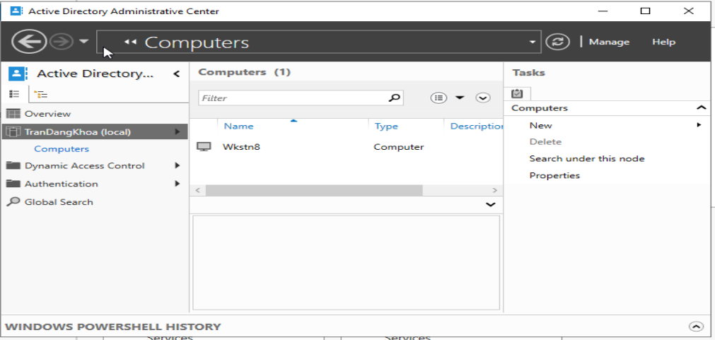

1. Click OK. The new object appears in the Computers container.
2. In the left pane, select ***Your domain*** (local) node and, in the center pane, double-click the People OU. The contents of the People container appears in the center pane
3. In the right pane, select New -> User. The Create User dialog box appears
4. In the First name text box, type *<User’s first name*>, and in the Last name text box, type *<User’s last name>*.
5. In the User SamAccountName Logon text box, type <*user login*>. In the Password and Confirm password fields, type Pa$$w0rd.
6. Scroll down and, in the Member of section, click Add. The Select Groups dialog box appears.
7. In the Enter the object name to select text box, type Domain Users and click OK.

The group appears in the Member Of text box.

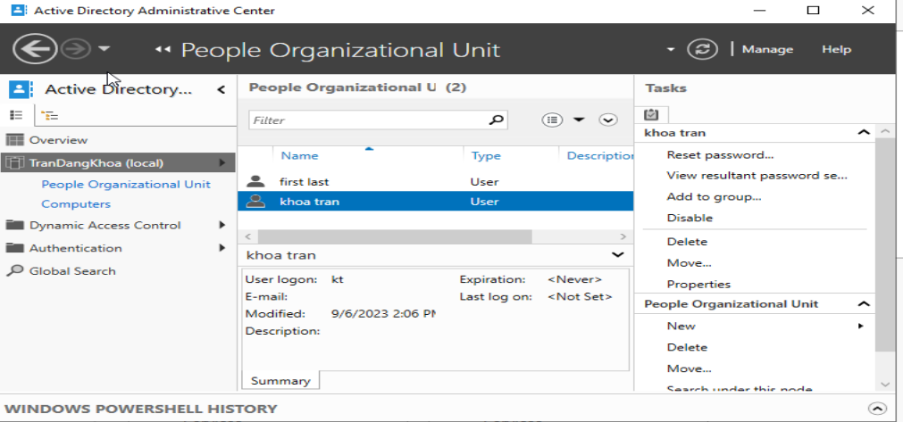

Click OK. The new user object appears in the People OU.

# EXERCISE 4: CREATING USERS WITH POWERSHELL

Using Powershell to create the OU: CIT and create the following user object in OU CIT:

* Nguyen Van A: nva
* Nguyen Van B: nvb
* Nguyen Van C: nvc

Hint:

* ***To create OU use cmdlets:***

New-ADOrganizationalUnit [-Name] <string> [-path <string>]

New-ADOrganizationalUnit–Name CIT–path “OU=CIT,dc=clc,dc=com”

* ***To create User use cmdlets:***

New-ADUser [-Name] <String> [-UserPrincipalName <String>] [-SamAccountName

<String>] [-GivenName <String>] [-Surname <String>] [-DisplayName <String>]

[-Organization <String>] [-AccountPassword <SecureString>] [-

ChangePasswordAtLogon <Boolean>] [-Enabled <Boolean>] [-Path <String>]

**Example**: New-ADUser - Name "Tran Thanh Dien" –UserPrincipalName

"ttdien@clc.com" – SamAccountName "ttdien" -GivenName "Dien" -Surname "Tran

Thanh" -DisplayName " Tran Thanh Dien" -AccountPassword (ConvertTo-SecureString

"CLC98765432$" –AsPlainText -Force) -ChangePasswordAtLogon $true –Enabled $true

–path “OU=CIT,dc=clc,dc=com”

New-ADUser - Name "Dinh Thuy Hoa" -UserPrincipalName B1910225@dien.clc.com SAMAccountName B1910225 -givenName Hoa -SurName "Dinh Thuy" -displayName

"Dinh Thuy Hoa" -AccountPassword (ConvertTo-SecureString CLC98765432$ AsPlainText -Force) -Enabled $true -path

"OU=DI19V7A3,OU=K45,OU=K45,Ou=CTU,dc=dien,dc=clc,dc=com"

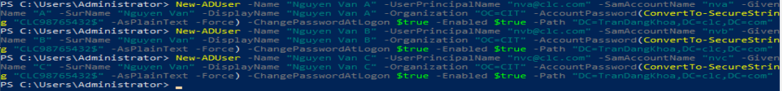

# EXERCISE 5: Joining a computer to a domain

1. Control Pannel -> System Security -> System
2. Click on **Change settings** on the section “Computer name, domain, and workgroup settings”
3. Click to choose the radio button next to **Domain**, input the <*domain name>* and then click OK
4. When prompt for username and password, please input the domain account that has the right to join the computer to the domain.

**EXERCISE 6: CREATING GROUPS**

# Creating Domain Local Groups

1. On the DC1 computer, in the **Active Directory Users and Computers** console, select the OU **CIT**
2. Right-click the **CIT** OU and, from the context menu, click New > Group. The New Object - Group dialog box appears

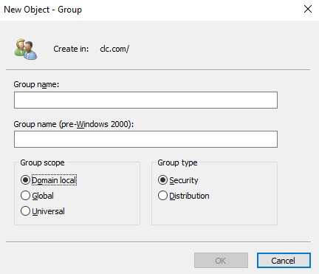

1. In the Group name text box, type **CIT**.
2. Under Group scope, select the Domain local option and click OK.

# Creating Global Groups

1. On the DC1 computer, in the Active Directory Administrative Center console, expand the ***your domain*** (local) node in the left pane and select the KCNTT OU 2. In the right pane, select New > Group. The Create Group dialog box appears

1. In the Group name text box, type Backup Managers.
2. Under Group scope, select Global and click OK. The new group appears in the KCNTT OU.

# EXERCISE 7: CREATING MULTIPLE OUS AND USERS

In this exercise, the students are requested to create the user account for students of Can Tho University. The students are given a list of users, which consist of the following information:

student’s number, Full Name and class name. Based on this information, the students are requested to:

1. Create a list of OUs with the following structure: CTU -> faculty -> school year -> Class

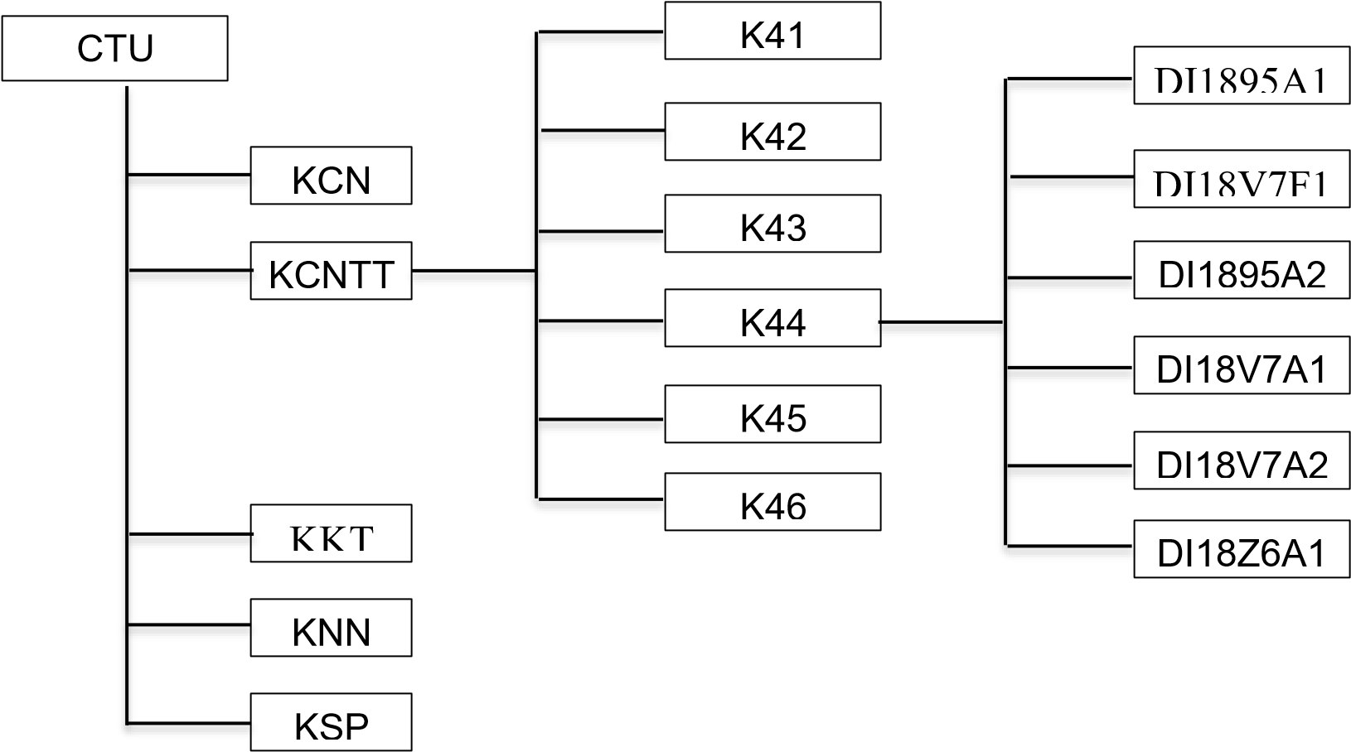

1. Create a list of user accounts and organized into corresponding OUs.

***Hint***

There are multiple methods to create multiple OUs and user accounts at the same time, including:

1. ***Powershell cmdlets: New-ADOrganizationalUnit and New-ADUser***
2. ***LDIFDE command***
3. ***CSVDE command***

Each method requires input file with different structure

The students are given the list of users with the structure as shown in the following table. The students have to extract the necessary information from this table and create the input file for the respective command.

|  |  |  |  |  |
| --- | --- | --- | --- | --- |
| **TT** | **Mã** | **Ho va ten** | | **Ten lop** |
| 1 | B1607052 | Vo Hong | Canh | DI16V7F1 |
| 2 | B1609833 | Nguyen Bao | Ngoc | DI16V7F1 |
| 3 | B1710138 | Tran Anh | Khoa | DI17V7F1 |
|  |  | … |  |  |

With the provided table, the student can extract the following information:

1. **Faculty**: The first two character of the field “Ten lop”

DI = KCNTT; TN = KCN; DA= VCNSH; FL=KNNg; KH = KKH; KT=KKT; LK=KL;

MT=KMT-TNTN; NN=KNN; TD=TDTT; TS=KTS; XH=KXH-NV

1. ***School year***: The next two character:

15 = K41; 16 = K42; 17 = K43; 18=K44; 19=K45; 20=K46; 21=K47

**Using Powershell cmdlets:**

1. ***To create a list of OUs:*** Create a Powershell script file (e.g., Create_ou.ps1) with each cmdlet in a line. The following example creates:
   1. OU CTU in the domain clc.com
   2. OU KCNTT insides OU CTU
   3. OU K44 insides OU KCNTT

New-ADOrganizationalUnit –Name CTU -path “dc=clc,dc=com”

New-ADOrganizationalUnit –Name KCNTT -path “OU=CTU,dc=clc,dc=com”

New-ADOrganizationalUnit –Name K44 -path “OU=

KCNTT,OU=CTU,dc=clc,dc=com”

1. ***To create a list of users***: create a Powershell script file (e.g., create_uers.ps1) each cmdlet in a line:

The following cmdlet create a user account with username (SAMAccountName) **B1607052** and pasword **rw0pEZP@n**

New-ADUser -Name "Vo Hong Canh" -UserPrincipalName "B1607052@dien.clc.com" SAMAccountName B1607052 -givenName "Canh" -SurName "Vo Hong" -displayName "Vo

Hong Canh" -AccountPassword (ConvertTo-SecureString "rw0pEZP@n" -AsPlainText -

Force) -Enabled $true -path "OU=DI16V7F1,OU=K42,OU=CNTT,Ou=CTU,dc=clc,dc=com"

The students are requested to use Excel and VBA script to create these cmdlet automatically (including random pasword)

**Using CSVDE command:**

***1. To create a list of OUs***: create a csv file (e.g., create_ou.csv) with the following structure:

# objectClass, dn

Organizational Unit, ou=KCNTT,OU=CTU,dc=clc,dc=com

Organizational Unit, ou=KCN,OU=CTU,dc=clc,dc=com

Organizational Unit, ou=K43,ou=KCNTT,OU=CTU,dc=clc,dc=com

Organizational Unit, ou=K41,ou=KCN,OU=CTU,dc=clc,dc=com

Organizational Unit, ou=K42,ou=KCNTT,OU=CTU,dc=clc,dc=com

Organizational Unit, ou=K42,ou=KCN,OU=CTU,dc=clc,dc=com

Organizational Unit, ou=K43,ou=KCN,OU=CTU,dc=clc,dc=com

***From the command prompt, run the following command: csvde –i –f create_ou.csv -***k

***2. To create a list of users***: create a csv file (e.g., create_uers.txt) with the following structure:

ObjectClass, DN, SamAccountName, GivenName, sn, userAccountControl

user,"cn=Tran Quoc Thinh-B1702182, ou=DI17V7F1,ou=K43,ou=KCNTT, OU=CTU, dc=clc, dc=com", B1702182, Tran Quoc Thinh,512

user,"cn=Pham Quoc Toan-

B1704699,ou=DI17V7F1,ou=K43,ou=KCNTT,OU=CTU,dc=clc,dc=com", B1704699, Pham Quoc Toan,512

user,"cn=Tran Chau Hai-

B1704727,ou=DI17V7F2,ou=K43,ou=KCNTT,OU=CTU,dc=clc,dc=com",B1704727, Tran Chau Hai,512

user,"cn=Bui Phan Anh Duy-

B1704797,ou=DI17V7F1,ou=K43,ou=KCNTT,OU=CTU,dc=clc,dc=com", B1704797,Bui Phan Anh,Duy,512

***then run the following command: csvde –i –f create_user.txt -k***

***Note: by default, Active Directory don’t allow to ad user without pasword. Therefore, to run the above command we have to modify group policy to not enforce security policy***

***3. Change user password***

Create a batch file (e.g., changepaswd.bat) with the following commands:

Net user B1702182 Qt%2HijG /domain

Net user B1704699 Mi$6EC^c /domain

Then run the batch file