

Seafile Inc.

24/01/2014

Seafile Business Edition

Seafile Business Edition

Seafile is an open source cloud storage platform. Seafile Business Edition is built around the open source edition, and provides more complete and advanced features. The additional features include

1. Full-text file search
2. Online preview for Microsoft Office files
3. File activity timeline
4. Cluster support, Scalability and High Availability
5. Scalable storage backend support, including S3, OpenStack Swift, Ceph

For a complete feature comparison between the open source edition and the business edition, please visit <http://seafile.com/en/product/private_server/>

In the following, we're going into more details about the advanced features in the business edition.

Full-text File Search

File searching is extremely useful when you have a lot of users and a lot of files stored in Seafile. The search feature in business edition is full-text. The contents in PDF and Office format files can be searched.

You can search inside a library or search all libraries. A sample search result can been found in the following picture.

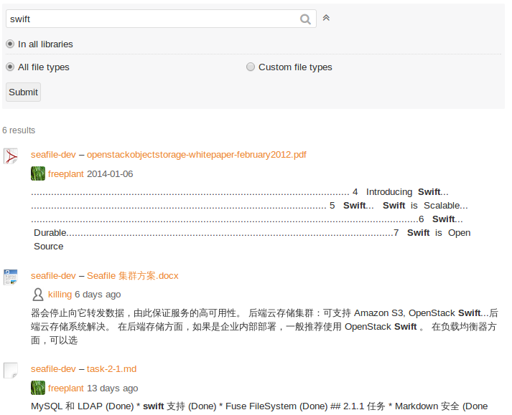

Preview of Microsoft Office Files

The open source edition only supports online preview of Text, PDF and ODF (Open Document Format) files. The business edition adds support for Microsoft Office preview.

Preview sample of .doc file.

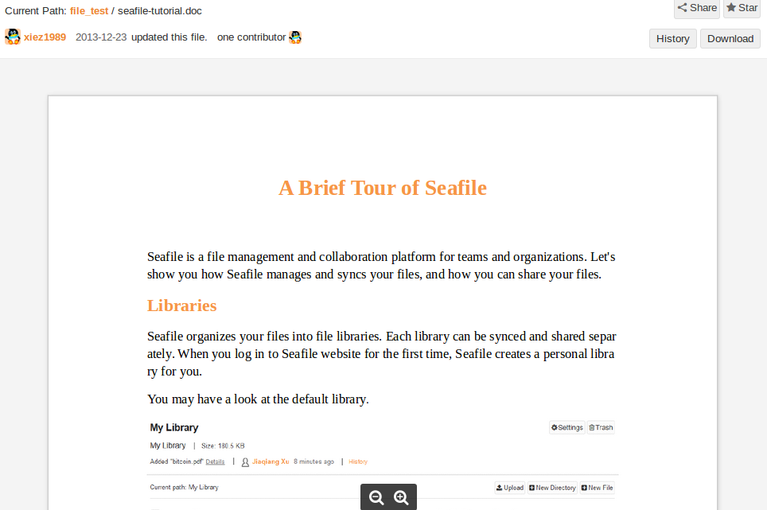

Preview sample of .ppt file.

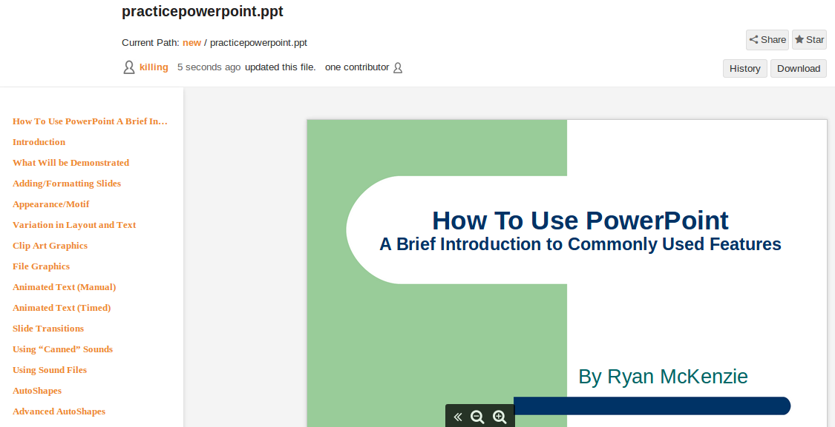

File Activity Timeline

When you’re working in a team, it’s very useful to know every member’s activity. Seafile business edition comes with a handy file activity feature. As you can see in the following picture, on your home page, you can instantly see what files other members are changing.

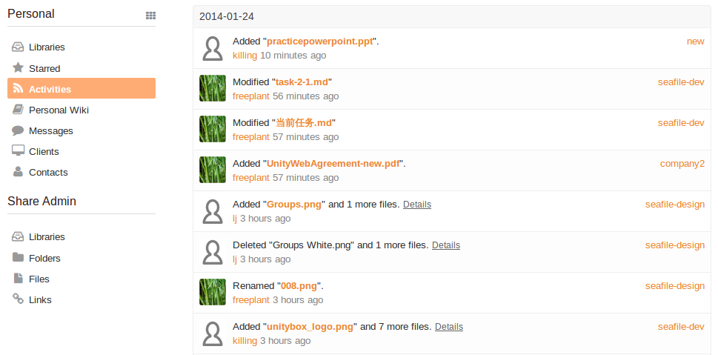

Seafile Cluster Architecture

For large deployments, scalability and high availability is usually a critical requirement. Seafile business edition supports clustering to enhance scalability, availability and performance. In the following, we’ll introduce Seafile’s clustering architecture.

Seafile cluster uses a 3-tier architecture:

1. Load balancer tier: Distribute incoming traffic to Seafile servers.
2. Seafile server cluster: a cluster of Seafile server instances.
3. Backend storage: Distributed storage cluster, such as S3, Openstack Swift, Ceph.

The architecture is presented in the following picture.

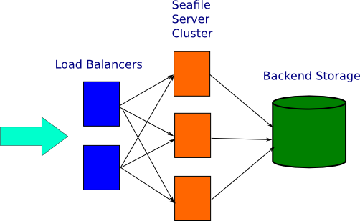

The load balancers receive requests from the users, including file syncing requests and web access requests. They then forward the received requests to one of the Seafile servers. The Seafile server processes the request, store to or load from data the backend storage system, then send replies to the user. The cluster is transparent to the end users. From the users’ perspective, the whole cluster looks like one big Seafile server.

This architecture has the following characteristics:

1. Scale-out: You can handle more traffic by adding more Seafile servers; you can store more data by adding more machines to the backend storage cluster.
2. High Availability: In the load balancer tier, HA can be achieved by deploying two load balancers in active-passive mode. The load balancer automatically detects the availability of Seafile servers. If a Seafile server node is down, no traffic will be forwarded to it.
3. Durability: Use S3, Swift or Ceph as storage backend, you can get very high durability.

Conclusion

Seafile Business Edition is the solution to build a more feature rich, powerful, and reliable Seafile service.