CPSC 488 — Assignment 3

Estimating the Impact and Value of Financial Information
Team members: Khoa Do, Daniel Diaz
Study period: 2012-2018
Submission date: November 8, 2026

1. Introduction and Objective
The objective of this project is to investigate whether financial news headlines can predict abnormal stock-market reactions and their estimated monetary impact.
Two prediction tasks were considered:
- Classification: Predict the Information Impact Score (IIS), a discrete measure ranging from −3 to +3 that describes the direction and unusualness of a market reaction.
- Regression: Predict the Monetary Information Value (MIV), an estimate of the abnormal change in a company's market capitalization associated with a news event.
We compared two text representations, Document-Term Matrix (DTM) and Term Frequency–Inverse Document Frequency (TF-IDF), using multilayer perceptron (MLP) models implemented in PyTorch.

2. Text Preprocessing and Vectorization
The financial news text was processed and converted into numerical features using two representations:
Document-Term Matrix (DTM): Represents documents using term-frequency counts.
TF-IDF: Weights terms according to their frequency within a document and their relative rarity across the training corpus.
The completed vectorization stage reported:
Dataset property | Observed value
Training documents | 127,440
Testing documents | 46,126
TF-IDF training vocabulary | 42,669 terms
The program successfully generated the DTM and TF-IDF training and testing CSV files.
Five financially informative terms: [Insert five terms identified from the news dataset and briefly justify their relevance.]

3. Classification Model and Results
A PyTorch multilayer perceptron was used to predict the discrete Information Impact Score from financial news text. Separate models were evaluated using DTM and TF-IDF features.
Model configuration: [Insert actual hidden-layer sizes, activation functions, optimizer, learning rate, batch size, and number of training epochs from 3_classify.py.]

4.1 Overall classification performance
Metric | DTM | TF-IDF
Training accuracy | 95.01% | 95.05%
Testing accuracy | 54.46% | 58.60%
Train–test accuracy gap | 40.55 percentage points | 36.45 percentage points
TF-IDF achieved the higher test accuracy, outperforming DTM by 4.14 percentage points. Both models obtained training accuracies of approximately 95%, but their test accuracies were substantially lower.
This discrepancy suggests that the models fit the training data much better than they generalized to previously unseen news observations. Potential explanations include overfitting, noisy relationships between financial headlines and market outcomes, and the limited information available from headline text alone.

4.2 Classification results by company
The following companies had the highest numbers of test observations.
Symbol | Test observations | DTM accuracy | TF-IDF accuracy
WDC | 285 | 53.68% | 57.19%
NFLX | 281 | 56.23% | 53.02%
REGN | 278 | 59.35% | 65.47%
GILD | 275 | 61.09% | 71.27%
MDT | 275 | 61.09% | 65.82%
LUV | 275 | 57.82% | 61.82%
KR | 274 | 66.06% | 68.25%
SLB | 270 | 52.59% | 54.07%
D | 265 | 52.83% | 55.47%
TXN | 264 | 58.71% | 56.82%
TF-IDF produced higher accuracy for eight of these ten companies. GILD showed the highest TF-IDF accuracy among the listed companies, at approximately 71.27%, while NFLX and TXN performed slightly better using DTM.
These results suggest that TF-IDF generally provided a more effective representation for classification in this experiment, although its advantage varied across companies.

4. Regression Model and Results
A second PyTorch multilayer perceptron was trained to predict the continuous Monetary Information Value (MIV). The regression models were evaluated using Root Mean Square Error (RMSE) and the coefficient of determination (R²).
Model configuration: [Insert actual hidden-layer sizes, activation functions, optimizer, learning rate, batch size, number of epochs, and any target scaling or transformation from 4_regression.py.]

5.1 Overall regression performance
Metric | DTM | TF-IDF
RMSE | $1,362,169,742.25 | $1,367,406,320.16
R² | 0.0108 | 0.0032
DTM achieved a slightly lower RMSE than TF-IDF, with a difference of approximately $5.24 million, or 0.38%.
However, the R² values for both models were extremely close to zero. The DTM model explained approximately 1.08% of the variation in the test targets, while TF-IDF explained approximately 0.32%, according to the reported R² values.
These results indicate that neither model demonstrated strong predictive ability for MIV. The large RMSE values also show substantial prediction errors in monetary terms, although the practical magnitude should be interpreted relative to the distribution and scale of MIV in the dataset.

5.2 Regression results by company
Symbol | Observations | DTM RMSE ($B) | DTM R² | TF-IDF RMSE ($B) | TF-IDF R²
WDC | 285 | 0.598 | 0.0307 | 0.592 | 0.0524
NFLX | 281 | 0.492 | −0.0121 | 0.484 | 0.0210
REGN | 278 | 1.215 | −0.0068 | 1.209 | 0.0025
LUV | 275 | 0.813 | −0.0225 | 0.808 | −0.0102
MDT | 275 | 1.665 | 0.0100 | 1.671 | 0.0022
GILD | 275 | 2.316 | 0.0230 | 2.333 | 0.0083
KR | 274 | 0.616 | −0.0505 | 0.603 | −0.0081
SLB | 270 | 2.324 | 0.0012 | 2.328 | −0.0022
D | 265 | 1.222 | 0.0042 | 1.223 | 0.0024
TXN | 264 | 1.957 | 0.0342 | 1.982 | 0.0093
RMSE is shown in billions of U.S. dollars, rounded to three decimal places.
Although TF-IDF improved RMSE for several individual companies, DTM achieved slightly better overall performance. The company-level R² values were generally small, with several negative values. Negative R² indicates that the model performed worse than predicting the mean target value for those observations.
These findings reinforce the difficulty of predicting monetary market reactions from financial news text.

5. Discussion and Analysis

6.1 Comparison of DTM and TF-IDF
The two vectorization methods performed differently across the prediction tasks.
For classification, TF-IDF achieved the higher test accuracy of 58.60%, compared with 54.46% for DTM. This suggests that weighting terms by their relative importance was beneficial for distinguishing IIS categories in this experiment.
For regression, DTM achieved marginally better overall results, but neither representation demonstrated strong predictive performance.
The results show that the best text representation may depend on the prediction objective. A representation that improves classification accuracy does not necessarily improve the prediction of continuous monetary values.

6.2 Generalization and model limitations
The classification models showed substantial differences between training and testing accuracy, suggesting overfitting or other generalization difficulties.
The regression models performed poorly in terms of R². Predicting MIV is particularly challenging because the target depends on both abnormal returns and company market capitalization. Consequently, companies with different market capitalizations may exhibit very different monetary impacts even when their abnormal percentage returns are similar.
Other important limitations include:
- Financial headlines provide incomplete information about investor expectations and market conditions.
- Multiple news events and other market developments can influence stock prices during the same event window.
- The event-study methodology estimates abnormal reactions associated with news; it does not establish that an individual article caused the observed market movement.
- Using the current S&P 500 constituent list for historical analysis introduces survivorship bias.
- A simple bag-of-words representation cannot fully capture word order, negation, context, or nuanced financial meaning.

6.3 Potential improvements
Future work could investigate regularization, early stopping, alternative MLP architectures, and hyperparameter tuning to improve generalization.
For classification, class-distribution analysis, majority-class baselines, confusion matrices, and per-class precision and recall would help determine whether the observed accuracy reflects meaningful predictive performance.
For regression, comparisons against a mean-prediction baseline, examination of extreme MIV values, and appropriate target transformations or scaling may help identify the sources of prediction error.
More advanced text representations, including contextual embeddings or finance-specific language models, could also be evaluated.

6. Conclusion
This project evaluated whether financial news text could predict abnormal stock-market reactions and their estimated monetary value using event-study targets and PyTorch multilayer perceptron models.
TF-IDF achieved the best classification performance, with a test accuracy of 58.60%, compared with 54.46% for DTM. However, both models exhibited substantial training–testing performance gaps.
For regression, DTM achieved the best overall RMSE of approximately $1.362 billion and an R² of 0.0108, indicating very limited predictive power.
Overall, the experiment demonstrates that financial news text contains some potentially useful predictive information, but the tested models did not reliably explain market reactions, particularly their monetary magnitude.
The findings highlight the importance of careful evaluation, avoiding data leakage, accounting for financial-market complexity, and recognizing the limitations of text-only prediction methods.

Both scripts have now completed, so we have actual classification and regression results to report. The key finding is that TF-IDF performs better for classification, while DTM performs slightly better for regression—but both models show substantial limitations on unseen data.

Results at a glance
Best classification test accuracy

58.60%
TF-IDF · DTM: 54.46%
Best regression R²

0.0108
DTM · TF-IDF: 0.0032
Classification accuracy
Training versus test accuracy for the two text representations.
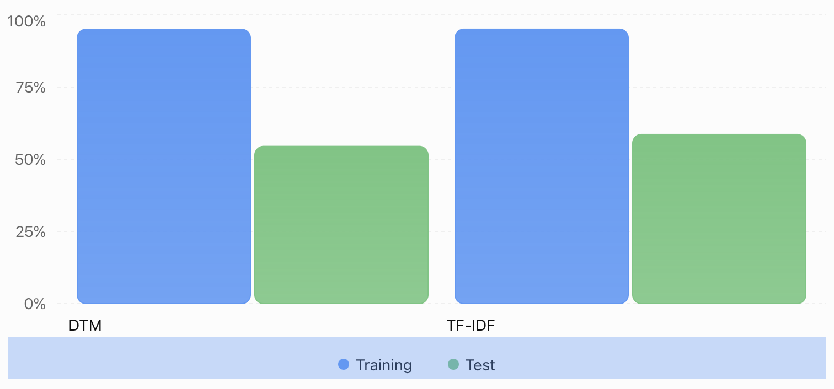
The roughly 95% training accuracies versus 54–59% test accuracies suggest substantial overfitting or poor generalization. The regression R² values near zero indicate very little predictive power for monetary information value on the test set.
The assignment also requires architectural details, preprocessing, sampling, and analysis—not just numerical results. The following is a report draft based on your screenshots and the assignment instructions, with explicit placeholders where the screenshots don't establish implementation details.

