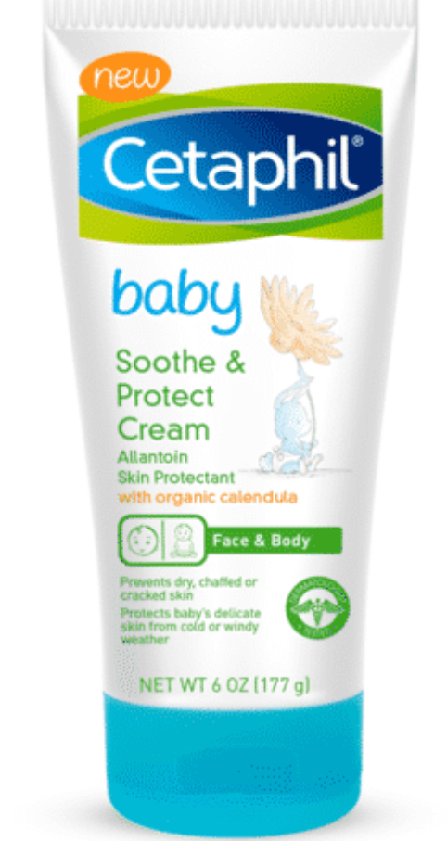

### 

## INTRODUCE PRODUCT

From the gentle Skincare experts comes Cetaphil Baby Soothe and Protect Cream, specifically formulated to protect against the harsh realities of weather and the environment. Dermatologist tested and recommended, this non-greasy formula is paraben, fragrance and petrolatum free to protect and relieve dry, chaffed and irritated skin.

## BENEFITS

* Includes skin protectant Allantoin which help rescue, prevent and relieve dry, cracked skin
* Absorbs quickly for immediate relief without leaving your baby’s skin feeling greasy
* Provides long-lasting protection against harsh weather conditions such as the cold and wind
* Dermatologist tested on sensitive skin
* Formulated with organic calendula and a unique blend of soothing moisturizers to provide relief for baby's dry, delicate skin

## INGREDIENTS

Butyrospermum Parkii (Shea) Oil, Calendula Officinalis Flower Extract ,Caprylyl/Capryl Glucoside, Caprylyl Glycol, Citric Acid, Glycerin, Glycine Soja, (Soybean) Oil, Helianthus Annuus (Sunflower) Seed Oil, Methylpropanediol, Panthenol, Pantolactone, Phenoxyethanol,Polyisobutene, Sodium Acrylate/Sodium Acryloyldimethyl, Taurate Copolymer,Sorbitan Oleate, Tocopherol, Water

## HOW TO USE

Apply as needed

## ORIGIN

Germany